Nineteenth Warwick Symposium on Parish Research

Parish, Power & Politics

Webinar on Blackboard Collaborate, Friday evening & Saturday 7-8 May 2021

CALL FOR PARTICIPATION

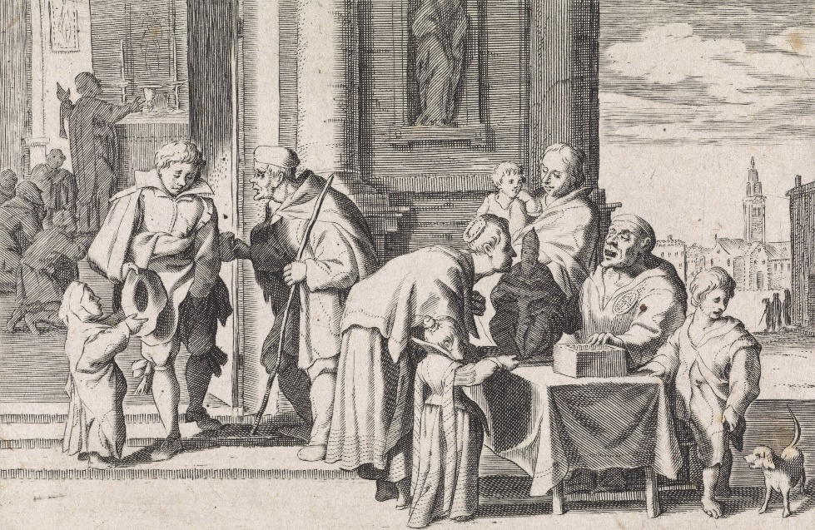
Cornelis de Wael, 'Beggars at the church door' (1629). Amsterdam, Rijksmuseum.

Parishes have always been about more than religion. Aspects like the election of officials, allocation of pews or administration of funds moved communal concerns well into the political sphere. We know much about processes of social and confessional differentiation, but what exactly were the power relations in parish communities? How did localities negotiate their dealings with manorial lords, city councils and state authorities? To which extent were parishes instrumentalized for secular purposes like local government or even resistance?

We have been fortunate in securing a keynote address by Keith Snell (Leicester):
'Parishes, pandemics and paths to take: post-Covid historical options'
Proceedings will be structured into six panels: 1. Local Politics of Poor Relief; 2-3. Politics of Belonging; 4-6. Open Sessions. To participate as a discussant, please send your email address & a brief biographical note by 1 May 2021 to: my-parish@warwick.ac.uk and we’ll send you a joining link shortly before the event.

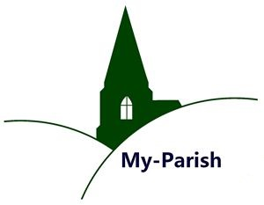
For info contact: b.kumin@warwick.ac.uk or marjolein.schepers@vub.be
For updates visit:
http://warwick.ac.uk/my-parish/parishsymposia/2021politics/

