Warwick Symposium on Parish Research
Parish Communication
Saturday 17 May 2025

Delegate List

In-Person Attendees

Ashley Armstrong University of East Anglia ashley.armstrong@uea.ac.uk

Ian Atherton Keele University i.j.atherton@keele.ac.uk

Angus Crawford University of Warwick angus.r.crawford@warwick.ac.uk

Kristi Flake University of Warwick Kristi.flake@warwick.ac.uk

Andrew Foster Independent Scholar andrew@awfoster.com

Marion Hardy Independent Researcher marionrhardy@gmail.com

Melchior Jakubowski University of Warsaw melek.jakubowski@gmail.com

Beat Kümin University of Warwick B.Kumin@warwick.ac.uk

Lynn Marriott University of Warwick Lynn.marriott@warwick.ac.uk

Béla Vilmos Mihalik HUN-REN RCH Institute of History mihalik.bela.vilmos@abtk.hu

George Palmer Emmanuel College, Cambridge gp506@cam.ac.uk

Paul Sutton Victoria County History – Shropshire ps@pshistory.com

Robert Swanson Shaanxi Normal University r.n.swanson@bham.ac.uk

Felicita Tramontana Roma Tre/Warwick University f.tramontana@warwick.ac.uk
Jonathan Willis University of Birmingham j.p.willis@bham.ac.uk

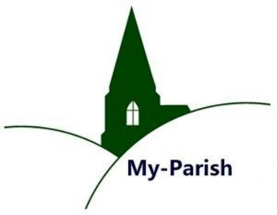
Virtual Attendees

Alice Blackwood Oxford University alice.blackwood@pmb.ox.ac.uk

Gillian Draper University of Kent g.m.draper@kent.ac.uk

Ian Hart Independent ihart7@aol.com

Valerie Hitchman University of Kent valerie.hitchman@btinternet.com

Alice Griffo Università di Torino alice.griffo@edu.unito.it

Helen Hofton Hertfordshire Association helen_hofton@hotmail.com
For Local History

Ralph Houlbrooke University of Reading r.a.houlbrooke@reading.ac.uk

David Noy Buckinghamshire Record Society d.noy@btinternet.com
and Open University
Christian Owen University of Cambridge cmao2@cam.ac.uk

Dave Postles Hertfordshire davep@davelinux.info

Kgomotso Ramushu University of Cambridge kkr33@cam.ac.uk

Adrian Rance-McGregor Independent Researcher adrianrance220@gmail.com

Nicholas Ringwood The University of Auckland / nrin005@aucklanduni.ac.nz
Waipapa Taumata Rau

Marek Słoń John Paul II Catholic University marek.slon@kul.pl
of Lublin

Anne Thompson Independent Researcher annethompson22@hotmail.com

Angela Webb ---------- wisaa25@tiscali.co.uk

Helen Whittle ---------- HWhi541162@aol.com

Hàìghlèàgh Winslade University of Wales Trinity St David 2413581@student.uwtsd.ac.uk

Symposium homepage:
https://go.warwick.ac.uk/my-parish/parishsymposia/communication/

