

Parish Studies Workshop
Berkswell and Beyond

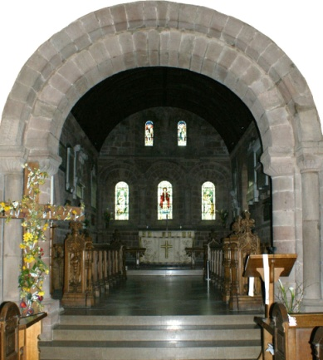

Parish history, art, heritage and culture come alive at
The Eleventh Warwick Symposium on Parish Research

An immersive, workshop-style event that explores the fabric of a community, its church and new directions in parish research

co-organized by the
Spirit of Berkswell Project &
Warwick Network for Parish Research

Saturday 25 May 2013
Berkswell, Warwickshire, 9.15am–5pm

For further details visit the ‘My-Parish’ online portal:
http://my-parish.org/events/parish-symposium-2013

Contact: Beat Kümin, b.kumin@warwick.ac.uk
Supported by Warwick’s  Humanities Research Centre

