Twenty-First Warwick Symposium on Parish Research
Parish and Performance
Saturday 13 May 2023
Institute of Advanced Study, University of Warwick, Coventry CV4 7AL
Co-organized by Beat Kümin (Warwick / My-Parish) & John Craig (Simon Fraser / Records of Early English Drama) with Daniel Gettings and Maria Tauber (Warwick)
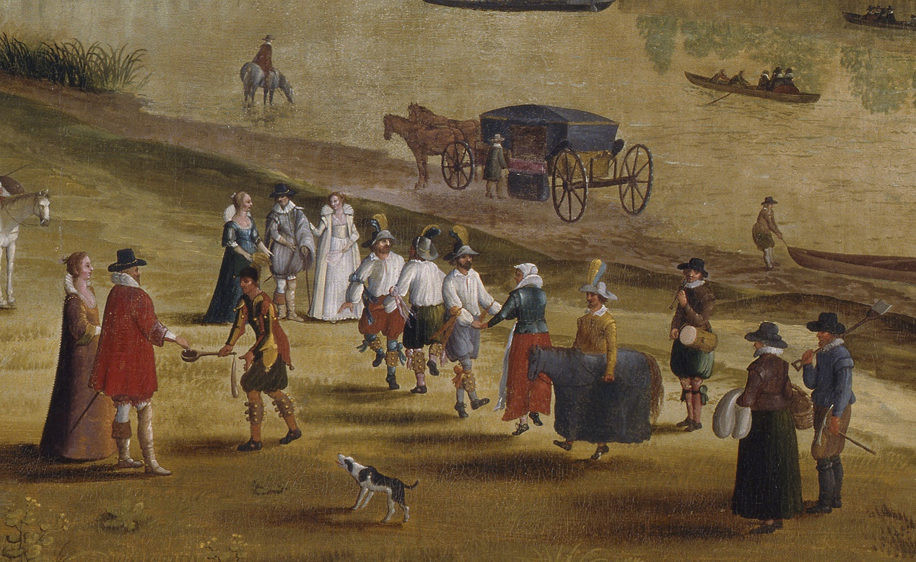
‘The Thames at Richmond, with the Old Royal Palace’
(unknown Flemish school, early 17thC). © The Fitzwilliam Museum, Cambridge.
FINAL PROGRAMME
9.45 – 10.15 Registration and Coffee (Institute of Advanced Study, Foyer)

10.15 – 10.30 Welcome and Introduction by the co-organizers (IAS Seminar Room)

10.30 – 11.30 Keynote Address, chaired by John Craig (Seminar Room)
Peter Greenfield (University of Puget Sound),
‘a strange perswasion’: English Parish Performances and the Records of Early English Drama

11.30 – 1 pm Session 1: MUSIC, DANCE & CHARIVARI, chaired by Beat Kümin (Seminar Room)

Susan Skinner (University of Plymouth), ‘Music, Place and Culture: the Male Voice Choirs of two Cornish Fishing Communities’

Michael Heaney, ‘From Centre Stage to Outcasts: Morris Dancers in Parish Performance 1540-1660’

Taylor Aucoin (University of Edinburgh), ‘The “Parish Football Fund” and the Hunt for Britain’s Nuptial Charivari’

Emily Winerock (Point Park University, USA/Shakespeare and Dance Project), ‘Choreographing Community or Performing Profanation? Competing Conceptions of Dancing in English Parishes, c. 1550–c. 1640’

1 – 1.45 pm LUNCH (IAS Common Room)

1.45 – 3.15 pm Session 2: DRAMA, chaired by Maria Tauber (Seminar Room)

Lynneth Miller Renberg (Anderson University), ‘Performing Joy: Plays and Emotion in Medieval York’

Lydia Fisher (University of Exeter), ‘The Drama of Stained Glass: an Examination of the 15th century Passion Window at St Kew, Cornwall’

Chris Highley (Ohio State University), ‘The Drama of the Parish: Performing Local Life in Early Modern London’

Kristi Flake (University of Warwick), ‘The Performance of the Book of Homilies in the English Parish, 1547-1720’

3.15 - 3.45 TEA

3.45 - 4.30 pm Session 3: PERFORMANCES – in the ‘Street’ space outside the IAS

David Fletcher (University of Warwick), ‘Parochial Tyranny’ – a Dramatic Reading

Tom ‘Strasz’ Straszewski (University of York), ‘“Heaven and Earth in Little Space”: Performing the Parish through the York Mystery Plays’

4.45 - 5.30 Session 4: PROCESSIONS, chaired by Daniel Gettings (Seminar Room)

Klaas Van Gelder (Vrije Universiteit Brussels/State Archives in Brussels), ‘The Parish as the Main Stage: Seigneurial Joyous Entries in the Burgundian and Habsburg Netherlands’

Bela Mihalik (Institute of History, Budapest), ‘The Performance of Unity: Processions in Eger in the first decade of the post-Ottoman Era, 1687-99’

5.30 - 6.00 CONCLUDING REMARKS AND REFRESHMENTS (Seminar Room)

For further info please contact b.kumin@warwick.ac.uk and / or johnc@sfu.ca
Any updates will be posted to the 2023 Symposium homepage at:
http://warwick.ac.uk/my-parish/parishsymposia/performance
We are grateful for the generous support of:
