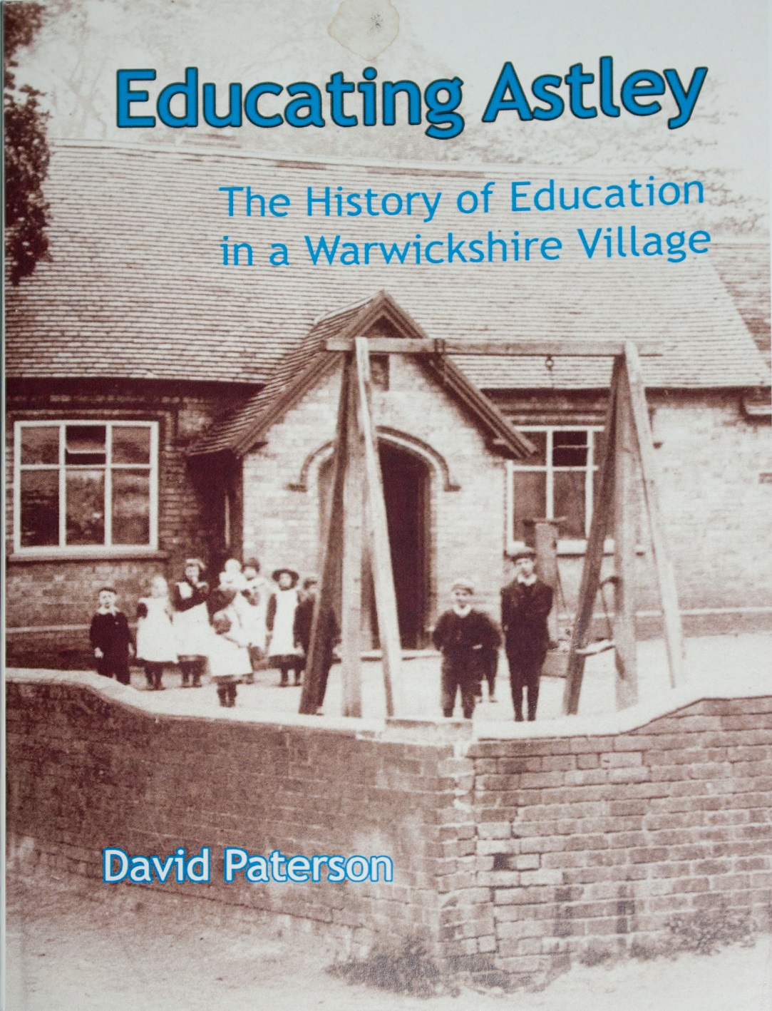
New Book from Local Author David Paterson’s latest book is on the history of education in the little north Warwickshire village of Astley. The cost is £3.95 and all the profits will be donated to Astley church. This is David’s third history of a school. Earlier volumes have been on King Edward Vl Grammar School in Nuneaton (Leek’s Legacy, 2011), and Chilvers Coton Free School (‘A good Eddication’, 2013). When researching the history of Chilvers Coton Free School, with its close links to the Newdigate family at Arbury Hall, he found many references to Astley school, which also owed much to the Newdigate family and similarly to Robert Evans, the father of George Eliot, and saw that there was enough information to produce a short book on the subject. It is published by Chilvers Coton Heritage Centre. The Centre has its own publishing ISBN and hopes to publish more small circulation local books in the future, especially those relating to the history of education in the area. Educating Astley is available at the Coton Heritage Centre, Astley Book Farm and Astley church, and online through the Centre’s website and through the George Eliot Fellowship’s website.

