
Modupe Otunaiya
University of Warwick
The Power of Nudges

ABSTRACT
In my research, I looked at the effect of nudges in a real life restaurant setting, by testing nudges on the usage of straws the results showed that straw usage decreased with the presence of the nudges.

CONCLUSIONS
What was observed was that straw usage decreased with the presence of the nudge. When the posters were up less straws were used compare to when the posters were not used.

RESULTS (CONTINUED)
OBSERVED | STRAWS | NO STRAWS
POSTER | 159  36% | 283  64% | 442  100%
NO POSTER | 370  51% | 361  49% | 731  100%
 | 529  45% | 644  55% | 1173  100%

METHODS
By contacting a local restaurant in city Centre, I was able to display nudge posters all over the restaurant. I observed over 3 days and only one day with the nudge posters.

AIMS
The hypothesis of the study being “straw usage will decrease with the input of nudges compared to the normal rate of straw usage.”

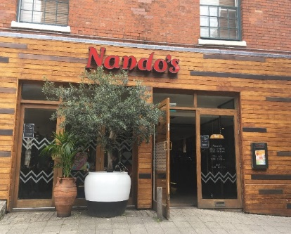
ACKNOWLEDGEMENTS
A special thank you to Professor Ulf Liebe and my supervisor Nicole Schwitter for helping me all the way though my project.

AIMS
The hypothesis of the study being “straw usage will decrease with the input of nudges compared to the normal rate of straw usage.”

INTRODUCTION
Decision making is known to be dependent on the dual process system.
- System 1, the automatic system and system 2, the reflective system.
- Nudge affects system 2.
- nudge is defined as “an aspect of the choice architecture to alter people’s behaviour without forbidding anything, an easy and cheap incentive” (Thaler et al, 2008)
- They are used to intentionally help individuals make better decisions by positively reinforcing or indirectly suggesting ideas, more beneficial to themselves or the world around them.
IT’S ONLY
ONE STRAW”
SAID 8 BILLION PEOPLE

MORE THAN 8 MILLION TONS OF PLASTIC IS DUMPED INTO OUR OCEANS EVERY YEAR. HELP US TO REDUCE THIS, USE LESS STRAWS.

REFERENCES
R. Thaler and C. Sunstein. (2008). Nudge. Penguin Book

FURTHER WORK
If my study was to continue, I would observe for a longer period of time. I would have the poster up for the duration of a week or possibly even longer.

DISCUSSION
- It seemed like social norms was the cause more than deeper processing.
- People seemed more hesitant to ask for straws when they heard no one else asking, but if someone else asked first they quickly asked for one too.

RESULTS
- The results showed that on Friday 442 customers ordered.
- It was recorded that only 159 straws were used on that day.
- Saturday had a total of 429 came in to have a sit down meal and 259 straws were recorded to have been used.
- Sunday had 302 customers with a usage of 83 straws.
- When the poster was up, 36% of people used straws while 64% of people did not use the straws.
- When the posters were not up 51% of people used straws and 49% didn’t use a straws.

