

About Quantitative Methods in Social Sciences

**What are Quantitative Methods?**

Quantitative methods encompass a range of data skills, from simple statistical analysis to more advanced predictive modelling**. The idea behind many quantitative approaches it to understand how and why something has happened and how we might prepare or predict changes in the future.** Quantitative methods typically involve working with data and particular software packages (e.g. Excel, SPSS, Stata, R) that help to manage, analyse and visualise a lot of numerical data.

**Why study Quantitative Methods?**

Quantitative skills are useful for answering all kinds of questions, such as understanding **why people vote the way they do, why crime rates are higher in some areas than others and how social class affects educational attainment.** So much of what we do every day now involves some kind of numerical data generation. Studying quantitative methods provide you with skills that are not only increasingly in demand across different kinds of employment sectors, but will also help you to understand and navigate through many everyday data-driven demands.

“Being able to have a larger focus on **quantitative methods** is really interesting for me, especially in the modern day where data exists everywhere. Employers are currently experiencing a shortage of graduates with this quantitative skills, allowing you to really stand out in the job market.”

“Choosing Warwick to study **Politics, International Studies and Quantitative Methods** is the best choice I have made so far. The degree provides a specific range of quantitative analysis tools, which is quite unique at undergraduate level. It has helped me to deepen my understanding of the world, so that I am able to develop in-depth and detailed political research skills.”

Hear from current Quantitative Methods degree students

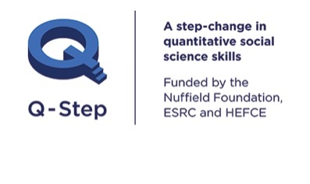

**Course information:**

BA Sociology & Quantitative Methods:

[www.warwick.ac.uk/sociology/prospective/ugstudy/socquant](http://www.warwick.ac.uk/sociology/prospective/ugstudy/socquant)

BA Politics, International Studies & Quantitative Methods:

[www.warwick.ac.uk/pais/study/studyundergrad/polintqm](http://www.warwick.ac.uk/pais/study/studyundergrad/polintqm)

**Request a university prospectus:** [www.warwick.ac.uk/prospectus](http://www.warwick.ac.uk/prospectus)

**Open day information:** [www.warwick.ac.uk/opendays](http://www.warwick.ac.uk/opendays)

For all other enquiries, please contact **Warwick Q-Step Centre:**

**Email:** [Q-Step@warwick.ac.uk](mailto:Q-Step@warwick.ac.uk) **Tel:** +44 (0) 24 7657 3511

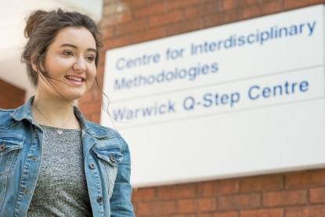

**BA Sociology and Quantitative Methods student**

**BA Politics, International Studies and Quantitative Methods student**

**Quantitative Methods**

**in Social Sciences**



**BA Sociology and Quantitative Methods** UCAS Code 52L8

As well as giving students a core grounding in the discipline of **Sociology**, this degree prepares students to work in ways that help to understand, participate and intervene in a data-driven digital society. The degree is specifically designed so that students can engage with real sociological problems using cutting-edge data analysis.

**BA Politics, International Studies and Quantitative Methods** UCAS Code 7L29

As well as giving a core grounding in **Politics and International Studies**, the degree will prepare students to work in ways that help to analyse quantitative data. The degree is designed to emphasize the link between big substantive themes in the discipline (such as security, poverty, democracy, national politics, foreign policy and so on) and different quantitative tools.

Undergraduate Quantitative Methods Degrees at Warwick University

Warwick University has developed two new undergraduate degrees. These degrees enable you to develop a strong grounding in the discipline of either **Politics & International Studies** or **Sociology**, while also gaining advanced skills in **quantitative methods**. Both degrees offer a **4-week paid placement period**. Current placement employers include: **Institute for Social and Economic Research, National Centre for Social Research, Office for National Statistics, Demos, Ipsos MORI, Family and Childcare Trust, Coventry Citizens Advice Bureau, Joseph Rowntree Foundation.**

**Your student experience at Warwick**

With a wide range of extra-curricular activities, you’ll never be short of something to do. As well as outstanding academic and research activities, you can expect the following from your time at Warwick:

**Warwick University – some facts and figures:**

* Founded in 1965
* A campus based on 290 hectares
* Four faculties: Arts, Medicine, Science and Social Sciences
* Around 24,600 students and 2,300 academic and research staff.
* Consistently listed in the Top 10 UK universities in the media league tables
* Ranked 48th in the QS World University Rankings in 2015/16
* Over 200 undergraduate degrees across 36 departments and centres.

Over 230 **student societies**

**Swimming pool,** climbing wall, **gym,** sauna, **athletics track,** tennis centre

One of the biggest **Students’ Unions** in the country

Campus accommodation with **Wi-Fi**

Cinema, theatre, conference hall and art gallery, in our own **Warwick Arts Centre**

70 **sports clubs**

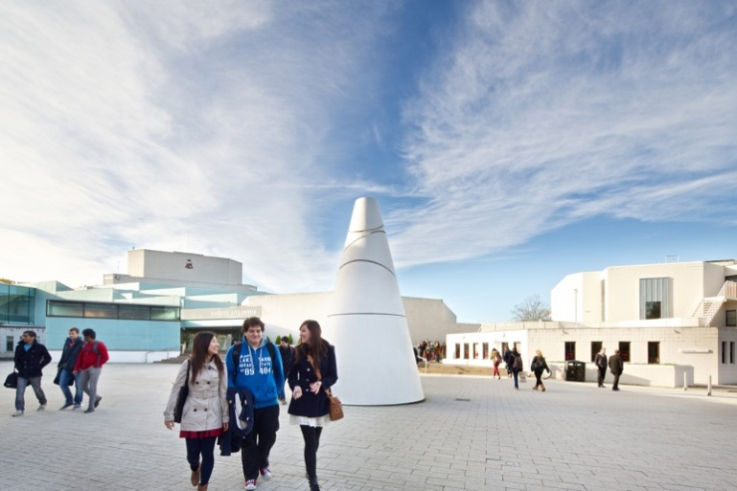

Cafés, banks, bars, hairdresser, supermarket and more all on campus