INTEGRATE AMR

Application for Support from the Early Career Fellow fund
Please send the completed proforma to Rika Nair c.nair@warwick.ac.uk
Name and Departments of Supervisors: Chrystala Constantinidou (WMS), Andrew Millard (WMS) & James Covington (School of Engineering)
Project Title: Using Fixed Phage for control and monitoring of bacterial load in the farm environment
Start and End date: July 2017-December 2017
Name of Applicant: Emily Stoakes
Current University/Department: University of Warwick, Warwick Medical School
Tel: 024 76178392
Email: e.a.stoakes@warwick.ac.uk
Title of PhD: Campylobacter jejuni flagellar biogenesis: the role of FlhF
Date of submission/ planned date of submission: September 2017
Please attach an up to date CV separately.

- Please provide a brief summary of the intended 6-month research project, including a list of desired outputs, outcomes and measures of success. Please consider that the judging panel will be from a variety of departments and disciplines (max 500 words)
It is estimated that ~45% of antibiotics used in the UK is within farming, in both disease prevention and treatment (1). This is usually necessary in intensive poultry production where thousands of animals are kept in confined spaces.

It is now widely accepted that for infections such as Campylobacter, farm antibiotic use is the principal cause of resistance in human infections (2,3). Campylobacter jejuni colonizes the intestine of poultry, is generally nonpathogenic in birds and is present in more than half of all commercial flocks (4).

Escherichia coli is one of the major avian pathogens responsible for colibacellosis in poultry at great costs to the industry (5). There is increasing awareness of the potential exchange of antibiotic genes between farm-animal and human E.coli strains in the human gut (6). Despite intensive efforts to improve on-farm biosecurity practice recent reports suggested that 24% and 50-80% of English supermarket chicken is ESBL E.coli and C.jejuni positive respectively (7).

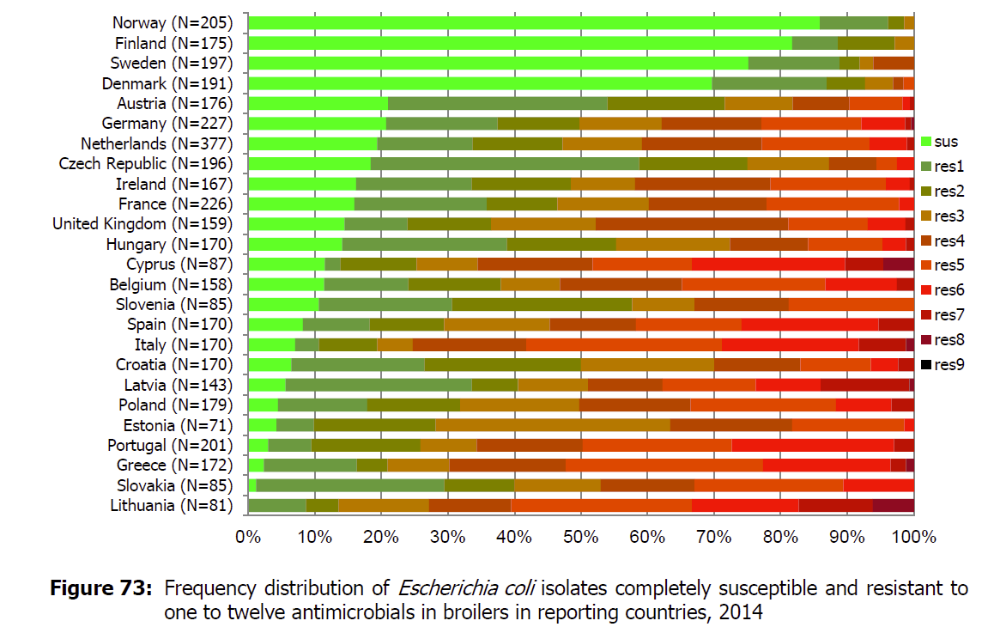
Although newly hatched chicks appear to be free of infection most commercial flocks become infected after broiler house placement. Environmental contamination is probably the most common source of infection with litter and contaminated water implicated (8). One promising strategy of farm bio-control is the use of lytic bacteriophages with the aim to reduce colonization. The use of phages in flock animals has so far produced mixed results focusing on treating the animals themselves rather than the environment (9).
Antibiotic use practices vary widely globally as evidenced by the frequency of antibiotic resistant E. coli isolates in broilers in reporting EU countries in 2014 (11).

We propose a methodology for reducing and monitoring the bacterial load in farm environmental sources such as water. Immobilization of the phage on a solid surface such as a ball, rather than direct addition to water supply, increases phage stability and resistance to degradation, ensuring that the phages fully retain their antimicrobial potency. It also decreases the amount of phage required for maintaining low bacterial load and allows easy replenishment when the bacterial load increases again. Fixed Phage is a biotechnology licensing company (http://www.fixed-phage.com/technology) that has developed technologies for the immobilization of bacteriophages on the surface of a range of substrates and has agreed to collaborate on this project.
There are three broad goals to this project:
- As a proof of principle we will explore the efficacy of treating E.coli with bacteriophages immobilized on small plastic balls.
- We will also explore using the electronic nose system (James Covington) for both confirming efficiency of the treatment as well as monitoring bacterial load to alert for the need of new treatment.
- We will also start collecting a range of C.jejuni strains and bacteriophages from chicken farms and supermarket chicken to be used as in goal 1 if time permitting and for use in future studies to follow on.

Specific aims:
SA1: A panel of E coli bacteriophages already available from other studies will be immobilised on plastic balls in collaboration with Fixed Phage.
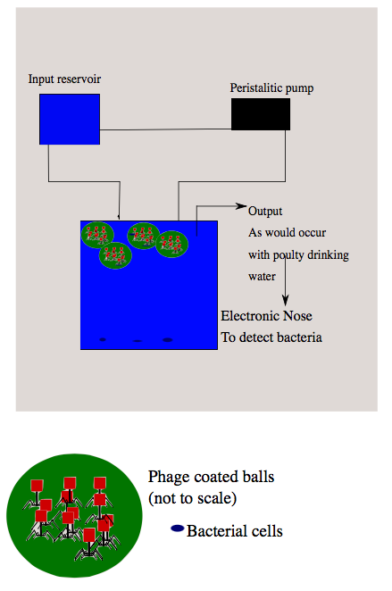
SA2: The efficiency of the immobilised bacteriophage treatment will be assessed using water with 10x diluted LB and varying numbers of E.coli cells/ml. We propose to use a system where the “culture” will be flowing (via a peristaltic pump) at a set rate over the immobilised balls sitting at the bottom of a tank. Colony forming units will be measured using standard methodology of the culture prior to treatment with bacteriophage and after and log₁₀ reduction in the bacterial load will be calculated.

SA3: Determine signature and efficiency of bacteriophage treatment of bacterial load using the electronic nose of water/culture before and after treatment.

SA4: Collect and isolate C.jejuni bacteriophages following standard methodologies (10).

References
1. Overview of Antimicrobial Usage and Bacterial Resistance in Selected Human and Animal Pathogens in the UK 2007, www.vmd.defra.gov.uk/pdf/AMR_overview07.pdf
2. Stockdale et al. 2015, Emergence of extensive fluoroquinolone resistance in Campylobacter gastroenteritis in Liverpool, UK, J Infect, 72(3), 398-400
3. Wimlarathna et al. 2013, Widespread acquisition of antimicrobial resistance among Campylobacter isolates from UK retail poultry and evidence for clonal expansion of resistant lineages, BMC Microbiology, 13, 160
4. Jorgensen et al 2011. Influence of Season and Geography on Campylobacter jejuni and C. coli Subtypes in Housed Broiler Flocks Reared in Great Britain. Applied and Environmental Microbiology, 77(11), 3741–3748.
5. Lutful Kabir 2010, Avian Colibacillosis and Salmonellosis: A Closer Look at Epidemiology, Pathogenesis, Diagnosis, Control and Public Health Concerns. International Journal of Environmental Research and Public Health, 7(1), 89–114.
6. Vieira A.R., et al 2011. Association Between Antimicrobial Resistance in Escherichia coli Isolates from Food Animals and Blood Stream Isolates from Humans in Europe: An Ecological Study, Foodborne Pathogens and Disease, 8: 1295-301
7. http://www.saveourantibiotics.org/publications/
8. Agunos A et al 2014 A Systematic Review Characterizing On-Farm Sources of Campylobacter spp. for Broiler Chickens. PLoS ONE 9(8): e104905.
9. Grant A. et al, 2016 Salmonella and Campylobacter: Antimicrobial resistance and bacteriophage control in poultry, Food Microbiology, 53(B), 104-109
10. Carvalho C et al, 2010 Method for bacteriophage isolation against target Campylobacter strains. Letters in Applied Microbiology, 50: 192–197.
11. EMEA, 2006. Reflection paper on the use of fluoroquinolones in food-producing animals in the European Union, http://www.ema.europa.eu/docs/en_GB/document_library/Other/2009/10/WC500005155.pdf

- Amount of consumables funding requested (maximum £1,500)
Growth media: £200
Plastic/gloves/consumables: £500
Immobilised phage: £800

- External collaborators / other sources of funding
Jason Clark – Fixed Phage

- Justification for support - How is the project multidisciplinary? How will it address the challenge of AMR and why is the candidate suited to address this challenge? (max 400 words)
This project combines the application of new cutting edge biotechnologies such as Fixed –Phage (Fixed-Phage Ltd) and electronic nose (Covington) with basic phage microbiology (Millard) and food microbiology (Constantinidou).

The candidate is well suited for this challenge as is nearing completion of a PhD on Campylobacter jejuni. Although the applicant has limited experience working with bacteriophages she has a good understanding of the issues of foodborne pathogens and antibiotic resistance. The candidate has extensive experience in microbiology techniques. The intention for this fellowship is for the candidate to gain experience on phage work initially using E. coli (as it is a lot easier to work with) and then try to apply knowledge gained on C. jejuni bacteriophages. Future funding based on this preliminary data will enable her to apply the breadth of experience and knowledge the candidate has already gained during her PhD in sequencing and genomics analysis in characterising novel C. jejuni bactreriophages isolated during the current project.

Please provide a 1 sentence summary of the link to AMR:

The project addresses the challenge for AMR by the development of a new methodology to reduce the bacterial infection and antibiotic use in intensively farmed animals like poultry, which are the major sources of C. jejuni and E. coli antibiotic resistance strains present on supermarket chickens and threatening public health.

- Follow-on funding (please outline how the candidate will build on the outcome of this short project in terms of future grant proposals, including specific dates, funders and schemes)
I intend to use the results of this project, as a part of the application to the Sir Henry Wellcome Postdoctoral Fellowships Scheme that is aimed specifically at those just completing their PhD. Target submission to this funding scheme is October 2017. Additional advantage of this scheme is that it has a rapid notification system, where only an initial proposal is submitted at the submission date and the answer is given within a month from submission. In case the answer is positive, a full proposal is then submitted.

If application to the Wellcome Trust should be unsuccessful, application will be made to the Leverhulme Trust Early Career Fellowship scheme, with target submission January 2018.

We will also explore collaborations with AHDB (Agriculture & Horticulture Development Board). They have a number of projects running trying to monitor chicken farms fro infection, so this project is very timely.

If this project were a success the preliminary data would be used for a high quality publication and also as the basis of a standard project grant application to the BBSRC.

- Have any of the supervisors worked together previously?

Constantinidou has a number of collaborative projects with Millard, but this is the first collaboration with bacteriophages at the centre of it. The intention is that this will lead to more collaborations that complement their expertise, i.e. foodborne pathogens and bacteriophages for Constantinidou and Millard respectively. Furthermore, both Constantinidou and Millard are PhD co-supervisors to the fellowship candidate. Both Constantinidou and Millard participated in collaboration with James Covington.
This project will also enable new collaborations to be developed with the biotechnology company Fixed Phage.

Applicant Declaration
I have read the Bridging the Gaps Funding Call supporting documentation and agree to abide by these conditions. I confirm that this is a new collaboration that is yet to receive funding either from external or internal sources.
I understand that if I am awarded funding I will be required to provide a 2-page report after 5 months.
Names and signatures of applicant: Emily Stoakes
Date: 15 January 2017
Supervisor Declaration
I have read the Bridging the Gaps Funding Call supporting documentation and agree to abide by these conditions. I confirm that this is a new collaboration that is yet to receive funding either from external or internal sources.
I understand that if I am awarded funding I will be required to assist the applicant in writing a grant application within the duration of their fellowship.
Names and signatures of supervisors: Chrystala Constantinidou, Andrew Millard and James Covington
Date: 15 January 2017

Early Career Fellowship Fund Proposal Feedback Form

- Quality (max 500 words)
Please comment on the degree of research excellence of the proposal, referencing:
- Novelty, relationship to the AMR research context and timeliness
- Appropriateness of the proposed methodology
As this is a multi-disciplinary proposal, please state which aspects of the proposal you feel qualified to assess.

- Importance (max 500 words)
Please comment on the ability of the proposed fellowship to enhance Warwick’s potential to be a centre of excellence for research on AMR, including how the research:
- Contributes to or helps maintain the health of mutidisciplinary collaborations
- Enhances the career prospects of an Early Career researcher in the area of AMR research
- Meets an informational need by establishing a unique activity
How complete and realistic are the opportunities for follow-on funding identified in the proposal?

- Applicant (max 200 words)
Please comment on the applicants’ ability to deliver the proposed project making reference to:
- Track record

- Proposal (max 200 words)
Please comment on the extent to which this proposal meets each of the criteria laid out in the call document not already covered in your previous answers.

- Overall Assessment
Please summarise your view of the proposal

My judgement is that (please bold as appropriate):
1 - This proposal does not meet one or more of the assessment criteria (Reject)
2 - This proposal meets assessment criteria but with clear weaknesses (Re-submit)
3 - This proposal meets assessment criteria but with minor weaknesses (Re-submit)
4 - This proposal fully meets all assessment criteria (Accept)

