INTEGRATE AMR

Application for Support from the Pump Priming fund

Please send the completed proforma to Rika Nair c.nair@warwick.ac.uk

Name of Applicants: Józef Lewandowski, Chris Dowson, Adrian Lloyd.
Departments: Chemistry, Life Sciences
Project Title: Isotopically labelled lipid II enabling antibiotic discovery
Duration (up to 4 months): 4 months

- Please provide a brief summary of the intended research strategy and methodology, including a list of desired outputs, outcomes and measures of success. Please consider that the judging panel will be from a variety of departments and disciplines (max 500 words)
Teixobactin is a recently discovered antibiotic that has potent killing activity against Mycobacterium tuberculosis. Although teixobactin is a promising lead compound for treating TB, further optimization through drug design and medicinal chemistry is necessary to produce a tuberculosis drug candidate with oral bioavailability. This project will use NMR structural binding data of teixobactin to lipid precursor targets to design improved analogs, which will be synthesized and tested in in vitro models. The project is a collaboration with Novobiotic Pharmaceuticals (Cambridge, MA) and Kim Lewis (Antimicrobial Discovery Center, Northeastern University, Boston, MA). The intended goal of the project is to produce a drug candidate for TB that shows potential for oral bioavailability.
Recently, in collaboration with Novabiotic we have solved a high-resolution NMR structure of teixobactin providing insights into its novel modes of action. Combination of solution NMR titrations of labelled teixobactin with natural abundance lipid II and solid state NMR on a sedimented complex of teixobactin and lipid II have provided initial exciting details of the interaction between these species hinting at one part of the antibiotic capturing pyrophosphate moiety and another part potentially binding sugar moiety. However, even though we have clear indication of interaction sites on the teixobactin side the lack of isotopically labelled lipid II prevents us from obtaining complete view of the complex. Here we propose to produce ¹³C and ¹⁵N labelled lipid II variants that will enable us to fully elucidate the nature of interaction in this complex. Furthermore, this will enable a new program characterising the modes of interaction of novel lipid II-binding antibiotics (beyond teixobactin hat will be identified using a novel lipid II binding assay) thus facilitating future medicinal chemistry programmes to improve effectiveness of these important class of antibiotics.
We will use our chemienzymatic synthetic capabilities (utilising an array of Mur ligases) to insert ¹³C and ¹⁵N isotopic variants of L-Ala, D-Glu, L-Lys (or meso DAP) or D-Ala to generate a suite of variously labelled UDP-MurNAc peptides that can. E converted to lipid II with a range of lipid tails (C15-C55) including short water soluble variants) for solution or solid state NMR experiments. Similarly, we have reconstructed a one-pot enzymatic synthesis of UDP-GlcNAc starting with glucosamine 1-phosphate, that allows us to introduce a ¹³C label into the N-acetyl moiety of the muramyl sugar ring, whilst other labelling strategies for other positions of the sugar ring are also possible and are under development for a broad range of NMR applications. Importantly isotopic labeled lipid II variants in combination with labeled teixobactin will open up wholly new approaches to determine the triple co-structure of teixobactin, lipid II and the enzymatic target Class A penicillin binding protein PBP inhibited by μM. This is important to determine as the K_{d} for teixobactin and lipid II alone is only low mM yet teixobactin has low μM potency indicating that the in vivo target is not ‘free lipid’ as described in the literature. In fact, this discrepancy holds for other lipid II binding antibiotics. As such the new analytical capabilities enabled by the production of isotopic labeling of lipid II will generate a step change in our capabilities for the future ration design of this important class of antibiotics.

- Amount of funding requested (maximum £25,000)
Amount requested: £13k

- External collaborators / other sources of funding
Novabiotic Pharmaceuticals (Cambridge, MA, USA)
Gates Foundation providing the added value of technical support to make these precursors.

- Breakdown of expenditure
We will make ~10 variants variants of ¹³C and ¹⁵N isotopically labelled lipid II (including variants of G-ve, G-ve and mycobacterial lipid II); 1-2 mg of lipid II is required per one NMR sample. We aim to make minimum total of 15-20 mg of lipid II.
To produce isotopically labelled lipid II, isotopically labelled precursors are required: 4 different amino acids (~£2k per gram) and sugar precursors (~£10-15k per gram). We estimate that to obtain the required amounts of isotopically labelled lipid II we will need £13k for such precursors.

- Justification for support. How does this research address the AMR challenges identified by the UK Research Councils. How does it represent value for money? (max 400 words)
This project will enable to develop a new analytical platform for atomic resolution understanding of natural and synthetic lipid II binding antibiotics. Antibiotics that bind lipid II are substrates that are already known to be resilient to emergence of resistance, e.g. vancomycin, teixobactin, nisin. This project ideally falls under the remit of Theme 2: “Accelerating therapeutic and diagnostics development” to combat AMR.
Structure based design will inform medicinal chemistry programmes. The proposed strategy relies on developing a platform of isotopically labelled variants of lipid II that can be used to probe interactions against a wide range of unlabelled lipid II binding compounds (rather than individually label these, which may be difficult, expensive and time consuming).

Please provide a 1 sentence summary of the link to AMR:
Lipid II is an essential well-validated antimicrobial target that is currently underexploited but for which we need, urgently, to find new classes of inhibitors that will be resilient to the emergence of resistance.

- Follow-on funding (please outline how this project will lead to an application to external research funding)
We would hope to approach Wellcome Trust or the Innovate Medicines Discovery Catapult for future funding beyond this pump priming application.

- Have any of the applicants worked together previously?

Yes. Lewandowski and Dowson have worked together. The collaboration with Novabiotic will build on very early pilot data.

Declaration
I have read the Bridging the Gaps Funding Call supporting documentation and agree to abide by these conditions. I confirm that this is a new collaboration that is yet to receive funding either from external or internal sources.

I understand that if I am awarded funding I will be required to write a case study to illustrate outcomes of the awards and to a provide a brief account of expenditure

Names and signatures of applicants:
Józef Lewandowski
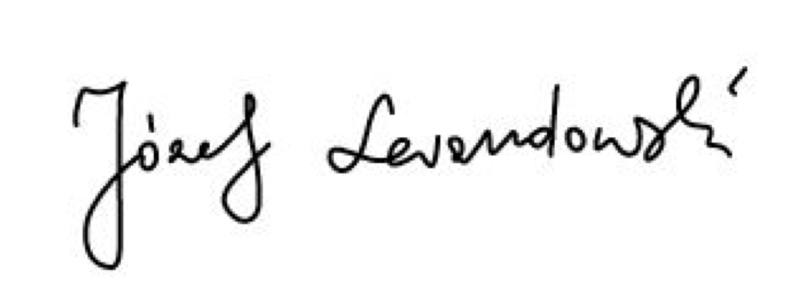
Christopher Dowson


Pump Priming Fund Proposal Feedback Form

- Quality (max 500 words)
Please comment on the degree of research excellence of the proposal, referencing:
- Novelty, relationship to the AMR research context and timeliness
- Appropriateness of the proposed methodology
As this is a multi-disciplinary proposal, please state which aspects of the proposal you feel qualified to assess.

- Importance (max 500 words)
Please comment on the ability of the proposed research to enhance Warwick’s potential to be a centre of excellence for research on AMR, including how the research:
- Contributes to or helps maintain the health of mutidisciplinary collaborations and/or contributes to the development of emerging technologies
- Meets an informational need by establishing a unique activity
- Complements other research in the area
How complete and realistic are the opportunities for follow-on funding identified for this work?

- Applicants (max 200 words)
Please comment on the applicants’ ability to deliver the proposed project making reference to:
- Track record
- Balance of skills of the project team

- Proposal (max 200 words)
Please comment on the extent to which this proposal meets each of the criteria laid out in the call document not already covered in your previous answers.

- Overall Assessment
Please summarise your view of the proposal

My judgement is that (please bold as appropriate):
1 - This proposal does not meet one or more of the assessment criteria (Reject)
2 - This proposal meets assessment criteria but with clear weaknesses (Re-submit)
3 - This proposal meets assessment criteria but with minor weaknesses (Re-submit)
4 - This proposal fully meets all assessment criteria (Accept)

