Supplemental online material.

Chlorine retention in ENCAT™ 30 catalysts, its affect upon the development of encapsulated Pd: insights from in situ Pd K, L₃ and Cl K-edge XAS.

Mark A. Newton, R. Nicholls, J. B. Brazier, B. N. Nguyen, C. J. Mulligan, K. Hellgardt, E. Barreiro, Hermann Emerich, King Kuok Hii, I. Snigireva, P. B. J. Thompson.

All data and related metadata underlying the findings reported in this manuscript can be obtained by request from the lead author at manewton68@gmail.com

1. k³-weighted Pd K-edge EXAFS and Structural and statistical data from EXAFS analysis.

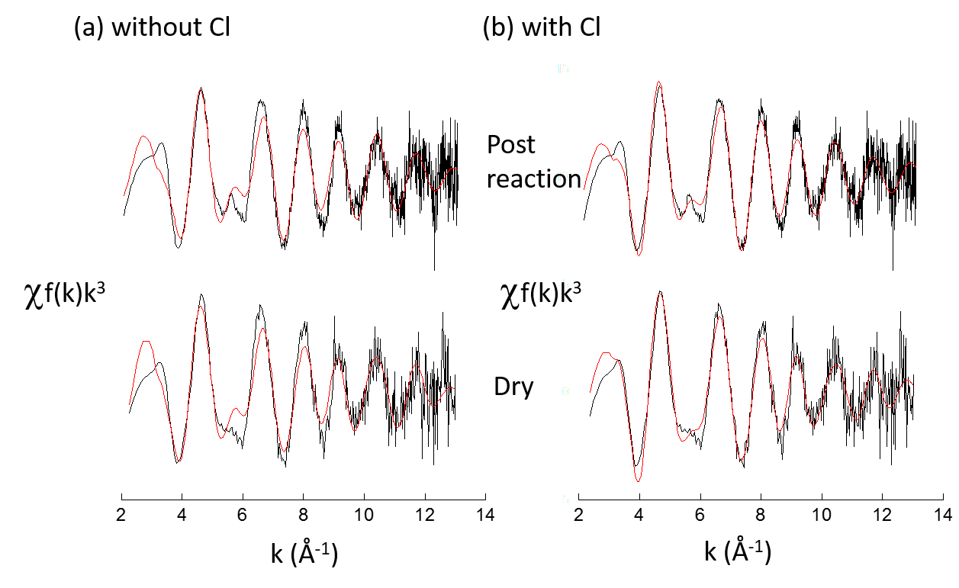
Supplemental figures S1 (SNBL) and S2 (BM23) shows the k³-weighted EXAFS data obtained for the two ENCAT™ 30 NP samples measured at the Pd K-edge for this study. Supplementary Table S1 reports the structural and statistical information arising from analysis using EXCURV (reference [25] main paper).
Figure S1. k³ weighted EXAFS, derived from Batch II of the ENCAT™30 NP catalysts measured on SNBL, corresponding to the Fourier transforms shown in figure 1(a) of the main paper
Figure S2. k³-weighted EXAFS, derived from Batch I of ENCAT™30 NP measured on BM23, corresponding to the Fourier transforms shown in figure 1(a) of the main paper. In this sample reduced Pd nanoparticle are easily formed at RT through exposure to the solvent mixture.

Table S1. Structural and statistical information derived from analysis of k³ weighted Pd K-edge EXAFS
 |  |  |  |  |  | EnCATTMNP
 |  |  | Batch II |  |  |  |  |  | Batch I
Shell | N | R | DW | E_{f} | R(%) |  | Shell | N₁^{Pd} | R₁^{Pd} | DW | E_{f} | R(%)
O | 3.2 | 2.11 | 0.018 | -0.9 | 42.25 | Dry, RT | O | 2.0 | 2.01 | 0.011 | 1.423 | 32
Pd | 3.5 | 2.80 | 0.022 |  |  |  | Pd | 3.0 | 2.73 | 0.019
O | 2.1 | 2.06 | 0.014 | 1.3 | 34.52
Pd | 3.1 | 2.79 | 0.022
Cl | 1.2 | 2.31 | 0.017
O | 1.2 | 2.02 | 0.01 | -3.371 | 30 | Post reaction | O | 0.7 | 2 | 0.010 | -1.5 | 44.15
Pd | 3.5 | 2.79 | 0.021 |  |  |  | Pd | 5.5 | 2.75 | 0.019
Cl | 0.8 | 2.30 | 0.009

Structure and order parameters derived from two batches of ENCAT™ 30 NP measured in their dry state prior to reaction with flowing 50:50 ethanol/water to 350 K, and post reaction at 350 K.
N = average coordination number (± ca. 10% stated value)
R = average bond distance for the indicated scatterer (± ca. 1.5% stated value)
DW = Debye-Waller factor, = 2σ², where σ is the root mean square internuclear separation
E_{F} = the edge position relative to the vacuum zero (Fermi energy)
R% = (∫ [χ^{T} - χ^{E}]k³dk/[χ^{E}]k³dk) x 100% where χ^{T} and χ^{E} are the theoretical and experimental EXAFS and k is the photoelectron wave vector
Other parameters: AFAC, related to the proportion of electrons performing an EXAFS type scatter on absorption, is 1. Structural data were obtained for by fitting the EXAFS in K space in the range: k = 2.5-13.5 Å⁻¹.

2. SEM and EDX. Imaging of the ENCAT catalyst, quantification of Cl Pd levels and retention of Na and S.
SEM and EDX measurements were carried out using LEO 1530 scanning electron microscope (SEM) operating at 20 keV. For particle size determinations and to avoid charging the samples were covered with 5 nm Au prior to imaging.
Figure S3 shows (a) an SEM image of the ENCAT™30 NP (Batch III) sample and (b-d) associated particle size distribution of the polymer vesicles from: (b) ENCAT™30 NP (Batch III); (c) ENCAT™30; and (d) ENCAT™30 NP (Batch II).
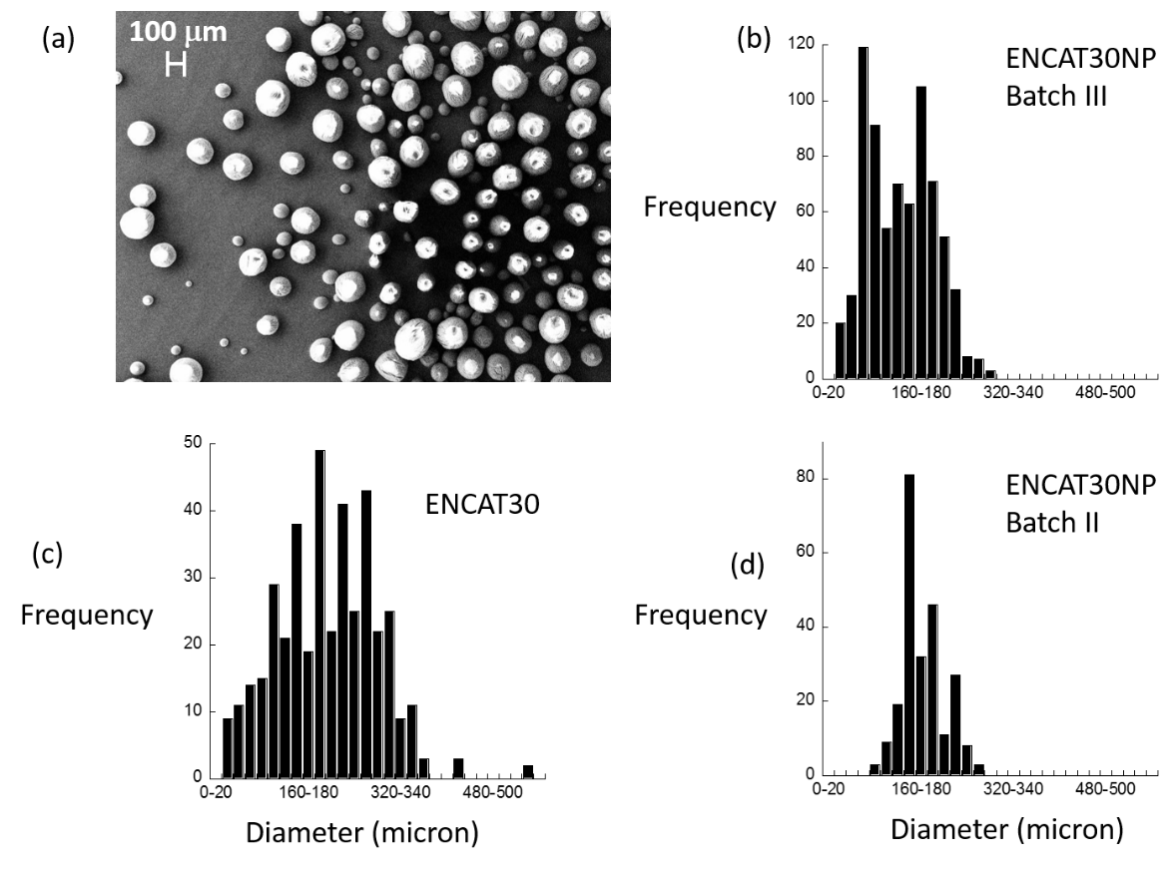
Figure S3. (a) SEM image of the ENCAT™30 NP (Batch III) sample. (b-d) particle size distributions derived from SEM for: (b) ENCAT™30 NP (Batch III); (c) ENCAT™30; and (d) ENCAT™30 NP (Batch II)
We note some evidence of much larger vesicles observed for the ENCAT™30 NP (Batch III); a situation that could clearly arise from the coalescence of the smaller particles present in ENCAT™30 NP (Batch III) over time.

ENCAT™30 NP Batch III (b) yields a particle size distribution that has a bimodal character that might indicate that the polyurea vesicles may be subject to coalescence processes as a function of their history. This notion is supported by the size distribution derived from ENCAT™30 NP (Batch II) (d). In this case the distribution is not bimodal but the particles detected correspond well to the double of the smaller particles observed in (b).
The particle size distribution arising from ENCAT™30 has broadly similar properties as that derived from ENCAT™30 NP (Batch III) and in this case a few examples of much larger particles are found that would further suggest that vesicle coalescence over time may be occurring in these systems.
Figure S4 shows (a) the EDX derived Pd/Cl ratios for the ENCAT™30 and ENCAT™30 NP samples (Batches II and III) and (b) the Pd/Cl ratio obtained from sampling particles of different size within the size distribution shown in figure S3 (b) for the ENCAT™30 NP (Batch III).
In both ENCAT™30 NP (Batches II and III – Batch I not having shown any evidence of the presence of Cl from Pd K-edge EXAFS) XRF indicates a very significant presence of Cl and net stoichiometry of ca. PdCl. From figure S4 (b), derived from EDX made as function of the particle size of the polyurea particles for ENCAT™30 NP (Batches III) some evidence for a week dependence of the Pd/Cl ratio on the diameter of the polyurea particles is obtained. The ENCAT30 sample shows a much reduced level of Cl (7< Pd/Cl <8).
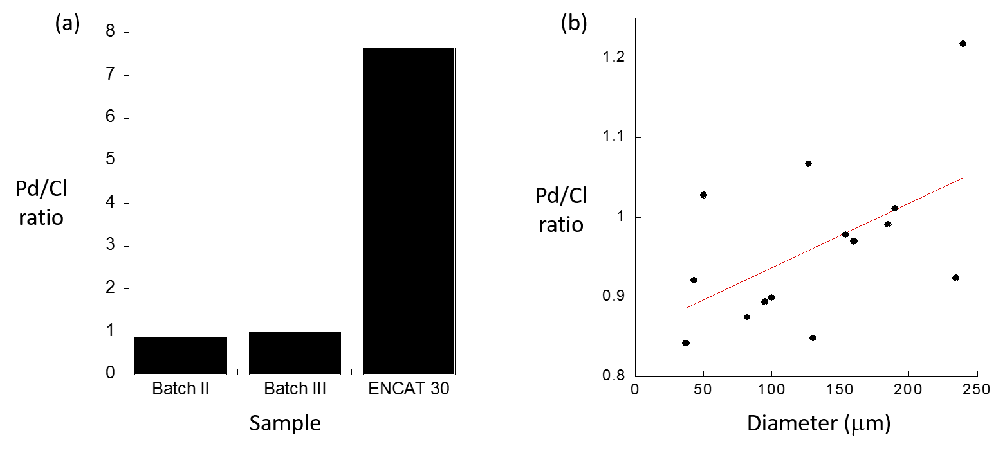
Recalling again that Batch I of the ENCAT™30 NP showed no evidence at all for Cl retention we can only conclude that this variability comes from the production process and the washing procedures used and a refinement of those processes could avoid Cl retention in the final product.
Figure S4. Pd/Cl ratios derived from EDX measurements for ENCAT™30 NP samples (Batches II and III) and ENCAT™30 NP. (b) Variation in Pd/Cl ratios as a function of the polymer vesicle diameter.

That said the avoidance of Cl containing solvents would seem to be the best way of avoiding Cl contamination entirely and its effects on the behaviour of the Pd component of the catalyst.
Along with Pd and Cl we have also used SEM/EDX to investigate levels of Na and S potentially present as a result of the used of Sodium lignosulphate in the encapsulation process. We that the levels of these elements are extremely variable even within a single sample. In the majority of measurements made we find little evidence (a few atomic %) of Sulphur sensitivity of the XRF experiment. However, in a few isolated cases, the presence of this element has been detected up to levels of up to 20 atomic %.
A similar story can be told for Na though this has been found to be more widely detectable across the samples tested and generally in the range of 0-10 atomic %, though again occasionally higher in a few instances. Hence the association of post edge features in the Cl K-edge XANES to the formation of NaClO_{x} salts is sustainable upon this basis.

