
TASMINH4 – My Story
By Brian as told to Tracey Adcock, research nurse
I was diagnosed with hypertension in 1995-6, despite the fact that I took regular exercise and maintained a healthy diet. Measurement of my blood pressure had been taken over numerous surgery visits, at three to six monthly intervals, up until December 2015. Over this period my blood pressure slowly increased and consequently so did my medication. Arranging appointments, driving and parking, waiting my turn and seeing my GP were all quite stressful and overall I felt my well-being was being adversely affected.
Taking back control
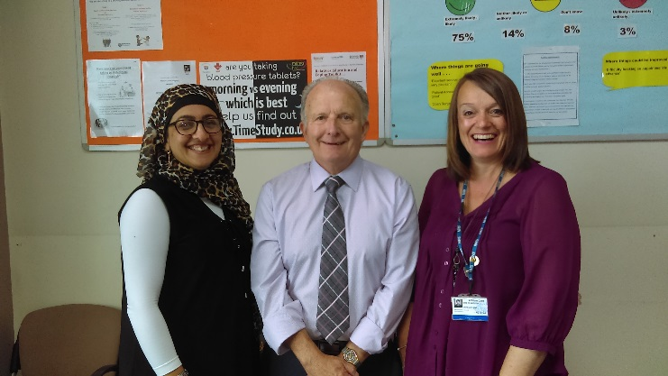
When I received an invitation to take part in TASMINH4, this was an ideal opportunity for me to take back ownership of my condition. After an initial assessment, I was found to be a suitable candidate, lent a monitor and given guidelines on how to monitor my blood pressure twice daily for one week each month. In January 2016 I started participating in this study.
Blood pressure monitoring was done in my own home, in my own time, in a calm and relaxed atmosphere and completely hassle free. Results are posted to my doctor and feedback via a phone call received on any alterations needed to my medication.
“It’s simply that easy”
To date, this has been a totally rewarding experience; I feel responsible; I can see at first-hand what is happening; I have taken decisions on my life-style which have benefited my blood pressure.
Overall, I believe that as a direct consequence of my participation the TASMINH4 study, I have been able to reduce my medication and feel so much better within myself.

