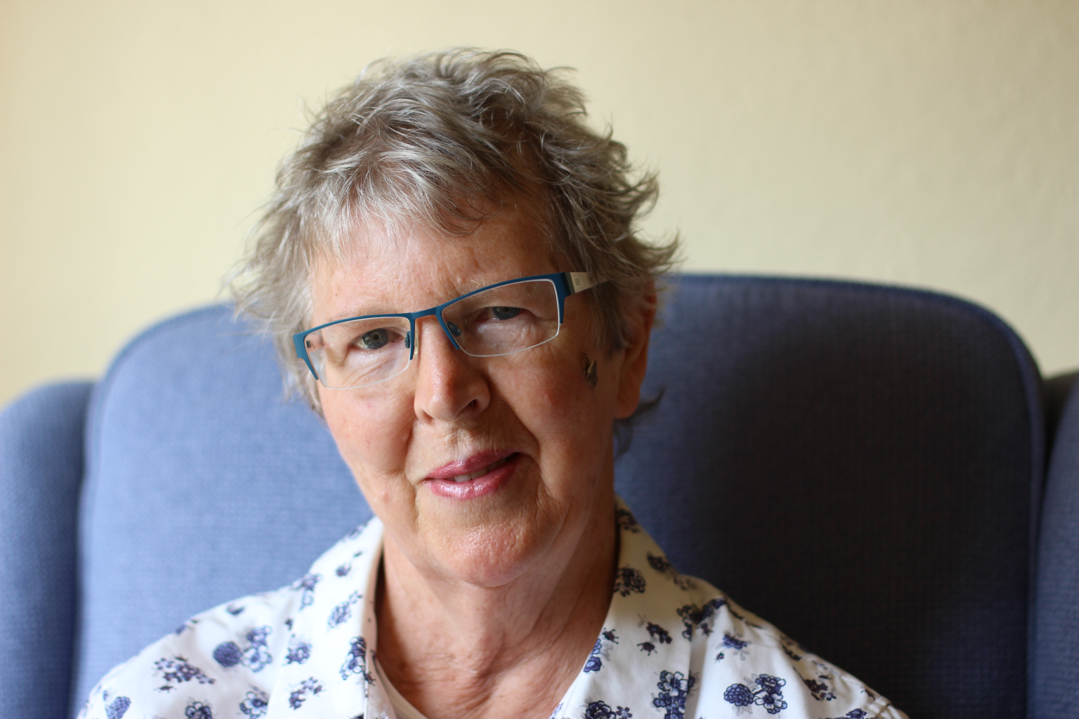
Why I Became Involved in Clinical Research: a Patient’s Tale
Based on an original handwritten account by Joyce, a patient at Castle Medical Centre

How and Why I became involved in clinical research
I had started to feel guilty about the extensive help I had received for numerous problems over the past 20 years or so:
- Breast cancer
- Heart disease
- Eye problems (detached retina in both eyes and cataracts)
- High blood pressure
- Broken arm in fall
Taking part in research studies seemed a good way to give something back. The letter from my GP surgery gave me the opportunity to join the PREFIT study (University of Warwick)
Self Interest: I had read about the concerns relating to aspirin possibly causing stomach ulcers. The HEAT study at University of Birmingham offered an opportunity to check out my position on this as I take aspirin daily.
Unexpected benefits to participating in a study
- The exercise programme included in the PREFIT study under the supervision of a physiotherapist was exactly what had been recommended by the GP to help to treat my chronic heart disease (CHD). This had all round benefits. I felt fitter and stronger and more confident to tackle tasks I thought I could not do.
- The completion of the diaries and record of exercise gave a structure to my day and a sense of achievement. This has continued as I still do the exercise programme.
- Being involved in a study along with many other people gives some sense of belonging. It is good to know in the Million Women Study (Oxford) that the very detailed questionnaires are being completed by 999,999 other women at around the same time and that I am contributing to knowledge which might help cancer research.

Note: Original handwritten story by patient filed at Castle MC
(Typed and submitted 12/8/14 by E Hoverd Research Nurse with permission from patient.)

