A Patient’s Experience of the Benefits of Participating in Research
as told to Sarah Joshi, research nurse
Background
I am relatively new to the Clinical Research Network, and as the number of health benefits for patients wishing to be involved in research has come as a surprise, I wanted to share with you a recent experience assisting the study team and GP surgery team by carrying out falls assessments, whilst working on a study looking at falls in the elderly.
Patient Experience
The participant was a gentleman over 90 who was eager to be involved and delighted to be offered an assessment. It transpired that he was housebound, but keen not to exclude such a motivated participant we offered to carry out the assessment at home.
We arrived to an unlocked, open door and a voice shouting for us to come to in. This very articulate and well organised gentleman had been a soldier in WW2, had worked all his life and had been widowed many years previously. His children all lived overseas but maintained regular phone contact. His medications were laid out with notes to remind himself when to take them, his kitchen table was set ready for supper and a basket of fresh vegetables was ready to be peeled.
During the assessment when we asked about falls we were told of a number of occasions when he had fallen in the night, including his last fall which had left him unable to get up for a number of hours, leaving him very cold and shaken. He spoke of being frightened of dying and not being found for a long time. His only outside contact is a three weekly internet shopping delivery. At this point he became emotional about his daily struggles to maintain independence.
Patient Benefits
Our assessment also highlighted other health issues, such as a skin condition, a significant postural hypotension and antihypertensive medication that could be reviewed.
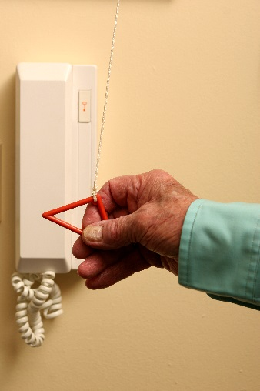
We spoke in detail about the services that were available, including a key safe for his front door, a panic alarm in case he falls, assistance with personal care and an occupational therapy assessment of his home. Even though we felt he would require little support to maintain his independence and safety, prior to our visit he was unaware of the services available. With his permission we were able to communicate this to his GP to raise awareness of his situation and offer our recommendations.
This every day, true story demonstrates the health benefits of participating in research and how this can become a conduit for many other benefits and types of care.

