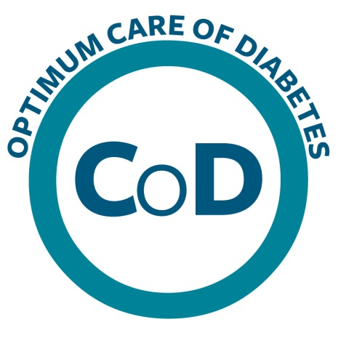
Attitudes towards bariatric surgery & research participation amongst non-morbidly obese patients with type 2 diabetes

Summary of study results
This is an NIHR, Research for Patient Benefit (RfPB) funded study investigating patient and clinician perspectives on weight management for non-morbidly obese people with type 2 diabetes, specifically with regard to the role of bariatric surgery and willingness to participate in future randomised, controlled trials. The study had 2 phases, the first involved qualitative interviews with patients, whilst the second phase used interview data to develop a patient survey which was mailed out to 1820 non-morbidly obese patients with type 2 diabetes. We also surveyed primary care diabetes leads (GPs & Nurses), diabetologists and bariatric surgeons. Your practice was one of the 44 GP surgeries which participated, providing invaluable support in identifying and recruiting eligible patients to one or both of these phases. Below summarises the results for each phase of the OCOD study.

Phase 1: Patient views on the role of bariatric surgery (qualitative interview study)
Twenty-two patients were interviewed. Willingness to consider WLS as a personally acceptable management option was variable, ranging from those who were willing (N=4) to consider surgery or undecided (N=5), to those who were unwilling (N=13).
Acceptability of WLS: Two factors seemed influential in those who adopted a willing or undecided stance towards surgery; condition-related impact (the extent to which either their diabetes &/or weight affected their life) & their perception of control over their diabetes &/or weight.
Condition-related impact: Some individuals felt that neither their weight nor their diabetes affected their lives, & these people were unwilling to consider surgery. Conversely, those who were willing or undecided all noted that their weight &/or diabetes adversely affected their lives.
Perceived control: Some individuals were dissatisfied with the effect of their weight &/ or diabetes on their lives but still felt surgery was inappropriate for them. In such cases the individual’s sense of personal control seemed influential with those unwilling reporting some capacity to alter their situation. In contrast, those who reported being unsure or willing to consider surgery reported having tried numerous strategies & being unable to lose weight themselves.
Participating in randomised controlled trials: Those who were ‘undecided’ or ‘interested’ in WLS were more willing to consider entering into an RCT than those who were not interested in surgery.
The information collected in this phase informed the content of the patient survey and the perceptions entered into later statistical analyses of survey responses
Dissemination: To date we have presented this work in a poster at the North American Primary Care Research Group (NAPCRG) and have submitted a paper to the Primary Health Care Research and Development journal which was accepted for publication 28th April 2013 – we are waiting for confirmation of when the paper will be published.

Phase 2a: Patient views on the role of bariatric surgery in their management (survey study)

34% (614/1820) responded. 72% were interested in participating in general weight management research; this was not specific to surgery and included any form of weight management. In relation to participating in a randomised controlled trial (RCT) which involved bariatric surgery 64% said that they would be willing to consider entering.
We undertook analyses to ascertain whether there were differences between those who were willing to participate in RCT research and those who were not. There were significant differences (P=<0.005) in perceived control, satisfaction with weight loss ability and impact of diabetes/weight on life.
A greater proportion of those willing to consider entering into a trial reported:
- Less control over their diabetes (Fig.1)
- Dissatisfaction with their ability to lose weight (Fig.2)
- Weight negatively impacting on life (Fig.3)
- Diabetes negatively impacting on life (Fig.4)
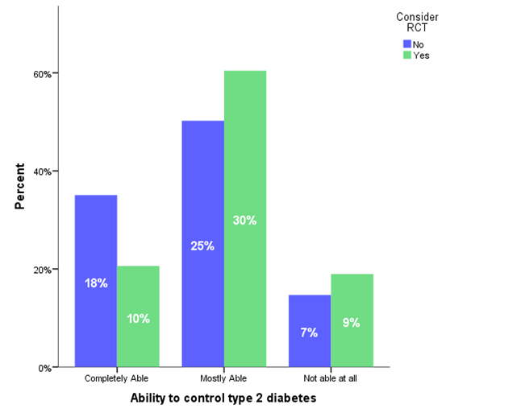
Figures 1 & 2 present results for perceived diabetes control & satisfaction with weight loss ability
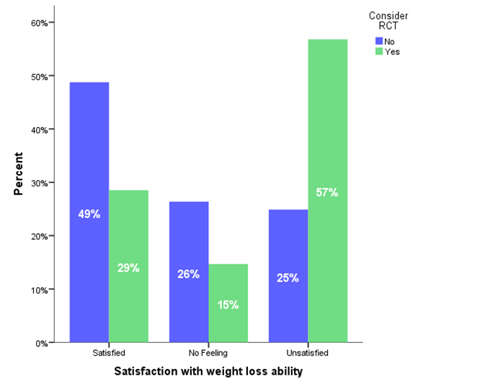
Fig.2
Fig.1

Completely able Mostly able Not able at all
How able are you to control your diabetes?
How satisfied are you with your ability to lose weight?
Satisfied No feeling Unsatisfied
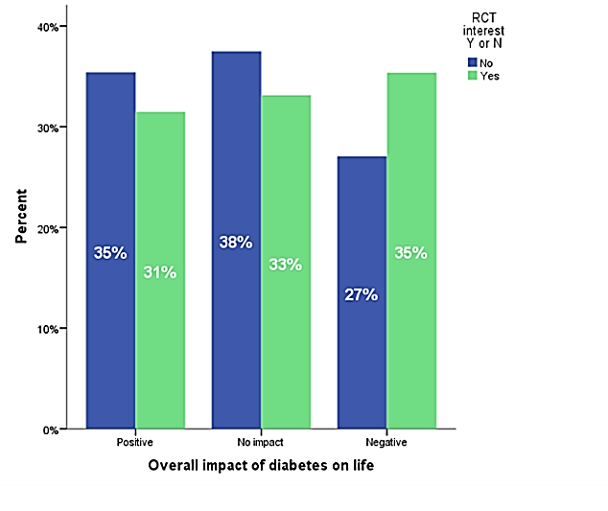
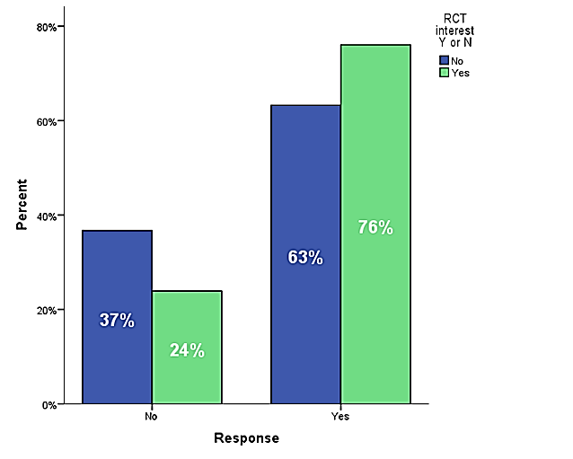
Fig.4
Fig.3

Positive No impact Negative
No Yes
Does your weight negatively impact on your life?
Overall, what impact has diabetes had on your life?
The above perceptions were entered into a regression analysis (logistic) to assess whether any were predictive of willingness to participate. The analysis indicated that only age (younger more likely), negative impact of weight on life and being unsatisfied with ability to lose weight were significant. Being on insulin was not shown to be influential in willingness to participate in bariatric RCTs.
Dissemination: To date we have presented our findings at the Society for Academic Primary Care (South West) Conference, and at the Endocrinology, Nutrition and Metabolism seminar, University of Southampton. The study has been well received and has generated positive feedback. We have presented a poster and a platform presentation at the British Obesity and Metabolic Surgery Society (BOMSS) in Glasgow (Jan 2013). An initial paper has been drafted with a view to submitting to Diabetes Care after further iterations.

Phase 2b: Clinician views on the role of bariatric surgery in the management of non-morbidly obese patients with type 2 diabetes

31% of surgeons (42/138), 15% of primary care clinicians (104/700) & 6% of diabetologists (35/600) responded. There was interest in participating in an RCT involving WLS amongst respondents, with 97% of surgeons, 90% or diabetologists & 74% of primary care leads answering ‘yes’ or ‘maybe’. However, we have no data by which to assess non response & the number of responses was too low for meaningful statistical analysis to be conducted. Unfortunately, we are unable to draw firm conclusions with regard to clinical equipoise/interest in bariatric RCTs.
Despite efforts to increase response rates, including working with clinical groups, piloting surveys & survey mediums & sending reminders, a key barrier which prevented adequate recruitment to the clinician survey related to difficulties accessing clinicians.
Dissemination: We have recently submitted an abstract of the above results to the British Obesity and Metabolic Surgery Society (BOMSS) and also intend to submit to next year’s Society for Academic Primary Care (South West) Conference

Study Conclusions
Overall, 64% (379/614) of patients were willing to consider participating in a WLS trial. Factors significantly & independently associated with willingness were younger age, negative impact of weight & dissatisfaction with ability to lose weight. Owing to methodological barriers we were unable to evaluate equipoise & interest amongst clinicians.

Future plans
- To publish the patient survey in an appropriate peer reviewed journal (Diabetes Care)
- As a result of the interest identified in this study, we aim to develop a model to estimate the potential costs & benefits of WLS in non-morbidly obese patients with T2DM to help justify the value of information from a definitive trial.
- To submit a case for an RCT to NIHR HTA prioritisation process, & design a trial of WLS in this population which would provide much needed evidence on the effectiveness & cost utility.

