
DEVELOPED BY

Superior, The Return of Race Science

Prologue, Chapters 1-3

By Angela Saini

&

Diversity Landscape of the Chemical Sciences

A report by the Royal Society of Chemistry



DISCUSSION BOOKLET 1

“It is time for parents to teach young people early on that in diversity there is beauty and there is strength.”
Maya Angelou

Acknowledgments

We thank the Royal Society of Chemistry for funding this work, through the Diversity and Inclusion Fund.

We also want to acknowledge the contributions from members of Warwick Chemistry, including representatives from the Warwick Chemistry STEM and Diversity Group, Warwick Postdoctoral Society of Chemistry and Warwick ChemSoc, who made this project happen.

We are grateful to Warwick Chemistry for enabling us to pilot this initiative.

The project is led by Zoë Ayres and Bo Kelestyn, and booklet lead Alex Baker, with support and guidance from Adam Alcock, Louis Ammon, Leanne Loveitt, Ally McLoughlin, Maria Kariuki, Kathryn Murray, Tania Read and Michael Staniforth.

All Diversity Book Club materials are brought to you as open access to enable you start your own club, through the hard work of the above individuals. We ask if you use these materials to keep the Acknowledgement Section in the Booklets you use and credit the Chemistry Department of the University of Warwick.


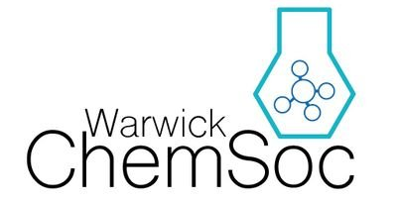
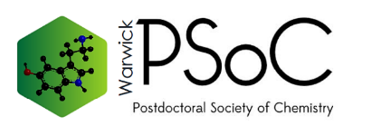

Icebreaker – “Two truths and a lie”
For this task come up with two statements about yourself that are true and one that is a lie. The group will then try and workout which one of your three statements is a lie

Truth –

Truth –

Lie –

Get Talking - How would you describe yourself?
If you had to a write a short bio for Twitter, Facebook etc. what would you write?

Thinking back - What challenged/surprised you from the chapters?
This could be something pertinent or something that really grabbed your attention and made you think twice

Discussion

How would you define race?
If someone were to ask you what is race, what would you say?

Where does our definition of race come from?
What are the societal, political and historical backgrounds of our definitions of race? Re-read page 3-4

How and why have societies and empires used race to their advantage?
Re-read page 5, page 19-22 and page 37

What are the differences and similarities between “human villages” and eugenics?
Thinking back to chapter 2 where “human villages” were discussed and chapter 3 where eugenics are discussed, what are the motives behind and outcomes of these acts and ideologies?

“Race wasn’t just a tool for classifying physical difference, it was a way of measuring human progress, of placing judgement on the capacities and rights of others”
Page 61.
“Eugenics is a cold, calculated way of thinking about human life, reducing human beings to nothing but parts of the whole … [it] assumes that almost all that we are is decided before we are born”
Page 71.

Reflecting - Look at the two quotes above and contrast them with your answer to Get Talking, how are their focusses different?
Did you define yourself by your appearance and race, or the content of your character? And does this matter?

Application

What societal systems do we have in place that characterise on race or bias based on race?
You can also think about the University? Is differentiation based on “race” always bad or just oversimplistic? Examples might include stop-&-search, discrimination in the beauty industry or being overlooked for promotions, jobs or housing

How does the concept of race impact Chemistry and its practitioners?
Bluntly, why do you think there are so few black chemists and what impact has this lack of inclusion likely had on the field? See pages 16-18 of the RSC report

Additional Notes;

