
DEVELOPED BY

Sway – Unravelling Unconscious Bias

Introduction to Chapter 4

By Pragya Agarwal

&

Is Publishing in the Chemical Sciences Gender Biased?

A report by Royal Society of Chemistry

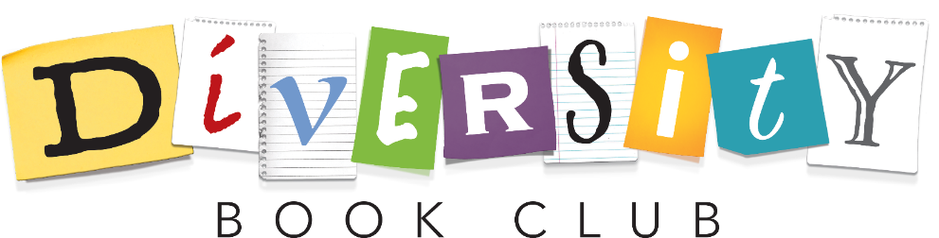
DISCUSSION BOOKLET 1

Discussion Booklet 1

“To know the true reality of yourself, you must be aware not only of your conscious thoughts, but also of your unconscious prejudices, bias and habits.”
Unknown

Icebreaker – “Talk Show”
For this task think about the one person you would want to interview if you had your own talk show and why. You will need to explain your choice to the group.

Thinking back - What challenged/surprised you from the chapters?
This could be something pertinent or something that really grabbed your attention and made you think twice.

This session we will consider what unconscious bias is and how it differs from conscious bias. We will then consider how unconscious biases form, why we use them and their historical basis, before exploring stereotype activation versus application, and whether scientists are biased.

Discussion

What is unconscious/implicit bias, how is it different from conscious or explicit bias? Re-read pages 16-17

A piece of work run by Harvard University explores implicit bias and offers a test to learn about your own implicit biases - (https://implicit.harvard.edu/implicit/takeatest.html)

What is “satisficing” and when do people do it?
How does it link to bias and conformation bias? Re-read pages 30-36

Where do our cognitive biases come from?
What are in-groups and out-groups? Re-read pages 43-48, 61-66, 73-75 and 93

Reflecting
Should these cognitive biases still matter today? Re-read pages 65-66

What is the difference between stereotype activation and application?
How does stereotyping affect multiple identity/intersectional groups? Re-read pages 107-119

Are positive stereotypes harmful?
Re-read pages 129-133

Application

Are Scientists biased or objective?

Re-read pages 133-136 and “The scientist is not a rational animal” by M.Breyl¹

Additional Notes;

References;
(1) Breyl, M. The Scientist Is Not a Rational Animal: Biases in Networking, Theory and Interdisciplinarity. Acad. Lett. 2021.

