
DEVELOPED BY

Sway – Unravelling Unconscious Bias

Chapter 5 to Chapter 8

By Pragya Agarwal

&

Is Publishing in the Chemical Sciences Gender Biased?

A report by Royal Society of Chemistry
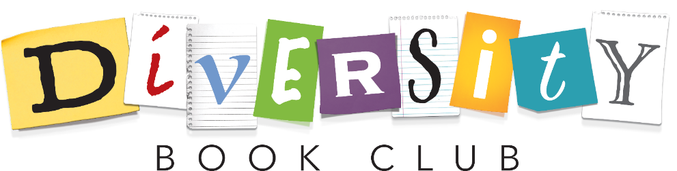

DISCUSSION BOOKLET 2

“Me? Biased? Unconscious bias is like jealousy: nobody likes to admit it, and often we’re unaware of it.”
Thais Compoint

Thinking back - What challenged/surprised you from the chapters?
This could be something pertinent or something that really grabbed your attention and made you think twice.

Last session we considered what unconscious bias is and how it differs from conscious bias. We considered how unconscious biases form, why we use them and their historical basis, and explored stereotype activation versus application, and whether scientists are biased.
In this session we will consider how we listen to and shape the messages we choose to hear, the concept of “othering” and the dangers of micro-aggressions. By exploring these topics, we will learn about the covert and subtle forms of prejudice that arise from a perception of cultural difference and how this can lead to the hardening of lines between in-groups and out-groups.

Discussion

What are “echo chambers” and “filter bubbles”? How can they influence/re-enforce people’s beliefs and opinions? Re-read pages 159-63

What does the Yale study on CVs and gender tell us about gender bias and self-bias? What can we learn from this? Re-read pages 205

What is “othering”? How does it link to micro-aggressions? Re-read pages 274-281

Reflecting
What is the issue with micro-aggressions? Re-read pages 281-285

“Individually these incidents [micro-aggressions] seem benign. But cumulatively I believe that they act like sort of low-grade microtraumas that can end up hurting you and your biology.”
Dr Roberto Montenegro, page 282

Application
How are awards (such as the Nobel Prizes) and publishing biased? Re-read pages 188-192
An interesting piece on women and Nobel Prizes can be found here¹

“Recognition is awarded partly on the basis of past recognition”²
Prof. Simine Vazire

How do you decrease bias in publishing and awards?
An interesting piece on gender bias in academia can be found here³

Additional Notes;

References;
(1) Feeney, M. K. Why more women don’t win science Nobels https://theconversation.com/why-more-women-dont-win-science-nobels-104370.
(2) Vazire, S. Our Obsession with Eminence Warps Research. Nature 2017, 547 (7661), 7–7.
(3) Llorens, A.; Tzovara, A.; Bellier, L.; Bhaya-Grossman, I.; Bidet-Caulet, A.; Chang, W. K.; Cross, Z. R.; Dominguez-Faus, R.; Flinker, A.; Fonken, Y.; Gorenstein, M. A.; Holdgraf, C.; Hoy, C. W.; Ivanova, M. V.; Jimenez, R. T.; Jun, S.; Kam, J. W. Y.; Kidd, C.; Marcelle, E.; Marciano, D.; Martin, S.; Myers, N. E.; Ojala, K.; Perry, A.; Pinheiro-Chagas, P.; Riès, S. K.; Saez, I.; Skelin, I.; Slama, K.; Staveland, B.; Bassett, D. S.; Buffalo, E. A.; Fairhall, A. L.; Kopell, N. J.; Kray, L. J.; Lin, J. J.; Nobre, A. C.; Riley, D.; Solbakk, A.-K.; Wallis, J. D.; Wang, X.-J.; Yuval-Greenberg, S.; Kastner, S.; Knight, R. T.; Dronkers, N. F. Gender Bias in Academia: A Lifetime Problem That Needs Solutions. Neuron 2021, 109 (13), 2047–2074.

