
DEVELOPED BY

Invisible Women, Exposing Data Bias in a World Designed for Men

Parts 5, 6 & Afterword

By Caroline Criado Perez

&

Breaking the Barriers, Women’s Retention and Progression in the Chemical Sciences

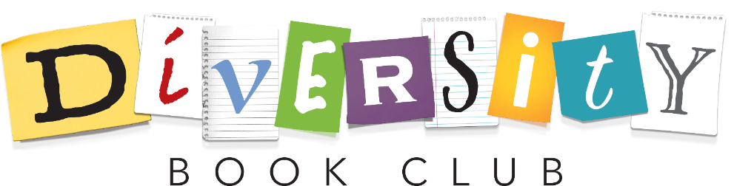
A report by the Royal Society of Chemistry

DISCUSSION BOOKLET 3

“My mother used to tell me, ‘Kamala, you may be the first to do many things, but make sure you are not the last,’ and that’s why breaking barriers is worth it. As much as anything else, it is also to create that path for those who will come after us.”
Kamala Harris
Acknowledgments

We thank the Royal Society of Chemistry for funding this work, through the Diversity and Inclusion Fund.

We also want to acknowledge the contributions from members of Warwick Chemistry, including representatives from the Warwick Chemistry STEM and Diversity Group, Warwick Postdoctoral Society of Chemistry and Warwick ChemSoc, who made this project happen.

We are grateful to Warwick Chemistry for enabling us to pilot this initiative.

The project is led by Zoë Ayres and Bo Kelestyn, and booklet lead Alex Baker, with support and guidance from Adam Alcock, Louis Ammon, Leanne Loveitt, Ally McLoughlin, Maria Kariuki, Kathryn Murray, Tania Read and Michael Staniforth.

All Diversity Book Club materials are brought to you as open access to enable you start your own club, through the hard work of the above individuals. We ask if you use these materials to keep the Acknowledgement Section in the Booklets you use and credit the Chemistry Department of the University of Warwick.





Thinking back - What challenged/surprised you from the chapters?
This could be something pertinent or something that really grabbed your attention and made you think twice.

Last session we looked at why women are often ignored or excluded from research and decision making. We also considered Arnstein’s ladder as a tool to understand levels of engagement within the university and departments, and the role we can all play in better engaging, supporting and representing women and minority groups. Alongside this we explored the trans-exclusionary aspects of “Invisible Women”.
This session we will look at how women have been excluded from positions of power, what are the consequences of this exclusion and how we can fix this exclusion. While doing this we will also explore the underlying systems and expectations that perpetuate this issue, such as how we measure GDP, childcare responsibilities and tax incentives; that undermine gender equality.

Discussion

Why is GDP measured the way it is? What and who does this approach exclude and why? Re-read page 239-241

“’…after a bit of to-ing and fro-ing’, and much debate over how you would measure and value unpaid household services ‘it was decided’, says Coyle, ‘that this would be too big a task in terms of collecting the data’.”
Page 241

How do cuts to public spending and tax incentives not work for the benefit of women? Re-read page 244-245 & 257-260)
Think back to Chapter 3 “The Long Friday” and why women went on strike and the consequences of “part-time poverty”.

Why is it important to have women in positions of power? (P. 265-266) Why does intersectionality matter too? (P. 289-291)

When considering abortion legislation in the U.S – states that have low numbers of female legislators (percentages shown in brackets) have passed laws to ban or restrict abortions, for example North Dakota (21%), Ohio (26.5%), Kentucky (22.5%), Arkansas (23.7%), Mississippi (13.8%), Georgia (30.5%) and Alabama (15.7%).^{1–4}

Intersectionality: “The interconnected nature of social categorizations such as race, class, and gender, regarded as creating overlapping and interdependent systems of discrimination or disadvantage; a theoretical approach based on such a premise.”
Oxford English Dictionary

For example – a woman of colour is not only a woman but also a person of colour and will have unique experiences based on the intersectionality of being both a person of colour and a woman. For example the experiences and outcomes, both historical and current, of black women around pain and high maternal death rates.^{5–7}

How are women in power perceived differently to men in (political) power? Re-read page 281-285
What barriers and abuse do women face in getting into office and in office? Do we see these issues in other areas such as Science? (P. 279-81)

Reflecting

54% of mothers would work outside the home if they could obtain convenient, reliable and affordable childcare. Why is this significant? Re-read page 251

“But it’s also because of the gender pay gap: for many heterosexual couples it makes financial sense for the woman to be the one to reduce her working hours, because she tends to be the one who is earning less.”
Page 251

“...Women choose to have families, which is a very significant responsibility and
not compatible with a competitive career as a professional chemist. Women face zero discrimination. Quite the opposite. Women chemists are encouraged at every
opportunity.”
Male survey respondent from RSC Report

Why is child-care perceived as a choice for women between children or career? (P. 252-253) Why is this often not the same for men?
Does this link to Chapter 3 – “The Long Friday”? Is this perception reinforced by gender asymmetrical parental policies? Are parental leave policies that prevent leave being transferred to the women (i.e. the man has to take leave or lose it) a step forward? (P. 84)

How could modern methods of working (working from home etc.) support parents in staying in the workforce? What else could be done?

This report provides tangible examples of support for those looking for a more in-depth consideration.⁸

Application

How can you use your privilege to be a better ally and empower others?
What is “naïve realism” or “projection bias”? Why do allies matter? (P. 270-271)

Next Steps
First things first, thank you for taking part in the sessions, we hope you enjoyed them and will join us for the next book. Your contributions have been appreciated and the discussions we have had are contributing to making a more inclusive community for all. However, this is the last booklet in the series exploring Caroline Criado Perez’s book and the linked RSC report, so any comments, critiques or feedback would be much appreciated by the authors of these booklets and the wider team.
Second, we will be holding a “Positive Action and Discussion Session” that all participants will be invited to. In this session we will discuss how we can bring about positive change in the community, curriculum and culture of the department and University.

We hope to see you all there!

Additional Notes;

References;
(1) Naftulin, J. Women Deemed “responsible” for Having Miscarriages Could Spend 30 Years in Prison under Georgia’s New Abortion Law — but It’s Often Impossible to Determine the Cause. Insider. May 2019.
(2) Brown, J. Colorado Measure to Ban Abortions after 22 Weeks of Pregnancy Fails. The Colorado Sun. November 3, 2020.
(3) Durkin, E.; Benwell, M. These 25 Republicans – All White Men – Just Voted to Ban Abortion in Alabama This Article Is More than 2 Year. The Guardian. May 15, 2019.
(4) National Conference of State Legislatures. Women in State Legislatures for 2019 https://www.ncsl.org/legislators-staff/legislators/womens-legislative-network/women-in-state-legislatures-for-2019.aspx (accessed May 20, 2021).
(5) Holland, B. The ‘Father of Modern Gynecology’ Performed Shocking Experiments on Enslaved Women. History.
(6) MBRRACE-UK. Saving Lives, Improving Mothers’ Care Lessons Learned to Inform Maternity Care from the UK and Ireland Confidential Enquiries into Maternal Deaths and Morbidity. Maternal, Newborn and Infant Clinical Outcome Review Programme.; 2020.
(7) Rao, V. “You Are Not Listening to Me”: Black Women on Pain and Implicit Bias in Medicine. Today. July 2020.
(8) Ellison, G.; Barker, A.; Kulasuriya, T. Work and Care: A Study of Modern Parents (Research Report 15); 2009.

