DEVELOPED BY

Straight Jacket – Overcoming Society’s Legacy of Gay Shame

Part Three

By Matthew Todd

&

Exploring the Workplace for LGBT+ Physical Scientists

A report by the Institute of Physics, Royal Astronomical Society & Royal Society of Chemistry
DISCUSSION BOOKLET 3

“Equality means more than passing laws. The struggle is really won in the hearts and minds of the community, where it really counts.”
Barbara Gittings
Acknowledgments

We thank the Royal Society of Chemistry for funding this work, through the Diversity and Inclusion Fund.

We also want to acknowledge the contributions from members of Warwick Chemistry, including representatives from the Warwick Chemistry STEM and Diversity Group, Warwick Postdoctoral Society of Chemistry and Warwick ChemSoc, who made this project happen.

We are grateful to Warwick Chemistry for enabling us to pilot this initiative.

The project is led by Zoë Ayres and Bo Kelestyn, and booklet lead Alex Baker, with support and guidance from Adam Alcock, Louis Ammon, Leanne Loveitt, Ally McLoughlin, Maria Kariuki, Kathryn Murray, Tania Read and Michael Staniforth.

All Diversity Book Club materials are brought to you as open access to enable you start your own club, through the hard work of the above individuals. We ask if you use these materials to keep the Acknowledgement Section in the Booklets you use and credit the Chemistry Department of the University of Warwick.

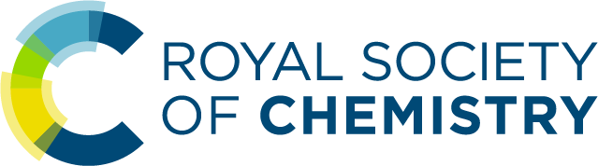
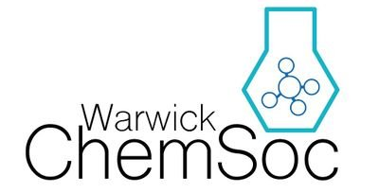

Thinking back - What challenged/surprised you from the chapters?
This could be something pertinent or something that really grabbed your attention and made you think twice.

Last session we discussed the personal consequences of the continued discrimination of the LGBTQUA+ community, as well as considering the objectification of the LGBTQUA+ community and why this occurs.
This session we will consider what it means to be an ally and what can be done to support the LGBTQUA+ community.

Discussion

How can a more positive environment for LGBTQUA+ individuals positively impact this community? Re-read pages 293 – 301 (Chapter 18: We Are Family).

What is an ally? How do you become an ally? Re-read Chapters 18 and 19.

‘‘I think everyone’s important and we need to celebrate that. I’ve been surrounded by heterosexual and homosexual role models growing up, and I’ve got so many people in my life who are gay and that I love and are important to me, and I feel a responsibility and a duty to do something about this and not to ignore it.’’
Rachel, page 299

Reflecting

How can events and initiatives for LGBTQUA+ individuals become more mainstream and help foster a community?

Re-read pages 306-307

What would be useful resources and training, for both members and allies, to better support the development of the LGBTQUA+ community? Re-read Chapter 19 (Towards a New Way of Living).

“The situation with trans people is very similar to that in the eighties with gay people that you describe. There are journalists who, based on zero evidence, portray trans people as dangerous or not who we say we are. Kids, like I was, are hearing that they are wrong, that they are unreal, all the time.”
Paris Lees, page 344

Paris Lees highlights the current prevalence of transphobia, how can we, as individuals and a department, better support the trans community?

Re-read pages 344-346.

Application

What steps can you take to be a better ally of the LGBTQUA+ community?
Think about what you currently do well and what could you improve on?

Next Steps
First things first, thank you for taking part in the sessions, we hope you enjoyed them and will join us for the next book. Your contributions have been appreciated and the discussions we have had are contributing to making a more inclusive community for all. However, this is the last booklet in the series exploring Matthew Todd’s book and the linked report, so any comments, critiques or feedback would be much appreciated by the authors of these booklets and the wider team.
Second, we will be holding a “Positive Action and Discussion Session” that all participants will be invited to. In this session we will discuss how we can bring about positive change in the community, curriculum and culture of the department and University.

We hope to see you all there!

Additional Notes;

