HPLC - UV

HP1100 and 1200 Machines

- Check solvent bottles (solvent levels and line labels). Make sure there is more than enough solvent to run your experiment.
- Open the software 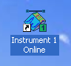

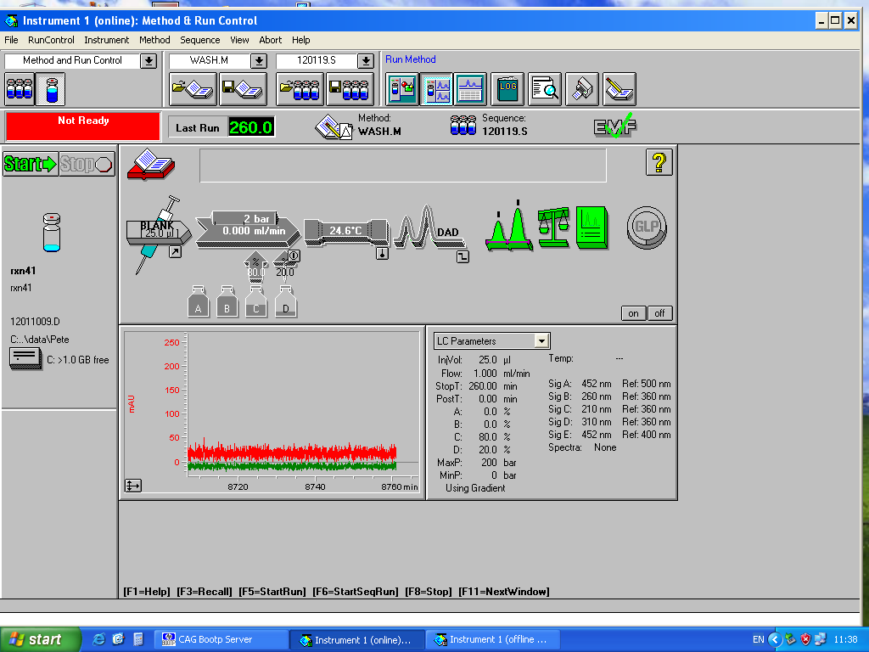
- Go to Method tab. Create new method or open existing method.

- Setup Method in the window below:
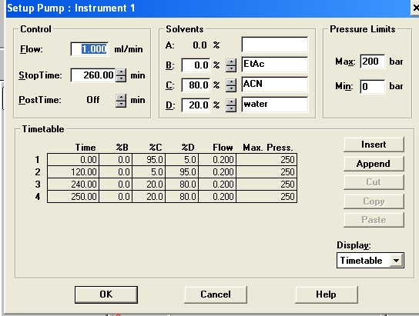

- Click on PUMP (Blue box) to change flow rate and solvents. Also use this box to setup method.

- Purge system
  - unscrew black knob and turn system ON (red box).
  - Wait until bubbles are out of system and then screw black knob again closed (don’t overtighten ) so the flow is now going through the column.
  - Ensure there are no leaks and the pressure is not too high.
- Check where the data will be saved. Double click on hard drive icon (Orange box). Type YOUR NAME or name of the folder where you want the data to be saved.
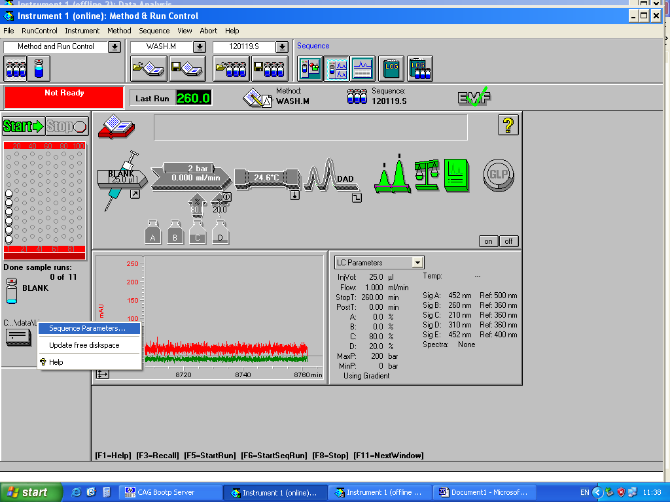
  - Click prefix counter (add date or experiment etc)
- Click on SEQUENCE TABLE (Purple box)
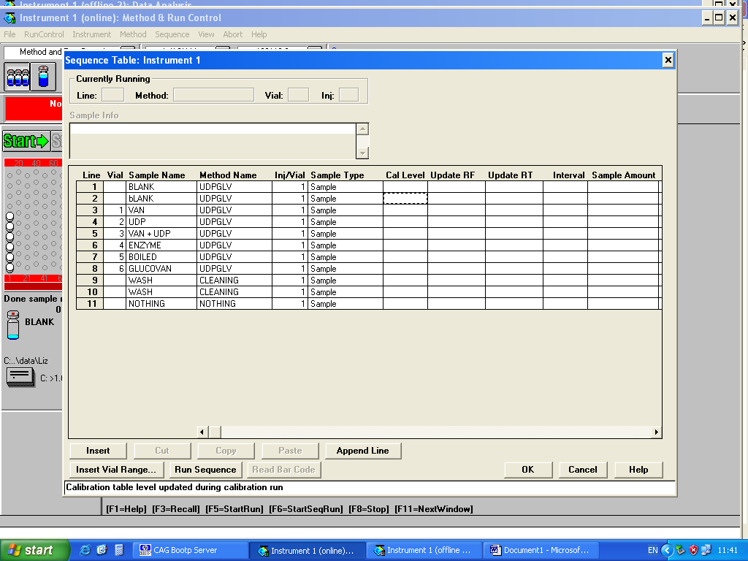
- Vial – this is the position of the vial in the rack. Leave blank if it is a wash run.
- Sample Name – something to identify your sample
- Method Name – list of saved methods, pick the one for that particular sample
- Inj/Vial – Number of times the machine will sample from each vial.

HPLC - MS

Bruker 2008

- Turn on detector
- Turn on pump
- Check vial 1 methanol is in place
- Change column - ensure no leak
- Check direct infusion inlet has not been initiated
- Turn on Pump – flow rate etc
- SAMPLE TABLE
  - Data D/Data/Paul/Paul/051110
  - Higlight Equilibriation line and 1 sample line
    - Change Sample Name
    - Position in Vial
    - Change LC method to LIGNIN ANALYSIS METHOD (or Equilibration)
    - Change MS Method to LOW1000Positive or Extralowpositive
- Right Click and Add New Samples - quantity
  - Tick increment box
- In result section on bottom, make sure data path is correct
  - Paul/etc
  - Acquisition on top line
- SWITCH EVERYTHING ON
  - Hystar has to be green to start
- START
- START SEQUENCE
- ACQUISITION SHUTDOWN SETTINGS
  - Make sure all boxes ticked
    - If wash needed then add 10 mins in first box

HPLC – UV – Fraction Collector
- Run small sample first to find threshold
- Click on second arrow
  - Set up gradient
  - Flow rate 20 ml/min
  - Max pressure 400
  - Stop time 20 mins (dependent on grad run)
- Check solvent levels
- Check DAD signal 210 normal
- Fraction collector
  - Peak based
  - Working mode – threshold only
  - Time based – max fraction 5 (do two lines in box (one TIME BASED and one OFF)
- Set up injector
  - 200 μl injector volume
  - Draw speed 1000 μl
  - Eject speed 1000 μl
- Click sample vial diagram
  - Info
  - Manual (mark circle)
  - Location
  - Fraction start location
  - Sample name
- Turn on DAD
- Purge system
  - Change solvents for Bugg filtered solvents
  - Open taps and purge to remove large bubbles
  - Click on 2nd arrow
    - Control A
  - Pump on / Purge on OK
  - Click on 2nd arrow
    - Control A
  - Change gradient 0% for A Purge 100% B Purge
  - Purge A bottle first
  - Purge B bottle
- Change solvent in gradient to initial conditions
- When finished run a wash programme of a blank of methanol
  - Go into Dave’s folder and do wash program 35 min and empty dirty tube etc
- TURN PUMP OFF / TURN DAD OFF / TAPS TO HORIZONTAL

