How to use the Freeze Dryer
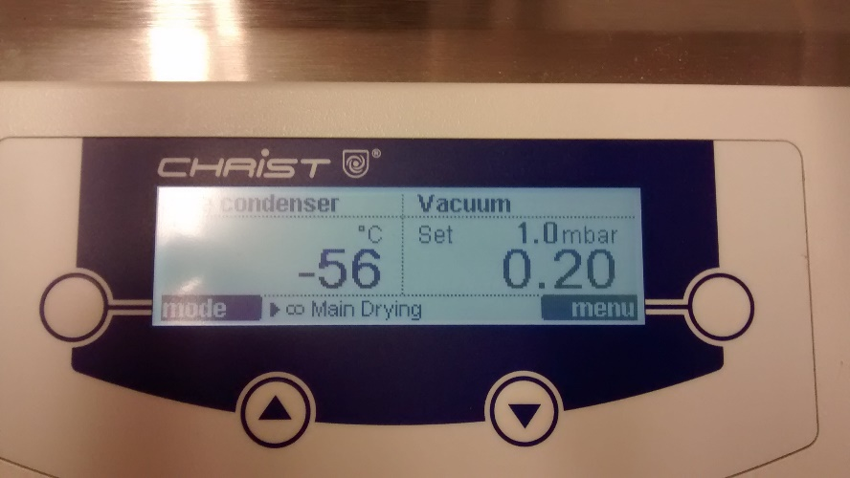
MODE/BACK
BUTTON
UP/DOWN SELECT BUTTONS
MENU/ENTER BUTTON

To Freeze a Sample…
(SKIP STEPS 1-5 IF MACHINE IS IN MAIN DRYING MODE, AS ABOVE)
1) Make sure the drain on the bottom left of the machine is closed tightly.
2) On the console, press the MODE button.
3) Use the arrows too select the “continue with phase…” option, then press ENTER button.
4) Select “warm up vacuum pump”, then press ENTER. Leave the machine until the temperature reads -50°C and the pressure is about 1.0 mbar, approx. 10 minutes.
5) Press the MODE button, select “continue with phase…” press ENTER, select “main drying”, then press ENTER.
6) Put your fully frozen sample (use liquid nitrogen, make sure its fully frozen) on one of the adaptors, secure with a green clip, and turn the black tap ON, you will hear a hiss.
7) After your sample has dried, turn the tap back up to the OFF position and unclip your sample, then take it off the machine
8) IF NO OTHER SAMPLES ARE ON THE MACHINE then press the MODE button, select STANDBY, and unscrew the drain on the bottom left. (optional step)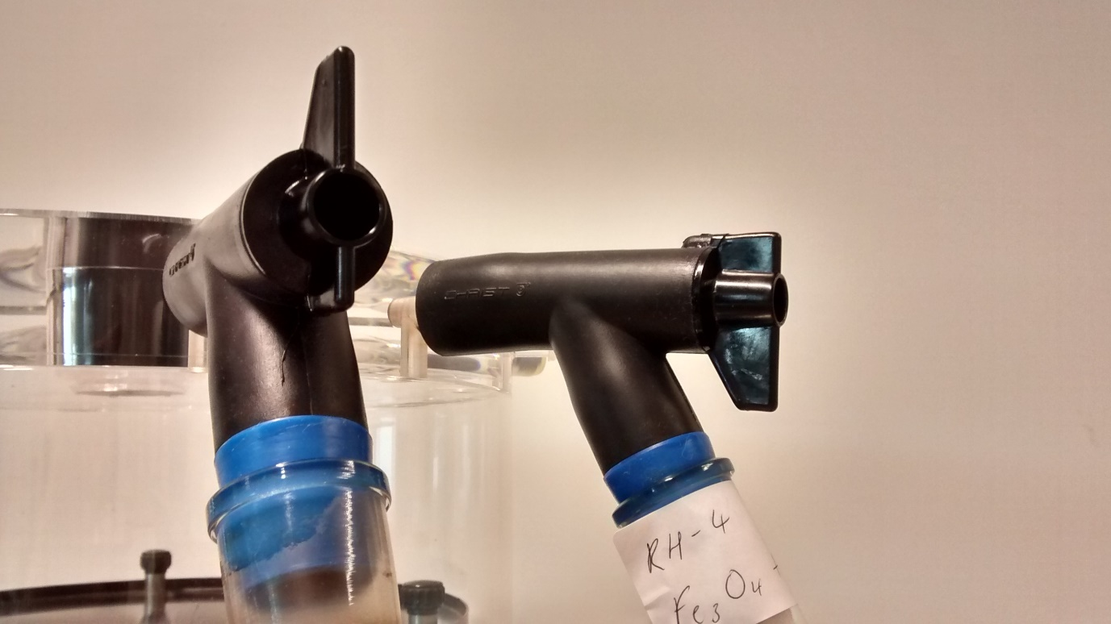
OFF
ON

FOR PROBLEMS OR MORE COMPLICATED STUFF, SEE CHRIS


