NMR tutorial Answer Sheet
Basics
- Williams and Fleming v. useful resource.
Chemical Shift
Signals are observed for each magnetic environment experienced by nuclei in the sample. Differences in electron density cause variations in the local magnetic environment. Lower electron density is “de-shielded” or shifted downfield. The aromatic region also lies downfield, usually around 7ppm.
Mark Downfield, Upfield, Deshielded and Shielded in the corrected boxes.

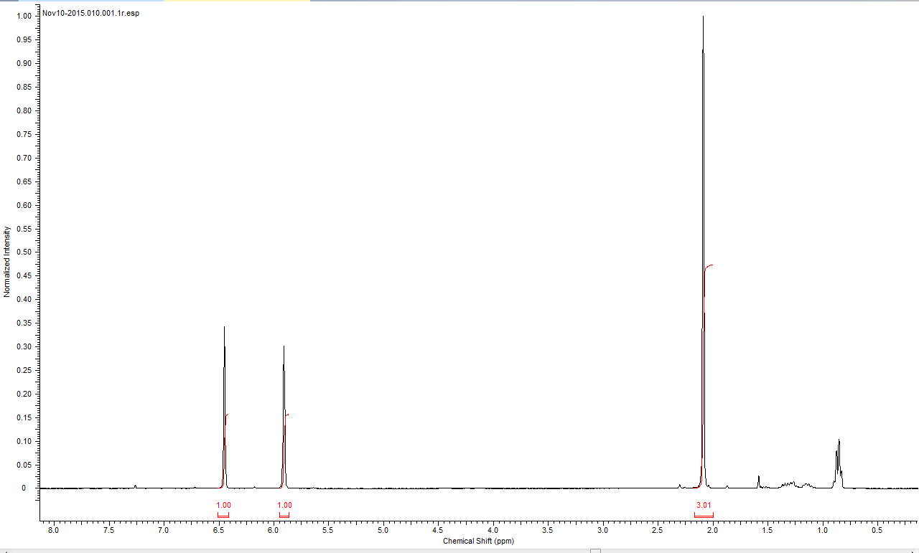
Shielded
Upfield
Deshielded
Downfield

Coupling
The magnetic field produced by neighbouring nuclei also has an effect on how nmr signals appear. This is coupling and is observed as splitting of the peaks. Splitting follws an N+1 Rule:
Singlet
Doublet
Triplet
Quartet
N=0 0 Adjacent H atoms
N=1 1 adjacent H atom
N=2 2 adjacent H atoms
N=3 3 adjacent H atoms

J values
In an unknown NMR the J Value, or spacing between peaks in Hz, can tell you what is coupling to what, as the J values will match.

I.e.:
B
C
C
B
A
A
The J value for this quartet will be the same as the J value for this triplet as they are coupling to each other.
Assign the splitting of the marked Hydrogens below

Septet (7)
Triplet
Triplet
Singlet
Singlet

Doublet

Doublet of doublets
Doublet of doublets
Doublet of doublets

7 X 3 Peaks Probably overlayed on each other
Multiplet

Sugar NMR
Label these sugars as Alpha or Beta

BETA
ALPHA

What is the splitting of the marked Hydrogen? (Solvent D₂O)
Doublet
Doublet

How can we differentiate these? The bond angles are the key. They affect the magnetic environment each proton is in and can have quite drastic differences to both chemical shift and coupling constants (J value). The alpha H has a chemical shift at ~5.2ppm while the Beta H has a chemical shift of ~4.6ppm (For Glucose).
Draw the Fisher Projections for each Proton above and estimate the coupling constant using the karplus relationship:

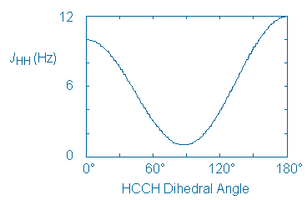
NB. The karplus equation is :
A B and C are constants dependant on the nuceli involved so always consider some lee-way when comparing the curve to your real results.
~4 VS ~12
60 Degrees vs 180 Degrees

Carbon NMR
Works much the same as proton NMR but you will observe larger chemical shifts. This is helpful, particularly for Sugars as the carbon peaks can be spaced out while the proton peaks overlap. Simplifying things as well we don’t see coupling in a Carbon NMR. Why?
1.1% of carbon is 13-C so low probability of finding two next to each other in a compound.

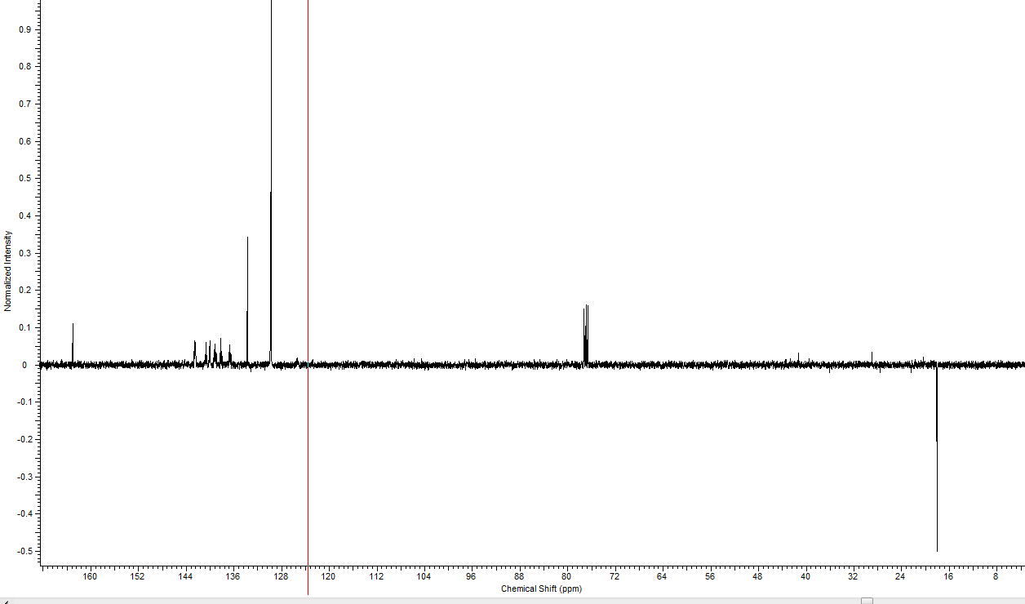

You can get negative signals in carbon NMR, this tells you how many attatched Hydrogens there are to that carbon nuclei.
What is the rule for assigning this?
0 and 2 on one side
1 and 3 on the other

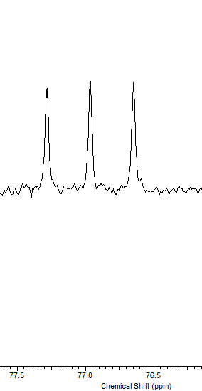

This is the CDCl₃ peak. Why is it a triplet?

Deuterium coupling

Fluorine NMR
Not common, but is in our group! 100% of Fluorine is 19-F which has spin 1/2, so behaves just like 1-H NMR.
However. In a standard Carbon NMR the Fluorine is not decoupled from the carbon.
Have a go at assigning the carbon nmr below (aromatic region only) for the PFP Ester below:
43
33
2
1

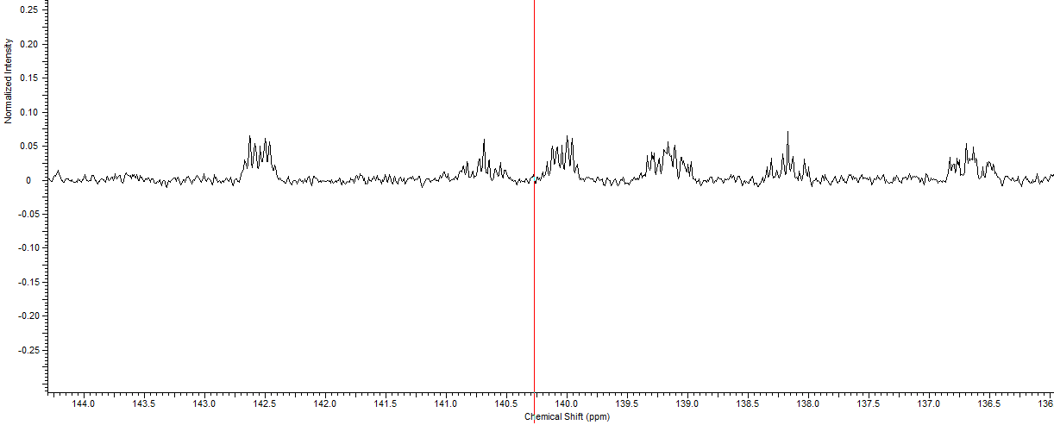
Doublet of triplet of triplets. (C4)

C

There are two peaks over laid here. I.e. they happen to have the same chemical shift.
A doublet of Triplets (C1)
And
A doublet of doublet of doublets (C2)

Doublet of multiplets.
I think this is C3 and a doublet of doublet of doublet of doublets.

