Turn on the UV-Vis and Quantum Northern temperature controller.
Wait for the green power button
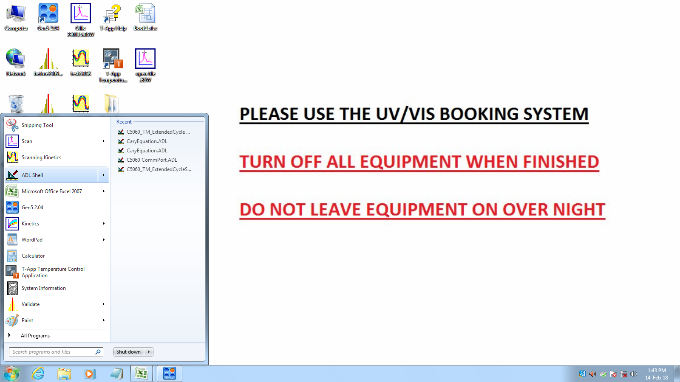
Open ADL shell
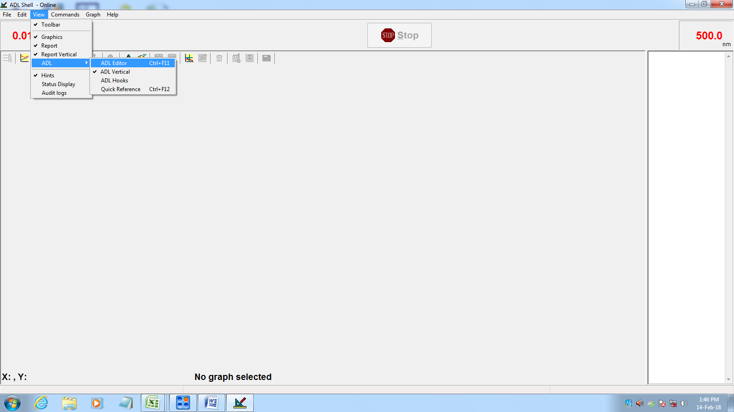
Go into View > ADL > ADL editor
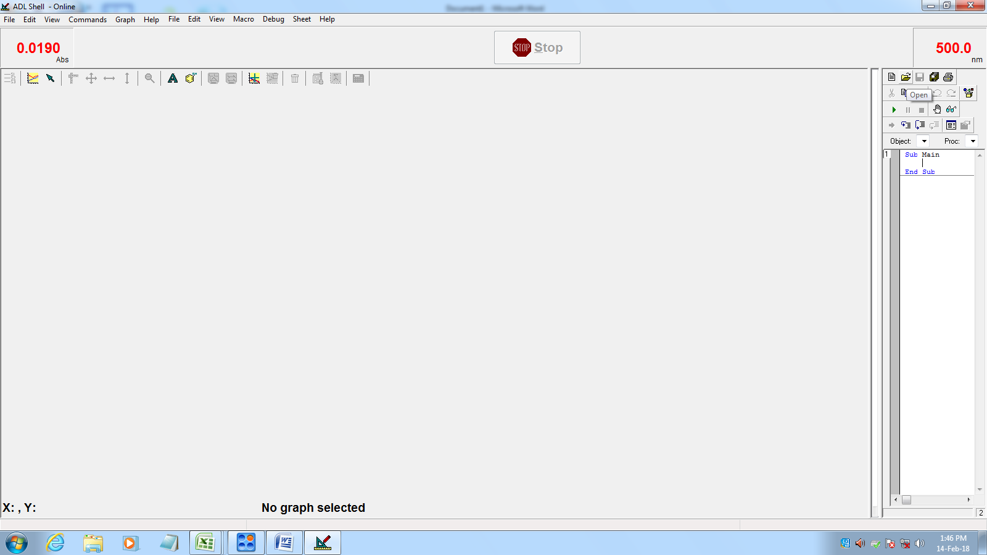
In the new window on the right, click open.
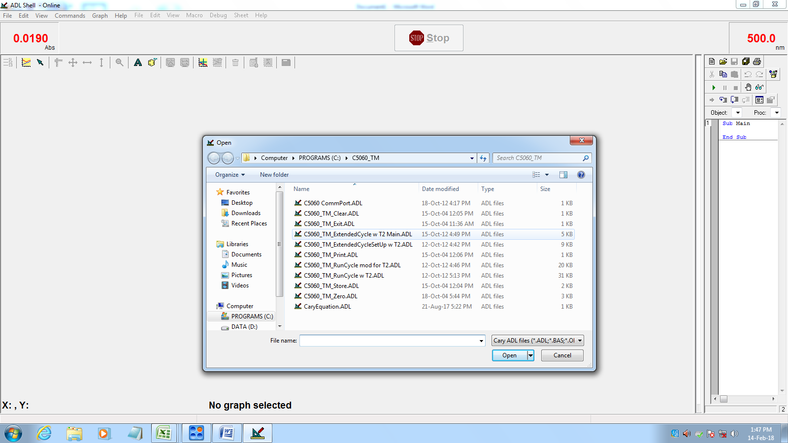
Open C5060_TM_ExtendedCycle w t2 Main.ADL
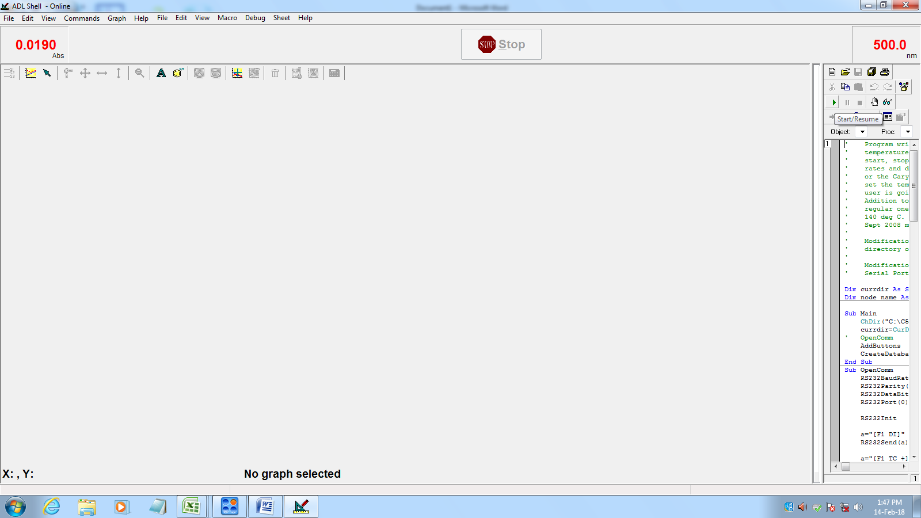
Click the play(green triangle) button to run the code.
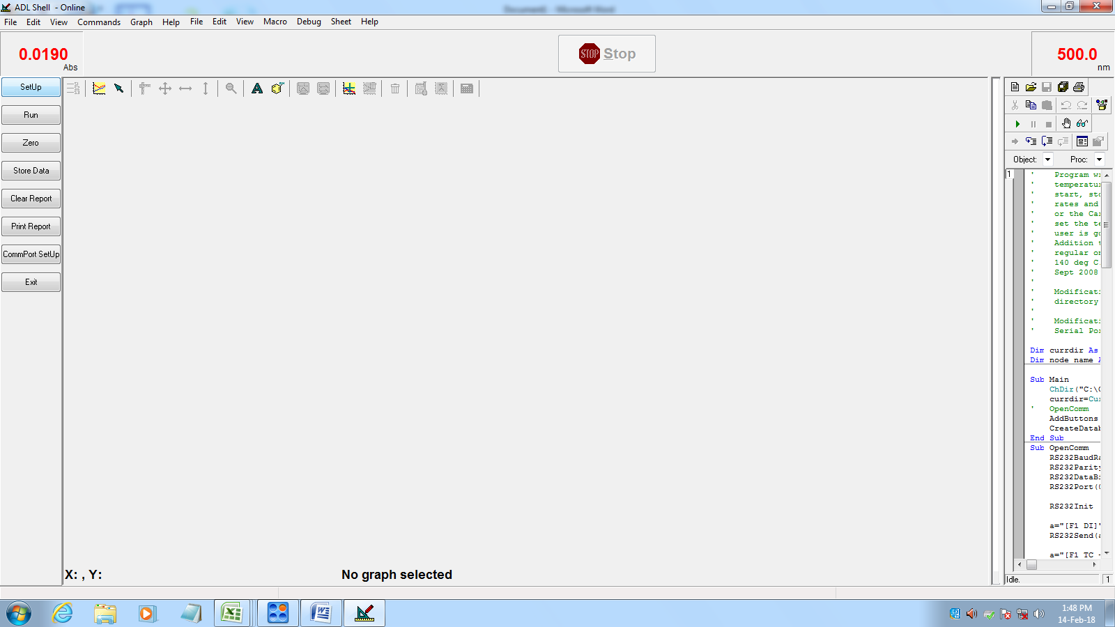
In the new window, click setup
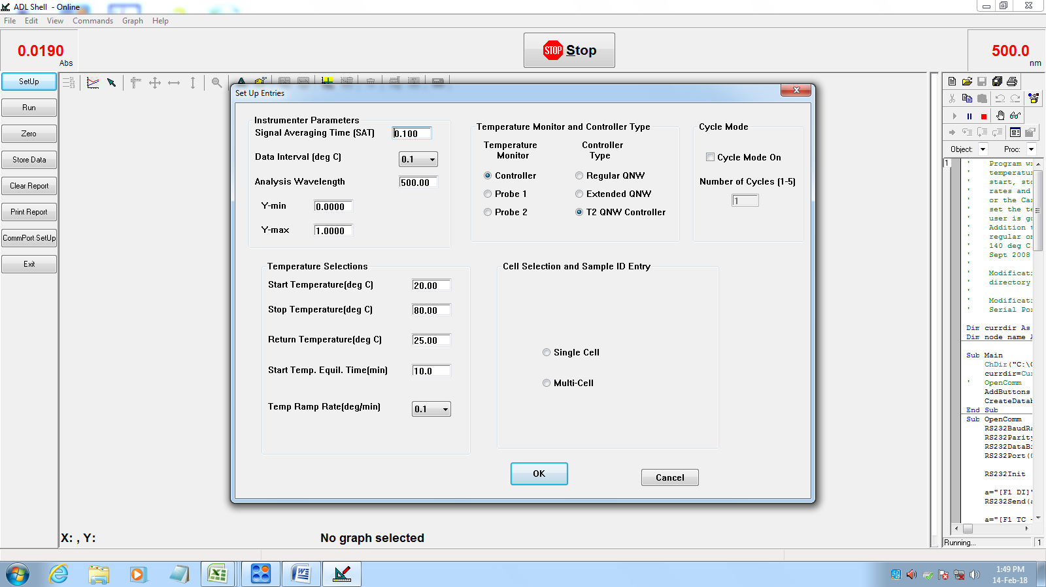
Enter experiment parameters. Change controller type to T2 QNW Controller. Select single cell or multi cell as required, and enter the sample name. Click OK. At this point, if stirring is required. Press the left arrow on the temperature controller screen until the “Set Stirring” screen is displayed. Adjust the speed with the up/down arrows, and toggle stirring on and off with the “set” button.
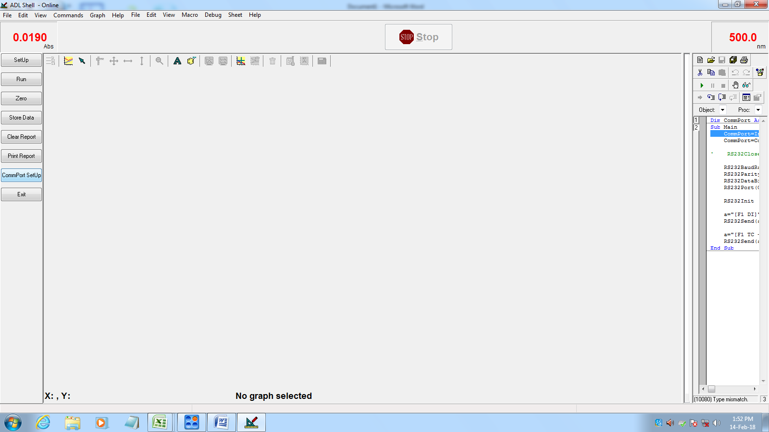

Click ComPort setup.
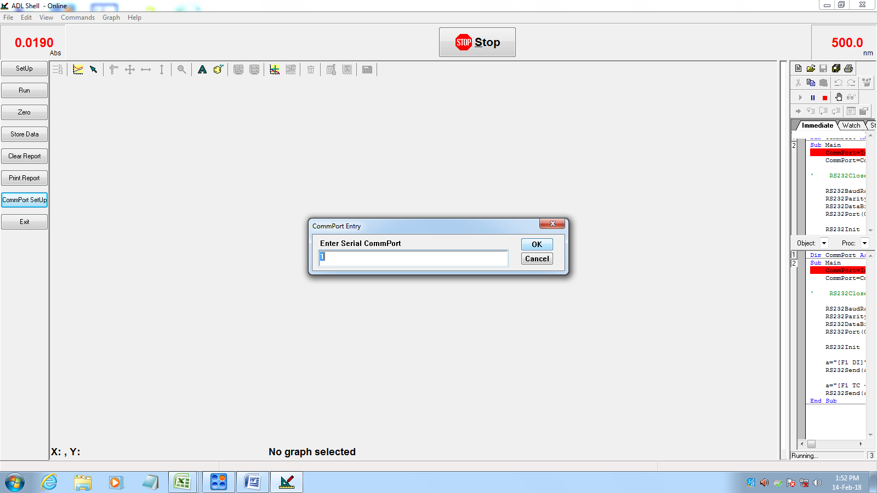
Then click okay.
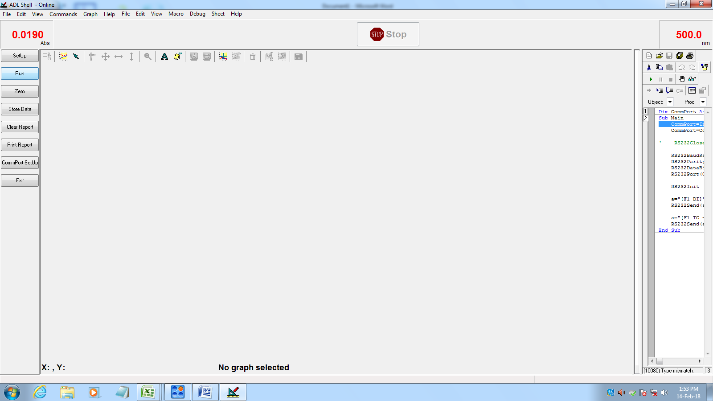
Click Run.

