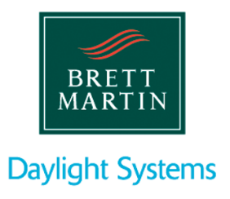
Design and Engineering Placement Opportunities

SALARY: £18,000
LOCATION: Coventry

Introduction to company:

With more than 50 years’ experience Brett Martin Daylight Systems is in the business of natural daylight and has built a solid reputation as the industry specialists in the provision of daylight solutions. We are the UK and Ireland’s leading rooflight manufacturer with an impressive portfolio of innovative solutions and an equally impressive client base, which boasts a wide spectrum of successful projects such as the Wembley stadium and the London Underground.

Placement Opportunity:

With a duration of 6 to 12 months depending on your university course requirements, the exciting and varied roles available will depend on your skills and experience, but could include a mix of research, design, development and engineering of new and existing products, manufacturing systems, and technical product support. With a clear interest in business, product design and/or engineering, and project management, the successful candidate will play an important role within the business, supporting, maintaining and even leading the management of new and on-going projects.

The individual:

We are looking for second/third year undergraduates of Industrial/Product Design, Mechanical/Manufacturing/Materials Engineering or similar discipline. You will have strong communication skills both verbal and written. Practical experience, ideally from a manufacturing background would be welcome but is not essential. You’ll be a confident person, comfortable with coordinating and supporting and possibly leading technical projects, dealing with people from all areas of the business. You will also have a mix of skills including being technically minded, practical, an excellent communicator, personable & articulate, confident & assertive, organised & capable, commercially aware, confident in CAD Design, with excellent time management and the ability to meet deadlines.

Salary & Benefits:

At Brett Martin we know how hard our employees work and what a substantial contribution they make to our business, and because of this we offer the people who join us a very attractive package. This includes:
• Salary: £18,000 per annum
• Up to 23 days holiday per annum, plus bank holidays

Training & Development:

Brett Martin are committed to the training and development of its employees, and a placement with us could lead to the offer of a permanent position in the future. We provide regular internal training and mentoring to ensure you settle into the business both professionally and personally.

Contact:

To apply for a placement, please email covhr@brettmartin.com using “Design and Engineering Placement” in the subject line, attaching your CV, examples of work, and an indication of desired placement duration.

