Setting up a LabCup Barcode Scanner
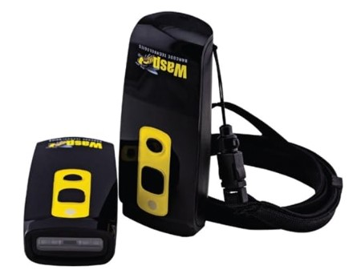

If you plan to carry out the stocktake using a barcode scanner, you must first contact Engineering Stores and book a date and time.
On your agreed date:
- Collect the scanner from Stores
- Make note of your allocated return time
Please return the scanner promptly once you have finished. It may be booked by another staff member or group, so timely return is important.
Contents of the Barcode Scanner Pack
- 1 x Scanner (Wasp Barcode Technologies)
- 1 x USB charging cable. Please either recharge the device before returning (if needed) or inform a member of the Physics Admin team of low battery.
Connecting your scanner to a computer or laptop
- Go to system settings on your computer or laptop
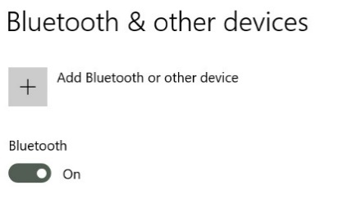
- Select or search for ‘Bluetooth & other devices’
- Turn on Bluetooth (if not already)
- Select ‘Add Bluetooth or other device’
- Select the kind of device you want to add. This is ‘Bluetooth’

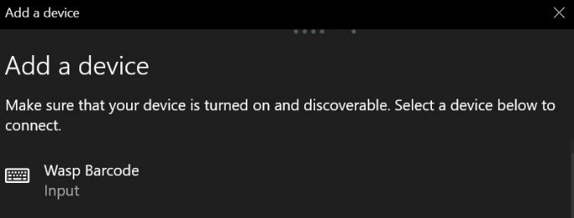
- ‘Wasp Barcode’ will appear in the list of discoverable devices. Select ‘Wasp Barcode’.
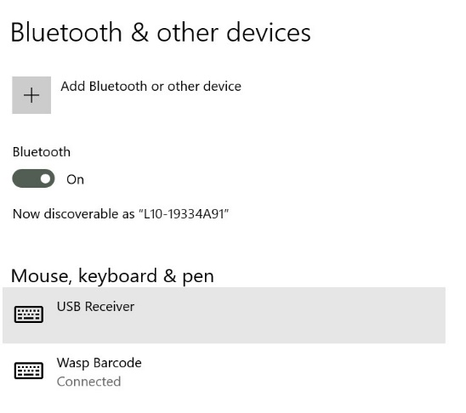
- The device is now set up and ready to go. You can select ‘done’. You will be able to see the ‘Wasp Barcode’ under the connected devices

You can now follow the instructions on how to undertake a stock take on LabCup:
- LabCup stock taking guidance (PDF)
- Alternatively - How to do a stock take (part of the LabCup training Moodle - Scroll down to 'Stock take in LabCup’)
Troubleshooting

- The scanner has lost connection?
The scanner has a range of up to 10metres from its connected laptop. Keep the scanner device within this range of the laptop.

- The scanner is not turning on?
Connect the scanner to your laptop using the USB charging cable. It may need charging indicated by a red light appearing on the front of the device. You can connect the device to your laptop via Bluetooth whilst charging.

