University of Warwick
Health and Safety documentation to support Student Projects
Guidance for Supervisors

Engineering Health and Safety
1/10/2014

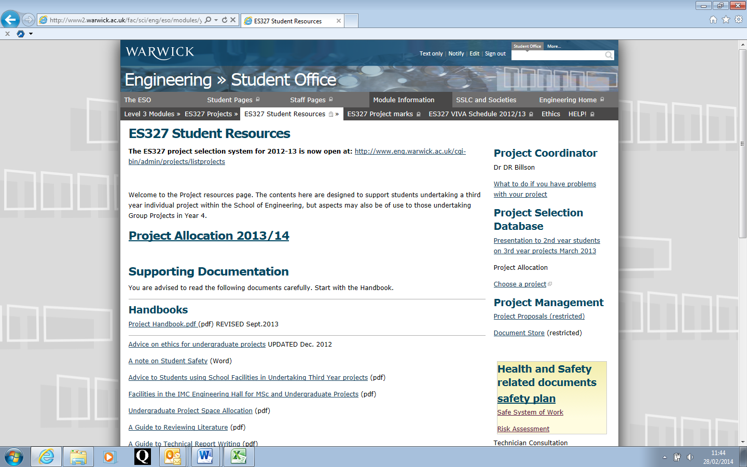
The above webpage incorporates detail on what health and safety (H&S) submissions need to be completed by the students. It is important if you are responsible for the supervision of a student during their student project that you understand what these are.
To summarise:
- A Note on Student Safety has been updated to reflect some minor changes which are covered in the following points.
- A Safety Plan is required for all student projects – this enables students to break down their project into smaller activities, which may or may not require a risk assessment and safe system of work. This document is a living document which they will be expected to submit at the end of week 3 to demonstrate that they have at least given some thought as to how they will deliver on the project and what sort of deliverables may be expected from a H&S perspective. This document should be reviewed and comments made at the 3 week interval and throughout the life of the project. This document will need to be updated as the project progresses and/or as circumstances change and a regular discussion around this held with the students during any progress reviews. It makes sense for this to feature in the project documentation that is submitted.
- A Safe System of Work (SSOW) will be required where there is a need to demonstrate how they will carry out each aspect of the work safely. If there are aspects of the student’s work that are already well documented, they should not be expected to re-write this – these are only required where there are risks associated with their work, where if they could do it incorrectly, they could put themselves or others at risk. These should demonstrate to you, the supervisor that they can do what they need to do to deliver on the particular activity in question. Similarly, these should be broken down into the different activities and you should comment if you think that there are steps within it that are incorrect or if they have missed anything important. These should be printed out and maintained in the project documentation. The Safety Plan should make reference to each one.
- A Risk Assessment is required for each part of a student’s project work (and any research) where there could be significant risks. Trivial risks do not have to be documented. The process for conducting risk assessments is via an on-line form that should be completed by the student. Information on risk assessment is contained here and it is critical that students and you as a supervisor understand the importance of these as risk assessment has a vital role to play in industry. If the documentation does not provide you with confidence that the student has identified the hazards sufficiently or has not explained how they will manage the risks, it is important that your feedback relevant comments to the student via the online form where necessary outlining why you do not deem it suitable and sufficient and to ensure that the risk assessment is revised and that your comments are reflected in the amended version when re-sent back to you for approval. Final (signed off) versions must be maintained by the supervisor and feature in the project submission. The Safety Plan should reference each risk assessment completed that is relevant to their project.
- In relation to the Control of Substances Hazardous to Health (COSHH) assessments, these are only necessary where students are using a hazardous substance which may cause harm in the context of how they intend to use it. A lot of the materials that are used in Engineering are standard formulated products which if students follow the instructions and guidance provided should pose little risk to themselves or others. Risks associated with these can be incorporated into the risk assessment using the Material Safety Data Sheet (MSDS) information provided. A COSHH assessment should be conducted for substances which could expose the student to a health or safety risk – this may arise naturally, as the product has certain risk/hazard and/or safety/precautionary phrases that state this, or perhaps it is being used in sufficiently larger quantities than normal or being used differently to normal or it is being mixed with other substances that may then provoke a different risk. Under these circumstances, it makes sense to have these thoroughly documented within a COSHH assessment. Final versions should be printed out and maintained within the project submission documentation. The Safety Plan should reference each COSHH assessment.

There is no change with the on-line recording of COSHH assessment at present. Students must be advised to use the Engineering Stores to obtain any materials that they require. Any new materials will need to be ordered by the supervisor and ordered through the e-Procurement OPeRA system. Information on how to assign the appropriate Hazard Level when making such purchases is available from the Health, Safety and Wellbeing pages. If you recall a need previously to obtain a MSDS number, there is no longer a requirement for a MSDS number to be obtained. You can follow the link if you require further information on How to interpret Material Safety Data Sheets. Students should be referred to this to support them conduct their own COSHH assessments where required.

Prior to any new material being brought into use the student should provide you as supervisor with the following information to provide you with confidence that the material is right for the location that they propose to use it and does not put them or others in the vicinity at risk:
  - The Material Safety Data Sheet (MSDS)
  - Reason for use of the material – what is it for?
  - Amount to be used
  - Frequency to be used
  - Method of application
  - Location where it is to be used
  - Ventilation available in this area
  - Proposed personal protective equipment (PPE) – further advice can be provided on this if not deemed fit for purpose
  - Proximity to others and other activities (as this may affect what you can use)

If you have not seen the website where all of this information is available, please familiarise yourself with them. Note that all relevant H&S documentation is available from the ES327 project page (in right hand column) as shown in previous screen shot. All students must submit a Safety Plan. The remaining screen shots show the pages that the students will then go to that support this – Risk assessments, SSOW and COSHH. On each you will find an outline on what is contained on each page and further guidance provided for you as the supervisor as deemed necessary.

Safety Plan webpage – provides students with guidance on how to complete the Safety Plan and what to do with it when completed. Note that access is possible here to the SSOW and Risk Assessments page as well as the Display Screen Equipment (DSE) Assessment guidance page. Note that for low risk student projects, the DSE Assessment is the minimum that should be completed together with the Safety Plan. Having said this, supervisors should encourage students to consider other methods to incorporate health and safety within their project submission e.g. to consider the equipment : human interface post design; evaluation of other risks if the item was developed; what evaluations may be necessary to put the item into production or to make use of the data; are there any lifetime safety considerations that may come up later?; what could happen if the software provided the wrong data or it was misunderstood – could this result in a safety concern? Students should be encouraged to think outside the box in relation to safety – it does not just have to be a case of risk assessment.
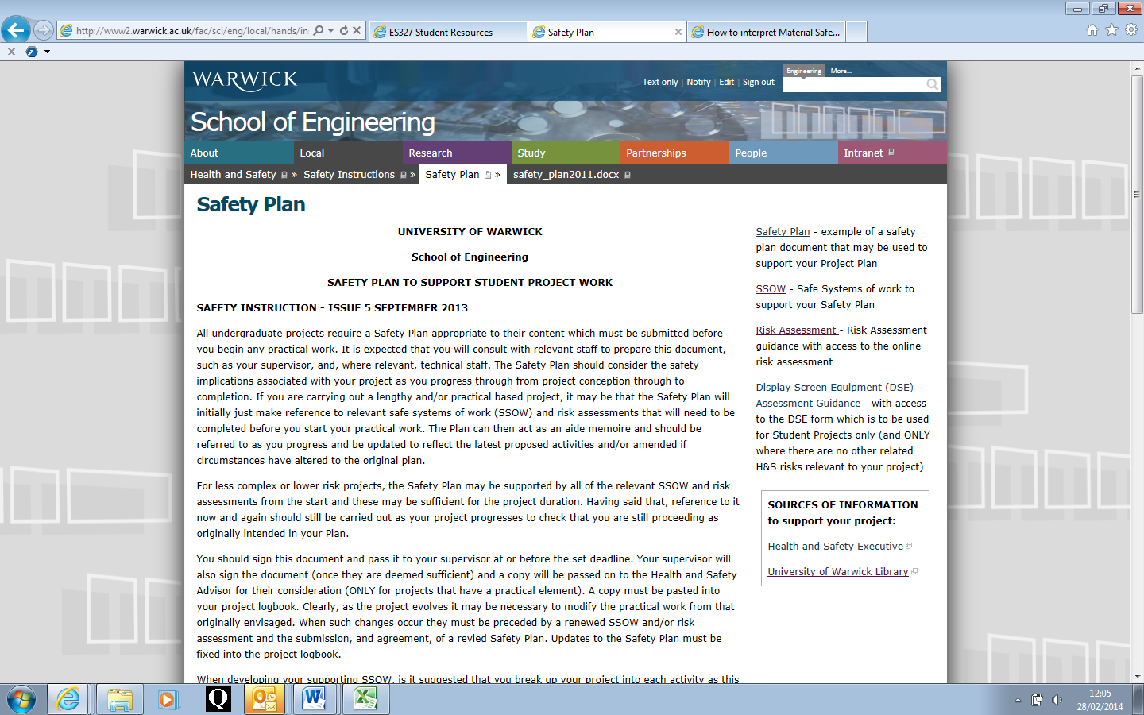
Risk Assessment webpage – provides some general guidance and gives students access to the risk assessment online form for student projects. This also contains the Risk Assessment Matrix which students can use to evaluate the level of risk (overall risk factor) – this is based upon the severity of the incident and the likelihood that it will occur. The expectation is that students will provide you with an overall risk factor for each hazard and the greater the risk, the more control measures you should see to manage this risk – either reducing the severity or likelihood of it occurring. Students are able to access all of the old and new style risk assessments on-line from here and elsewhere on the safety pages. Please familiarise yourself with the process and forms if you have not done this before.
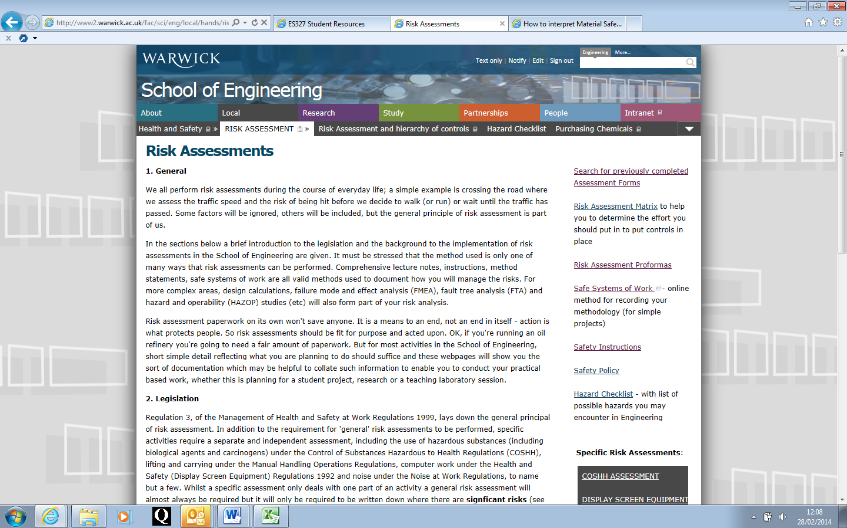
The Safe System of Work (SSOW) webpage – access to the on-line form, a Word version and previously submitted SSOW are possible from here:
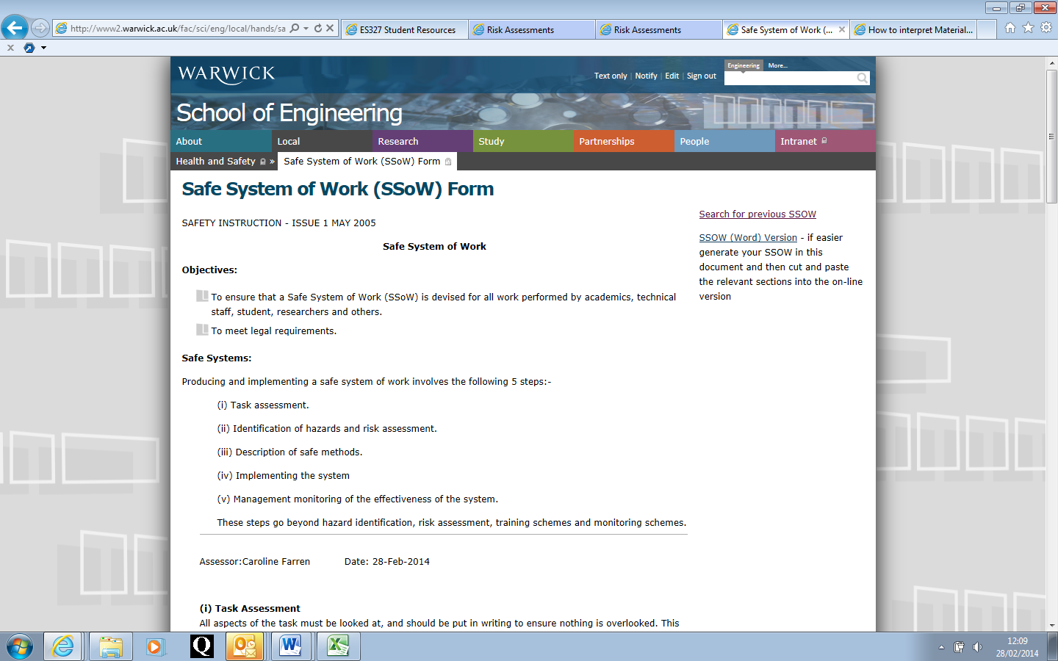
COSHH Assessment webpage - provides some general guidance and gives students access to the on-line COSHH assessment form as well as the ability to search old assessments.
