Area Inspected | F112 and F112a |  | Date of Inspection | 31/01/2014
Inspection team | Caroline Farren, Andrew Allan (Facility Manager), Martyn Darby, Ian Griffith, Jonathan Meadows (Technical Services) Jonathan Clarke (Local Lab Facility Manager) |  | Date of Report | 10/03/2014
Persons with responsibility for the above area | Li Ran / Phil Mawby |  | Action plan required by (14 days) | 24/03/2014

Introduction
The purpose of this report is to highlight good practice, hazards that may not be appropriately controlled within the working environment and potential shortfalls in the management of safety. Observations made reflect levels of health and safety at the time of the inspection. The number of observations requiring attention as detailed in this report is 8.
The report has been allocated a single overall rating based upon the most serious finding during the inspection.
Summary of findings
At the time of the inspection there was no active work taking place using the larger electrical test rigs. There was also nobody present who had an in depth knowledge of the rigs which made it difficult to ascertain whether risks are being sufficiently managed in these spaces. There are a few risk assessments which were able to be downloaded post inspection from the online system. This has made it possible to gain some appreciation of the hazards in these areas. The report reflects this and has affected the ratings provided.
Risk assessments and safe operating procedures are not available in the research spaces for reference by those who have access to the area. Not all of the risk assessments are suitable and sufficient in that they do not all demonstrate that risks are being mitigated sufficiently. Instead there is an acceptance of significant risk where controls are not in place and good engineering practice has not been applied.
There is evidence of engagement with the School’s Technical Services team to safeguard some or part of the test rigs but this is done on an as needs basis. At this time there does not appear to be a standard process for engaging with the Technical Services team in terms of provision of information that gives the Technical team an overall scope of the design and this could mean that risks are not addressed sufficiently. An exchange of information must be provided at this time such that each party understands the scope and/or limitations of any modifications.

Lowest Rating: - Unacceptable Rating guidance can be found at the end of the report.
F

F112
Observation | Comments | Photos (where applicable) | Rating | Management Response & closure date
- During the time of the inspection those involved were advised that the test rig (see photo) was no longer in use. | Any test rigs that are no longer in use must be locked off and not be able to be re-energised. It could not be established whether a risk assessment had been completed for this particular test rig. | 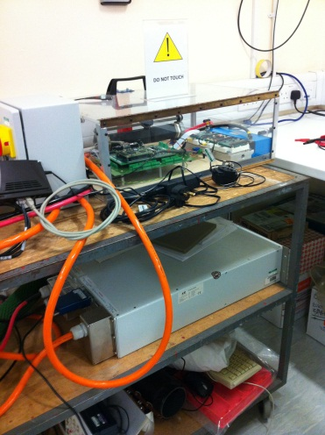 | E | Housekeeping could do with improving, it’s a shame that it does look like it is on its way out of the door. Authorisation, based in risk assessment.  AS4: Are there any current risk assessments/ssow in place, did not seen any in the area?
- Soldering stations with portable fume extractors are in use in this area. Different solder wires are understood to be used including leaded and rosin based solder. | The portable fume extractor is not fit for purpose and will not remove solder fumes from the work environment. These are not permitted for use in industry and must be removed.  If soldering is required a tip extraction fume extractor must be used or soldering must be carried out in a space that has built in extraction.  Rosin free and lead free solder must be considered over rosin and leaded solder due to the risks associated with rosin (known sensitiser) and lead (due to its detrimental environmental impact). The above should be considered as part of the risk assessment. It was not clear how much soldering takes place. | 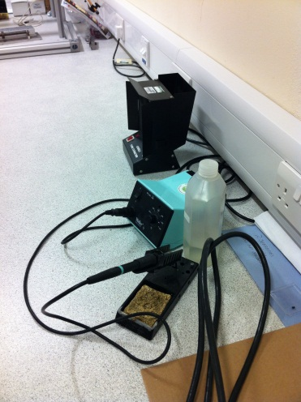 | E | Engineering Dept should establish the type of extract they will accept for use in the department. Not only is the rosin fume an issue, but the lead too has health effects. The type of station ‘Purex’ appears to be ideal.  AS4: Equipment still in the area. 2/3/15  Not sure what type of solder is being used and for what duration.
The level of supervision of students in this area was unclear. | It is not known what rules are in place in relation to lone working in this area or other spaces where electrical research is taking place. |  | D
- The external stairwell and disabled refuge was filled with technical equipment which appeared to be waiting to be removed. | The external stairwell is a fire escape and disabled refuge area and must not be used for the storage or overspill of equipment. Any equipment requiring disposal must be left in a suitable location or it remain in situ in the laboratory until an appropriate company can remove and dispose of it safely following the School’s local arrangements. | 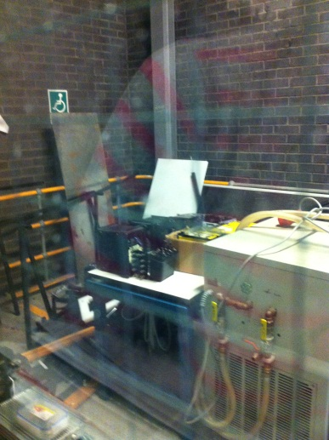 | E | This was removed by AS4 in 2014.  Action Completed.
F112a
Observation | Comments | Photos (where applicable) | Rating | Management Response & closure date
- Kryo 30 is evidently used in this space as a bottle is available on the floor of this laboratory. It appears that a coca cola bottle is used to decant from the 20 litre bottle. | Any chemicals in use must be handled, used and stored appropriately and in accordance with the Material Safety Data Sheet. A MSDS was not available during the inspection and no appropriate storage appeared to be available for these types of materials used in this space. | 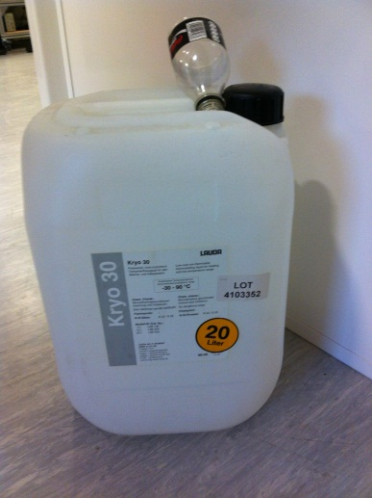 | D | AS4: Is this still used?  If so, where is it stored?  Is a MSDS sheet now available where it is being used?
- The test rigs shown in the photographs were not in use during the inspection. Nor was there any person available who could advise on what research was being carried out connected to them. | Risk assessments and safe operating procedures for the test rigs in the photographs were not available at the time of inspection, however post inspection it became evident that there are 3 risk assessments for this area which were put together last year which are:  RA 1972 entitled Experiment with dc source (Dc voltage 400V), power electronic converter, open loop control through dSpace platform, load bank. Measure the temperature.  This risk assessment is not suitable or sufficient to provide assurance that the risks connected to work with 300-400V DC have been duly considered as it only makes reference to the fact that there are emergency protections buttons, source action protection, safety leads. The additional control makes reference to having a qualified person in the lab.  RA 1987 entitled: Development of a test rig - Assembly and testing of circuits  RA 1990 entitled: Electro-thermal modelling of the behaviour of power semiconductor devices inside electronic converters. This recognises electrocution as a risk and states as above that Emergency protections buttons; source action protection; safety leads, etc. will be in place.  This risk assessment makes specific reference to: Never switch the rig on with the converter lid open. Good engineering (and safe) design should make it impossible to energise the rig with the rig lid open. In this particular risk assessment there is also a further recognition of a design flaw that could Damage to the converter/ local electrical network: due to inherent design flaw the converter switch default state is ON. This means that at switch off, if the DC supply has not been disconnected, the capacitor banks within the converter may back-discharge into the DC source, instead of into the load bank. The control No in-built system measure to prevent that is in place yet. DC source should be physically disconnected from the converter, before the test rig is switched off. This test rig therefore relies on persons completing an operation in a certain order to prevent the electricity from discharging in an unsafe condition. This is not good engineering design, nor is it a good (or safe) methodology for handling risk.  It is not known who the ‘competent’ person is that oversees the research in this space, or how this is organised. Local rules were not displayed and no lock-off mechanisms were visible which could be used to prevent test rigs from being energised in the absence of such competent staff.  Risk assessments must be deemed suitable and sufficient by the principal investigator to provide assurance that the risks in these areas will be controlled prior to permitting the rigs to be used. Currently these do not provide this assurance. | 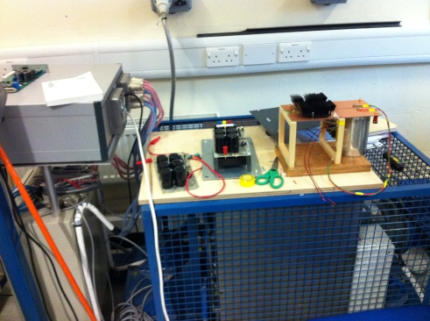  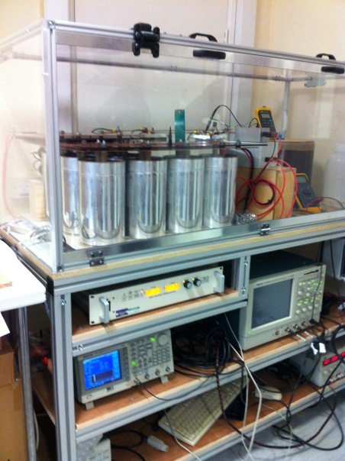 | F | Action taken to prevent use of the rig in the first photo.  Second photo equipment appears to be interlocked.  What is needed are adequate and up to date risk assessments and SOP’s. The control measures need to be physical, not a person waiting for an electric shock  AS4: Evidence of some RA/SSOW but not for all rigs?  Have they been completed?  2/3/15
Observation | Comments | Photos (where applicable) | Rating | Management Response & closure date
- Evidence of soldering was visible in this area. | See comments for soldering in F112 as equally this applies to this area. |  | E | Refer to section 2.
- The level of supervision of students in this area was unclear, although the risk assessments imply that a ‘competent’ person must be present during testing | There was no ‘competent’ person available during the inspection although two students were working at desks in the adjoining room which was readily accessible to this space. The overall management and supervision of this space was unclear. No local rules were on display. |  | D | AS4: Still no local rules on display.  2/3/15

Ratings guidance
Exemplary | No issues raised, ‘best practice’ observed | A
Very Good | No Issues raised | B
Generally Good | Issues raised, technical issues – not serious | C
Areas for Improvement | Issues raised, areas for improvement | D
Unsatisfactory | Serious issue(s) raised, no immediate risk of harm/damage | E
Unacceptable | Issue(s) of imminent danger, immediate rectification required or suspension of use of facility/equipment/procedure | F

