Area Inspected  Laser Application Areas, School of Engineering |  |  | Date of Inspection | 16/12/2013
Inspection team  Mike Smith, University Laser Safety Officer,  Andrew Allan, Building and Facilities Manager, SoE |  |  | Date of Report | 14/01/2014
Persons with responsibility for the above area.  See Report, column 1 |  |  | Action plan required by | 28/01/2014

Introduction
The purpose of this report is to highlight good practice, hazards that may not be appropriately controlled within the working environment and potential shortfalls in the management of safety. Observations made reflect levels of health and safety at the time of the inspection.
The report has been allocated a single overall rating based upon the most serious finding during the inspection.
Summary of findings

This was a survey of areas in School of Engineering where applications are carried out involving use of lasers.

At the time of the survey, over-all there was little evidence of active work with laser applications which probably reflects the intermittent nature of research. As a consequence many of the areas visited were storage areas for either redundant or temporarily unused equipment. These areas overall had poor housekeeping standards. The introduction of regular reviews of area utilisation and use of dedicated, managed storage could help to improve the situation.

Staff are encouraged to indicate whether areas are in active use or not and provide detail of a contact person(s). This is important for tracking ownership and dealing with issues which might arise.

Staff are encouraged to manage equipment life-cycle more effectively, especially to consider options such as using managed storage, re-use by others, upgrades, donation, disposal as scrap.

There were examples of good laser safety management principles being applied in some labs notably D010.

The practice of mixing office and experimental work areas is discouraged. If segregation is not achievable, risk assessments must be carried out to identify control measures which protect staff in office areas from hazards in the work areas, to include physical demarcation where possible.

Lowest Rating: - Issues raised, areas for improvement
D

<Insert Location>
Observation | Comments | Photos (where applicable) |  |  | Rating | Management Response & closure date
D105 Research Cell  Academic Responsible, Dr Petr Denissenko (not present).  Mr Andrew Bishop (PG) attended the inspection.  No laser work is currently carried out in this laboratory although it can be assigned for such.  General housekeeping is poor.  There is lots of clutter on all benches and the floor area (trip hazards) - appears to be a general ‘dumping ground’ with no evidence of ownership or responsibility for management of equipment and instruments.  There was evidence of experimental work being carried out – liquid handling (various bottles, flasks, open beakers, the majority unlabelled) but no indication as to what liquids were being handled or nature of the work. | Requirement:  Improve general housekeeping, especially the handling and storage of liquid chemicals and labelling/identification of liquid containers.  Recommendation:  Consider designating active work areas and separate storage areas for un-used/unwanted/redundant equipment. | 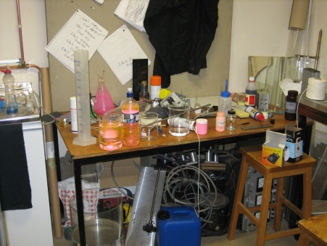  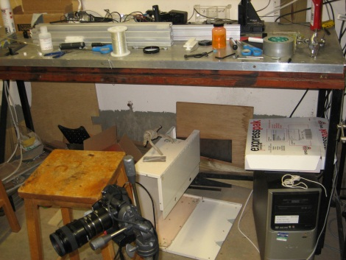 |  |  | D | PD2: Both rooms have since been tidied. 26/2/15  PD2: The class 3a laser will shortly be used in D105 and Andrew Bishop will put the paperwork in order. 26/2/15
Rooms A008a and A008b Laser research Laboratories  Academic Responsible, Dr Petr Denissenko (not present).  Mr Andrew Bishop (PG) attended the inspection  No laser work is currently being carried out.  A laser protection window blind is faulty, preventing laser work from being carried out as the window blind is interlocked to the laser activation system. | Requirement:  The interlock system must be fully repaired and operational before laser work re-starts in this lab. |  |  |  | C | 28.01.2014 update (MS, Laser Safety Officer).  There has been email correspondence (Andrew Allan, Petr Denisenko, Mike Smith) about fixing the window bling but it is still not completed.  AS4: Arranged for repair of laser blind, This has now been fixed. 15/1/214  PD2: Both rooms have since been tidied. 26/2/15  PD2: The interlock in A008a, b is now operational.
Room D010 Laser Laboratory  Academic Responsible Dr Brenda Timmerman (not present)  Mr Paul Hackett attended the inspection  Good laser application control measures are evident:  - Beam enclosures with interlocks  - Securely fixed equipment using purpose designed optics tables  - Use of beam stops and shielding  - Correct use of warning labels and warning signs  - Routing of service cables and pipework to avoid trip hazards  - Use of remote laser controls to minimise need to work in higher risk areas.  At first glance seems cluttered because of the high equipment density but on closer inspection is a well organised, well managed area.  The tight space is cause for concern (see below) as there is the intention to bring more laser application kit into this room. |  | 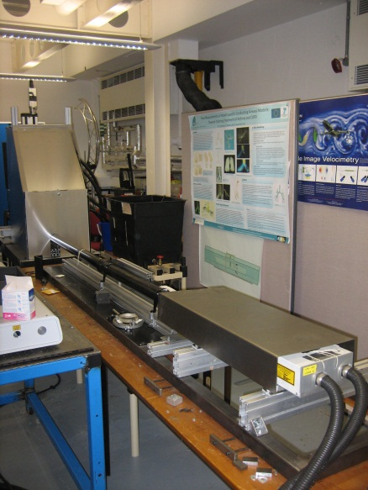  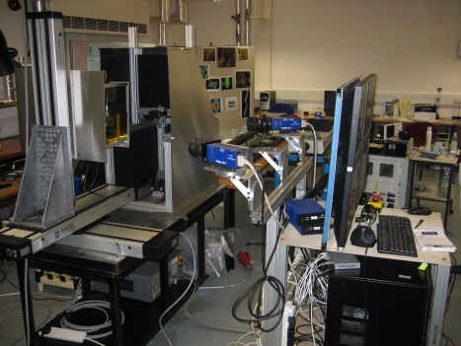 |  |  | A
Room D004e Optical Engineering Lab  Academic responsible Prof Peter Bryanston-Cross (not present)  Mr Paul Hackett attended the inspection  This is currently a storage room for laser equipment.  As such safety issues are of low concern, equipment is stored tidily and securely.  The room is intended to house new research work involving use of lasers. | Requirements:  A large, heavy piece of kit (pictured) will be moved into D010; the move must be properly risk assessed paying attention to potential manual handling ergonomic hazards.  There is a substantial (size-wise) ‘spare’ JK HLS2 laser in this room; a decision should be taken as to its future (dispose, store, use?).  Recommendation:  Depending on the nature of future laser applications, modifications to the room should be considered which improve laser safety e.g. more effective door and window shields. | 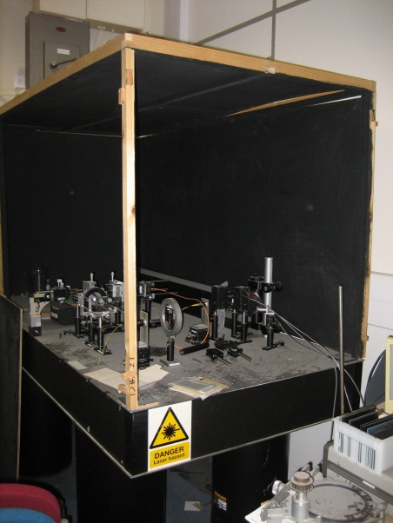 |  |  | C | AS4: Laser work about to start soon in this area. Room now under the control of David Towers. 27/2/15  DPT: “We are about to start some low power laser work in the lab (D004e). I’ll check the draft of the risk assessment for laser use and make sure this is in place.” 27/2/15  DPT: Optical table was moved back in 2014 from D004E to D010. 2/3/15  DPT: JK HLS2 laser has been retained in D004E for the time being. 2/3/15  DPT: Jonathan Meadows installed a new interlock system into D004E last year to connect to the door and the new laser blinds that were fitted. 2/3/15  DPT: Our initial work in D004E has been with various white light sources (not lasers). Now looking to use 50mW continuous wave 532nm laser, class 3B.  Now looking to cover the two other windows (not protected by laser blinds) with Thorlabs bk5 black out material that has a rubberised coating and hence is not transparent .  As the beams we are using in the experiments are all expanded there are no high power densities and hence I don’t believe there would be a thermal problem (although we can test this of course to double check).  3/3/15  MS: In my opinion, for the remaining non-covered windows it would be best option to fit laser resistant screen material as per original plans, indeed this would be essential if/when higher power density beam work starts. There are lots of options for laser resistant barriers, Lasermet’s laser blocking curtains spring to mind http://www.lasermet.com/laser-safety-curtains.php  Regarding the use of Thorlabs BK5, the material is OK as blackout material for the intended work with a 3B green 50mW CD laser (there is a distinction between blackout and laser resistant barrier material) provided additional beam control measures are applied ………. E.g. orientation of the beam such that direct or stray beam impingement on the blackout is virtually impossible, use of beam stops, alignment of optics, mirrors etc to minimise reflections. And as David recommends, check the thermal stability of BK5 to a beam hit.  3/3/15
Room F004 Metrology Lab  Academic responsible Prof Derek Chetwynd (present at the inspection)  Only two low class lasers are used in this room (Class 1 and 2), presenting very low hazard.  The lab appears well organised and tidy i.e. well managed |  |  |  |  | B
Room F004 Surface Parameters Lab  Academic responsible Prof Derek Chetwynd (present at the inspection)  There are two laser-containing instruments in this lab, both are Class 1 laser products and consequently low risk.  The lab appears well organised and tidy i.e. well managed |  | 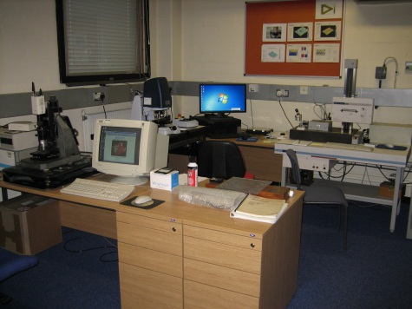 |  |  | B | Email received from Prof Chetwynd 14.01.2014 pointing out that this room is F005 not F004
F411 Electronics (Comms) lab/office  Academic Responsible Prof Roger Green (not present)  Dr Yunfei Chen attended  This area doubles a desk/write up area and an experimental area, with poor demarcation between the two (no physical barrier).  There were sets of experimental equipment set up on benches with no indication of whether there were associated hazards.  There was an experimental set-up on an open bench involving a Class3b laser (pictured), not an ideal location and lacking some basic laser safety controls (shielding, clear warning signs, little if any demarcation from non-laser experimental work on the same bench, inappropriate orientation, adjacent to an unshielded window). Two pairs of laser safety goggles were by the set-up, it is not clear whether they are used as a primary control measure to protect from eye damage. If this is the case there should be much more rigorous control measures used in the area to restrict access to other persons | Requirement:  There should be clear and effective segregation of office areas and experimental work areas, ideally physical barriers.  Hazard warning signs should be displayed where necessary.  A risk assessment for Class 3b laser work carried out in this area should be carried out, or reviewed if one already exists, and better control measures for this work should be identified and implemented. | 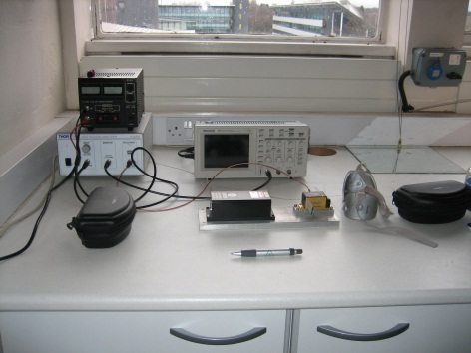 |  |  | D | AS4: Laser area has been segregated with screens, hazard warning signs erected, SSOW and RA approved by Mike Smith. 16/09/14.  AS4: Risk assessment mentions installation of “Laser On” warning light which has not been installed yet.  Also F412 is about to be reused so a revisit of the SSOW/RA would be required if the laser work is still current.  AS4: Raised work request for warning lights in F411 (11470). 20/11/14  AS4: Meeting with Mike Smith to discuss F411 requirements.  AS4: Checking with RJG to see if this work is still active. 2/3/15  RJG: Not laser work, but using light emitting diodes in themail visible and near infrared.  2/3/15
F422 and F423 Ultrasonics labs  Academic Responsible Prof David Hutchins (not present)  Dr Duncan Billson attended  Ultrasonics experimental work is intermittently carried out in F422 although it doubles as a store for unused equipment which is stored untidily.  Similar comment applies to F423 regarding storage. There are lasers in this room, they are not in use at present but will be in future.  There are room design features suitable for work involving lasers (window blinds, door/warning light interlocks etc). | Requirement:  Improve general housekeeping.  Recommendation:  Consider designating active work areas and separate storage areas for un-used/unwanted/redundant equipment. |  |  |  | C | AS4: Rooms still require improvements in housekeeping.
F414-418 ‘Clean room’  Academic Responsible ?  Dr Duncan Billson attended  This is a purpose designed laboratory housing a powerful laser system, but one which is totally enclosed therefore classed as Class 1 laser product and low risk. It is not yet commissioned. |  |  |  |  | B
D106 Turntable research cell  Academic responsible Prof Peter Thomas (present)  No work currently done in this lab. |  |  |  |  |  | PJT:” D106: Still do not have a new PhD student to continue work in there.” 25/2/15  AS4: No work currently done in this area, but area still requires a tidy up. 2/3/15
Coriolis Lab  Academic responsible Prof Peter Thomas (present)  PIV fluid dynamics work is currently being set up in this laboratory. Risk assessments for the experimental procedure have identified controls for preventing accidental exposure to laser beams – the primary control will be prevention of access to the rig and use of remote control to operate the lasers. |  |  |  | B
Cavitation research, labs D100, D100A, D100B  Academic responsible ? Was Prof Shengcai Li but it is not clear who is currently responsible.  Paul Hackett, Huw Edwards attended  D100. Responsibility for the main (largest) area could not be established. There is a cavitation research rig set up in the area but it is not currently in use  Two class4 lasers in the area appear to be in storage; a JK Q-switched YAG bearing a Dept of Physics label P/10509, (pic 1) and a JK Derma-lase DLRI ruby laser.  A third class4 laser is part of the cavitation rig assemblage (pic 2). A hole in the casing close to the normal beam aperture suggests it is not fit for safe operation.  A large amount of miscellaneous equipment, instruments, furniture, storage boxes, filing cabinets, electrical equipment and chemicals are randomly store in the area (pics 3, 4).  Flammable solvents are stored in an unlabelled cabinet along with other chemicals and combustible materials (pic 5).  D100A  This room adjoins the main D100 lab separated by a lockable door. ‘Ownership’ is indicated by a door sign (Reza Ali/Peter Thomas).  There is equipment in the room but no indication whether work is active.  It could not be established whether work involving use of lasers takes place although there is a laser warning sign on an inside wall of the room and the door windows are blacked out.  D100B  Cavitation research work has been carried out in this room using Litron Nd:YAG class4 laser which is in the room mounted on an optical table (pic 6).  It could not be established whether cavitation work has been completed in this room.  The room appears to double as an office – there are desks and PC workstations. An attempt has been made to segregate this from the experimental area using de-mountable panels but this arrangement is not ideal. | Required:  A competent person should be nominated to responsibly manage D100.  Decisions should be taken about the class 4 lasers in D100 i.e. designate person(s) responsible for them, dispose as scrap, place into a managed store and/or repair.  Cavitation work must not restart before a full risk assessment is carried out and appropriate safety controls are implemented. An overhaul of the cavitation rig laser must be included as a control measure.  Storage of materials, equipment and furniture in D100 must be improved.  Flammable solvents must be stored securely and in purpose designed flammable storage cupboards.  There should be some clear indication whether D100B is currently being used as an office and or for experimental work. If both there must be better segregation.  There should be some clear indication whether D100A is currently being used for experimental work, and especially for experimental work involving use of lasers. If the latter, laser hazard warning signage, access control, and other laser usage control measures in the room should be reviewed. |  | 1.  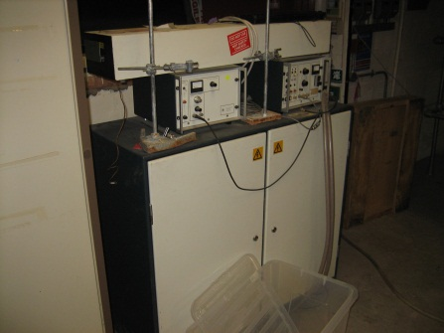  2.  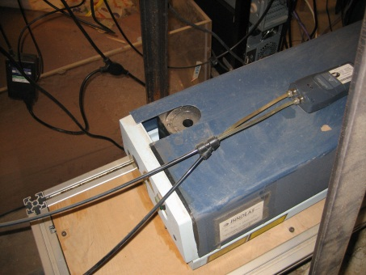  3.  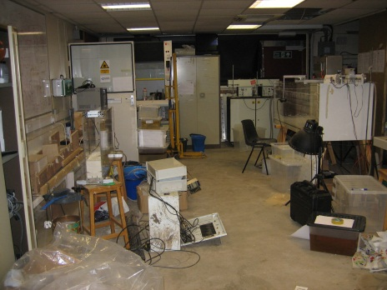  4.  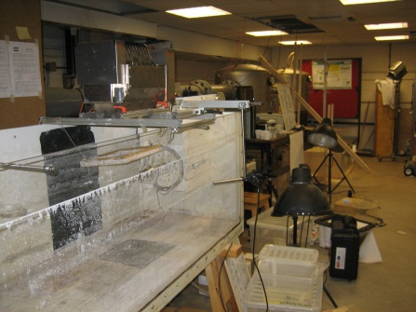  5.  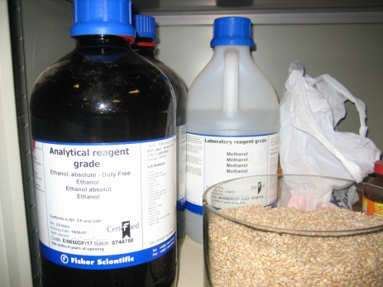  6. 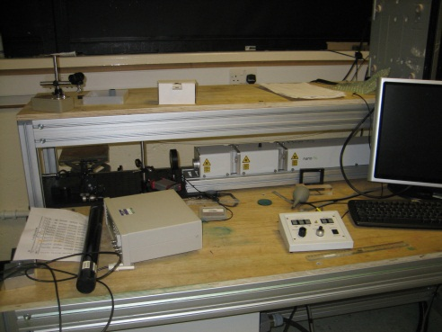 | D |  |  | AA: Email response from Prof Thomas 14.01.2014:-  Regarding room D100A in your report for which you note that:  > "... This room adjoins the main D100 lab separated by a lockable door.  > ‘Ownership’ is indicated by a door sign (Reza Ali/Peter Thomas).  > There is equipment in the room but no indication whether work is  > active. ...  Reza Ali was a PhD student/post doc who is no longer working at Warwick. My PhD student Mr Musa Ozcan is the main person who now works in room D100a. Him and myself are responsible for the room now; I will change the sign on door to reflect this.  Occasionally there are also undergraduate projects located in that room for a few months.  > " ...It could not be established whether work involving use of lasers  > takes place although there is a laser warning sign on an inside wall  > of the room and the door windows are blacked out. ...  There is no work involving lasers going on in lab D100a.  The laser-warning sign was probably put up around 1995/96 when a previous PhD student/post doc attempted some laser experiments (LDA + PIV) in there for a few months.  It was probably also at this time that the windows were blacked out.  The laser experiments were unsuccessful and they were abandoned after a few months. Since then there has been not been any further laser work in D100a. The present PhD project by Musa Ozcan currently conducted in the lab, using the rotating disk apparatus, relies entirely on hot-film measurements. This measurement technique is very low risk and does not involve lasers.  AS4: Emailed Dr Shengcai Li 10/12/14 to see if any of the equipment in D100 was his and if it was still required.  AS4: D100 area since been tidied.  PJT: “D100A: There is a PhD student (Mr Musa Ozcan) working in the lab. He is not using any lasers for his work. I think D100A is reasonably tidy for a room that is in constant use. Most stuff on benches around central tank facility is stuff which is in daily use.” 25/2/15  PJT: “D100:As you know it has been cleaned up.  My PhD student Benedict is not currently using any lasers in D100.  However, he has plans for some short term (a few hours) use of lasers.” 25/2/15  AS4: D100A Does have a sign indicating who is using it.  AS4: D100A/B still requires tidy up.  AS4: Still no nominated ‘responsible academic’ for D100.  AS4: No flammables cabinet yet installed.
HRI Wellesbourne campus, room 20 (Quantarc 04.00.073.006)  Academic responsible Prof. Peter Bryanston-Cross.  The room was not physically inspected.  Observations are based on dialogue between the Laser Safety Officer and HRIW Maintenance Manager (David Trevethic).  This room was used for development of experimental PIV laser work, there is no evidence that work is currently carried out in the area but it is used as storage for the PIV rig equipment (pics).  There is pressure on HRIW facilities management to use this room for other purposes. It is included in plans to accommodate Science Park tenants. | Required:  A decision should be taken about future use of the room.  There is other workshop space available at HRIW. |  | 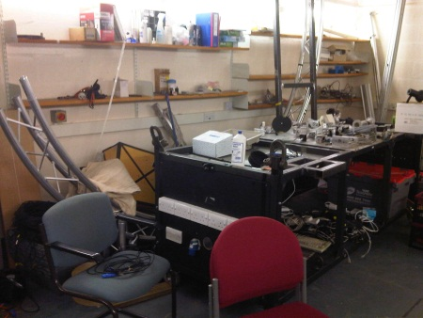  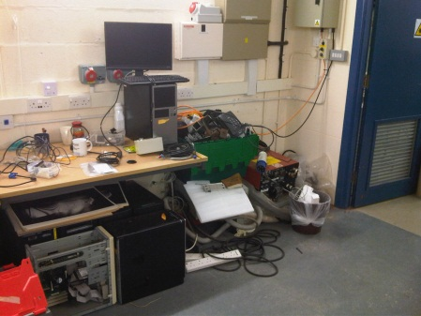  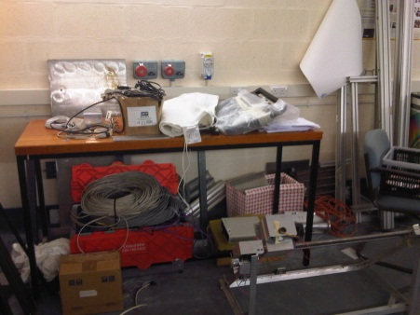 | C |  |  | AS4: Area not currently used for any research activities.  Project this was supporting may finish at the of Mar15.

Ratings guidance
Exemplary | No issues raised, ‘best practice’ observed | A
Very Good | No Issues raised | B
Generally Good | Issues raised, technical issues – not serious | C
Areas for Improvement | Issues raised, areas for improvement | D
Unsatisfactory | Serious issue(s) raised, no immediate risk of harm/damage | E
Unacceptable | Issue(s) of imminent danger, immediate rectification required or suspension of use of facility/equipment/procedure | F

