Initial observations from the 1st Floor research labs tour.
1st floor areas visited.
F112, F112A. Science city not included in tour. D1** Mezz areas included in the ground floor tour.
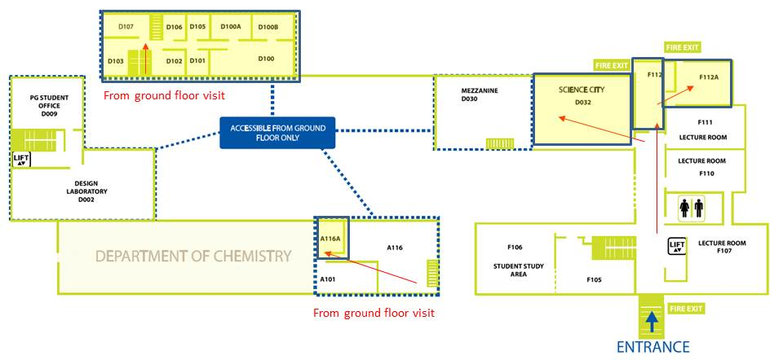
General Observations
F112 – Power Electronics Lab (31.4 Sq.m) - Phil Mawby, Li Ran
Area in reasonable condition, but could do with a tidy up. Gas alarm on wall does not have a valid in date test date. Where are the records showing when this was last tested? No visible SSOW/COSHH/Risk assessment documents on display.
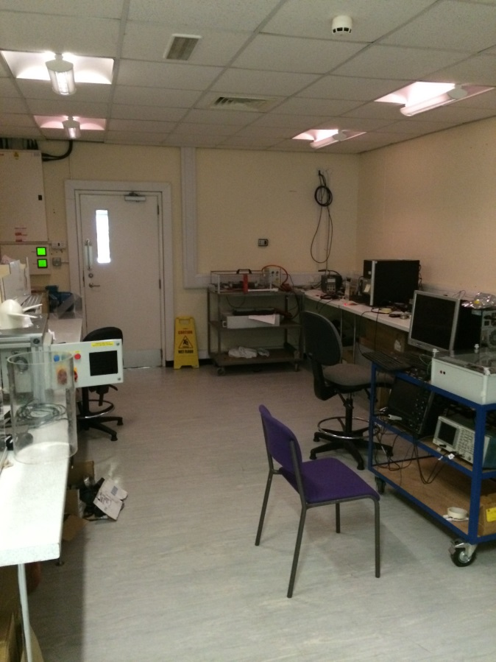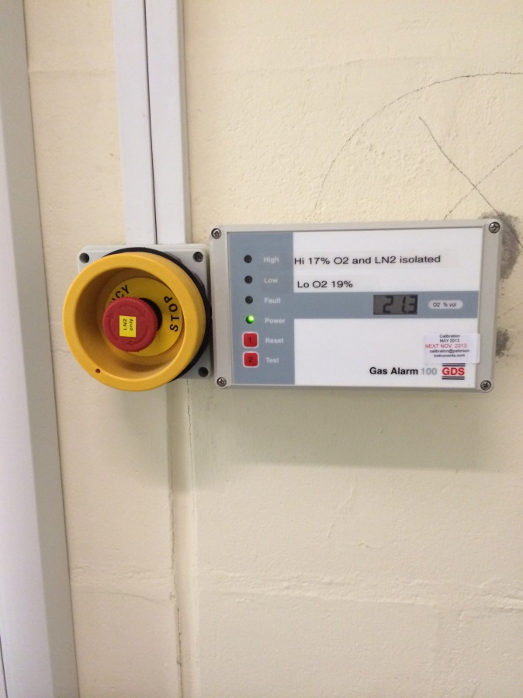

F112A – Power Electronics Lab - (53 Sq.m) Li Ran
Area in reasonable condition, again could do with a tidy up. Some evidence of SSWO/Risk assessments but not on all rigs and not all current.
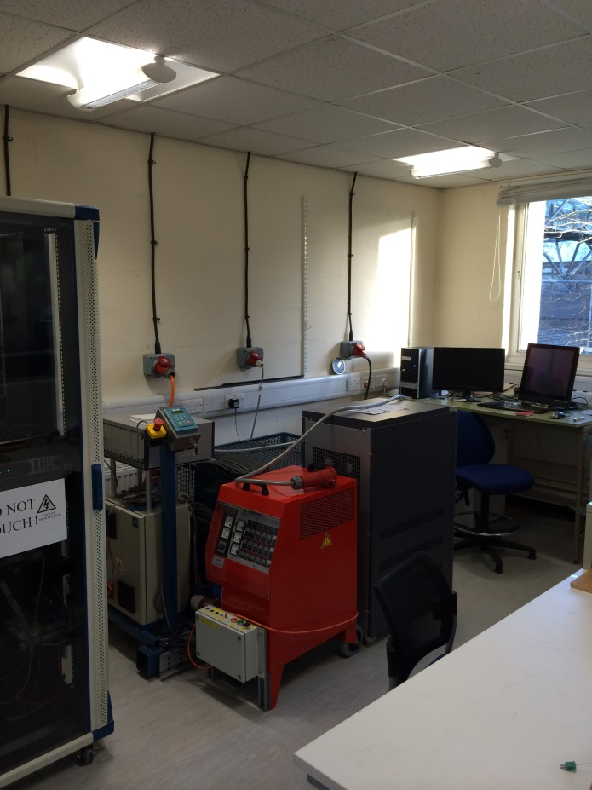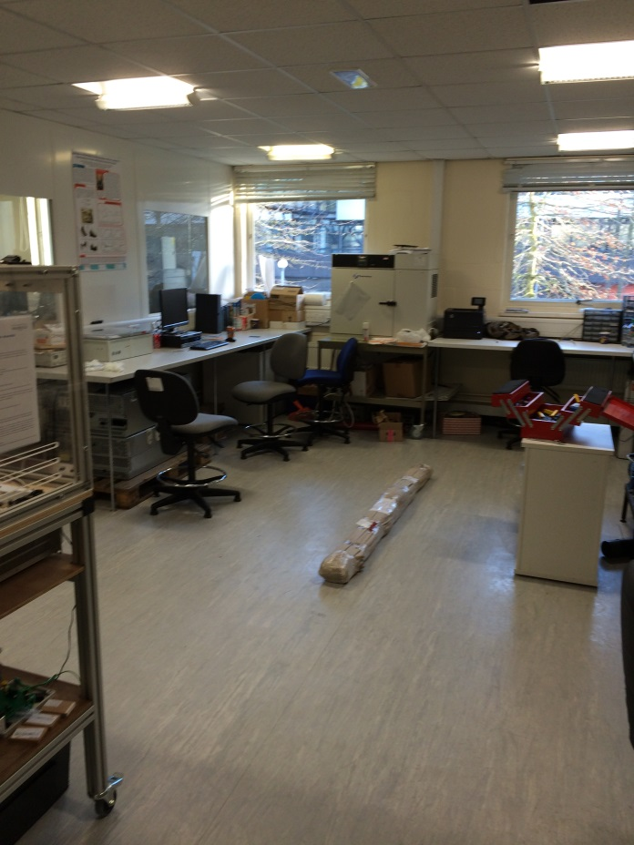
Points to consider
Need to confirm status of Gas alarm on the wall. Need to ensure suitable and in date safe systems of work and risk assessments are available in the area.
A lot of projects in various states of condition within the area, again not somewhere (at present) you would be happy to showcase, but with a little work it could be.
New equipment recently installed in clean room. Has a risk assessment been completed for this kit?

