Initial observations from the 2nd Floor research labs tour.
2nd floor areas visited.
F206, A201, A205 A/B/D.
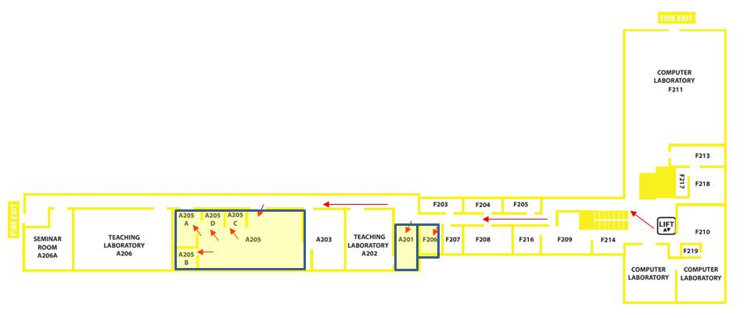
General Observations
F206 – Physiological Signals Measurement Lab (15.03 Sq.m) - Natalia Khovanova
Refurbished last year due to roof leak. Currently being used by Natasha and students.
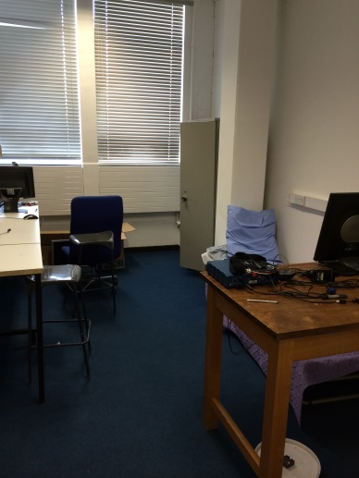
A201 – HIL Simulation & Control Lab - (25.11 Sq.m) Jihong Wang
Area is used and kept in reasonable order.
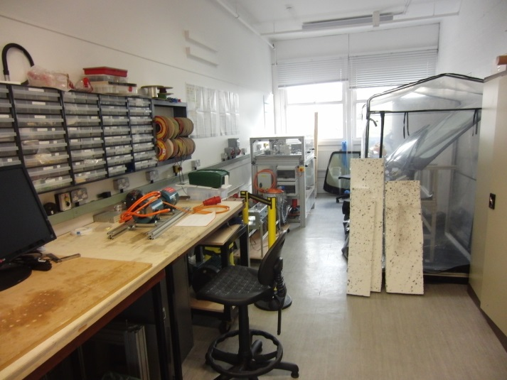
A205 A/B/D – Power & Control Systems Research Lab – Jihong Wang (A205B – Phil Mawby)
A205 = 128.6 Sq.m, A205A = 21.26 Sq.m, A205B = 11.84 Sq.m, A205D = 11.28 Sq.m
Mixture of office and lab space. The labs are used for research and teaching activities (Y3, Y4 and MSc projects).
Areas are kept in reasonable order. SSOW/RA on show.
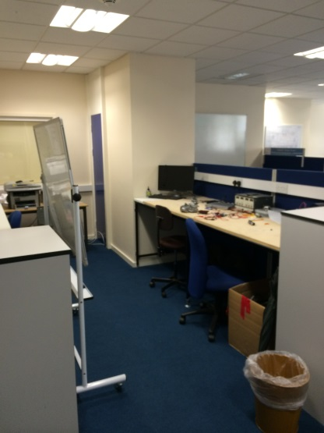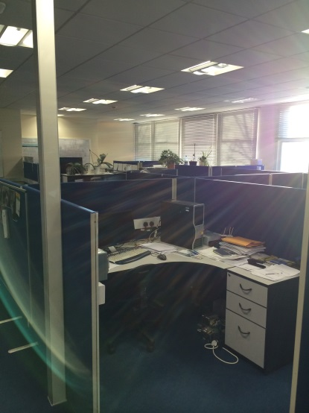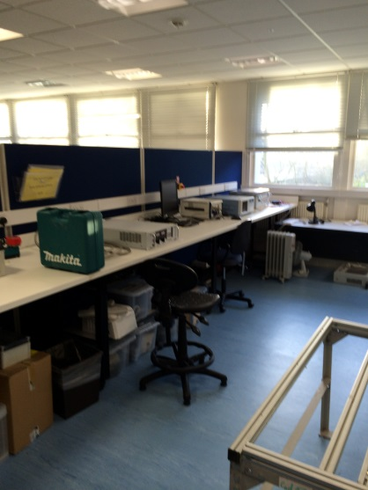
A205 A205 A205
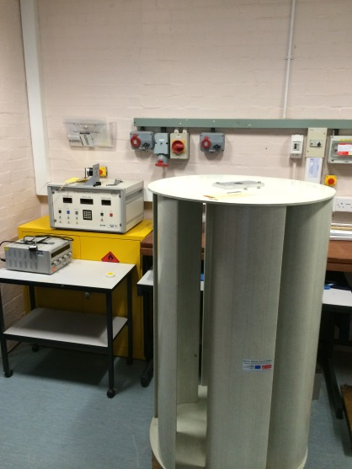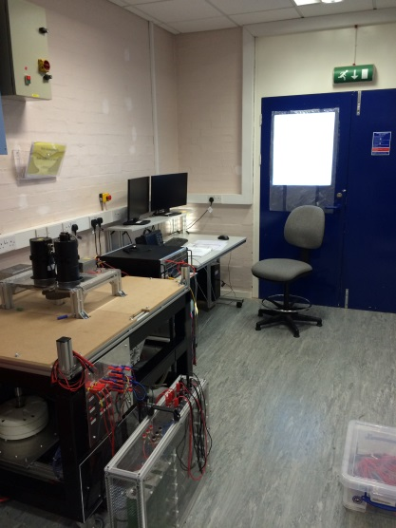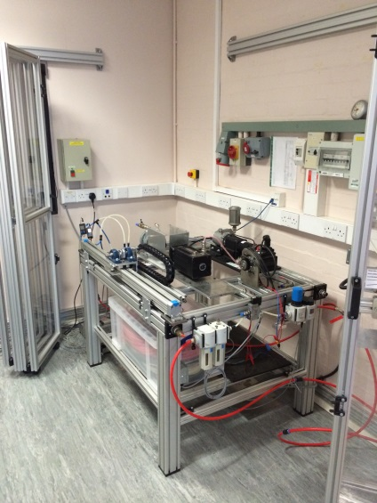
A205D A205A A205A
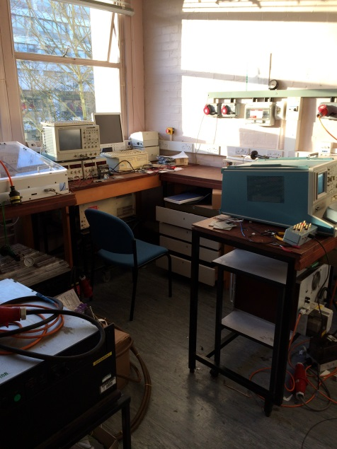
Points to consider
F206 could be moved elsewhere with little effort.
A205 provides good total space with potential for conversion into large teaching area.
Area kept in good order with evidence of SSOW and risk assessments on display.

A205B

