Initial observations from the 4th Floor research labs tour.
4TH floor areas visited.
A408C, A406, F411, F412, F414, F418, F416, F419, F428, F420, F426A/B/C, F429, F423, F422.
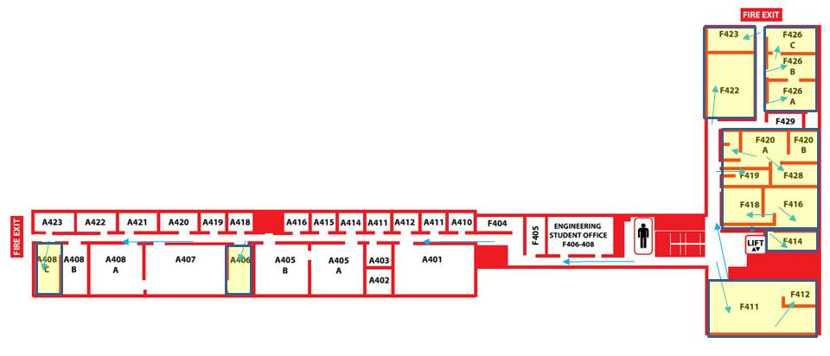
General Observations
A408C – Neural Engineering lab – (23.52 Sq.m) - Christopher James
Currently office and lab space. Lab equipment in the process of being moved down to D002 on the ground floor and will form part of the Brain & Behaviour lab. A408C will then revert to PhD/Post Doc office space.
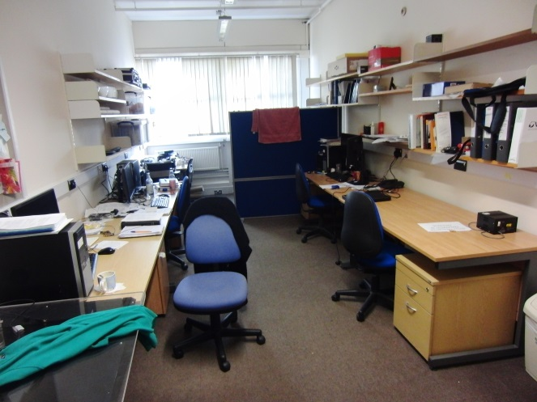
A406 – Multimedia Lab - (24.57 Sq.m) Tardi Tjahadi, Roger Green
Some evidence of lab work being carried out, although no indication by whom and when. Area in need of a tidy up. Mixed lab and Post Doc research space.
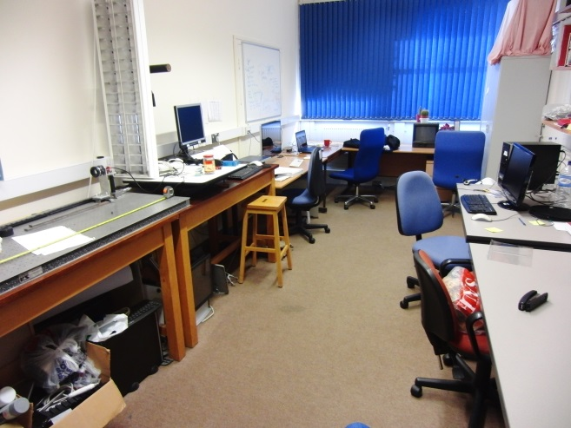

F411 – Comsys Lab – (91.75 Sq.m) - Roger Green ( Mark Leeson, Matthew Higgins, Yunfei Chen)
Mixture of PhD students and lab space. Laser area set up at rear although approved for current use by laser officer existing precautions need to be upgraded depending on future use with illuminated laser warning sign and interlock on door, laser blinds and properly segregated area.
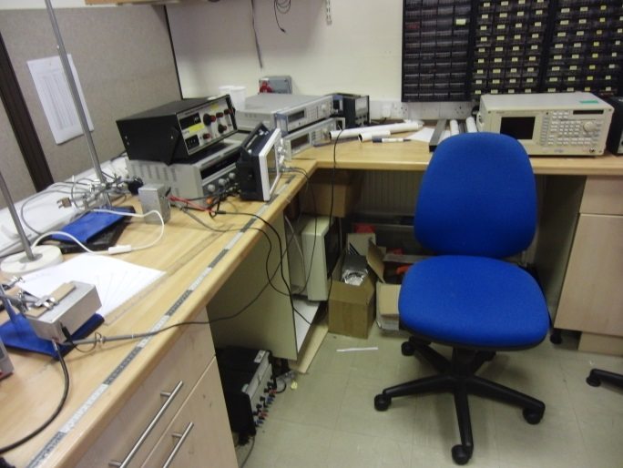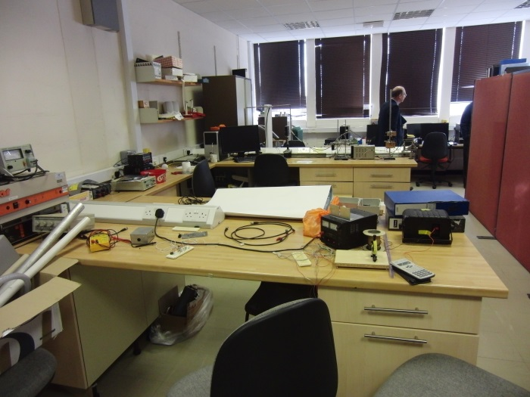
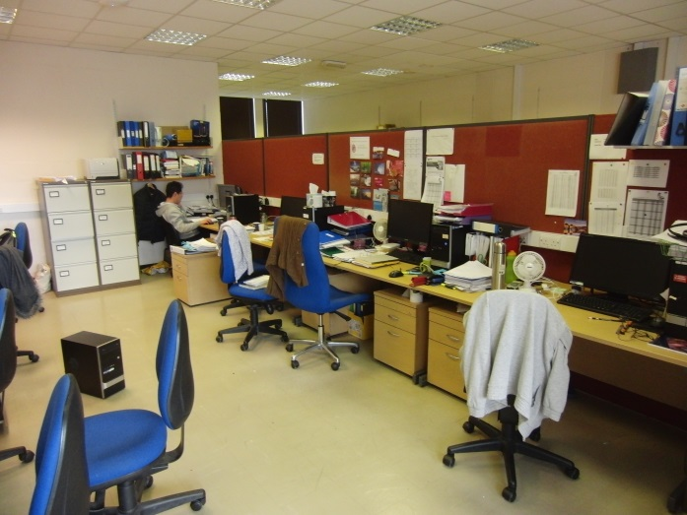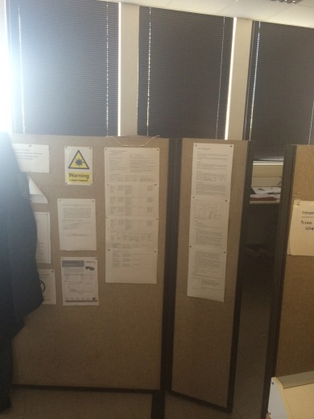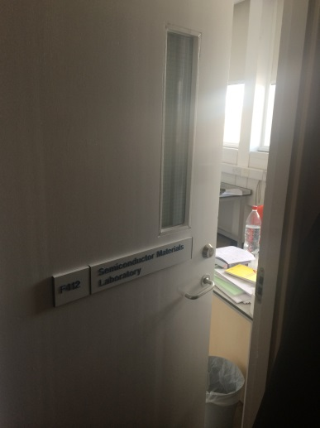
F412 – Semiconductor Materials Lab (14.12 Sq.m) John Murphy
Room at the back of F411. This is in the process of being converted for use by John Murphy. New black out blinds recently fitted for light sensitive work.
F414 – Microsensors & Bioelectric Engineering Lab (18.49Sq.m) Julian Gardner
Electronic and mechanical workshop/office area. Area supports teaching and research.
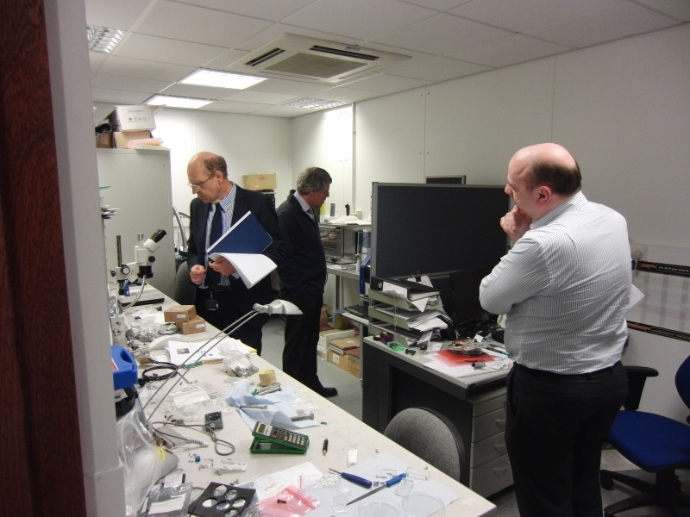

F416 – (F418/018) Microsensors & Bioelectric Engineering Lab (40.38 Sq.m) Julian Gardner
Main lab area with access to F414 & F418. Includes fume cupboard and extract for F428 (F416/026) and eye wash facility. Used for things like sensor testing. Area kept in good order. Used for research and teaching.
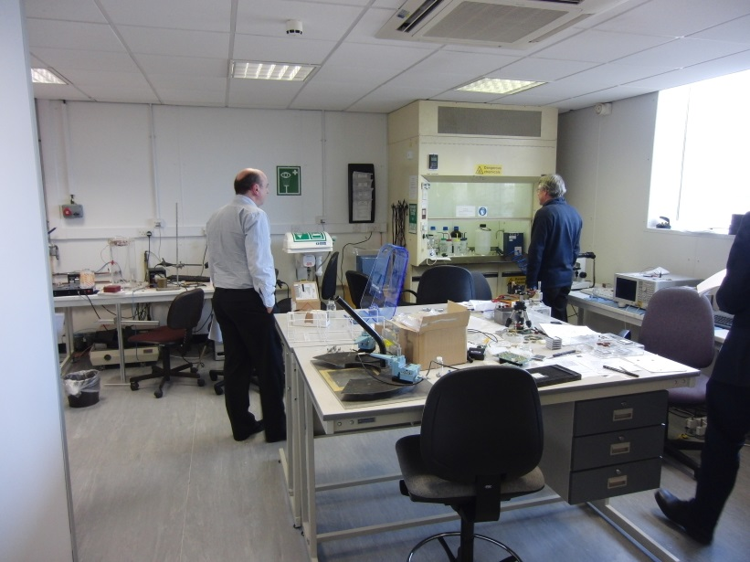
F418 - (F428/019) Microsensors & Bioelectric Engineering Lab (28.59 Sq.m) Julian Gardner
Clean room facility, used for rapid prototyping and inspection work. Used for research and teaching.
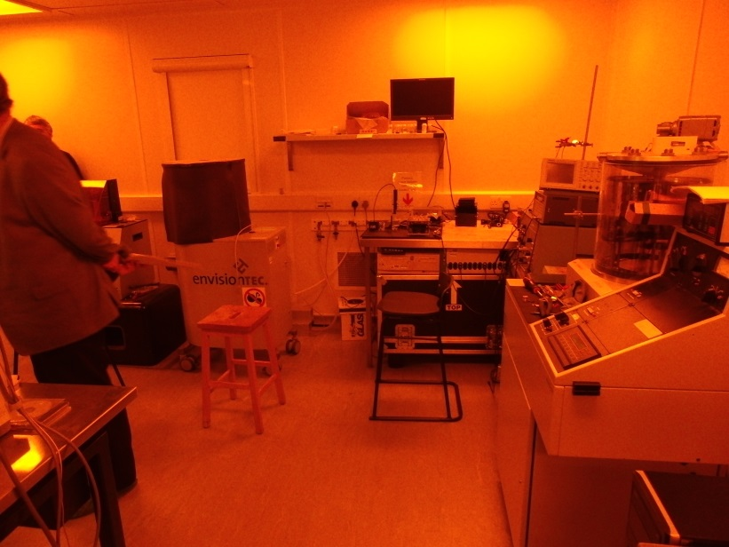
F419 – Gas Supply & Control room (13.92 Sq.m)
Area in the process of being tidied up.
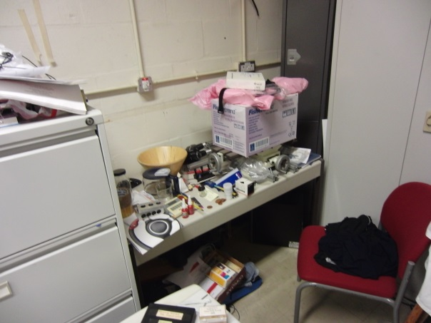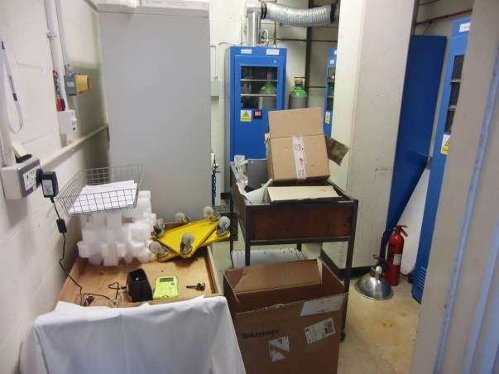
F420 – Microsensors and Bioelectric Engineering Lab (33.31 Sq.m) Julian Gardner
Area used for research and teaching. Lab space mixed with PhD and Post Doc office area. Also houses the anechoic rooms (035/036 – 10.99 Sq.m).
Drinking facility next to soldering/rework area.
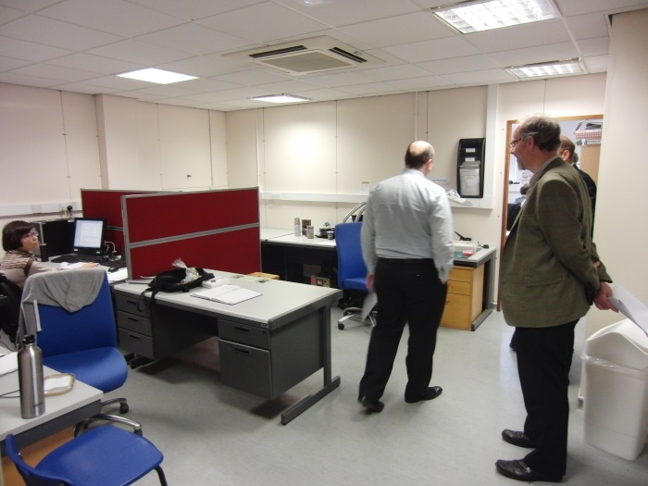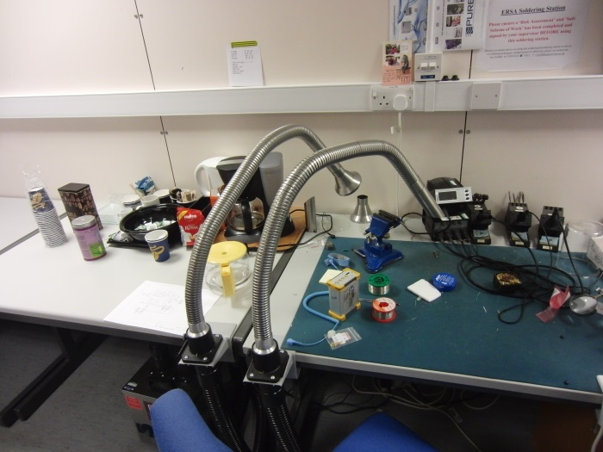
F420B – Office area (17.06 Sq.m)
F428 Microsensors and Bioelectric Engineering Lab (F416/026) - (20.77 Sq.m)
Used for teaching and research. Area kept in good order.
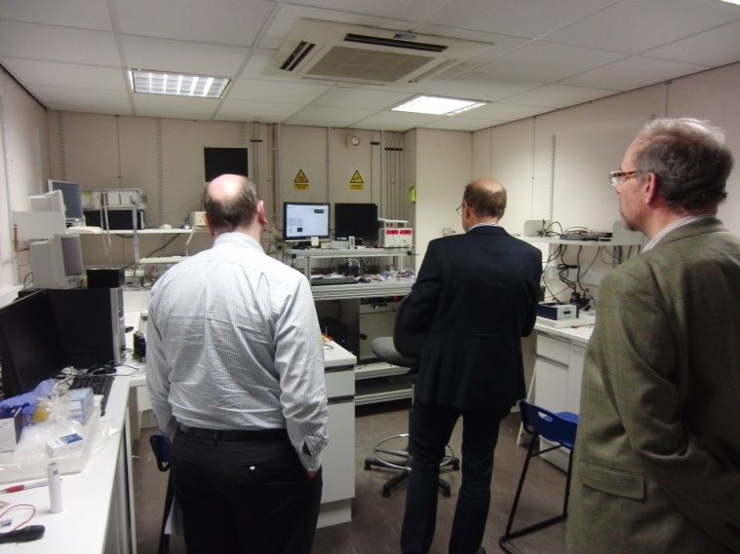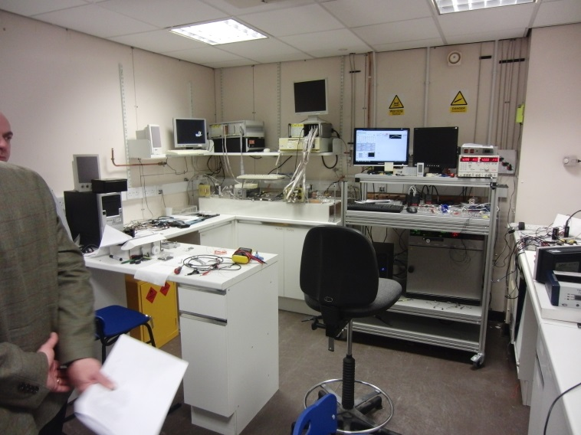
F426 A/B/C - Microsensors and Bioelectric Engineering Lab (30.14 Sq.m) Simon Leigh
Used for both research and teaching. Areas in need of some work, tidy up has started by Simon.
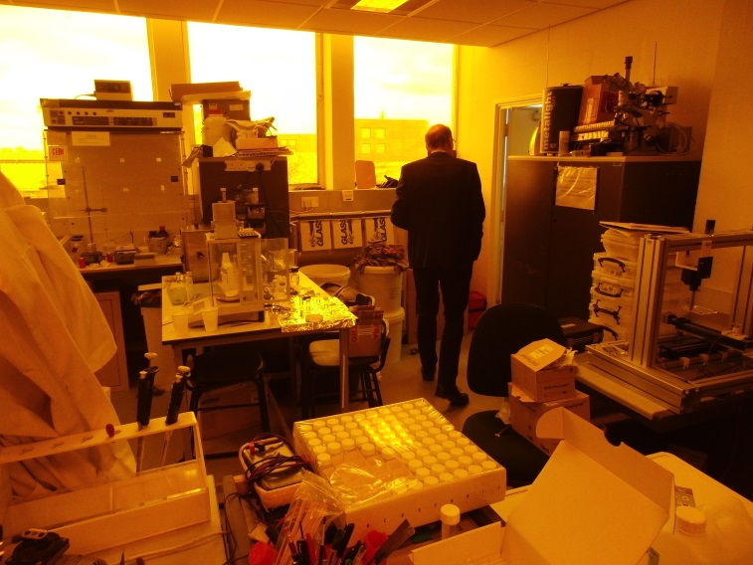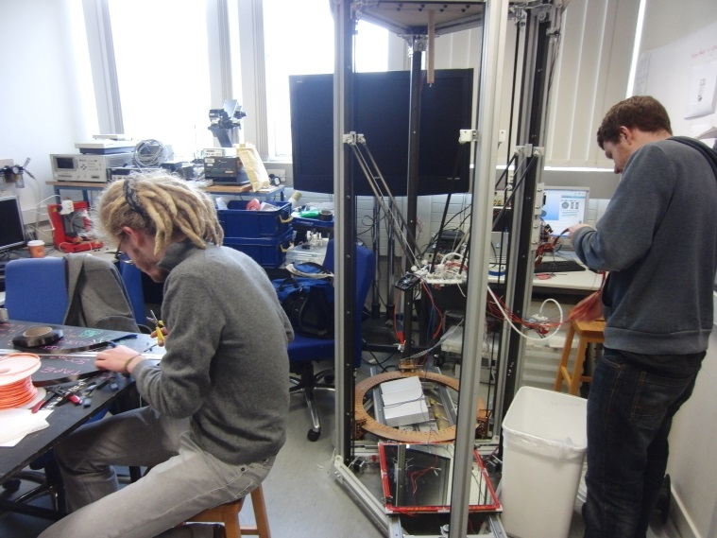
F420 A = 30.14 Sq.m, F20 B = 24.11 Sq.m, F420 C = 23.25 Sq.m
Additional help required to improve the layout and facility. Requests raised with technicians to assist with improvements.
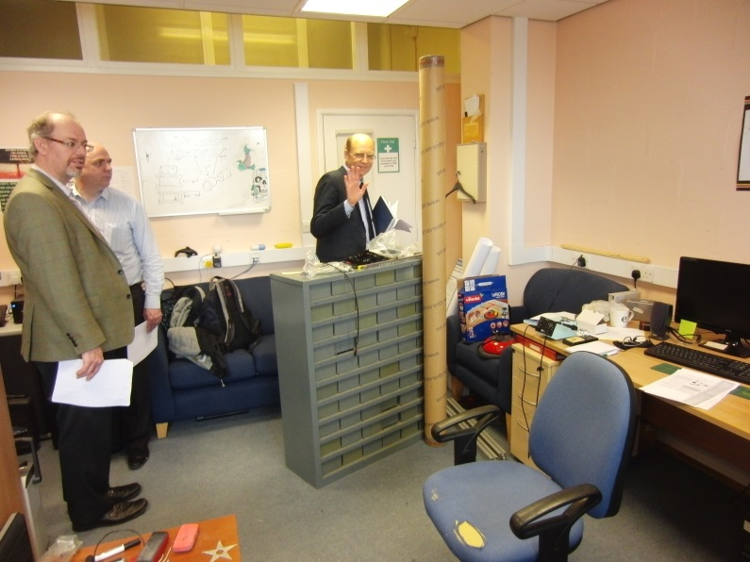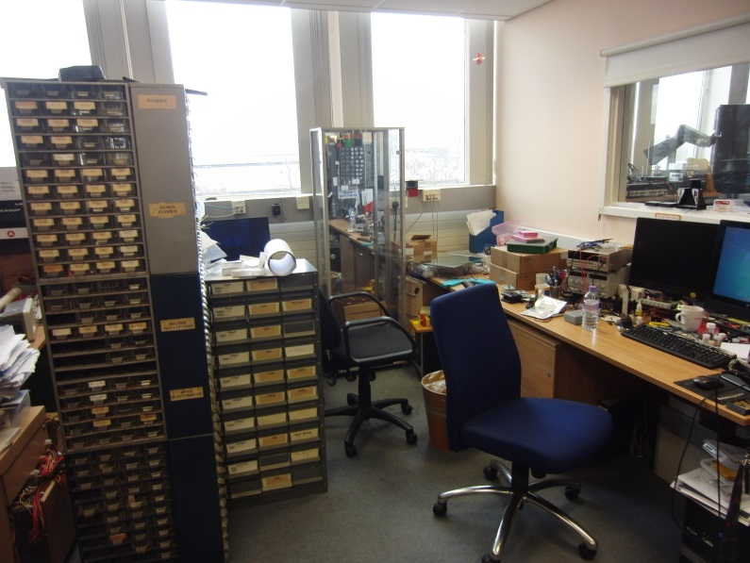
F423 – Ultrasonics Research Lab (21.65 Sq.m) - Dave Hutchins, Duncan Bilson
Area in a bit of a sorry state and in need of a tidy up. Leaking roof has been reported (& allegedly fixed).
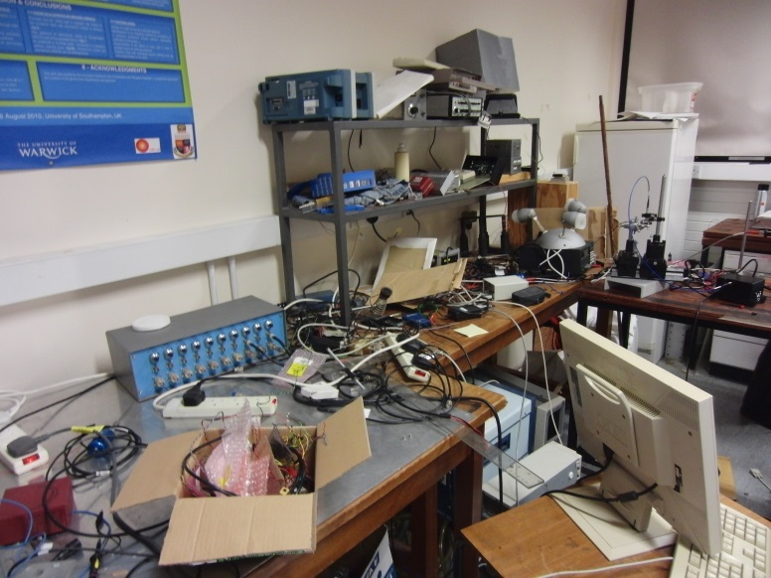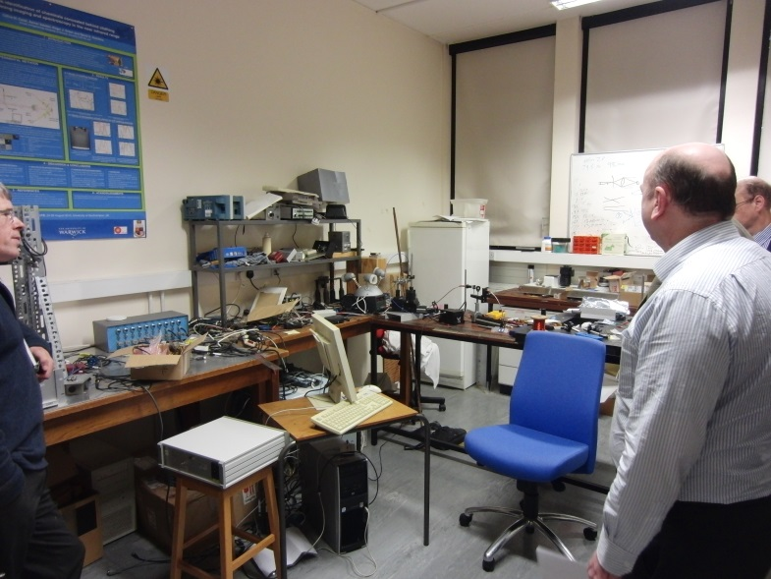

F422 – Ultrasonics Research Lab (57.75 Sq.m) - Dave Hutchins, Duncan Bilson
Good sized room in need of a tidy up/clear out. Area was being utilised by students.
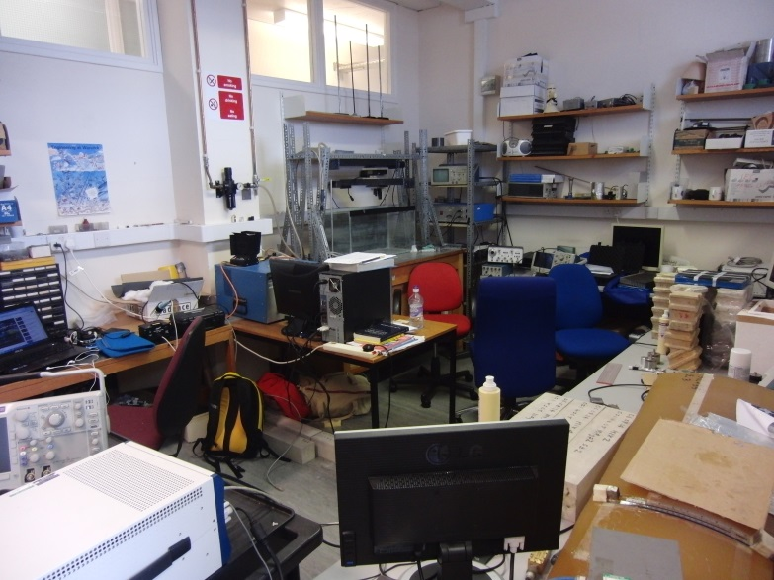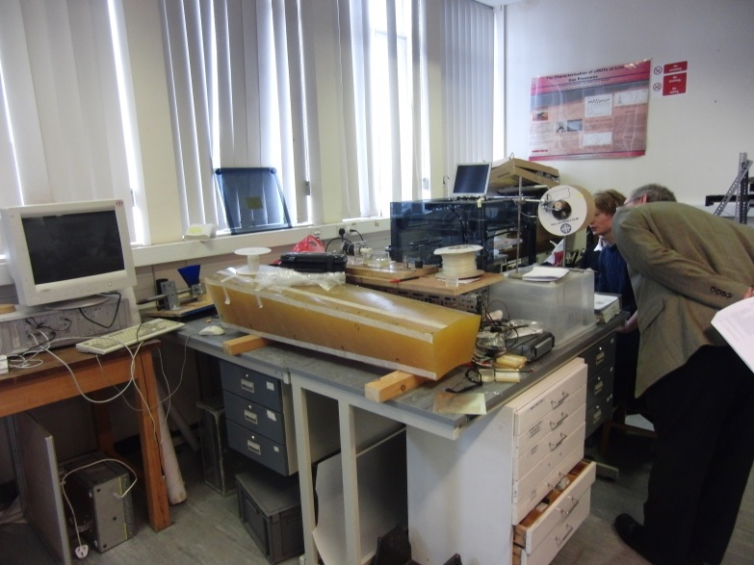
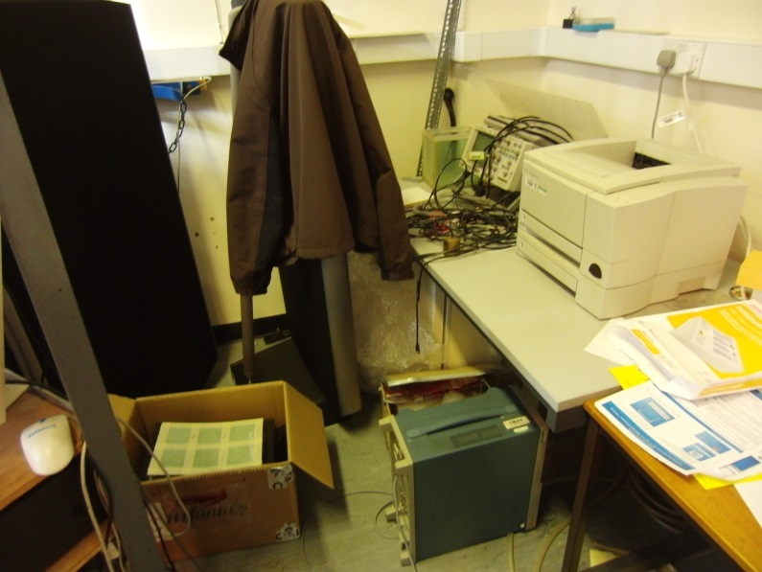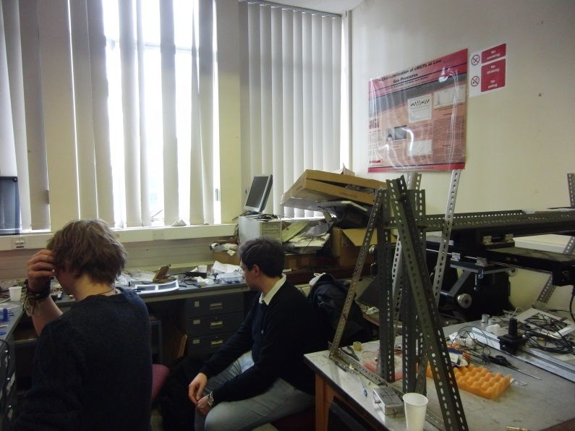

Points to consider
Although much tidier than the ground floor research areas, there was still room for improvement in most locations. Very few rooms were somewhere you could gladly showcase the work being undertaken.
Need to review the existing utilisation of space and what work is actually being undertaken, little evidence in some areas as to what was being done. Need to identify what research is actually being carried out, the revenue generated and interest/relevance of that research.
A lot of the areas were multifunctional being used for research, teaching and office space.
Some areas had SSOW/RA on show, having said that, most of these were out of date and needed reviewing.

