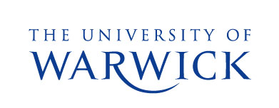
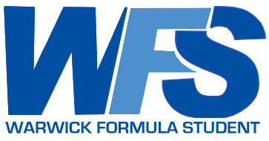
PRESS RELEASE

University of Warwick Formula Student Team visits local primary school
30th April 2008
Last Wednesday (23rd April) the University of Warwick Formula Student team (WFS) visited Priors Field Primary School in Kenilworth with their award-winning racing car, and took it for a spin around the playground to introduce the pupils to the exciting world of engineering.
The team of twelve engineering students from the University is taking part in a high profile project to design, assemble and test a prototype single-seater racing car which will be taken to compete at an international competition at Silverstone in July, just days after the annual Formula 1 race is held there.
WFS made the trip to Priors Field to promote the subject of engineering amongst some of the areas youngest pupils. Commenting on the day, WFS Project Manager Rich Emmett explained, “The team take great pleasure in showing off last year’s car, and look forward to having the opportunity to present the latest car, the ‘W7’ which is currently in the assembly phase.”
Speaking at the University, Academic Project Supervisor Dr Steve Maggs said, “The pupils watched a brief presentation as part of their assembly and then got a chance to see the car in the playground. They all seemed to be impressed with the car, and asked some interesting and challenging questions to the team. It’s amazing how much some pupils know about the workings of the car and even the engine, at such a young age.” The team has a connection with the Royal Academy of Engineering which supports the team recognising the high profile nature of the project and its ability to attract attention from young people with an interest in technology.
Warwick Formula Student already has strong connections with Kenilworth, with Kenilworth Vehicle Rental (KVR), one of team’s primary sponsors, providing transport to the team.
The team will also be visiting a secondary school in Coventry in June to promote some of the engineering schemes available to young people through the Royal Academy of Engineering’s Best Programme.

Editorial Information
- Print quality images available online at: http://www2.warwick.ac.uk/fac/sci/eng/meng/formulastudent/news/press/300408_1/ Please credit photography to William Jones. For non media use, please seek permission from WFS before use.
- The WFS team is funded mostly through sponsorship of supporting companies, without whom the project would not be able to function.
- The award-winning Warwick Formula Student official website contains full details on this year’s project: http://formulastudent.warwick.ac.uk
- Full details of the Royal Academy of Engineering Best Programme can be found at http://www.raeng.org.uk/education/best.htm

For further information contact:
Matt Skidmore  Sponsorship Manager  University of Warwick Formula Student Team  skidmore@formulastudent.warwick.ac.uk  07734 206 498 | Dr Steve Maggs  Senior Teaching Fellow (Project Supervisor)  University of Warwick  steve.maggs@warwick.ac.uk  024 7657 2531

