Fusing BDNF with EGFP for imaging

Introduction:
The function of BDNF is ambivalent, due to its isoforms [1]. These comprise of the pre-region, pro-domain and mature-domain (figure 1). These domains are separated in routine as part of post-translational cleaving in the soma – we’ll be focusing on all subdomains bar the pre-region, which is broken down and recycled with no reported impact on cell function.

The remaining subdomains are known to signal pathways both apoptotic and anti-apoptotic, hence being able to image the uptake and translocation of the different domains is of interest to model its signalling. To distinguish between the isoforms, the pro- and mature-domains need to be tagged separately.
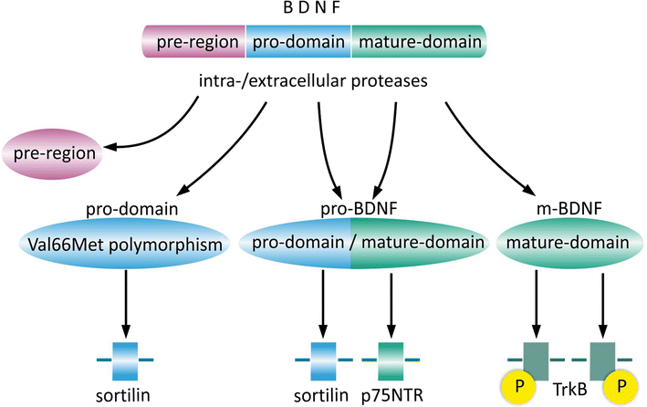
Figure 1: whole BDNF protein with its subdomains labelled and corresponding membrane receptors with which the isoforms interacts with, taken from [1].
Method:
LUHMES cell line was firstly used to isolate BDNF mRNA, which was then reversed transcribed to create BDNF cDNA (Figure 2A). This was then ligated onto an AddGene N1 EGFP plasmid (tagging at its N-terminus mature domain) (figure 2 B-C) [2] and transfected into TOP10 E. coli cells [3].
Figure 2: Gene maps of vector ligation of BDNF gene (A) into pEGFP-N1 vector (B), to form the ligated vector complex of BDNF tagged with EGFP at its n-terminus in (C).
  - Bibliography
[1] https://link.springer.com/article/10.1007/s10571-017-0510-4
[2] https://www.addgene.org/vector-database/2491/
[3] https://www.thermofisher.com/order/catalog/product/C404010

