Electronic Handling of Student Work March 2015
Q What electronic tools can I use to access student assessments for marking?
A Students’ exam scripts / marks /comments on performance have been classified by the University as ‘Restricted’ information. Please refer to University guidance on information classes at :
http://www2.warwick.ac.uk/services/gov/informationsecurity/handling/classifications .

N.B., the table below highlights alternate student information which may be categorized as ‘Reserved’, the highest classification.

Table 1 - Classification types
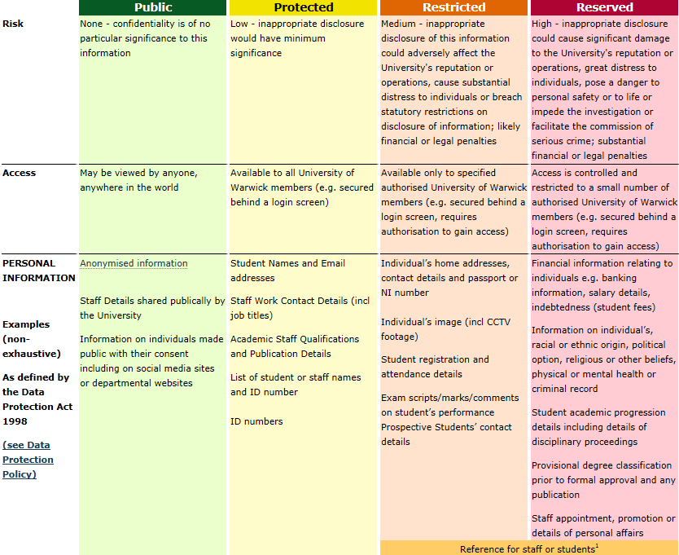
The manner in which information in each class can be handled differs from class to class. The University offers guidance on how to best handle such information electronically at : http://www2.warwick.ac.uk/services/gov/informationsecurity/handling/electronic/ ;
and in paper form at :
http://www2.warwick.ac.uk/services/gov/informationsecurity/handling/paper/ .
Examples
- According to the guidance, the University expects that student work only be transmitted by e-mail to internal Warwick University domains (e.g., @warwick.ac.uk). N.B., Take care when entering e-mail addresses.
- Files can be shard via Teambuilder / Files.Warick.ac.uk.
- Files can be shared via One Drive @University of Warwick but only to @warwick.ac.uk addresses (or other internal domains). Also, One Drive IS NOT BACKED-UP!

Tables 2 and 3 are reproduced from the guidance webpages and shows many of the options for data transfer with respect to different security classifications.
Table 2 - Options for electronic data transfer wrt classification
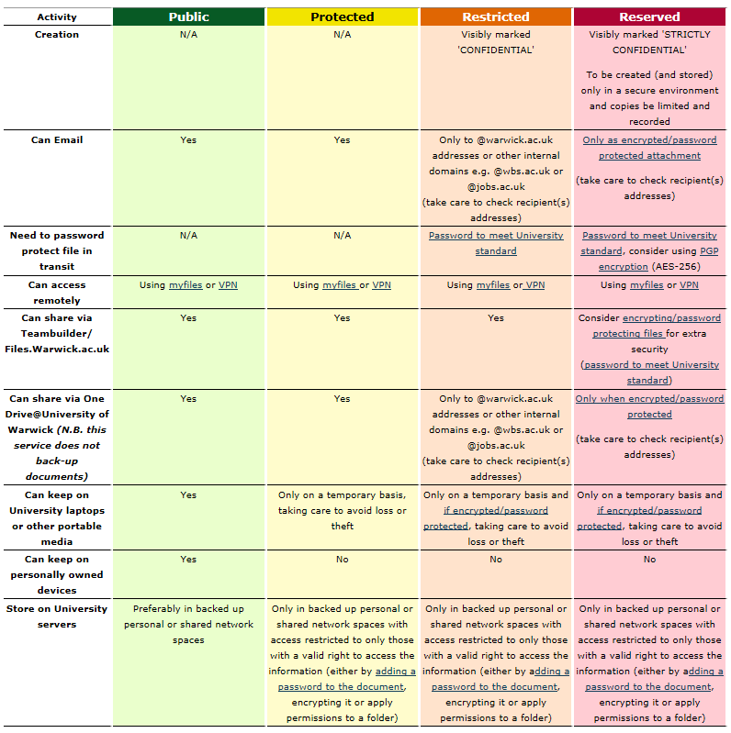
Table 3 - Options for hardcopy data transfer
