Technical Report
The Virtual Lung Disease Management Research Group
2011

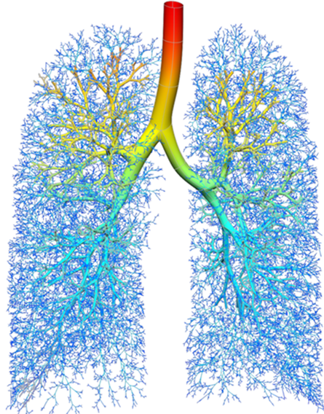
Contents
Introduction 4
Lung Performance Methods (Page 5) 4
Lung Anatomy (Pages 9-11) 4
Medical Imaging techniques 6
Generating a Valid Airway Geometry Model in 1D modelling (pages 16-17) 6
Hagen – Poiseuille Equation Method (Pages 18-19) 7
1D Navier Stokes Equation model (Pages 19-20) 8
Derivation of the Hagen-Poiseuille Equation (Pages 22-25) 9
Numerical Solution for 1D Simulation for Velocity and Pressure (Pages 26-27) 13
Crank-Nicolson Method (pages 27-31) 14
LU decomposition (Pages 31-34) 17
Gauss Seidel Iteration (Pages 34-35) 19
Forward Euler (pages 36-37) 20
Laminar or Turbulent? (Pages 41-43) 21
STL editing 23
Mesh Generation (Pages 55-57) 23
Numerical Methods (Pages 57-59) 26
RANS and URANS - (Unsteady) Reynolds Averaged Navier-Stokes 26
k-ε 26
Spalart-Allmaras (SA) 26
LES – Large Eddy Simulation 27
DES – Detached Eddy Simulation 27
Validating the Model (Pages 61-65) 27
Results 31
1D Simulation (Page 66) 32
Initial Testing and Validation of Model 32
Geometry Parameters 32
Figure 29. Geometry Parameters 32
Simulation Parameters 32
Results 33
Discussion of Results (Page 69) 34
Limitations of the Model (Page 71) 36

Figures
Figure 1- Anatomy of the Upper airway - image taken from (Lin, Tawhai, McLennan, & Hoffmann, 2009) and range of airways in lung (Weibel, Sapoval, & Filoche, 2005) 5
Figure 2 – Parcel of fluid in a pipe 10
Figure 3 – Mesh Grid of airway as straight tube 13
Figure 4 - Mesh Grid of Airway with Bifurcation 14
Figure 5 - Unsteady laminar Simulation 22
Figure 19- Structure of Polyhedral mesh (left) and tetrahedral mesh (right) 24
Figure 20 – Prism Layer Mesh 25
Figure 21- a) Mesh Resolution in the trachea b) mesh resolution in the bronchiole 25
Figure 25- Plot of CPU time and mass flow rate against number of mesh elements 28
Figure 26- Pressure and velocity streamline plot for Inspiration geometry in Star CCM+ 30
Figure 27 - Pressure and streamline velocity magnitude plot run using Fluent code courtesy of J. W. De Backer 30
Figure 28 - Residual Error Plot for Validation Exercise 31

Graphs
No table of figures entries found.

1.0 Introduction

The purpose of this report is to combine all of the elements of the project which are of a technical nature, and is to be used as a point of reference from the main report.

Lung Performance Methods (Page 5)

Spirometry - This test can give an accurate graph of the Lung volume and flow rate against time but cannot give details of the flow characteristics within the lung.
Particle Image Velocimetry (PIV) – A technique by which laser light is scattered by the airborne particles inside the lung airways, and an image of the positions of the particles within the flow can be taken.
Gamma Scintigraphy – Technique where by the transit of a dosage form through its intended site of delivery can be non-invasively imaged in vivo via the judicious introduction of an appropriate short lived gamma emitting radioisotope.
Acoustic Doppler Velocimetry (ADV) - A similar technique to PIV, but instead uses ultrasonic pulses to map the position of suspended particles in a flow, using ultrasound.

Lung Anatomy (Pages 9-11)

Figure 1 shows the anatomy of the upper airway, the horizontal section at the top of the figure is the mouth piece, there is a nasal airway above this which is not included in this figure. Below the mouth we have the pharynx which is separated in to three main areas, two are shown in the diagram, the laryngopharynx is where the airway joins the oesophagus. At the top of the trachea is the larynx where the vocal cords are found. The trachea then extends about 10cm (McGowan, Jeffries, & Turley, 2003) where it splits into a high number of smaller airways that form the lower respiratory tract.

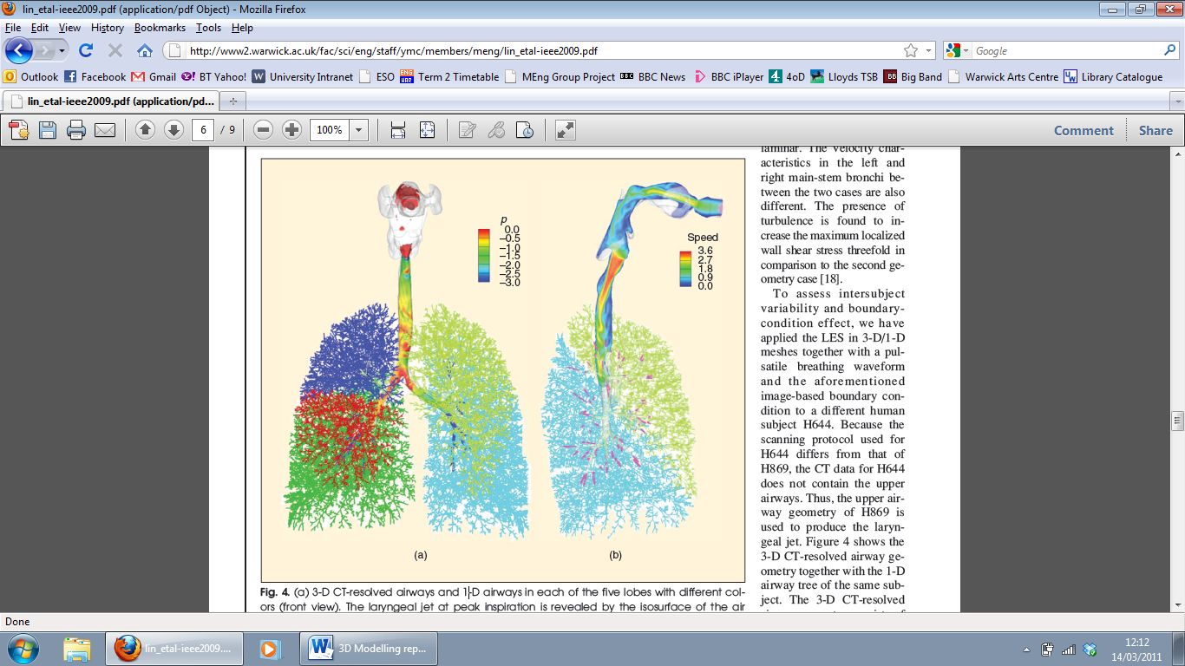
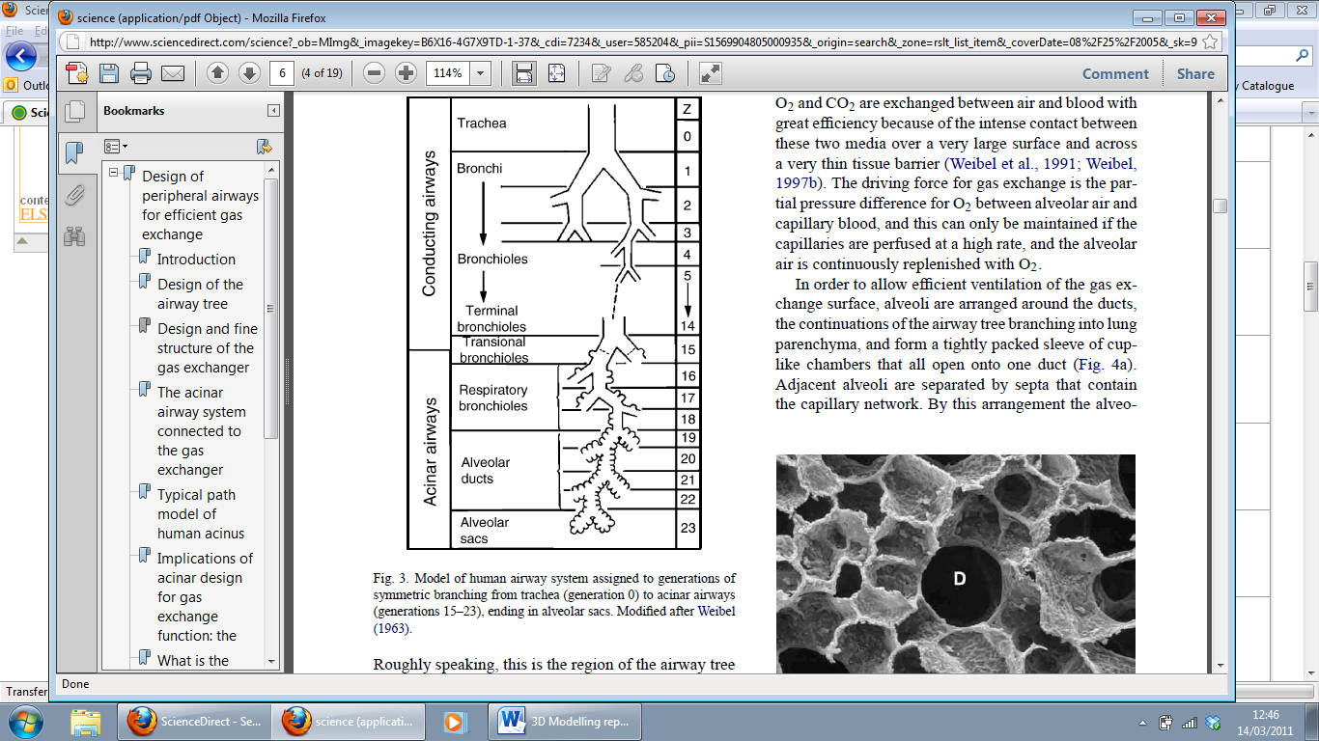
Trachea
Larynx
Laryngopharynx
Epiglottis
Tongue
Oropharynx
Figure 1- Anatomy of the Upper airway - image taken from (Lin, Tawhai, McLennan, & Hoffmann, 2009) and range of airways in lung (Weibel, Sapoval, & Filoche, 2005)
The airway incorporates a range of different size tubes, the names of the tubes and the generation number they can be found at are shown in Figure 1. The generation numbers are for each time the airway bifurcates i.e. the main bronchi are generation 1.
During inspiration (breathing in) the diaphragm, which is the domed, thin sheet of muscle attached below the ribs, contracts causing a downward movement of the muscle. This movement can be as much as 10cm during heavy exercise or 1cm during normal resting breathing (West, 2001). This results in the vertical dimension of the chest cavity to be increase. At the same time the intercostal muscles, the muscles between the ribs, contract causing the ribs to move upward and forward increasing the lateral dimension of the chest. This movement causes the intrathoracic pressure, pressure within the chest cavity, to fall. This process is reversed for expiration (breathing out).
The lungs are filled with tiny alveolar sacs, the number of them is in the order of $2^{23}=8388608$, and as such they provide most of the lung volume and surface area. The alveoli are surrounded by a membrane that can expand and contract with the change of pressure, they can be considered as a party balloon. As the intrathoracic pressure drops the alveoli expand to fill the space and as such a pressure drop occurs within, this pressure drop is below atmospheric pressure and so drives the flow through the conducting airways to the alveoli level.

Medical Imaging techniques
There are several imaging techniques available which can create images of the inner workings of the human body, to a relatively good degree of accuracy. The most common method of medical imaging technique for producing accurate images of the lungs is Computational Tomography (CT) scanning. This involves a rotating x-ray device which uses an array of ionising radiation and a detector to takes slices of the human body part being examined. These slices are used together to form an image of the inner workings of the body. Typically about 1000 slices are taken and used to form the image.
Magnetic Resonance Imaging (MRI) is another common imaging method. It involves the use of a magnetic field created by an electromagnet with radio waves to produce images of body tissue, muscles and organs. The magnetic field aligns particles inside the body, and when radio wave pulses are fired at the body, the particles emit a certain amount of energy which is picked up by a receiver. This is one of the few imaging methods which does not involve the use of ionising radiation (X-rays).
Another imaging method is Dual Energy X-ray absorptiometry, or DEXA imaging. This is used specifically to measure the structure of bones within the human body. It creates images by using low energy x-rays, which are received by a receiver. The signal received corresponds to the density of the bone structure being measured.
Digital Subtraction Angiography (DSA) has an application mainly for measuring blood vessels and body parts associated with blood flow. A dye is injected into the patient to allow blood flow to be recognised more easily by the x-rays that are used to form the image. The results are then sent to a computer for analysis.
Ultrasound imaging uses a transducive device which sends sound waves into human tissue. The frequency of the sound waves are dependent upon the tissue being analysed. Certain frequencies of sound wave are reflected back and received by a certain bodily material, so therefore using a wide spectrum of frequencies will allow for an image to be formed based upon the time it takes for sound waves of certain frequencies to be reflected back from these materials.

Generating a Valid Airway Geometry Model in 1D modelling (pages 16-17)

The method for simulating lung geometry uses a fractal bifurcation model in which a single stem airway splits by dichotomy into child airways which each subsequently split further for a specified number of generations. Two variations of Weibel’s Symmetric Model (1) are used to define simplified models of the bronchial anatomy, these simplifications allow calculation of the flow velocity and pressures throughout the system using numerical methods. The structure of the geometry will be described by a series of 1D centre lines distributed in 3D space similar to that used by Lin et al (2). The simpler of these models defines the splitting of each parent branch into two identical and symmetric child branches the dimensions of which are specified by a constant reduction factor relating to the parent branch. The orientation of each child branch is rotated by a constant angle about an axis perpendicular to the plane of the parent branch and subsequently by a constant angle axially about parent branch. This series of rotations improve the space filling properties of the geometry by creating a three dimensional geometry in which each downstream branch is in a different plane to its parent. The dimensions of each element of an abridged section of the airway are shown in Table 1. The schematic arrangement of this section of the airway is shown in Figure 1. The more complex of the geometric models is a modification of Weibel’s model which incorporates asymmetric bifurcation of the child branches following the parameters described by Liu et al in their 2003 study (3). In this asymmetric model each parent branch splits into two child branches of differing dimensions. The dimensions of one child branch correspond to a reduction defined by one generation higher than the parent whilst the dimensions of the other correspond to a reduction of three generations higher than the parent. The orientation of the child branches are rotated in a similar fashion to that used in the simpler model however the angle of rotation is determined by a random number generated following a Gaussian distribution. The mean and standard variation of this Gaussian distribution are defined in order to simulate the natural morphological irregularities present in the bronchial anatomy (5). The dimensions of an abridged section of the airway are shown in Table 2. the schematic arrangement of this section of the airway is shown in Figure 2. Both of the geometric models are numbered using the method used by Weibel starting with the stem branch as the first generation and all distal branches numbered as higher generations from the stem.

Hagen – Poiseuille Equation Method (Pages 18-19)

Between methods 1) and 2), the Hagen –Poiseuille Equation model is the most simple and least computer power demanding, but is also the less accurate of the two. The equation assumes that:
- The bronchioles are simulated as long cylindrical pipes
- Flow within the bronchioles are laminar viscous and incompressible
- There are no losses at the bifurcation due to distortion of the flow provide as it splits between the two consecutive bronchioles
Equation 1
$$∆P= \frac{8μL}{πr^{4}} Q$$
Equation 2
$$U_{m}= \frac{Q}{πr^{4}}$$
Equation 3
$$R= \frac{8μL}{πr^{4}}$$
Using the Hagen-Poiseuille Equation, we are able to derive an expression for resistance of the fluid, $Res$, which should not be confused with resistance force or frictional forces in the bronchiole. The resistance of the fluid is then used to calculate the overall resistance of the bronchiole tree for any number of dimensions for either a symmetrical or an asymmetrical model as done by B. Mauroy et al (2004).The equations used by B. Mauroy are as follows:
Symmetrical Model
Equation 4
$$R_{N}= R_{0}\left[1+ \sum_{p=1}^{N}{\frac{1}{2p}{\left(\frac{1}{h^{3}}\right)}^{p}}\right]$$
Asymmetrical Model
Equation 5
$$R_{N}= R_{0}\left[1+ \sum_{P=1}^{N}{\left(\frac{1}{h_{1}^{3}+h_{2}^{3}}\right)}\right]$$

1D Navier Stokes Equation model (Pages 19-20)
This model is formed by the application of three equations which are used by (reference)
- Equation of Motion (derived from 1-D Navier Stokes)
Equation 6
$$\frac{∂u_{i}}{∂t}+ u_{i}\frac{∂u_{i}}{∂x}+ \frac{1}{ρ}\frac{dp_{i}}{dx}+ \frac{8ν}{r_{i}^{2}}+ F_{i}=0$$
- Equation of Continuity
Equation 7
$$\frac{dr_{i}}{dt}+ u_{i}\frac{dr_{i}}{dx}+\frac{r_{i}}{2}\frac{∂u_{i}}{∂x}=0$$

- Equation of Airway Wall
Equation 8
$$\frac{d^{2}r_{i}}{dt^{2}}= \frac{1}{m_{i}}\left[2πr_{i}∆p_{i}+ \frac{\overline{r_{i}}- r_{i}}{α_{i}}- β_{i}\frac{dr_{i}}{dt}\right]$$

Using the above Equation 6 and Equation 7, we are able to calculate the average flow velocity and change in pressure at any desired location of the lungs with the change of time. Equation 9 simulates a relative accurate approximation of the behaviour of the expansions and contractions of the airways during a breathing cycle. Together, the three equations are able to simulate and approximate the velocity of the flow and change of pressure in a lung geometry exhibiting similar behaviour to an actual breathing lung model.
Similar to the Hagen-Poiseuille equation model used in this study, the 1D Navier Stokes equation model adopts the same assumptions, but takes in account loses caused by the distortion of the air flow profile as it crosses the bifurcation area. Similar versions of the 1D Navier Stokes method have been used extensively in other studies as can be seen in () and ().
Lung Parenchymal Model (pages 20-21)
Due to the important role and the effects of the alveoli on the behaviour of the air flow and pressure changes in the bronchioles, a lung parenchymal model is applied. A 1D model has been chosen over several other 3D models due to the simplicity. As opposed to 3D models which are highly complex and require high processor computational power to solve.
The lung parenchymal model is formed from the following equations:
- Alveolar Pressure Equation
Equation 9
$$ρ_{al}= ρ_{pl}+ σ_{e}+ σ_{s}$$
- Equation of Elastic Term
Equation 10
$$σ_{e}= \frac{2c}{λ}\left(a_{1}+a_{3}\right)Eexp\left[2\left(a_{1}+a_{3}\right)E^{2}\right]$$
- Equation of Surface Tension
Equation 11
$$σ_{s}= \frac{4γ}{λ∆}$$
This model has been acquired from () and is assume to be relatively accurate approximation of the behaviour in the alveoli. Further studies on the characteristics of the alveoli are required to create a more accurate model.

Derivation of the Hagen-Poiseuille Equation (Pages 22-25)
$$τ$$
$$P$$

$$R$$
$$δx$$
$P+δP$

Figure 2 – Parcel of fluid in a pipe
Assume a parcel of fluid in a pipe shaped like a cylinder as seen in Figure 2. Assuming that there is no acceleration experienced by the parcel of fluid,
Equation 12
$$Pπr^{2}= \left(P+ δP\right)πr^{2}+ 2πrδxτ$$
Equation 13
$$δPπr^{2}= -2πrδxτ$$
Equation 14
$$τ= \frac{r}{2}\left(\frac{-dP}{dx}\right)$$
We know that
Equation 15
$$τ= μ\frac{du}{dy}= -μ\frac{du}{dr}$$
Combining Equation 15 and Equation 16
Equation 16
$$\frac{du}{dr}= -\frac{1}{2μ}\left(\frac{-dP}{dx}\right)r$$
Applying boundary condition, $u=0$ at $r=R$ and integrating
Equation 17
$$u= \frac{1}{4μ}\left(\frac{-dP}{dx}\right)\left(R^{2}- r^{2}\right)$$
Further integrate around the area to volume rate or flux
Equation 18
$$Φ=Q= \int_{0}^{R}{u\left(r\right)}dA= \int_{0}^{2π}{\int_{0}^{R}{u\left(r\right)rdrdθ}}=2π\int_{0}^{R}{u\left(r\right)dr}$$
Equation 19
$$Q= \frac{πR^{4}}{8μ}\left(\frac{-dP}{dx}\right)$$
Rearrange to suit electricity analogy of relationship of voltage, current and resistance
Equation 20
$$∆P= \frac{8μ∆x}{πR^{4}}Q$$
For consistency of variable presentation R is change to r as R is used later on as a representation of Resistance
Equation 21
$$∆P= \frac{8μ∆x}{πr^{4}}Q$$

Summing of Resistance of Hagen Poiseuille Equation
Symmetrical
The total of all resistance with the ratio change in both length and radius are h
Equation 22
$$\sum{R}= R_{0 }+ R_{1}+…+R_{i}+…+ R_{N}$$
Taking generation 1
Equation 23
$$\frac{1}{R_{1}}= \frac{1}{R_{1L}}+ \frac{1}{R_{1R}}$$
Since it is symmetrical, $R_{1L}$ = $R_{1R}$
Equation 24
$$\frac{1}{R_{1}}= \frac{2}{R_{1L}}$$
Equation 25
$$\frac{1}{R_{1}}= \frac{πr^{4}}{8μ∆x}2\left(\frac{h^{4}}{h}\right)= \frac{πr^{4}}{8μ∆x}2h^{3}$$
Equation 26
$$R_{1}= \frac{8μ∆x}{πr^{4}}\left(\frac{1}{2h^{3}}\right)$$
Taking generation 2
Equation 27
$$R_{2}= \frac{8μ∆x}{πr^{4}}\left(\frac{1}{2^{2}h^{3}h^{3}}\right)$$
A geometric progression can be seen, Thus the sum of R
Equation 28
$$\sum{R}= R_{0}\left(1+ \sum{\frac{1}{{\left(2h^{3}\right)}^{N}}}\right)$$
Where N is the number of generations
Non Symmetrical
The total of all resistance with the ratio change in both length and radius are $h_{1}$ or $h_{2}$
Equation 29
$$\sum{R}= R_{0 }+ R_{1}+…+R_{i}+…+ R_{N}$$
Taking generation 1
Equation 30
$$\frac{1}{R_{1}}= \frac{1}{R_{1L}}+ \frac{1}{R_{1R}}$$
Equation 31
$$\frac{1}{R_{1}}= \frac{1}{R_{0}\frac{1}{h_{1}^{3}}}+ \frac{1}{R_{0}\frac{1}{h_{2}^{3}}}$$
Equation 32
$$R_{1}= R_{0}\left(\frac{1}{h_{1}^{3}}+ \frac{1}{h_{2}^{3}}\right)$$
Generation 2
Equation 33
$$R_{2}= R_{1}\left(\frac{1}{h_{1}^{3}}+ \frac{1}{h_{2}^{3}}\right)= R_{0}{\left(\frac{1}{h_{1}^{3}}+ \frac{1}{h_{2}^{3}}\right)}^{2}$$
The same as the symmetrical version, a geometric progression can be witness, thus the sum is
Equation 34
$$\sum{R}= R_{0}\left[1+ \sum{{\left(\frac{1}{h_{1}^{3}}+ \frac{1}{h_{2}^{3}}\right)}^{N}}\right]$$
Where N is the number of generations

Numerical Solution for 1D Simulation for Velocity and Pressure (Pages 26-27)
Values of velocity and pressure were approximated with the use of the equation of motion, Equation 6 and the equation of continuity, Equation 7. This was done through several steps as seen in Yongmann M. Chung (2010)
- Setting up grid mesh
- Discretisation of variables using Crank-Nicolson method
- Splitting pressure variables using splitting method
- Introducing a pseudo-velocity via LU Decomposition
$$P_{0}$$
$${δx}_{i-1}$$
$${δx}_{i}$$
$${δx}_{i}^{c}$$
$${δx}_{i+1}^{c}$$
$$∆x_{i}$$
$P_{N}$ =
$P_{a}$
$$=$$
$$P_{0}$$

$$P_{0}$$

$$P_{1}$$
$$P_{i-1}$$
$$P_{i}$$
$$P_{i+1}$$
$$P_{N-1}$$
$$u_{1}$$
$$u_{2}$$
$$u_{i-1}$$
$$u_{i}$$
$$u_{i+1}$$
$$u_{i+2}$$
$$u_{N-1}$$
$$u_{N}$$
$$P_{av}$$

Grid Mesh

Missing
Figure 3 – Mesh Grid of airway as straight tube

Figure 4 - Mesh Grid of Airway with Bifurcation
To further simplify the problem the airway is at first assume to possess no bifurcation and is a straight tube as seen in Figure 2. The bifurcation is then introduced later when the simultaneous equations of the numerical problem are derived already thus changing the grid into Figure 3 without making the problem over complex.
As we are interested in the pressure difference across each element in the grid, the pressure is taken at intervals between the elements for velocity. Several different distances are defined for the grid to account for the changes in length of elements at the occurrence of a bifurcation to further increase the accuracy of the simulation as shown in Figure 2 and Figure 3.
In other to take in account of boundary conditions which will be either be provided by the 3D simulation or values acquired through research, an extra cell is allocated which is not dictated by the two governing equations but reacts to their neighbouring cells as seen at the top and bottom of the grid in Figure 2. This is to further ensure that the simulation is stable and the ends of the grid.

Crank-Nicolson Method (pages 27-31)
In other to solve the two governing Equation 6 and Equation 7 for velocity and pressure, it was decided to apply the Crank-Nicolson method. This is because of its simplicity in comparison to other more advance techniques which requires more processing time and computer power also being unconditionally stable, thus reducing the complexity of the problem for numerical simulation.
The two governing equations are rearranged to have all known variables on the right hand side of the equation and all unknown variables on the left. The rearranging produces
Equation 35
$$\frac{∂u_{i}}{∂t}+ u_{i}\frac{∂u_{i}}{∂x}+ \frac{1}{ρ}\frac{dp_{i}}{dx}+ \frac{8υ}{r_{i}^{2}}u_{i}=- F_{i}$$
Equation 36
$$\frac{r_{i}}{2}\frac{∂u_{i}}{∂x}=-S_{i}$$
Equation 37
$$S_{i}= \frac{dr_{i}}{dt}+ u_{i}\frac{dr_{i}}{dx}$$
$S_{i}$ is made out of source terms which are specified to simulate the effect of the changes of the radius of the airway, thus why it is placed on the right hand side of equation ()
Discretising the Equation 12 and Equation 13 by applying Crank-Nicolson produced the following equations with Equation 15 corresponding to Equation 12 and Equation 16 corresponding to Equation 13.
Equation 38
$$\frac{u^{n+1}-u^{n}}{∆t}+ \frac{1}{2}\left(Hu^{n}+ Hu^{n+1}\right)+ \frac{1}{ρ}Gp^{n+\frac{1}{2}}+ \frac{1}{2}\left(Lu^{n}+ Lu^{n+1}\right) =- F$$
Equation 39
$$\frac{r_{i}}{2}Du^{n+1}=-S_{i}$$
Where the discrete operator for $u_{i}$($∂u_{i}/ ∂x)$ is H, discrete linear operator for $\left(8υ/r_{i}^{2}\right)$ is L, gradient operator for $\left(dp_{i}/dx\right)/ρ$ is G and the discrete divergence operator for $∂u_{i}/ ∂x$ is D
Equation 40
$$Hu^{n+1}= u_{i}^{n+1}\frac{∂u_{i}^{n+1}}{∂x}$$
Equation 41
$$Hu^{n}=u_{i}^{n}\frac{∂u_{i}^{n}}{∂x}$$
Equation 42
$$Gp= \frac{dp_{i}}{dx}$$
$$= \frac{p_{i}-p_{i-1}}{δx_{i}^{c}}$$
$$=-\frac{1}{δx_{i}^{c}}p_{i-1}+ \frac{1}{δx_{i}^{c}}p_{i}$$
Equation 43
$$Du= \frac{∂u_{i}}{∂x}$$
$$= \frac{u_{i+1}- u_{i}}{δx_{i}}$$
$$= -\frac{1}{δx_{i}}u_{i}+ \frac{1}{δx_{i}}u_{i+1}$$
Equation 44
$$Lu= \frac{8υ}{r_{i}^{2}}u_{i}$$
Due to the solving of discrete convective operator, H requires the use of an iterative method to solve which is unwanted as the whole solution already requires iterations and this would only increase computational time and processing power needed. Linearisation is applied
Equation 45
$$u_{i}^{n+1}\frac{∂u_{i}^{n+1}}{∂x}= u_{i}^{n}\frac{∂u_{i}^{n+1}}{∂x}+ u_{i}^{n+1}\frac{∂u_{i}^{n}}{∂x}- u_{i}^{n}\frac{∂u_{i}^{n}}{∂x}$$
Rearrange
Equation 46
$$u_{i}^{n+1}\frac{∂u_{i}^{n+1}}{∂x}+ u_{i}^{n}\frac{∂u_{i}^{n}}{∂x}= u_{i}^{n}\frac{∂u_{i}^{n+1}}{∂x}+ u_{i}^{n+1}\frac{∂u_{i}^{n}}{∂x}$$
Equation 47
$$u_{i}^{n}\frac{∂u_{i}^{n+1}}{∂x}+ u_{i}^{n+1}\frac{∂u_{i}^{n}}{∂x}= Hu^{n+1}+Hu^{n}$$
Prescribing a new discrete convective operator N
Equation 48
$$Nu^{n+1}= \frac{1}{2}\left(Hu^{n+1}+Hu^{n}\right)$$
$$= \frac{1}{2}\left(u_{i}^{n}\frac{∂u_{i}^{n+1}}{∂x}+ u_{i}^{n+1}\frac{∂u_{i}^{n}}{∂x}\right)$$
$$=\frac{1}{2}\left(u_{i}^{n+1}\frac{∂u_{i}^{n}}{∂x}+ u_{i}^{n}\frac{u_{i+i}^{n+1}-u_{i-1}^{n+1}}{∆x_{i}}\right)$$
$$=\frac{1}{2}\left(-\frac{u_{i}^{n}}{∆x_{i}}u_{i-1}^{n+1}+\frac{{δu}_{i}^{n}}{δx}u_{i}^{n+1}+\frac{u_{i}^{n}}{∆x_{i}}u_{i+1}^{n+1}\right)$$
To further simplify Equation 15, a splitting method is applied to split the pressure difference variable to pressure variables. This is done by adding $Gp^{n-\frac{1}{2}}/ρ$ to either sides of Equation 15
Equation 49
$$\frac{u^{n+1}-u^{n}}{∆t}+ Nu+ \frac{1}{ρ}Gδp+ \frac{1}{2}\left(Lu^{n}+ Lu^{n+1}\right) =-\frac{1}{ρ}Gp^{n-\frac{1}{2}}- F$$
With $δp$ = $p^{n+\frac{1}{2}}- p^{n-\frac{1}{2}}$
Thus rearranging the Equation 26 and Equation 16, the future time steps to the left hand side and current time step to the right hand side and forming a matrix
Equation 50
$$\left(\begin{matrix}A & G \\ D & 0\end{matrix}\right) \left(\begin{matrix}u^{n+1} \\ δp\end{matrix}\right)= \left(\begin{matrix}w \\ k\end{matrix}\right)$$
Equation 51
$$A= \frac{1}{∆t }I+N+ \frac{1}{2}L= \frac{1}{∆t }I+M$$
$$=\frac{1}{∆t}u_{i}^{n+1}+ \frac{1}{2}\left[-\frac{u_{i}^{n}}{∆x_{i}}u_{i-1}^{n+1}+ \frac{u_{i}^{n}}{∆x_{i}}u_{i+1}^{n+1}+ \frac{{δu}_{i}^{n}}{δx}u_{i}^{n+1}\right]+ \frac{1}{2}\frac{8υ}{r_{i}^{2}}u_{i}^{n+1}$$
$$= -\frac{u_{i}^{n}}{2∆x_{i}}u_{i-1}^{n+1}+ \left[\frac{1}{2}\frac{{δu}_{i}^{n}}{δx}+ \frac{1}{∆t}+ \frac{4υ}{r_{i}^{2}}\right]u_{i}^{n+1}+ \frac{u_{i}^{n}}{2∆x_{i}}u_{i+1}^{n+1}$$
$$=a_{i}u_{i-1}^{n+1}+ b_{i}u_{i}^{n+1}+ c_{i}u_{i+1}^{n+1}$$

Equation 52
$$w= \frac{1}{2}u^{n}- Gp^{n-\frac{1}{2}}- \frac{1}{2}Lu^{n}- F$$
Equation 53
$$k= -\frac{2}{r_{i}}S$$
Equation 54
$${δp=p}^{n+\frac{1}{2}}- p^{n-\frac{1}{2}}$$
I is an identity matrix
Take note that despite not visible in the matrix an extra line is added at the top of the matrix and at the bottom of the matrix for boundary conditions to suit the mesh grid.
In exception of the top and the bottom rows were boundary conditions are set. The matrix is a tridiagonal matrix.

LU decomposition (Pages 31-34)
Due to the Crank Nicolson method being an implicit method, LU decomposition is used to separate the variables for velocity and pressure difference therefore allowing a reduction in complexity of the problem are then explicit and easier to solve.
Equation 55
$$\left(\begin{matrix}A & G \\ D & 0\end{matrix}\right)≈\left(\begin{matrix}A & 0 \\ D & -∆tDG\end{matrix}\right)\left(\begin{matrix}I & ∆tG \\ 0 & I\end{matrix}\right)=\left(\begin{matrix}A & A∆tG \\ D & 0\end{matrix}\right)$$
Equation 56
$$DGp=D\left(Gp\right)$$
$$=\frac{Gp_{i+1}- Gp_{i}}{δx_{i}}$$
$$= \frac{\left(\frac{p_{i+1}-p_{i}}{δx_{i}^{c}}\right)- \left(\frac{p_{i}-p_{i-1}}{δx_{i}^{c}}\right)}{δx_{i}}$$
$$= \frac{1}{δx_{i}^{c}δx_{i} }p_{i-1}+ \left(-\frac{1}{δx_{i}^{c}δx_{i} }-\frac{1}{δx_{i+1}^{c}δx_{i} }\right)p_{i}+ \frac{1}{δx_{i+1}^{c}δx_{i} }p_{i+1}$$
$$=ep_{i-1}+ gp_{i}+ hp_{i+1}$$
Equation 57
$$e= \frac{1}{δx_{i}^{c}δx_{i} }$$
Equation 58
$$g= -\frac{1}{δx_{i}^{c}δx_{i} }-\frac{1}{δx_{i+1}^{c}δx_{i} }$$
Equation 59
$$h= \frac{1}{δx_{i+1}^{c}δx_{i} }$$
Comparing the difference between the new matrix produce in equation () and equation (), the error of resulted from the LU decomposition can be derive
Equation 60
$$\left(\begin{matrix}A & G \\ D & 0\end{matrix}\right)\left(\begin{matrix}u^{n+1} \\ δp\end{matrix}\right)- \left(\begin{matrix}A & A∆tG \\ D & 0\end{matrix}\right)\left(\begin{matrix}u^{n+1} \\ δp\end{matrix}\right)= \left(\begin{matrix}∆tMGδp \\ 0\end{matrix}\right)$$
The above shows that the error resulted is of the second order which is considered acceptable in exchange for the time saved in simulating a simplified problem in comparison to simulating a complex problem.
Further applying the LU decomposition

Equation 61
$$\left(\begin{matrix}A & 0 \\ D & -∆tDG\end{matrix}\right)\left(\begin{matrix}I & ∆tG \\ 0 & I\end{matrix}\right)\left(\begin{matrix}u^{n+1} \\ δp\end{matrix}\right)= \left(\begin{matrix}w \\ k\end{matrix}\right)$$
The matrix equation further split into two equations with the introduction of pseudo-velocity, $u^{*}$
Equation 62
$$\left(\begin{matrix}A & 0 \\ D & -∆tDG\end{matrix}\right)\left(\begin{matrix}u^{*} \\ δp\end{matrix}\right)=\left(\begin{matrix}w \\ k\end{matrix}\right)$$
Equation 63
$$\left(\begin{matrix}I & ∆tG \\ 0 & I\end{matrix}\right)\left(\begin{matrix}u^{n+1} \\ δp\end{matrix}\right)= \left(\begin{matrix}u^{*} \\ δp\end{matrix}\right)$$

The resulting tridiagonal matrix algorithm is then decomposed again into simultaneous equations to reduce demand in memory. The decomposition of the tridiagonal matrix algorithm into simultaneous equations removes zero values which are found in the tridiagonal matrix algorithm.
Equation 64
$$Au^{*}=w$$
Equation 65
$$∆tDGδp= Du^{*} -k$$
Equation 66
$$u^{n+1}= u^{*}- ∆tGδp$$
Equation 67
$${δp=p}^{n+\frac{1}{2}}- p^{n-\frac{1}{2}}$$

TOBY PART INTRODUCING BIFURCATION

Gauss Seidel Iteration (Pages 34-35)
The application of the Gauss Seidel Iterative Method was decided upon in this study over more advanced iterative techniques in existence. Despite the ability of more advanced iterative techniques to converge with less iterations; they are relatively complex in comparison to the Gauss Seidel Iteration Method and demand a significant amount of computation power. It has been decided that the gain of reducing the demand of computational power and cost outweighs the gain of reducing the number of iterations to converge results.
Breaking up the matrix in simultaneous equations
Equation 68
$$a_{i}u_{i-1}^{*}+ b_{i}u_{i}^{*}+ c_{i}u_{i+L}^{*}+d_{i}u_{i+R}^{*}=w$$
L and R indicate and left and right locations of the point at bifurcation area.
Using Gauss-Seidel iterative method
Equation 69
$$u_{i}^{*}=\frac{w}{b_{i}}- \frac{a_{i}u_{i-1}^{*}+c_{i}u_{i+L}^{*}+d_{i}u_{i+R}^{*}}{b_{i}}$$
To improve the stability of the Gauss-Seidel method, a relaxation factor was applied
Equation 70
$$u_{i}^{new}= \frac{w}{b_{i}}- \frac{a_{i}u_{i-1}^{*}+c_{i}u_{i+L}^{*}+d_{i}u_{i+R}^{*}}{b_{i}}$$

Equation 71
$$u_{i}^{*}= αu_{i}^{new}+ \left(1-α\right)u_{i}^{old}$$
Where $u_{i}^{new}$ is the new iterative value and $u_{i}^{old}$ is the old iterative value
With the new values of pseudo-velocity,$u_{i}^{*}$ we can solve for $δp$
Applying Gauss-Seidel Iterative Methods again to the following equation
Equation 72
$$e_{i}{δp}_{i-1}+ g_{i}{δp}_{i}+ h_{i}{δp}_{i+L}+ j_{i}{δp}_{i+R}=k$$
Equation 73
$${δp}_{i}=\frac{k}{g_{i}}- \frac{e_{i}δp_{i-1}+h_{i}{δp}_{i+L}+j_{i}{δp}_{i+R}}{g_{i}}$$
Equation 74
$${δp}_{i}^{new}= \frac{k}{g_{i}}- \frac{e_{i}δp_{i-1}+h_{i}{δp}_{i+L}+j_{i}{δp}_{i+R}}{g_{i}}$$
Equation 75
$$= α{δp}_{i}^{new}+ \left(1-α\right){δp}_{i}^{old}$$

With the values of ${δp}_{i}$ and $u_{i}^{*}$, we are able to predict the next time step velocity, $u_{i}^{n+1}$ and pressure, $p^{n+\frac{1}{2}}$

Forward Euler (pages 36-37)
Despite being able to be solved analytically as a second order ordinary differential equation if solved for $r_{i}$, it is more straight forward to apply forward Euler than to apply an analytical method into the computational code used to approximate the changes in the airway. This is due to results produced by the analytical method being case dependent.
Equation 76
$$m_{i}\frac{d^{2}r_{i}}{dt^{2}}+ β_{i}\frac{dr_{i}}{dt}+ \left(\frac{1}{α_{i}}- 2π∆p_{i}\right)r_{i}= \frac{\overline{r_{i}}}{α_{i}}$$
The equation of the airway wall (), is split into two first order different equations
Equation 77
$$\frac{dr_{i}}{dt}=f$$
Equation 78
$$\frac{df}{dt}= \frac{1}{m_{i}}\left[2πr_{i}∆p_{i}+ \frac{\overline{r_{i}}-r_{i} }{α_{i}}- β_{i}f^{n}\right]$$

Applying Forward Euler
Equation 79
$$r_{i}^{n+1}= r_{i}^{n}+ f^{n+1}∆t$$
Equation 80
$$f^{n+1 }= f^{n}+ \frac{1}{m_{i}}\left[2πr_{i}∆p_{i}+ \frac{\overline{r_{i}}-r_{i} }{α_{i}}- β_{i}f^{n}\right]∆t$$
The result is iterated for small time steps using pressure change,$∆p_{i}$ defined by the solution of the 1D Navier-Stokes Equation () and Continuity Equation () to get a relative accurate approximation. The time steps taken for the above equation () and () are much smaller than the time steps used in the Crank-Nicolson method.
The new value of radius, $r_{i}^{n+1}$ is then replaced into the Crank-Nicolson Method to simulate changes of airway radius at different time steps to simulate a true breathing cycle.

Laminar or Turbulent? (Pages 41-43)
In order to obtain accurate results from the simulations it is imperative that the correct numerical method and mesh structure is chosen. This choice is largely dependent on the nature of the flow being studied, i.e. whether it is laminar or turbulent. Figure 1 shows the magnitude of the velocity in the trachea to be in the order of 3 ms⁻¹ and with a trachea diameter of approximately 15mm the Reynolds number for the flow can be determined, Equation 81.
Equation 81- Reynolds number based on trachea diameter
$$Re= \frac{Vd}{υ}= \frac{3×0.015}{15.11×{10}^{-6}}≈1500$$
The Reynolds number for turbulent transition for flow within a pipe occurs${10}^{3}<Re<{10}^{4}$$CITATION Whi09 \backslash l 2057 (White, 2009)$. This range is based on flow within smooth cylindrical pipe and this range will vary with flow geometry, surface roughness and inlet condition fluctuations. Due to the non-circular shape of the trachea the transition to turbulence is likely to occur at lower Re values. As such the flow in the trachea is likely to be in the transition to turbulence. The assumption of laminar flow in the higher generations, above generation 2, as assumed in the one dimensional section will hold for the 3D model, this is supported by Equation 82.
Equation 82 – Reynolds number based on velocity and diameter or 6th generation
$$Re= \frac{Vd}{υ}= \frac{0.5×0.002}{15.11×{10}^{-6}}≈66$$
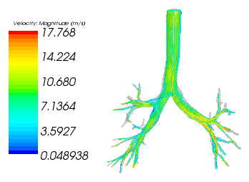
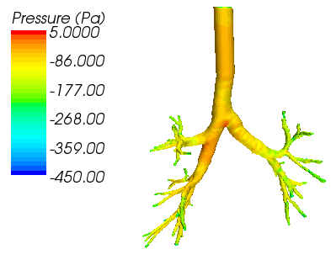
Figure 6 shows the results of an unsteady laminar simulation this simulated the flow with a steady boundary condition of a pressure drop of -225 Pa (De Backer, et al., 2008) over a period of 5.0s with a time step of 0.1s. Initially the flow was turbulent but as time progressed the flow developed into the results shown above. The majority of the flow is laminar however there are regions of turbulent flow around the first bifurcation. This is illustrated in Figure 7, which shows the lateral component of the flow in the trachea, this lateral flow is the turbulent flow. The large eddy (recirculating flows) are clearly visible in Figure 7 c), because of this a turbulence model should be selected so this turbulence can be fully described.
Figure 5 - Unsteady laminar Simulation

STL editing

Mesh Generation (Pages 55-57)
The edited CT data was then imported into our chosen CFD package, Star CCM+ (CD Adapco), to generate the surface and volume mesh and run the CFD simulations. Star CCM+ was chosen as the software is fully integrated allowing the models to completely setup from meshing to displaying results in one program. Also the software was readily available within the department and there is a wealth of resource material available allowing the team to learn the program quickly. The University’s subscription with CD-Adapco gave additional technical support which may provide solutions to any problems we may have.
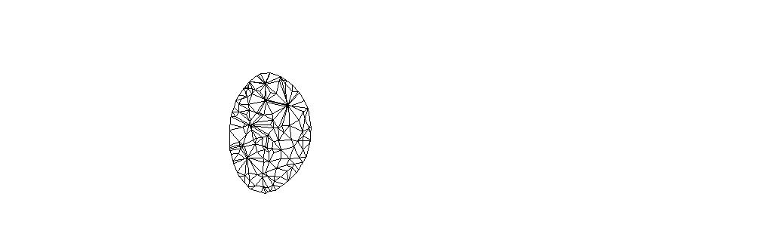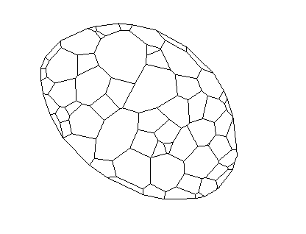 When meshing the geometry in Star-CCM+ it was discovered that the surface was not a manifold i.e. the edges of a cell was shared with more than two triangles. This meant that the surface re-mesher model, that re-triangulates the imported geometry to improve the surface quality and optimize it for volume meshing, could not be used and so a surface wrapper model was opted for. The mesh used for these simulations was a tetrahedral volume mesh, this was chosen as it requires less CPU time to generate and solve than its polyhedral counterpart. The CPU time taken for a polyhedral and tetrahedral mesh are summarised in Table 1. The polyhedral mesh does take a lot longer to generate but this is counteracted in requiring half the time to solve. The polyhedral mesh also has a better convergence than the tetrahedral mesh, and it is for these reasons that the mesh used for the simulations will be a polyhedral mesh.
Figure 19- Structure of Polyhedral mesh (left) and tetrahedral mesh (right)

Table 1 – Comparison of mesh types
Volume mesh type | CPU time for mesh generation  (s) | Solver CPU time per iteration  (s)
Polyhedral | 316 | 6.35
Tetrahedral | 179 | 13.93
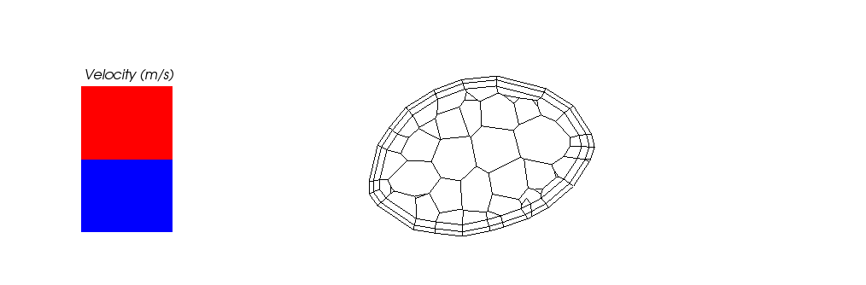As discussed previously the flow is likely to be turbulent and so a prism layer mesh should be considered, Figure 12. This mesh will allow the velocity profile with steep gradient at the boundary wall can be adequately described. A prism layer mesh model allows the user to add thinner layers of mesh radially to the wall of the trachea, as the velocity profile only changes rapidly radially. The Star CCM+ prism layer model allows the user to adjust the number of layers and the thickness of the prism layer as a percentage of the base size.
Figure 20 – Prism Layer Mesh
Due to the vast range of sizes in the lung a fine mesh in the trachea will result in a relatively coarse mesh in the bronchioles. Figure 7 illustrates this effect showing the mesh resolution in two different parts of the lung for a constant mesh size throughout. The mesh should be refined resulting in a coarser mesh in the trachea and a finer mesh in the terminal branches. This can be achieved in Star CCM+ by…
** FINISH DESCRIPTION OF HOW TO MAKE REFINED MESH INCLUDING EXAMPLES **
** I have found how to make a refined mesh in Star CCM+ now and so will include it in subsequent simulation **
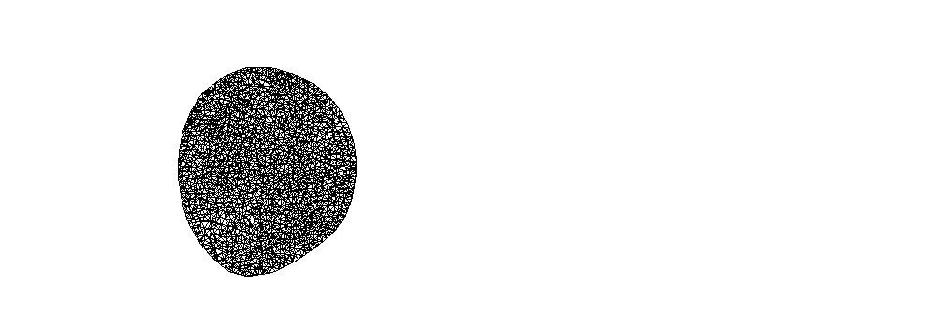For these comparison simulations the geometry chosen was for a scan taken during exhalation as this is when the lung volume is the smallest. This ensured that these model comparison simulations were as computationally inexpensive as possible.
Figure 21- a) Mesh Resolution in the trachea b) mesh resolution in the bronchiole

Numerical Methods (Pages 57-59)
Ideally, in order to obtain a high accuracy solution of the flow, we would like to use Direct Numerical Simulation (DNS). This method solves the Navier-Stokes equations directly without using averaging like other methods described later. The precise methods used in DNS are similar to the techniques described in the 1D section and these methods require a great deal of memory to store velocity fields in 3 dimensions for numerous time steps (Ferziger & Peric, 1999), this memory require can often exceed what is available. DNS has been used within the lung to model the flow of the upper airway (Lin, Tawhai, McLennan, & Hoffmann, 2009), but the method is too expensive for this project and so will only be used for the one dimensional analysis of the higher generations. The other CFD models available are discussed below.

RANS and URANS - (Unsteady) Reynolds Averaged Navier-Stokes
The approach of this model is to average out all of the unsteadiness in the turbulence (Ferziger & Peric, 1999). This model therefore gives engineering approximations of turbulence rather than scientific law. The fundamental principle behind the model is that for a statistically steady flow every variable can be rewritten as a sum of two components, an average value and a fluctuating value. Averaging the non-linear terms within the Navier-Stokes equations produces new terms that need to be modelled. These new terms are modelled by introducing another term called eddy viscosity, ν_{t}. RANS is a well established method and there are a variety of models and codes available that model the eddy viscosity. The two models considered here are the k-ε model and the Spalart-Allmaras (SA) model. Only a brief overview of the methods will be given here for more detail please consult Cebeci (2004) or Ferziger & Peric (1999).

k-ε
This is one of the most common models used in the engineering community (John, 2004). This is a two differential equation method, meaning it adds to extra equations that need to be solved (Cebeci, 2004). This model defines the eddy viscosity as:
Equation 83- Eddy viscosity term in k-ε model
$$ν_{t}=\frac{Ck^{2}}{ε}$$
Where C is a constant, k represents the transport of turbulent kinetic energy and ε is its rate of energy dissipation; k and ε are found from differential equations. This model has performed well for some flows for example re-circulating flows. However the addition of two more differential equations add expense to simulations and after three decades of study only partial solutions are available (John, 2004).

Spalart-Allmaras (SA)
On the other hand the SA method is only a one differential equation method, where the eddy viscosity is given by:
$$ν_{t}=Ck^{0.5}l$$
Where C and k are defined as above and l is obtained from an algebraic equation. Since this model only requires one extra differential equation it is less expense than k-ε model.

LES – Large Eddy Simulation
There is a wide range of length and time scales within turbulent flow (Ferziger & Peric, 1999) and for most engineering applications we are only concerned with the characteristics of the large scale flows. The basic idea behind LES is to decompose the turbulence into the small scale and the large scale, most commercial code achieves this by determining the smallest scale that can be solved and setting this as the threshold (John, 2004). The size of the eddies that can be solved is dependent on the size of the mesh spacing, eddies that are smaller than the mesh spacing will be averaged across the cell. The model then uses space averaged Navier-Stokes equations, this averaging produces a Reynolds stress tensor which needs to be modelled for, the model considered in this report is the Smagorinsky model. The LES model is much less computationally expensive than Direct Numerical Simulations but more expensive than RANS models. Where possible DNS is preferred but for high Reynolds flow in complex geometries LES is the preferred method (Ferziger & Peric, 1999).
DES – Detached Eddy Simulation
This is a relatively new method, first proposed in 1997, and was motivated by the need to model high-Reynolds separated flow, particularly in the aerospace industry (Spalart P. R., 2009). It is a hybrid of LES for the majority of the flow and RANS models in the boundary, this is because LES requires great expense in modelling the walls. This means that the DES method should be less computationally expensive and produce similar results. Since we are not concerned with separation of flow there is little added advantage in this method.

Validating the Model (Pages 61-65)
A sensitivity analysis was conducted on the 3D model. This analysis aims to identify how stable the simulation is by looking how the simulation responds to changes in the model parameters. For this simulation the variable parameter is the mesh base size, which defines how many mesh elements (tetrahedrons) are within the geometry. Multiple simulations were created with different mesh sizes varying from 500,000 to 5,170,000 elements. To study the effect of changing the mesh size on the simulation another parameter was monitored, for this analysis this parameter was the mass flow rate in the trachea. The figure below shows the results from the sensitivity analysis.
Figure 25- Plot of CPU time and mass flow rate against number of mesh elements
Ideally the mass flow rate in the trachea would have the same value in every simulation but, as shown in Figure 16, the mass flow rate increases and the number of mesh elements increases. Intuitively this must be true since a decreased base size means the curvature of the trachea can be estimated more accurately like a circle than a polygon. This means that the area of the trachea increases slightly with an increase of mesh elements, and hence a larger mass flow rate is observed. The log scale of the graph makes it easy to see that at around 3,000,000 elements the mass flow rate is within 2% of the preceding and following values, this means that the simulation is stable and changing the number of mesh elements further will have a negligible effect on the results.
The CPU (Central Processing Unit) time per iteration is also plotted against number of mesh elements, this illustrates the computational expense for simulations with greater number of mesh elements. As such it was decided that the base size used for simulations will be 0.4mm, which corresponds to 3.8 million elements in Figure #. This was chosen for the accuracy of the model and the realisable CPU time per iteration as the a base size of 0.35mm took twice as long per iteration making the simulation far too computationally expensive. This mesh size is of the same order to the mesh used by De Backer (J.W. De Backer, 2008) in his simulations of 3D flow within a human lung.
A similar test was conducted for an unsteady model where by the time step and number of cycles the unsteady boundary conditions need to be simulated for until the results of each cycle become regular, and finding the number of time steps for the simulations that give an acceptable result. A similar test will be conducted for the one dimensional section, the lowest value of the time step from these tests will then be used in both models allowing them to be coupled. These values for the number of mesh elements and number of cycles will then be used for subsequent simulations thus ensuring our results are accurate.
**INSERT AND DISCUSS TIME STEP RESULTS**
The final robustness test the simulations are subjected too is a validation test. This test hopes to show the accuracy of the numerical results of the simulation by directly comparing them to the results obtained from another simulation in another software package. With kind permission of J. W. De Backer we are able to compare our results with simulations conducted using Fluent another commercial CFD code. The DES method was used on a polyhedral mesh with prism layer.
The original geometry was provided by J. W. De Backer and is the same geometry as used in the Fluent simulations. The editing of the STL file was completed independently and as such there may be some discrepancies between the two simulations, however the only geometry processing completed was preparing the ends of the bronchioles, which would have little effect on the results. We were unable to use the same boundary conditions as were applied to the simulation in Fluent, although the distributions of velocity and pressure should be similar between the two simulations if the magnitudes are not. For these simulations a uniform pressure drop across the trachea and all terminal bronchioles of -250 Pa was applied, this produced a mass flow rate in the trachea of 0.0021kg/s which corresponds to forced inhalation.
The results show very similar velocity distributions with the flow increasing around the bend in the trachea, which suggests the cross sectional area decreases here and demonstrates the imperfections in the geometry of the lungs. The pressure distribution is also very similar with the bronchiole region of the lungs being very similar to
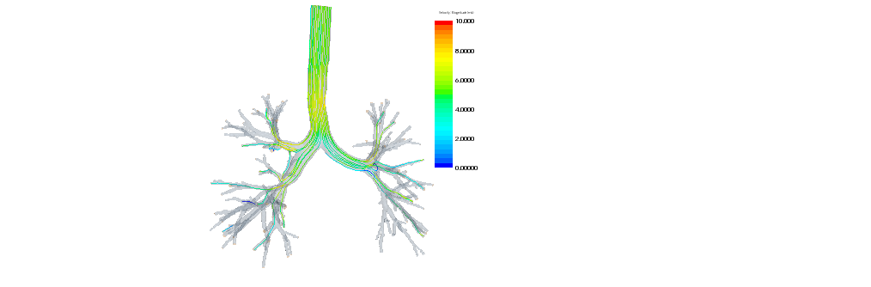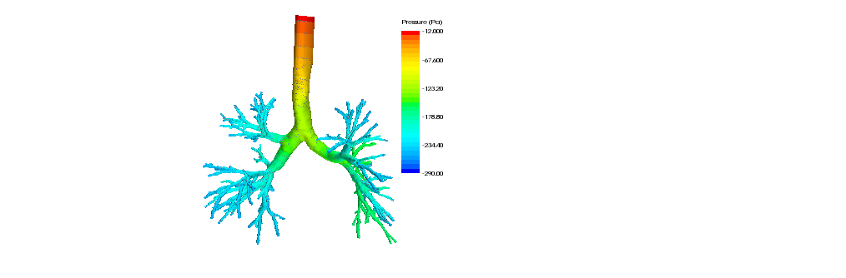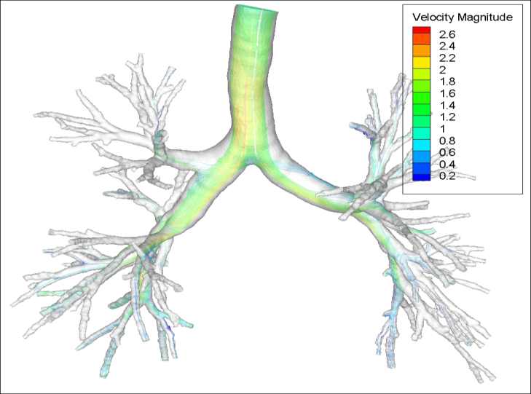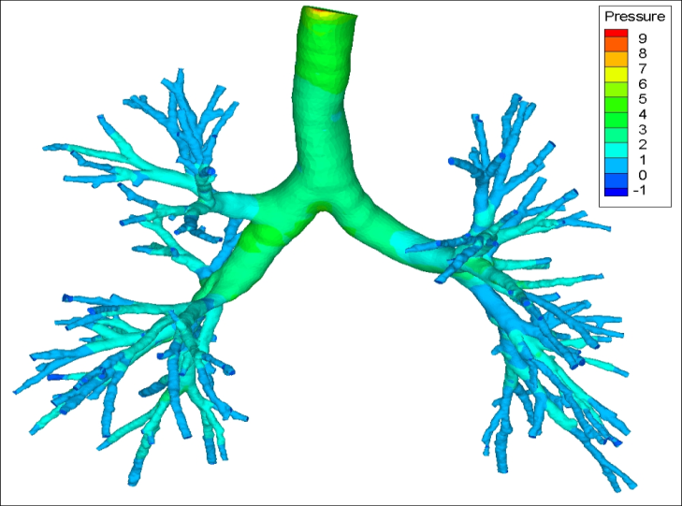
Figure 26- Pressure and velocity streamline plot for Inspiration geometry in Star CCM+
Figure 27 - Pressure and streamline velocity magnitude plot run using Fluent code courtesy of J. W. De Backer
Figure 20 shows the residual error plot for the simulation on the inspiration geometry, the residual plot monitors if the solutions per iteration are converging to a value. The plot monitors 5 equations which are the continuity equation, three dimensions or momentum and an energy equation. Following the mesh discretisation of the domain, meshing the geometry the linear system below is described. Equation 2 shows this linear system, where A is a sparse matrix of coefficients relating to the linear system, x is a vector of all the unknowns in each cell and b is a vector of residuals (values of x from a previous time step) a previous iteration. To solve for x the inverse of matrix A needs to be found since matrix A is 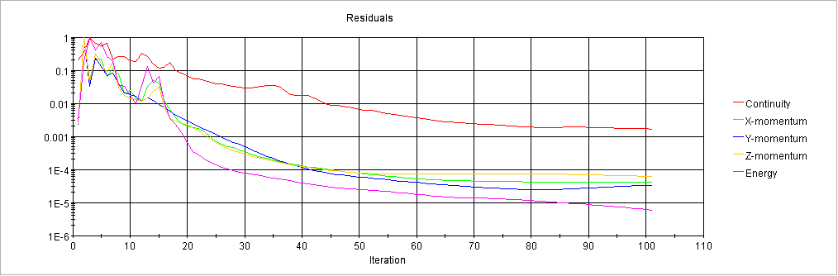sparse Gauss elimination or LU decomposition would be costly and so an algebraic multigrid iterative method is used in Star CCM+.
Figure 28 - Residual Error Plot for Validation Exercise

Equation 84- Linear Equation of Solution
$$Ax=b$$
The residual error is then found by the difference between the residual vector and the calculated values for that iteration, Equation 3. Ideally the residual error should be zero indicating an exact solution, however for the simulations an error in the order of 10⁻⁴ is acceptable.
Equation 85- Calculating the Residual error
$$r=Ax-b$$
Figure 20 shows the approximate number of iterations the simulations need to be run to before they converge. Subsequent simulations can then be run to a similar number then terminated reducing computing time.
Results ** Present here the results of subject specific boundary condition simulation of healthy and unhealthy patients. **

1D Simulation (Page 66)

Initial Testing and Validation of Model
The primary set of results gathered from the 1D simulation is a trial simulation designed to test the validity of the numerical simulation against previously established results.

Geometry Parameters
The simulation is performed on the symmetrical geometry of 24 generations. The initial radius is 10mm, the initial length is 50mm and the reduction ratio is 0.8. The parameters for the entire geometry are shown in Figure 15.

Figure 29. Geometry Parameters
Generation | Length | Radius | No. of branches
0 | 0.05 | 0.01 | 1
1 | 0.04 | 0.008 | 2
2 | 0.032 | 0.0064 | 4
3 | 0.0256 | 0.00512 | 8
4 | 0.02048 | 0.004096 | 16
5 | 0.016384 | 0.003277 | 32
6 | 0.013107 | 0.002621 | 64
7 | 0.010486 | 0.002097 | 128
8 | 0.008389 | 0.001678 | 256
9 | 0.006711 | 0.001342 | 512
10 | 0.005369 | 0.001074 | 1024
11 | 0.004295 | 0.000859 | 2048
12 | 0.003436 | 0.000687 | 4096
13 | 0.002749 | 0.00055 | 8192
14 | 0.002199 | 0.00044 | 16384
15 | 0.001759 | 0.000352 | 32768
16 | 0.001407 | 0.000281 | 65536
17 | 0.001126 | 0.000225 | 131072
18 | 0.000901 | 0.00018 | 262144
19 | 0.000721 | 0.000144 | 524288
20 | 0.000576 | 0.000115 | 1048579
21 | 0.000461 | 9.22E-05 | 2097152
22 | 0.000369 | 7.38E-05 | 4194304
23 | 0.000295 | 5.90E-05 | 8388608

Simulation Parameters
The simulation parameters specified initial conditions of air at atmospheric pressure and zero velocity throughout the system at t = 0. Pressure boundary conditions applied at the opening of the initial branch and at the ends of the distal branches. The pressure at the initial branch is constant at atmospheric pressure (101325 Pa), the pressure boundary conditions imposed at the distal branches is a transient boundary condition ranging between 101825 Pa and 100825 Pa following a sinusoidal variation over a time period of 10 seconds. The form of the pressure boundary condition is to approximate the variation in pleural pressure in a typical breathing cycle.

Results
The mean pressure and velocity in each generation of the geometry are displayed in Figure 16.
Generation | Mean Pressure (Pa) | Mean Velocity (ms⁻¹)
0 | 100524.6 | 3.31994
1 | 99083.7 | 3.31976
2 | 97931.0 | 3.31949
3 | 97008.9 | 3.31906
4 | 96271.2 | 3.31838
5 | 95681.0 | 3.31733
6 | 95208.9 | 3.31569
7 | 94831.2 | 3.31314
8 | 94529.0 | 3.30915
9 | 94287.3 | 3.30293
10 | 94093.95 | 3.29327
11 | 93939.2 | 3.27828
12 | 93815.4 | 3.25513
13 | 93716.4 | 3.21961
14 | 93637.2 | 3.16564
15 | 93573.85 | 3.08483
16 | 93523.15 | 2.96651
17 | 93482.6 | 2.79878
18 | 93450.15 | 2.57156
19 | 93424.2 | 2.28206
20 | 93403.45 | 1.94065
21 | 93386.8 | 1.57289
22 | 93373.5 | 1.21345
23 | 93362.9 | 0.894041
Figure 31. Pressure Variation
Figure 30. Geometry Parameters

Figure 32. Velocity Variation

Discussion of Results (Page 69)
From Figure 18 it can be seen that the mean velocity in the trachea at peak inspiration is around 3.3 ms⁻¹. The velocity remains within a tight range for the first 14 generations before falling linearly to a mean value of 0.9 at the outlets. The mean pressure across each of the elements drops exponentially with each generation. This is due to the variation in size of the mesh elements as the pressure drop is linear throughout each bronchial path however the size of the mesh elements decreases logarithmically with each generation.
The results of the model are assessed for accuracy by comparison to the results produced by Lin et al. (2009) in a similar 3D and 1D coupled model.

** IMAGE **
Visualisation of first 1D simulation results

From the comparison shown in Figure 19, it is clear that although the results produced by the model are within a similar range to the results produced by Lin et al there are some variations. Whilst the mean inlet velocity is within 9% of the results produced by Lin et al the pressure variation across the system differ greatly.
This discrepancy can be attributed to a number of factors. The primary factor is the difference in numerical scheme; Lin et al use 3D large eddy simulation to simulate flow through the upper airway and the integral form of continuity and energy equations to calculate flow pressures and resistances in the lower airways. The scheme in this study uses the 1D Navier Stokes equations and continuity equations to solve the flow through the entire system. This method assumes laminar flow and smooth, cylindrical airway walls. Whilst this assumption has been shown to be valid for the lower airways (reference Mauroy et al) it is not valid for the upper airways as it neglects the effects of vorticity of flow in the bronchus and also assumes that flow splits symmetrically at each bifurcation. Neglecting the effect of turbulence in the bronchus increases the magnitude of error in the simulation.
Due to the form of the geometry the mesh element sizes vary between each generation with coarse mesh elements in the lower generations and a finer mesh in the distal generations. The coarse size of the mesh elements in the lower generations means that there is likely to be a larger error in the simulated velocity and pressure in this section of the results. This may account for the discrepancy between the results of this study and he results gathered by Lin et al. Further studies have increased the mesh size in order to apply a finer mesh to the initial elements and produce a more accurate simulation of flow through the upper airways.
The geometry used by Lin et al is from a different subject to that used in this study. In addition to this the geometry includes a model of the upper airway which is missing from this study. The effects of using a different and more complete geometry are that the flow through the each system will differ between each study. The magnitude of the difference should, however, be small as the geometries are similar in nature, i.e. they both constitute a series of airways branching by dichotomy.
The boundary conditions used also influence the results, theoretically the boundary conditions for each study should represent the real system, however, each study uses different approximations in order to define the flow at the boundaries of the system. This study specifies pressure boundary conditions of atmospheric pressure at the inlet and alveolar pressure at the outlets. Lin et al specify velocity boundary conditions defined by the tidal volume change in individual lobes of the lungs in order to produce a more physiologically realist boundary condition (reference Lin et al).

Limitations of the Model (Page 71)
This trial has be performed which a simplified version of the model. This is in order to reduce the computational time and to ensure that the system for solving the 1D Navier stokes equations is functioning correctly.
The following simplifications are made.
The first simplification is in the 1D Navier Stokes scheme used to simulate the flow velocity and pressure, the limitations of this system are discussed above. An addition limitation of this initial test is that the airway walls are assumed to be rigid. The model does not take into account elastic deformation of the airway walls due to the changing pressure within the system. This assumption is a simplification of the real system which is being simulated by the model and has been addressed in further trials.
The boundary conditions are simplified in that the distal boundary condition has been defined based purely on the alveolar pressure. The effects of the transmural pressure and the pleural pressure on the alveoli have been neglected and the variation in alveoli pressure with time has been approximated to sinusoidal oscillation. This simplification has been made in order to simplify the computation of the model, and to assess the stability and accuracy of the model with the assumed rigid airway.

- http://www.scintipharma.com/html/what_is_gamma_scintigraphy_.htm
http://ehealthmd.com/library/ctscan/CTS_work.html
http://www.patient.co.uk/health/MRI-Scan.htm
http://www.patient.co.uk/health/DEXA-Scan.htm
http://www.droid.cuhk.edu.hk/web/service/angio/dsa.htm
http://www.ehow.com/how-does_5007492_ultrasound-scan-work.html

