Erin’s Guide on How to write an introduction

- Look at your target journal’s total word requirements. Journals vary in length and convention for how long the introduction should be. They typically vary in length from about 4-6 paragraphs.

- Know your story - fitting all the background information in 4-6 paragraphs requires economy and focus. You want your writing to be tightly focused on the main story you are telling. In the paper by Mensh & Kording linked in the introduction section, they argue that your paper is successfully written if, “readers can still describe the main contribution of your paper to their colleagues a year after reading it” (2017). They, therefore, argue that you (i) focus on a single message – the one knowledge gap that your research answers; (ii) write as simply as possible by avoiding or defining technical terms; and (iii) follow a prescribed and expected structure, defined below.

- Follow the Context-Content-Conclusion structure. This suggested structure will help you highlight why the paper matters in the introduction. Mensh & Kording created a diagram (Figure below) showing each section of the paper and how they contain context (blue), content (black) and conclusions (red).
- Paragraph 1 should focus on the importance of the work. It should introduce the context and the ‘big problem’ your work addresses. This is your opportunity to convince your reader that the rest of the paper is worth reading!
- Paragraphs 2-4 should be progressively more specific than those above it and explain the ‘knowledge gap’. The knowledge gap should explicitly state what is missing in the current literature. Key here is that there may be many things missing, but you want these paragraphs to introduce primarily the gap that your work addresses!
- The final paragraph or penultimate paragraph should explain how you addressed the knowledge gap. This often starts with, "Here we…". The final paragraph often summarises the results specific to the knowledge gap and states the conclusion that you will draw.

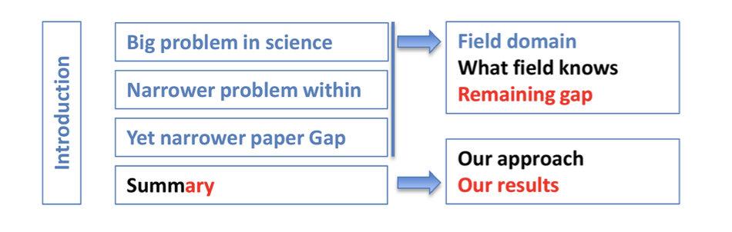

Other key points:
- Funnelling process. Start broad, end at the specific hypothesis.
- Start with an interesting problem that is understandable to a general academic, not boring/unknown scientific terms.
- No room for waffle, every sentence counts

