Department Application
Bronze and Silver Award
Name of institution | University of Warwick
Department | School of Life Sciences
Focus of department | STEMM
Date of application | May 2018
Award Level | Silver
Institution Athena SWAN award | Date: November 2016 | Level: Silver
Contact for application  Must be based in the department | Professor Gary Bending
Email | gary.bending@warwick.ac.uk
Telephone | 024 76575057
Departmental website | https://www2.warwick.ac.uk/fac/sci/lifesci/

TABLE OF CONTENTS
1. | LETTER OF ENDORSEMENT FROM THE HEAD OF DEPARTMENT |  |  |  | 6
2. | DESCRIPTION OF THE DEPARTMENT |  |  |  | 8
3. | THE SELF-ASSESSMENT PROCESS |  |  |  | 10
 | (i) | A description of the self-assessment process |  |  | 10
 | (ii) | An account of the self-assessment process |  |  | 12
 | (iii) | Plans for the future of the self-assessment team |  |  | 13
4. | A PICTURE OF THE DEPARTMENT |  |  |  | 14
4.1. | Student data |  |  |  | 14
 | (i) | Numbers of men and women on access or foundation courses |  |  | 14
 | (ii) | Numbers of undergraduate students by gender |  |  | 14
 | (iii) | Numbers of men and women on postgraduate taught degrees |  |  | 20
 | (iv)) | Numbers of men and women on postgraduate research degrees |  |  | 23
 | (v) | Progression pipeline between undergraduate and postgraduate student levels |  |  | 24
4.2. | Academic and research staff data |  |  |  | 30
 | (i) | Academic staff by grade, contract function and gender: research-only, teaching and research or teaching-only |  |  | 30
 | (ii) | Academic and research staff by grade on fixed-term, open-ended/permanent and zero-hour contracts by gender |  |  | 32
 | (iii) | Academic leavers by grade and gender and full/part-time status |  |  | 32
5. | SUPPORTING AND ADVANCING WOMEN’S CAREERS |  |  |  | 35
5.1 | Key career transitions: academic staff |  |  |  | 35
 | (i) | Recruitment |  |  | 35
 | (ii) | Induction |  |  | 38
 | (iii) | Promotion |  |  | 39
 | (iv) | Department submissions to the Research Excellence Framework (REF) |  |  | 40
5.2 | Key career transition points: professional and support staff |  |  |  | 41
 | (i) | Induction |  |  | 41
 | (ii) | Promotion |  |  | 41
5.3 | Career development: academic staff |  |  |  | 44
 | (i) | Training |  |  | 44
 | (ii) | Appraisal/development review |  |  | 46
 | (iii) | Support given to academic staff for career progression |  |  | 49
 | (iv) | Support given to students (at any level) for academic career progression |  |  | 51
 | (v) | Support offered to those applying for research grant applications |  |  | 52
5.4 | Career development: professional and support staff |  |  |  | 54
 | (i) | Training |  |  | 54
 | (ii) | Appraisal/development review |  |  | 56
 | (iii) | Support given to professional and support staff for career progression |  |  | 57
5.5 | Flexible working and managing career breaks |  |  |  | 58
 | (i) | Cover and support for maternity and adoption leave: before leave |  |  | 58
 | (ii) | Cover and support for maternity and adoption leave: during leave |  |  | 59
 | (iii) | Cover and support for maternity and adoption leave: returning to work |  |  | 59
 | (iv) | Maternity return rate |  |  | 59
 | (v) | Paternity, shared parental, adoption, and parental leave uptake |  |  | 60
 | (vi) | Flexible working |  |  | 61
 | (vii) | Transition from part-time back to full-time work after career breaks |  |  | 64
5.6 | Organisation and culture |  |  |  | 64
 | (i) | Culture |  |  | 64
 | (ii) | HR policies |  |  | 66
 | (iii) | Representation of men and women on committees |  |  | 67
 | (iv) | Participation of influential external committees |  |  | 69
 | (v) | Workload model |  |  | 69
 | (vi) | Timing of departmental meetings and social gatherings |  |  | 70
 | (vii) | Visibility of role models |  |  | 71
 | (viii) | Outreach activities |  |  | 72
6. | CASE STUDIES |  |  |  | 74
7. | FURTHER INFORMATION |  |  |  | 76
8. | ACTION PLAN |  |  |  | 77

GLOSSARY
AS | Athena SWAN
BBSRC | Biotechnology & Biological Sciences Research Council
COSHH | Control of Substances Hazardous to Health
CPD | Centre for Professional Development
DLHE | Destinations of Leavers from Higher Education
E,D&I | Equality, Diversity & Inclusion
ECU | Equality Challenge Unit
FTC | Fixed Term contract
GH | Gibbet Hill
GP | Graduate prospects
HESA | Higher Education Statistics Analysis
HoS | Head of School
HR | Human Resources
HS | Health and Safety
IGGY | International Gateway for Gifted Youth
KIT | Keeping in Touch
LDC | Learning Development Centre
CLL | Centre for Lifelong Learning
MASP | Medical Application Support programme
MRC | Medical Research Council
MSc | Master of Science
NERC | Natural Environment Research Council
NSS | National Student
OEC | Open ended contract
OPDA | Office for Postdoctoral Affairs
PDR | Personal Development Review
PDRF | Postdoctoral Research Fellow
PGT | Postgraduate teaching
PhD | Doctor of Philosophy
PSS | Professional and Support Staff
RCUK | Research Councils UK
RG | Russell Group
RSB | Royal Society of Biology
SAT | Self-Assessment Team
SLS | School of Life Sciences
SSLC | Staff Student Liaison Committee
STP | Scientific Training Programme
UG | Undergraduate
UoA | Unit of Assessment
UoW | University of Warwick
WCC | Warwick Crop Centre
WISB | Warwick Integrative Biology Centre
WLA | Warwick Learning Account

Letter of endorsement from the head of department

School of Life Sciences
Gibbet Hill Campus
University of Warwick
Coventry CV4 7AL, UK
(0)24 76574251
life.sciences@warwick.ac.uk

Dear Equality Charters Manager
As former Head of School of Life Sciences (SLS) 2014-2017, it is with great enthusiasm that I support this application for an Athena SWAN (AS) silver award. I led the SLS Bronze award application in 2014 and have been a member of the AS committee (now Self-Assessment Team (SAT)) since 2012. As Head I placed an inclusive culture and commitment to collegiality as a SLS central commitment and I am proud to have led the embedding of the AS ethos.
We recognise that an inclusive working and learning environment provides the basis for outward looking, sector-leading science. When I began as Head of School in 2014 the School was under review and morale was low. I created a senior management structure for teaching and research, ensured that issues of equality were considered in all aspects of School life, and offered all staff the opportunity engage with the School’s development. As a result, SLS has become highly positive, collegiate School with a transparent culture that ensures equal opportunities for all.
Significant policy changes led to success at all levels. The reputation of the School for supporting women in science has been strengthened by the award of a Royal Society Leverhulme Trust Senior Research Fellowship to one of our female academics, the fast tracking of one female academic through probation and the recruitment of three female assistant professors of six appointed. We improved staff morale and saw the rapid improvement of student satisfaction.
SLS has led on several developments within the University that are set to become exemplars nationally. We identified that academics were more likely to take 6-months parental leave, returning in order to support PhD students and research and calculated the impact of a University-wide initiative for a period of teaching relief to enable a stepped return to work so that academics could support their research. This was implemented by UoW in 2015.
It has been a pleasure to see the significant changes achieved through SLS commitment to the AS values and I am confident that this will be continued by Prof Frigerio and the senior management team.
Professor Laura Green OBE, DPVC for Research (former Head of School)

I succeeded Laura Green as Head of School in September 2017. As Laura’s Deputy I was part of the senior team which reshaped SLS over the last 3 years. We have made great progress since beginning to engage with AS. Our 2018 PULSE staff survey results show an upward trajectory across the board with 80% of staff agreeing that they are treated with fairness and respect at the University, an 11% increase since PULSE 2016. We are committed to continuing to build on this success.
In 2017, we agreed a 10-year strategic plan, paving the way for a new building and new staff appointments. This provides a valuable opportunity to embed our commitment to inclusivity with a focus on community, accessible space and gender-neutral facilities.
We are ambitious and our Silver Action Plan (SAP) outlines the challenges that we will address over the next 4 years. Using information from staff and student surveys we have ensured that our SAP is specific and measurable, so that we are clear when our actions have been achieved and share this with others and can assess where there is still work to do.
The information presented in the application (including qualitative and quantitative data) is an honest, accurate and true representation of the institution/department. I am fully committed to continuing the School’s excellent work in this field.
Yours sincerely,

Professor Lorenzo Frigerio, Head of School (former Deputy Head)
(597 WORDS)

Description of the department
Note: all staff data is presented as FPE (full person equivalent)
Warwick School of Life Sciences (SLS) is a diverse community of students and staff with a passion for biosciences research and teaching. SLS was ranked 5th in the Guardian and 10th in the Times for 2018 UK Biosciences degrees and was the second highest ranked Bioscience department for student satisfaction in the 2016 National Student Survey (NSS). In the Destinations of Leavers from Higher Education (DLHE) survey SLS graduates are ranked in the top 10 for high earnings 5 years following graduation.
Research in SLS is based around 4 themes; Biomedical Science, Biotechnology, Environmental Bioscience and Plant and Crop Science. We lead University interdisciplinary centres in Epidemiology, Environmental Science, Food, Antimicrobial Resistance and Synthetic Biology. The 2014 Research Assessment Exercise ranked quality of SLS research 2nd in UoA 6 Agriculture, and 28th in UoA Biology. Research income has grown from £10.5 million in 2013/14 to £13.2 million in 2016/17.
SLS runs 3 and 4-year undergraduate (UG), Royal Society of Biology (RSB)- accredited degree programmes in Biological Sciences, Biochemistry, Biomedical Science and Medical Microbiology and Virology (950 enrolled in 2017-2018). Over the last 5 years the percentage of females on UG degree programmes has increased from 60% to 64 % (Figure 2.1).

Figure 2.1 SLS Undergraduate student population by gender (HESA Sector 2016/17 Female 63%, Male 37%. HESA Russell Group 2016/17 Female 68%, Male 32%)
At postgraduate level there are five taught (PGT) masters programmes which include two biotechnology and three agriculture-based courses (75 students enrolled in 2017-2018). The percentage of females on PGT programmes has ranged between 38 % and 62 % over the last 5 years (Figure 2.2).

Figure 2.2 Postgraduate taught population – full time by gender (HESA Sector 2016/17 Female 70%, Male 30%. HESA Russell Group 2016/17 Female 72%, Male 28%)
SLS has 150 postgraduate research (PGR) students who are either on Doctoral Training Partnerships funded by BBSRC, EPSRC, NERC and Waitrose or are self-funded. Over the last 5 years the percentage of female PGR has increased from 49% to 60 % (Figure 2.3).

Figure 2.3 Postgraduate research student population by gender (HESA Sector 2016/17 Female 60%, Male 40%. HESA Russell Group 2016/17 Female 60%, Male 40%)

Over the past 3 years SLS has invested significantly in outreach to build an extensive programme involving local, national and international engagement.
Approximately 200 SLS staff are located on the Gibbet Hill campus (GH), on the edge of the University of Warwick (UoW) campus in Coventry and 50 SLS staff are located in Wellesbourne, 15 miles from UoW campus. SLS is fully integrated across GH and Wellesbourne, with staff regularly travelling between the sites. Data in the submission are therefore combined. All UG and PGT teaching is conducted at GH.
Communication at all levels of the School ensures our success and we have valued the AS process for the opportunity that it provides to cement values of inclusivity in all aspects of our work. Colleagues based at both GH and Wellesbourne are fully integrated onto SLS governance and activities (Figure 2.4).
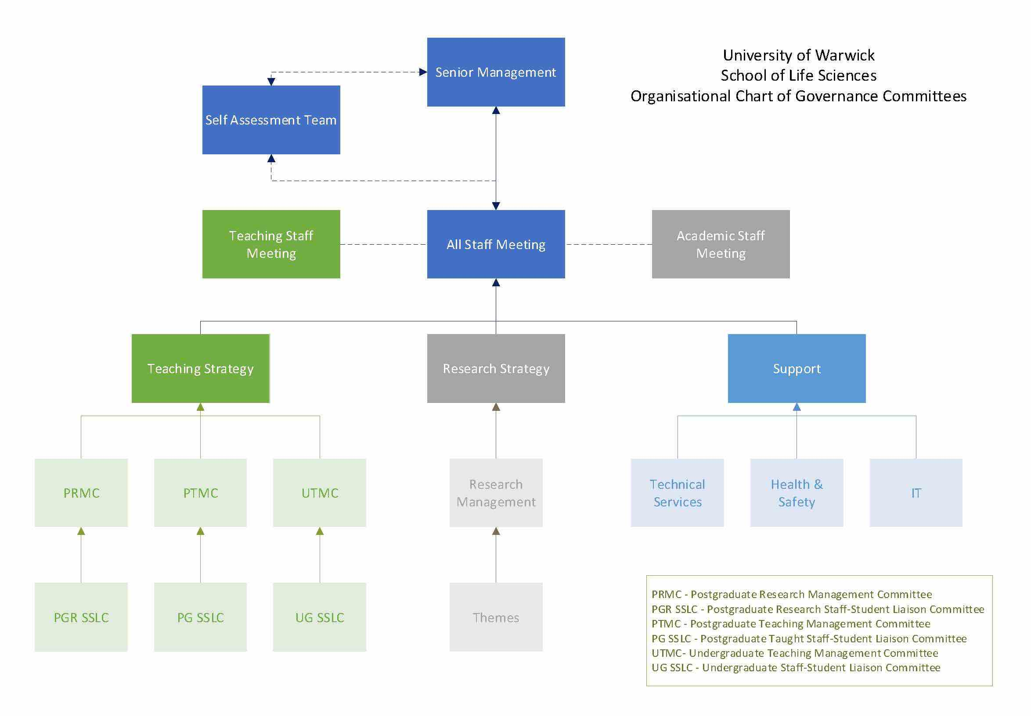
Figure 2.4 SLS Governance Structure, May 2018
Our success as a School has enabled us to grow from 146 academic staff in 2013 to 172 in 2017, with an increase in the proportion of female staff from 36% to 41% (Figure 2.5). The number of Professional and Support Staff (PSS) has remained constant over the past 5 years, with a total of 114 in 2017. While numbers of staff have risen there has been a small drop in the percentage of female staff from 64% to 59% (Figure 2.6).

Figure 2.5 Number and percentage of academic staff in SLS by gender (HESA Sector 2016/17 Female 45%, Male 55%. HESA Russell Group 2016/17 Female 44%, Male 56%)

Figure 2.6 Number and percentage of PSS in SLS by gender (HESA Sector 2016/17 Female 62%, Male 28%. HESA Russell Group 2016/17 Female 62%, Male 28%)
(WORDS 523)

The self-assessment process
- A description of the self-assessment team

Following our Bronze renewal in 2014, we created a dedicated Self-Assessment Team (SAT) with an exclusive AS agenda (Table 3.1). This ensures the sustained focus on responding to staff feedback and delivering against actions to ensure a sustained difference to the culture of the School. The SAT includes academic and PSS representatives at different career stages and UG, PGT and PGR students to ensure reach across SLS. A committee secretary supports the collation of data, surveys and data analysis underpinning this application. Other members have been recruited following staff requests for specific staff and student representation.
Membership of senior staff ensures strategic commitment and implementation of changes agreed by the SAT. This is important as it enables to ensure that the work of the SAT is linked to all aspects of work in SLS and to enable us to respond proactively to updated ECU guidance such as that on intersectionality.
In order to ensure that SAT members are able to fully contribute, workload of academic staff is balanced using a workload model (Section 5.6 v). All committee members are encouraged to use the annual Personal Development Review (PDR) to review workloads with their line-manager and recognise contributions that can be put forward for merit pay award nominations.
Table 3.1 Self-Assessment Team (SAT)
Committee Member | Profile | SAT Responsibilities
Gary Bending (M)(V) | Professor of Environmental Microbiology; PULSE champion; UoW Athena committee; UoW gender taskforce | Committee Chair  Organisation and culture lead
Claire Algar (F)(A) | UoW Equality, Diversity & Inclusion Officer, UoW Athena Committee, Co-Chair Athena Network meetings, ECU Athena panellist | Support and guidance for this application
Claire Barratt (F)(A) | Senior Science Support Assistant | Administration and data support  UoW Athena Network meetings
Gina Chen (F)(V) | Undergraduate student | Undergraduate representation
Rebecca Freeman (F)(A) | Head Student Engagement and Recruitment  Maternity leave from July 2017- April 2018 | Support and career development of UG/PG students  Implementation of SAP
Jenny Bowskill (F)(A) | Acting Head Student Engagement and Recruitment (Maternity cover) | Support and career development of UG/PG students  Implementation of SAP
Lorenzo Frigerio* (M)(A) | Head of School (from September 2017) | Implementation of SAP
Miriam Gifford (F)(A) | Associate Professor, Director of Education and Deputy Head of School | Implementation of SAP
Raksha Gohel (F)(V) | Chair of the UG Student Staff Liaison Committee, Undergraduate student | Undergraduate representation
Robert Huckstepp (M)(V) | Assistant Professor, Deputy Director of Post-doctoral Affairs | Support and career development of PDRF
Steve Jackson (M)(A) | Associated Professor, Director of Post-doctoral Affairs | Support and career development of PDRF; implementation of SAP
Charlotte Moonan (F)(V) | Business Development and Marketing Officer | Career development of PSS; flexible working
Amy Newman (F)(V) | Postgraduate student | Postgraduate representation
Fal Patel (F)(A) | HR Officer; PULSE Champion#  Works flexibly to support childcare arrangements | Support and career development of academic and PSS; Implementation of SAP
Antonia Sagona (F)(V) | Assistant Professor, BBSRC Future Leader Fellow | Outreach
Phil Young (M)(V) | Director of Undergraduate Studies. Works flexibly to support childcare arrangements | Support and career development of UG students, Implementation of SAP
Teja Sirec, (F) (V) | Postdoctoral Research Fellow | Career development of PDRF
Critical Friends
Zana Stamataki a Senior Lecturer at the College of Medical and Dental Sciences at the University of Birmingham, and a Royal Society Dorothy Hodgkin Fellow. She is a member of the Women in Academia Medicine and Science steering group and a STEM ambassador.
Holly Bridge an Associate Professor in the Department of Clinical Neurosciences at Oxford University
#PULSE Champion: volunteers who engage with the development and analysis of PULSE survey and identifying University and SLS initiatives to improve working conditions at Warwick.
*replacing the former head of School, Prof Laura Green
V: Volunteer; A, Appointed

Our two external critical friends have provided a valuable external view on our application, having been involved in successful Silver applications at their own institutions.
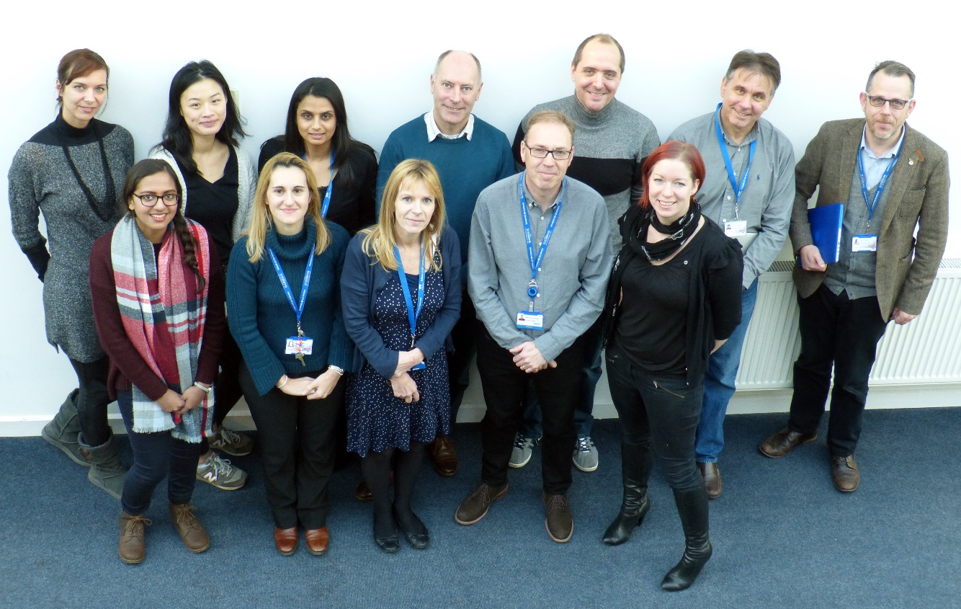
Figure 3.1 Members of the SAT
- An account of the self-assessment process

The SAT has led the analysis of data for this application, consultation and communication with staff, delivery of our Bronze Action Plan (BAP) and the development of the Silver Action Plan (SAP). We meet monthly to ensure that we sustain momentum and are able to feed outcomes back to staff within a short timeframe. Members were assigned specific responsibilities, with leads assigned to each objective and component actions to ensure accountability. Sub-group meetings of SAT and consultation events (focus groups, snap surveys) were organised when further discussion and analysis was required. SAT members led on the writing of sections of this application that fell within their area of responsibility for implementation.
Progress on delivery of the BAP and our vision for Silver is presented to SLS through termly Staff meetings to encourage feedback. Student representatives report on progress to the relevant UG or PG Student Staff Liaison Committee (SSLC). Minutes from Staff and SAT meetings are accessible to staff and students via the dedicated AS webpage on the SLS intranet.
Following the renewal of our Bronze award, we took time to review our AP and ensure all actions were SMART to enable the measurement of success. Members of the SAT visited Biology at York University, a Gold AS Award holder, in 2015 to benefit from their experience. Based on practice shared from this visit we introduced snap surveys to gather detailed information on staff experiences including flexible working, mentoring and career development. Results were communicated back to all staff at termly staff meetings along with agreed actions to be taken forward with a view to ensuring that all staff are clear their voice is heard within SLS.
Warwick conducts PULSE surveys every 2 years to gather staff experience of working conditions and the outcomes of the survey form the basis of actions at School and University level. The SAT leads the analysis of the PULSE survey and the SAT Chair leads an All Staff PULSE meeting following the release of the results to share the data and discuss next steps. Data from 2014 and 2016 surveys were used as the basis of workshops with staff groups (academic, postdoctoral, PSS) to review the findings, prioritise areas for action and develop actions for our action plan (Appendix A). These areas included:
- flexible working and work-life balance
- career development for PSS
- the annual PDR
- postdoctoral career development
The headline data from the 2018 PULSE survey was released in April 2018 and comments received by SLS in May 2018. As such we have included headline data from the survey in this document. We held the 2018 PULSE All Staff Meeting on the 16th May 2018 to present the PULSE outcomes to staff and plan a series of workshops to develop appropriate actions in early June (SAP 3.1).
- Plans for the future of the self-assessment team

Silver Action Plan
SAP 3.1: Analyse 2018 PULSE survey results and hold workshops with staff groups to develop specific actions and monitor progress

The SAT will continue to meet monthly following submission in order to ensure timely progress is being made against the SAP. Senior management membership of the SAT will be maintained in order to ensure that the group continues to be strategically aligned to the direction of the School and the implementation of agreed actions. The 2018 PULSE survey will be used to further refine specific actions and monitor progress.
Membership of SAT continues to be reviewed annually following staff PDR and workload model reviews. Senior management and HR Officer membership will continue for continuity of strategy and to ensure the implementation of actions. The SAT is a standing item on the SLS All Staff Meeting agenda ensuring that all staff are regularly updated and given the opportunity to engage. We have found the inclusion of external views, through our critical friends, extremely valuable and will continue to seek external views through this approach.
Silver Action Plan
SAP 3.2: Review SAT membership annually to ensure a diverse SAT

(WORDS 879)

Picture of the Department
Throughout section 4 we present an outline of where the School stands at the time of application, highlight the impact of our BAP and identify how we will continue to progress through the SAP. We provide data for the last 5 years (2012-2017). Wherever possible we have benchmarked both against the HESA 2016/17 Sector and RG data and ECU data.

Student data

(i) Numbers of men and women on access or foundation courses

n/a

(ii) Numbers of undergraduate students by gender

At undergraduate level the School is currently above sector average with a higher proportion of female students 64% compared to 63% HESA sector 2016-17 and under RG 2016-17 68% (Figure 2.1). We consistently have more female applicants and this ratio is maintained in the student offers and enrolment data (Figure 4.1, Table 4.1). We are proud of the diversity of our student body (20% Asian, 8% Black, 72% state educated, 17% Low Socio Economic groups and 3% Mature students in 2016/17) and provide a comprehensive induction and support programme to ensure integration at all levels.

We have continued success in recruiting female students and are committed to maintaining strength in this area though:
- Prominence of female staff in core staff positions
- High visibility of female staff and student representation at open days
- Raising the profile of AS at outreach, recruitment and induction events
- Highlighting and celebrating academic and research successes of female students and staff on our webpages

Figure 4.1 SLS undergraduate student enrolments by gender

Table 4.1 Proportion of UG applicants, offers, enrolments

 |  | Total Numbers
 |  | 12/13 | 13/14 | 14/15 | 15/16 | 16/17
Female | Applications | 846 | 765 | 942 | 1,344 | 1,749
Female | Offers | 701 | 678 | 825 | 1,200 | 1,564
Female | Accepts | 101 | 131 | 125 | 161 | 188
Female | Enrols | 103 | 129 | 121 | 157 | 190
Female | Population | 450 | 417 | 380 | 396 | 465
Male | Applications | 568 | 480 | 552 | 862 | 1,055
Male | Offers | 450 | 406 | 454 | 721 | 925
Male | Accepts | 66 | 90 | 74 | 95 | 102
Male | Enrols | 66 | 90 | 73 | 89 | 103
Male | Population | 300 | 274 | 233 | 240 | 262

Although numbers have increased we have seen a slight fall in conversion for all students (Table 4.2). We have increased engagement via email and Offer Holder Open Days following application in order to try and support better conversion.

Table 4.2 UG conversion rates

 |  | Conversion %
 |  | 12/13 | 13/14 | 14/15 | 15/16 | 16/17
Female | Apps to Offers | 82.9% | 88.6% | 87.6% | 89.3% | 89.4%
Female | Offers to Accepts | 14.4% | 19.3% | 15.2% | 13.4% | 12.0%
Male | Apps to Offers | 79.2% | 84.6% | 82.2% | 83.6% | 87.7%
Male | Offers to Accepts | 14.7% | 22.2% | 16.3% | 13.2% | 11.0%

We aim to grow our undergraduate population by 2020 and strive to maintain our current gender balance, translating into 10 years of high level female representation. Our actions build on our close relationship with the RSB and eTrust to champion the principles of AS on the local and national stage in order to continue this positive recruitment trend and share practice (SAP 4.1/SAP 4.2/SAP4.3).
Silver Action Plan
SAP 4.1: As part of the West Midland RSB Committee organise an annual outreach event promoting AS and STEM in local schools and colleges

SAP4.2: Organise a national RSB / Heads of University Bioscience workshop to share good practice on promoting AS and STEM at UG level

SAP 4.3: Develop and implement an SLS eTrust Inspire annual residential summer school for 15-16 year old female students

Undergraduate degree classification by gender

In our Bronze Action Plan we committed to improving the number of students graduating with a ‘good’ honours degree (2.1 or 1st Class). The reviewing and restructuring of our degrees over the past 3 years has had a positive impact on student achievement. The number of students graduating with good degrees has increased (67% in 2011; to 84% in 2015/16) (Figure 4.2). This is above the sector average of 78% and close to the RG female average of 89%). We have also seen increased student satisfaction (Table 4.3), gained accreditation of all of our undergraduate degrees by the RSB who commended our strong community and support, and gained numerous student and teaching awards.

Figure 4.2 number and percentage of good honours degrees awarded to undergraduate students (HESA Sector 2015/16 Female 78% Male 65%, HESA Russell Group 2015/16 Female 89%, Male 80%)

Table 4.3 Life Sciences NSS scores (2012/13 to 2015/16).
 |  | The teaching on my course | Assessment and feedback | Academic support | Organisation and management | Learning resources | Personal development | Overall Satisfaction
2015/16 | Score | 92 | 87 | 91 | 85 | 94 | 87 | 94
2014/15 | Score | 91 | 80 | 88 | 75 | 97 | 86 | 90
2013/14 | Score | 85 | 76 | 84 | 78 | 93 | 84 | 81
2012/13 | Score | 85 | 55 | 82 | 73 | 91 | 78 | 78

(iii) Numbers of men and women on postgraduate taught degrees

At PGT level SLS has seen an increase in the proportion of female students with 62% of 79 students in 2016/17 (Figure 2.2). Since achieving Bronze (2014) we have doubled the number of female PGT students (20 in 2013/4 to 49 in 2016/17) (Figure 4.3).

In 2014/15, we identified that conversion rates in female offer holders for PGT courses were lower than for male offer holders (2014/15 conversion rates: 20% female v 39% male; Figure 4.3). We promoted Athena SWAN in all SLS PGT material (websites, offer letters, open days, recruitment events) and ensured better gender balance at all recruitment events. We have seen a steady improvement (33% female conversion 2016/17; Figure 4.3) suggesting direct impact of our commitment to AS.

Figure 4.3 Proportion of female PGT applicants, offers, enrolments and conversion rates.
The number of students who do not complete our PGT programmes are usually very small (Table 4.4). In the last 3 years we have strengthened the support offered to PGT students through the provision of specific careers support and a senior tutor and we plan to further improve this provision in 2018/19 by ensuring PGT students meet regularly with a named tutor (SAP 4.4).

Table 4.4 PGT Non-completion by gender
 | 12/13 |  | 13/14 |  | 14/15 |  | 15/16 |  | 16/17
 | No. | % | No. | % | No. | % | No. | % | No. | %
Female | 5 | 9.8 | 2 | 5.3 | 3 | 8.3 | 0 | 0 | 0 | 0
Male | 2 | 5.4 | 3 | 7.9 | 0 | 0 | 1 | 3.8 | 0 | 0
Summary | 7 | 8 | 5 | 6.6 | 3 | 4.3 | 1 | 1.7 | 0 | 0

We also offer a part time variant of our PGT degrees which enables students to access the degrees on a flexible basis (Table 4.5). These will be emphasised in our marketing materials to encourage those wishing to engage in education part time to consider studying at Warwick (SAP 4.5).
Silver Action Plan
SAP 4.4 Improve PGT student support through the provision of a structured pastoral tutorial programme and ensure all offer holders are aware of the support provided

SAP 4.5 Increase promotion of part time PGT study
Table 4.5 Student enrolment on part time master’s taught courses.

(iv) Numbers of men and women on postgraduate research degrees

Part time students: PGA’s/PGCert/MSc
 | 2014/15 |  |  | 2015/16 |  |  | 2016/17 |  |  | 2017/18
 | Male | Female | Total | Male | Female | Total | Male | Female | Total | Male | Female | Total
Food & Env Safety MSc (Enrol) | 1 | 1 | 1 | 1 | 1 | 1 | 0 | 0 | 0 | 0 | 0 | 0
Food & Env Safety Msc (Awards as MSc) |  |  |  |  | 5 |  |  | 1
Food & Env Safety Msc (Awards as PGDip/PGCert/PGA) |  |  |  |  | 1 |  |  | 2
Medical Biotechnology & Business Man MSc |  |  |  |  | 1 | 1 |  | 1 | 1 |  | 1 | 0
MSc Integrative Biosci (Enrol) |  | 1 | 1 |  | 1 | 0
MSc Integrative Biosci (Awards as PGDip/PGCert/PGA) |  |  |  |  | 1
Total | 1 | 2 | 3 | 1 | 10 | 11 | 0 | 4 | 4 | 0 | 1 | 1
% | 33 | 67 | 100 | 9 | 91 | 100 | 0 | 100 | 100 | 0 | 100 | 100
We have 251 PhD students, with a female representation of 60% which is in-line with the HESA 2013 average (60%) (Figure 2.3). Analysis of our PGR offer data suggests that although we receive fewer female applications, we make more offers and subsequently enroll more female PGR students (Figure 4.4). Although this has translated into more female than male PGR students in most years, data analysis highlighted a drop in conversion rates between 2012/13-2014/15 for female students (Figure 4.4). There has been a significant drive to improve these rates, through better post-offer communication, improved induction material and increased promotion of AS and we have seen a significant improvement (2016/17 75% conversion rates for female applicants; Figure 4.4). UG, PGT and PGR admission data are monitored on a monthly basis by our Director of Admissions and reported to the Teaching Strategy Committee.

Figure 4.4 Proportion of female PGR applicants, offers, enrolments and conversion rates.

PhD submission rates are monitored by the Director of Graduate Studies (Table 4.6). While there are occasions in which students withdraw due to personal circumstances, more often the non-completion statistics reflect instances of students submitting after the deadline, transferring to a new institution when supervisors change location or transferring to different degree types. Students receive day-to-day support from their supervisor and have formal monthly progress meetings, whose outcomes are recorded centrally in SLS. Each student also has an independent Advisory Panel which produces an annual report, including a judgement on the level of progress. Unsatisfactory progress leads to an action plan for improvement and/or is referred to the Director of Graduate Studies for action, to ensure that students are provided with the support they need.

Table 4.6 PGR completion by gender
 | Total number registered | Male (submitted within 4 years) | Female  (Submitted within 4 years) | Total % submitted with 4 years
2008/2009 | 34 | 14 (9) | 20 (19) | 82.3
2009/2010 | 34 | 13 (9) | 21 (17) | 76.4
2010/2011 | 30 | 12 (11) | 18 (14) | 83.3
2011/2012 | 28 | 14 (10) | 14 (11) | 75
2012/2013 | 32 | 17 (13) | 15 (12) | 78.1

(v) Progression pipeline between undergraduate and postgraduate student levels

We have implemented a number of initiatives to support the progression of students from UG to PG level study and graduate level jobs which has translated into overall improvement over the last 5 years (Table 4.7). Numbers fell slightly in 2015/16 but the percentage of students entering graduate level work rose to 81% and we will continue to monitor these trends.

Working with the SLS Careers Adviser and the Directors of PGT and PGR we ensure that options for postgraduate study are highlighted to students in timetabled sessions from year 1 of each degree and applications are supported through one-to-one appointments and tailored workshops open to all. The introduction of the 4-year undergraduate MBio programme in 2013 has also enabled those students who are committed to a PhD but unable to obtain a place following their 3rd year to further build up the research experience required.

Table 4.7 DLHE students entering further study
Academic year | Male | Female | Total (% population)
2011/12 | 28 | 36 | 64
2012/13 | 32 | 50 | 82
2013/14 | 31 | 42 | 73
2014/15 | 33 | 54 | 87
2015/16 | 28 | 45 | 73

Our Bronze Action Plan committed to improving the number of students successfully gaining access to Medical School. We implemented the Medicine Application Support Program (MASP) which supported through the process and improved the number of successful applicants from 11 (2014/15) to 31 (2015/16) and 25 (2016/17) (Table 4.8).

Table 4.8: Data for MASP
 |  | Interviewed |  |  | Offered Place
Year | Enrolled | All | Male | Female | All | Male | Female
2014/15 | 16 | 13 (81%) | 3 | 10 | 11 (85%) | 2 | 9
2015/16 | 49 | 39 (80%) | 22 | 17 | 31 (79%) | 15 | 16
2016/17 | 37 | 31 (84%) | 11 | 20 | 25 (81%) | 9 | 16

Through MASP it became clear that female students were more likely to be rejected, both pre and post interview. Through focus group discussions with rejected candidates, it became clear that female applicants were concentrating on perceived weaknesses rather than application strengths (suggesting “imposter syndrome” was prevalent in females). We held coaching sessions for all students who wished to attend, aimed at ensuring students were focusing on their strengths rather than their weaknesses during the application process. This targeted approach had a marked impact, with pre-interview success in female applicants rising from 55% (2015-16) to 79% (2016-17).
We are committed to building on the success of MASP to build structures to support students to progress from UG to a range of PG study.
Silver Action Plan
SAP 4.6: Using the MASP model, we will introduce additional tailored support programs:
- Scientific Training Program (STP) for NHS clinical scientists
- MSc/MA postgraduate degrees
- PhD postgraduate research degrees.

- Academic and research staff data
- Academic staff by grade, contract function and gender: research-only, teaching and research or teaching-only

Staff Population
In our Bronze Action Plan we committed to increasing the number of female academic and research staff within SLS. We have improved the gender balance of interview panels and ensured a good balance of interviewed candidates. Thus we have increased the number of female academic and research staff from 52 (2013) to 71 (2017).
SLS currently has 172 members of academic/research staff and a female representation of 41% (Figure 4.5). This is still currently below the national average (ECU 2016-17 45%) and we continue to strive to improve this through our recruitment policies and our SAP. Since 2013 numbers of female staff have steadily increased (64 in 2015 to 71 in 2017). This includes a significant increase in women at FA6 (26 in 2013 (46%) to 45 in 2017 (50%); Figure 4.6).

Figure 4.5 Academic and research staff by gender

Figure 4.6 Percentage female academic and research staff by grade
Between 2013-16, three female FA7 staff members left the department and two were promoted. This meant the number of FA7 female staff members fell from 10 (2013) to 5 (2016). To address this issue, a significant recruitment drive increased this number to 9 in 2017 (47%) (Figure 4.6).
When reviewed by role, the number of female staff in research only, research and teaching and teaching only positions has increased over the past 5 years (Figure 4.7). Our work so far has resulted in male/female ratios of academic staff improving but we still have some way to go to meet the sector average of 45%. In the coming year we are embarking on a significant recruitment campaign and we continue to strive to address gender balance (Section 5.1.(i)) (SAP 4.7).

Figure 4.7 Female academic and research staff by role
Silver Action Plan
SAP 4.7: Improve our academic male/female staff ratio to at least the sector average by 2022
FA6-9 Staff
- Academic and research staff by grade on fixed-term, open-ended/permanent and zero-hour contracts by gender

At the FA6 level most (97% at 2017) staff are employed on fixed term contracts (FTC) since funding typically comes from research grants/contracts and is thus for a limited period. Warwick has no zero-hour contracts and only 3% (2017) on open ended contracts (data not shown due to small numbers). Over the past 5 years staff numbers on FA6 FTC have increased (51 in 2013 to 87 in 2017) which partly reflects improved success in gaining grant income enabling the recruitment of PDRFs. This includes the large Warwick Integrative Synthetic Biology Centre (WISB) which employs around 10 FA6 staff. We have maintained a gender balance in the PDRF community over the last 5 years (Figure 4.8A). For FTC PDRF career progression is of particular importance and is a focus during PDR. It is common for PDRF to seek to gain experience at a number of institutions before obtaining a permanent academic post and we are committed to providing the support and experience required for them to explore positions elsewhere or make competitive applications for internal jobs or independent fellowships where possible. At the FA7 level we currently (2017) have more female FTC staff than males although this varies year by year (Figures 4.8B); these are typically early career staff holding fixed term research fellowships, an important career progression step to more advanced academic positions.

At FA7 for open ended contracts (typically assistant professors), there are more male than female staff members and this continues at higher grades (FA8 and FA9) (Figures 4.9/ 4.10/4.11). We are committed to improving the gender balance of our staff profile and have improved the support, mentoring and career coaching of our FA6 and FA7 staff in response to PULSE and SLS surveys and offer a supportive workplace to attract academic staff at all levels. PDR has been modified to include specific discussions on promotion and several initiatives have been implemented to improve staff progression and retention (see section 5).
Figure 4.8 Academic and research staff on FTC at FA6 (A) and FA7 (B) level by gender
A
B

Figure 4.9 Academic and research staff at FA7 on open ended contracts by gender.

Figure 4.10 Academic and research staff at FA8 level on open-ended contacts by gender

Figure 4.11 Academic and research staff at FA9 level on open-ended contacts by gender (HESA Russell Group 175 (20%) female 710 (80%) male)

Our turnover data indicates that most leavers are FA6, reflecting PDRF leaving at the end of fixed term research contracts (Table 4.6/4.7) as discussed above. In 2014/15 the School underwent a strategic restructure, which accounted for the unusually high number of senior staff who left (7 male and 1 female FA9; Table 4.6). Review of the data highlights that staff turnover does not disproportionally affect our female staff members.

(iii) Academic leavers by grade and gender and full/part time status

Table 4.9 Gender breakdown of academic leavers (grades FA6-FA9)
Figures in brackets give numbers of part time staff, and % of part time leavers
Year | Male | Female | % Female
2012
FA6 | 18 | 9 (1) | 33% (100%)
FA7 | 2 | 0 | 0
FA8 | 4 (3) | 0 | 0
FA9 | 5 (4) | 1 (1) | 17% (20%)
TOTAL | 29 (7) | 10 (2) | 26% (22%)
2013
FA6 | 10 | 12 (4) | 55% (100%)
FA7 | 1 | 0 | 0
FA8 | 1 | 0 | 0
FA9 | 1 | 0 | 0
TOTAL | 13 | 12 (4) | 48% (100%)
2014
FA6 | 5 | 9 (3) | 64% (100%)
FA7 | 5 | 1 (1) | 17% (100%)
FA8 | 0 | 0
FA9 | 1 | 1 (1) | 50% (100%)
TOTAL | 11 | 11 (5) | 50% (100%)
2015
FA6 | 14 (1) | 6 (2) | 30% (66%)
FA7 | 1 | 1 | 50%
FA8 | 2 | 1 | 33%
FA9 | 7 (1) | 1 | 13%
TOTAL | 24 (2) | 9 (2) | 27% (50%)
2016
FA6 | 12 | 5 | 29%
FA7 | 1 | 2 (1) | 67% (100%)
FA8 | 0 | 0
FA9 | 0 | 1 | 100%
TOTAL | 13 | 8 (1) | 38% (100%)
2017
FA6 | 14 (3) | 8 (1) | 36% (25%)
FA7 | 2 (1) | 0
FA8 | 0 | 0
FA9 | 1 | 0
TOTAL | 17 (5) | 8 (1) | 32% (17%)
Table 4.10 Academic leavers by gender and reason for leaving (total for reporting period 2012-17)

Reason for leaving | Female | Male
Agreed termination/severance | 1 | 3
Capability dismissal | 0 | 2
Compulsory redundancy – fixed term | 36 | 45
Compulsory redundancy – not fixed term | 1 | 1
Dissatisfaction with employer | 2 | 2
Voluntary redundancy | 2 | 3
Going for better job | 8 | 20
Normal retirement | 0 | 2
Other non-work related reason | 0 | 2
Other work related reason | 4 | 6
Relocating | 0 | 2
Resignation (no reason given) | 0 | 1
Resignation due to ill health | 2 | 0
Returning to education | 1 | 2

(WORDS 1882)

Supporting and advancing women’s careers
- Key career transition points: academic staff
- Recruitment
SLS is proud of its diversity and we make every effort to present ourselves as welcoming and inclusive. Adverts for vacancies are written in a gender-neutral language, female staff are prominent on our SLS webpages and our AS status is prominent (Figure 5.1). We aim to build on this by presenting case studies of recent female recruits to SLS (SAP 5.1.1).

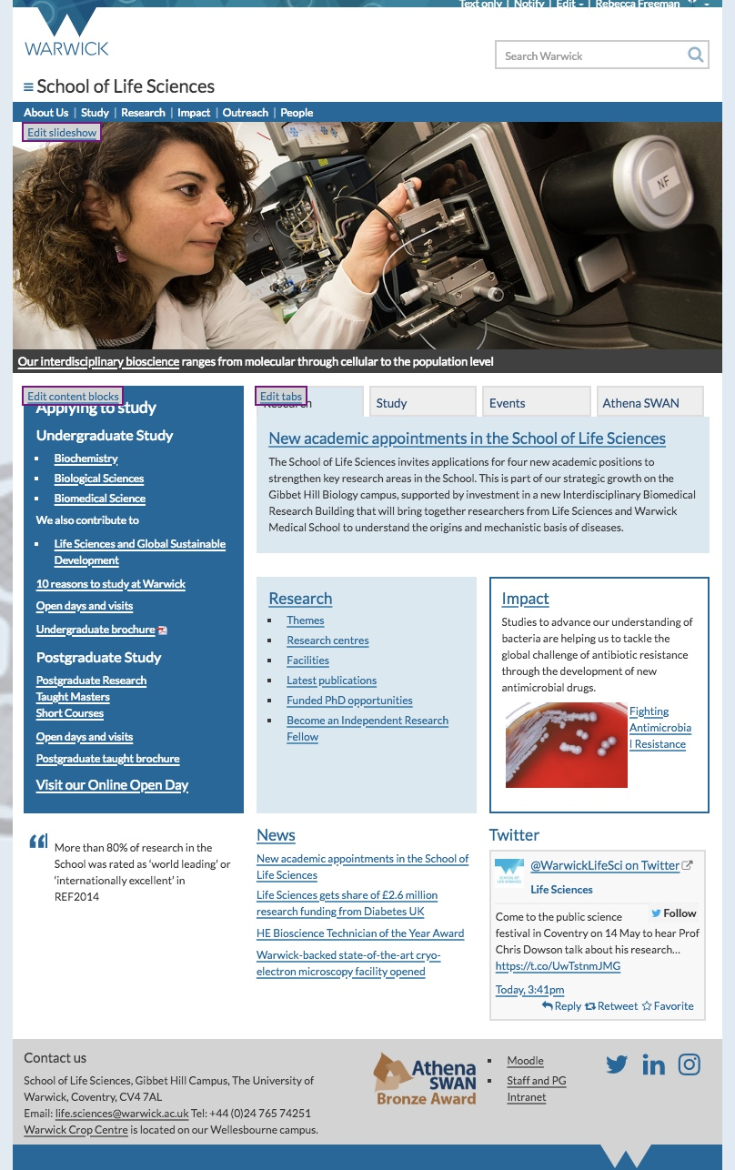
Figure 5.1 SLS website

Since 2014/15 of the 2123 people who have applied for positions in SLS, 822 (39%) applicants were female and 1301 (61%) male (Table 5.1). 391 candidates attended interviews, including 150 (38%) females and 123 offers were made, 57 (46%) to females. Despite lower numbers of female applicants, the shortlist/offer conversion rate for interview is significantly higher than for males (female: 150/57 (38% conversion); male: 241/66 (27%) suggesting that SLS is viewed as an inclusive workplace (Figure 5.2)).

Table 5.1 Job Applications and Success Rates
 |  |  | Female |  |  | Male
 |  | Total number of offers | Applied | Shortlisted | Offered | Applied | Shortlisted | Offered
2014/15 | Level 4 | 1 | 1 | 0 | 1 (100%) | 0 | 0 | 0
2014/15 | Level 5 | 4 | 55 | 5 | 2 (50%) | 51 | 3 | 2 (50%)
2014/15 | Level 6 | 34 | 224 | 38 | 16 (47%) | 327 | 56 | 18 (53%)
2015/16 | Level 5 | 5 | 20 | 4 | 4 (80%) | 17 | 9 | 1 (20%)
2015/16 | Level 6 | 53 | 285 | 66 | 23 (43%) | 497 | 104 | 30 (57%)
2015/16 | Level 7 | 9 | 100 | 13 | 5 (56%) | 208 | 25 | 4 (44)
2015/16 | Level 9 | 1 | 1 | 0 | 0 | 1 | 1 | 0
2016/17 | Level 5 | 3 | 17 | 3 | 2 (67%) | 13 | 7 | 1 (33%)
2016/17 | Level 6 | 11 | 90 | 17 | 3 (27%) | 144 | 27 | 9 (83%)
2016/17 | Level 7 | 1 | 28 | 4 | 0 | 42 | 8 | 1 (100%)
2016/17 | Level 9 | 1 | 1 | 0 | 0 | 1 | 1 | 0
Total |  | 123 | 822 | 150 | 57 | 1301 | 241 | 66
% |  |  | 39% | 38% | 46% | 61% | 62% | 54%

Figure 5.2 percentage female applicants, shortlisted and offers
The UoW Recruitment and Selection and learning module is a requirement for all staff who take part in the recruitment process and since 2016, we have sent regular email reminders to ensure that staff are aware of the requirement. This has resulted in the number of participants trebling from 9 to 29 between 2016 and 2017 (Table 5.2). This marks a positive trend but remains a small proportion of our staff and we are committed to a HoS and HR campaign to ensure that staff complete the training and are excluded from recruitment processes if they do not (SAP 5.1.2). We will also make the 2016 UoW Unconscious Bias module mandatory in order to further strengthen our processes (SAP 5.1.3).
Year | Total | Female | Male | Academics | Research | Teaching | Support
2013 | 15 | 7 | 8 | 9 | 4 | 0 | 2
2014 | 16 | 8 | 8 | 9 | 5 | 2 | 0
2015 | 9 | 6 | 3 | 0 | 4 | 0 | 5
2016 | 9 | 6 | 3 | 6 | 2 | 0 | 1
2017 | 29 | 11 | 18 | 19 | 4 | 2 | 4
Table 5.2 Completion of the Recruitment and Selection e-module
Shortlisting is completed by at least two individuals, using criteria provided on the person specification, ensuring transparency for shortlisting and feedback. We offer Skype interviews if applicants’ personal circumstances make it difficult for them to attend in person. Interview panels are formed using the UoW panel composition guidelines. Both males and females are represented on panels wherever possible, but this can be challenging given the current imbalance in male/female headcount in SLS and a concern for ensuring that female staff are not given undue workload in this area. We are committed to ensuring female and male representation on all interview panels (Table 5.3) from July 2018 and will include junior staff on panels as observers to facilitate their development (SAP 5.1.4/SAP 5.1.5).
Table 5.3 Representation on interview panels
Year | Total Number of recruitment panels | Number of panels with female panel members | Number of panels with male panel members
2015 | 51 | 37 | 46
2016 | 57 | 44 | 54
2017 | 48 | 27 | 33
Silver Action Plan
SAP 5.1.1: Develop a range of case studies on our recruitment webpages showcasing recently recruited females to SLS, what attracted them to the department and their experience since taking up their appointment.
SAP 5.1.2: Implement a Head of School and HR driven initiative to ensure that all staff with a role in Recruitment complete the mandatory Recruitment and Selection module by the end of 2018
SAP 5.1.3: Implement a Head of School and HR driven initiative to ensure all staff involved in recruitment and promotion selection complete the Unconscious Bias training module prior to the 2019 promotion process
SAP 5.1.4: Require male and female representation on all interview panels within SLS from July 2018
SAP 5.1.5: Include junior members of staff as observers to interview panels as part of their ongoing training and development and to allow for a wider pool of panellists in future rounds of interviews.

Induction is crucial to our commitment to ensuring SLS is a welcoming and community focused School. All new SLS staff members are sent a welcome email from SLS HR team providing them with information about their first day and links to essential information. In 2017 we responded to staff feedback by developing an induction booklet, which contains key information including:
- Induction

- Health and Safety
- UoW Diversity in the Workplace Policy, Dignity at Warwick Policy and mandatory Diversity in the Workplace Module
- AS principles and our commitments to and inclusive culture
All staff are welcomed by the HR team through an induction meeting, providing key information on SLS structure, key staff members; and first aiders. An introductory email is sent to the whole School, which contains a synopsis of the new staff member’s role, and their photo. This facilitates quick integration into SLS. Staff are also encouraged to attend the UoW Welcome Meeting which introduces areas such as the Library, Sports Centre, Arts Centre, IT Services and the E,D & I team. UoW has extensive opportunities for mentoring, coaching and job shadowing along with a programme of Inspiring Women talks by speakers from a range of sector and external job roles.
Line managers then take over induction, introducing key staff a tour of SLS and discussion regarding training/support required. For academic staff, line managers also provide a review of laboratory Health and Safety, including a review of H&S and COSSH forms.
In 2016, we introduced popular HoS ‘Welcome Coffee Mornings’ for new staff. These are held once a month and give new and existing staff an opportunity to meet the HoS and other new starters in an informal setting.
To enable continuous improvement, we have introduced a short questionnaire for new staff on the induction process. A total of 71 new staff have completed this and as a result we have introduced improved directions and maps, and more detailed information about support including childcare, flexible working, mentoring and skills development.
Documented probation assessment meetings with line-managers provide the opportunity to ensure that staff feel well supported, identify training needs and review objectives.
Silver Action Plan
SAP 5.1.6: Revise current paper-based induction feedback process to a compulsory online form to ensure a full demographic of feedback and improved opportunity for response analytics for further enhancement of the induction programme
SAP 5.1.7: Develop the induction booklet into an online Virtual Learning Environment (VLE) module to enable completion ahead of arrival and easier links to other training and development modules available online at the institution

In our Bronze Action Plan we committed to improving the historically low number of female staff who have applied for promotion. We introduced a series of measures to actively encourage internal applicants to apply for promotion, including working with Team Leads to identify talent, and the provision of peer support for applications. Since implementation in 2014/15, all female staff members who applied for promotion have been successful at the first attempt. There were 10 successful applications in 2016-17 (including 2 women), relative to a total 13 applications (including 2 women) over the 3 previous years combined (Table 5.4).
- Promotion
Analysis of internal promotion data between 2013-2017 (Table 5.4), shows:
1) All female staff members who have applied for promotion have been successful
2) There are still fewer female than male staff applying for promotion. To address this, we have implemented improvements to the PDR process, which now include a review of staff CVs, and discussion of strengths and weaknesses with a view to providing clear guidance on personal and professional development.
Table 5.4 Promotions
Year | Level applied for | Applied (Successful)
Year | Level applied for | Male | Female
2013-14 | Professor | 1 (0) | -
 | Reader | 1 (1) | -
 | Senior Research Fellow | 1 (1) | -
2014-15 | Principal Research Fellow | 1 (1) | -
 | Professor | 3 (3) | -
 | Reader | 1 (1) | -
 | Senior Teaching Fellow | - | 1 (1)
 | Senior Research Fellow | 1 (1) | -
2015-16 | Professor | 1 (1) | 1 (1)
 | Professorial Teaching Fellow | 1 (1) | -
 | Reader | - | 1 (1)
 | Senior Teaching Fellow | 2 (1) | -
2016-17 | Professor | 3 (2) | -
 | Reader | 5 (5) | -
 | Senior Research Fellow | 1 (1) | 2 (2)
 | Senior Teaching Fellow | 1 (1) | -
 | Total | 23 (20) | 5 (5)

UoW have recently substantially revised the academic promotion process to ensure that it is clear and transparent. There is an open call for promotion applications each summer and any academic staff member can apply, without having to be put forward, combating selection bias. Applicants are required to submit a CV and supporting statement to the SLS Promotion Review Panel which consists of senior academics, and candidates deemed ready for promotion are forwarded to the University-wide promotion review. We recognise that it is key that panel members complete Unconscious Bias training and have included this in the SAP.
Since 2015 the Promotion Review Panel have proactively requested and reviewed CVs from all staff from level 8 and above in order to recommend promotion to Reader and full Professor. Candidates who are not deemed ready are provided with clear and constructive feedback, highlighting how they can improve their CV and promotion prospects. This is also followed up as part of their PDR. We promote the ‘Demystifying the Promotions Process’ sessions that are run by the University which enable people to
hear from those who have successfully completed the process to benefit from their experience.
- Department submissions to the Research Excellence Framework (REF)
Silver Action Plan
SAP 5.1.8: Embed CPD within the PDR process to improve development and promotion prospects. Include discussion of the new University promotion criteria in the PDR process.
SAP 5.1.9: Ensure Research Theme leads actively identify and seek out talent suitable for promotion or new opportunities from within their groups

For RAE08, 48 (84%) males and 9 (16%) females were included in the submission. 16 males and no females were excluded. For REF2014, 43 males (80%) males and 11 (20%) females were included. 12 males and 3 females were excluded. For REF2014, the male/female ratio correlated with the ratio of total academic staff which indicates that there was no gender bias in REF2014.
- Key career transition points: professional and support staff
- Induction
The Induction Programme for PSS mirrors that offered to Academic staff (Section 5.1 ii).
- Promotion
Promotion is primarily through recruitment to the next level of the grade structure either in a new role, revision of roles in response to changing business needs or through secondment opportunities at a higher level. SLS has developed a career guidance document which has been distributed to all PSS staff and is discussed in PDR. It offers:
- opportunities to gain additional experience by supporting wider Institutional activities e.g. open days, exams and graduation ceremonies
- opportunities for job shadowing, mentoring and coaching
- training courses to gain new skills and experience

Through PDR SLS encourages PSS engagement with training courses offered by UoW LDC for both individual skills-based training e.g. delivering presentations, minute writing, IT training and longer-term courses designed to support staff at different levels of seniority (Table 5.5).

Table 5.5 Professional and Support Staff engagement with LDC professional development schemes (2014-2017)
Programme | Male Participants | Female Participants
Warwick Preparing to Manage (WPM) | 1 | 4
Warwick Introduction to Management (WIM) | 1 | 5
Warwick Administrative Management Programme (WAMP) | 0 | 3
Warwick Leadership Programme (WLP) | 0 | 1
Staff discuss their career aspirations and identify training and development needs as part of the annual PDR and we have seen an increased uptake from PSS since 2013 (Table 5.6). In 2016 HR facilitated sessions to inform staff about the PDR process and encourage participation. As a result, we saw a significant increase in participation from all staff and our 2018 PULSE results saw a 13% increase in staff members who felt that the PDR assists them with their longer term career development (38% overall). We will build on this in our action plan with a view to ensuring all staff participate in a PDR on an annual basis (SAP 5.2.1)

Table 5.6 PDR completion by gender and job role
 |  |  | 2013 | 2014 | 2015 | 2016 | 2017
 |  | Total Staff | 262 | 261 | 261 | 271 | 286
 |  | Total PDR’s Completed | 53 (20%) | 71 (27%) | 177 (68%) | 118 (44%) | 184 (64%)
Academic | F | Staff | 13 | 14 | 13 | 14 | 19
Academic | F | PDR’s Completed | 2 (15%) | 3 (21%) | 11 (85%) | 8 (57%) | 14 (74%)
Academic | M | Staff | 51 | 48 | 43 | 47 | 53
Academic | M | PDR’s Completed | 9 (18%) | 20 (42%) | 34 (79%) | 18 (38%) | 49 (92%)
Research | F | Staff | 39 | 41 | 51 | 54 | 52
Research | F | PDR’s Completed | 7 (18%) | 11 (27%) | 26 (51%) | 29 (54%) | 41 (79%)
Research | M | Staff | 43 | 46 | 47 | 48 | 48
Research | M | PDR’s Completed | 4 (9%) | 5 (11%) | 30 (64%) | 14 (29%) | 16 (33%)
Support Staff | F | Staff | 74 | 69 | 68 | 63 | 67
Support Staff | F | PDR’s Completed | 11 (15%) | 24 (35%) | 46 (68%) | 28 (44%) | 36 (54%)
Support Staff | M | Staff | 42 | 43 | 39 | 45 | 47
Support Staff | M | PDR’s Completed | 20 (48%) | 8 (19%) | 30 (77%) | 21 (47%) | 28 (60%)

Silver Action Plan
SAP 5.2.1: Implement compulsory PDR for all academic and PSS in SLS to ensure that all staff have the formal opportunity to consider their progress, performance, skills development and career progression on an annual basis.

- Career development: academic staff

(i) Training
In our Bronze Action Plan we committed to actively encourage engagement with leadership and management courses aimed at senior staff ensuring that time to engage with these courses is factored as part of the workload model. This has resulted in the promotion of 2 senior academic staff who engaged with the Aurora Leadership Programme and one PSS staff member through the Warwick Leadership Programme.
The University strongly supports training and development for all staff. The Learning and Development Centre (LDC) provides a range of training activities tailored to academic staff of all levels. Opportunities are promoted via a weekly email, at staff meetings by the HoS, and at SLS seminars. This commitment to development of academic staff has led to significant engagement (Table 5.6), with participation of ~39% of female, and ~46% of male, academics.
Table 5.7 Academic and Professional and Support Staff (PSS) engagement with LDC training schemes (2013-2017)
Gender | Female | Male
Academic | 28 (39%) | 46 (46%)
PSS | 41 (61%) | 16 (34%)
Total | 67 (48%) | 62 (41%)

All staff: are currently encouraged to complete the Diversity in the Workplace e-learning module (Table 5.8). We are proud of our current 59% completion rate but as the training expires after 3 years we recognise the importance of continued encouragement to ensure all staff are up to date. We circulate regular emails to remind staff to complete the training and require all new starters to complete this on arrival (Table 5.8). We are committed to strengthening our efforts to ensure staff completion through our SAP as we regard it as an important approach to ensuring a general understanding of the value of inclusivity across the School (SAP 5.3.1).

Table 5.8 Number of members of staff within SLS who had up to date training in the Diversity in the Workplace module
 |  | 2013 | 2014 | 2015 | 2016 | 2017
 | Total staff | 262 | 261 | 261 | 271 | 286
 | Training completed | 42 (16%) | 67 (26%) | 101 (39%) | 87 (32%) | 170 (59%)
Academic | Staff | 60 | 58 | 48 | 52 | 61
Academic | Training completed | 15 (25%) | 18 (31%) | 18 (38%) | 8 (15%) | 24 (39%)
Research | Staff | 82 | 87 | 98 | 102 | 100
Research | Training completed | 6 (7%) | 21 (24%) | 35 (36%) | 43 (42%) | 71 (71%)
Teaching | Staff | 4 | 4 | 8 | 9 | 11
Teaching | Training completed | 1 (25%) | 4 (100%) | 4 (50%) | 3 (33%) | 6 (56%)
Support | Staff | 116 | 112 | 107 | 108 | 114
Support | Training Completed | 20 (17%) | 24 (21%) | 44 (41%) | 33 (31%) | 69 (61%)

PDRF: are encouraged to take up LDC training through PDR and through the Office for Postdoctoral Affairs (OPDA). PDRFs are also able to enrol on the Postdoctoral Transferable Skills training programmes: a nationally recognised certificate worth 60 Master’s credits, or a university recognised transferable skills award worth 30 Master’s credits. Many PDRFs look for opportunities to develop their CV by gaining teaching experience and wherever possible we provide opportunities in SLS. In the 2016/17 academic year 6 PDRFs (4 female) were given tutor roles, 3 male PDRFs were allocated lectures and 7 (3 female) were allocated MSc teaching. Since 2012, 24 PDRFs (14 females and 10 males) have completed an LDC-run, nationally recognised qualification of Associate Fellow of the Higher Education Academy.
Newly appointed level 7 academic staff: are required to complete the Academic and Professional Pathway for Teaching Excellence. These staff have an academic mentor appointed formally, with termly and annual reviews by the HoS.
Level 8 and 9 staff: have the opportunity to complete the Warwick Leadership Programme as well as the other LDC ad hoc courses.
All teaching staff: are actively encouraged to achieve Higher Education Academy (HEA) Fellowship which offers a nationally recognised qualification to staff. We also require that staff complete SLS personal tutor training (beyond what is expected by the university) as a condition for completion of their probationary period in order to ensure that teaching staff are equipped with the skills required to support students.
- Appraisal/development review
Silver Action Plan
SAP 5.3.1: Implement a Head of School driven initiative to make the E&D Diversity in the Workplace training module compulsory for all staff members

In our Bronze Action Plan we committed to increasing participation in the PDR process in order to better identify staff development needs. We held a training session during an Academic Staff Meeting to explain the PDR process and advice on targets that individuals should be achieving at each career level and saw a 15% increase in participation in 2017 (Table 5.6).
All staff are strongly encouraged to take part in a PDR on a yearly basis, with the option for a mid-term review with their line manager if required. For PDRF staff, PDRs are conducted by their line manager, and academic staff reviews are conducted by a senior SLS academic. Historically, there has not been much uptake of PDR within our PDRF community, anecdotally due to their regular progress meetings with their line managers. In 2017, we ensured that line managers encouraged this opportunity to discuss developmental needs.
Currently over half of our staff participate in the PDR process, a substantial increase since 2013 (Section 5.2 (ii) Table 5.6). In addition to PDR, new appointments are assigned at least one mentor with whom they meet at least twice a year or whenever requested by the mentee, as well as engaging in termly probation reviews with the HoS. These meetings provide the opportunity for aspects of an individual’s development, including training and support, to be identified and acted upon, as well as target setting for independence, e.g. grant income, publication outputs.
UoW run a merit pay scheme which recognises sustained excellent performance. Our analysis suggests there is no gender difference in nomination for merit pay (Table 5.9).
Table 5.9 Merit pay awards in 2017
Gender | Eligible | Nominated | Percentage Nominated
Female | 122 | 42 | 34.43%
Male | 109 | 33 | 30.28%
In our Bronze Action Plan we committed to improving Postdoctoral training though the creation of the OPDA consisting of a Director of Postdoctoral Affairs, his deputy and a Chair of a newly formed Postdoctoral Society. The creation of this team has resulted in increased engagement with training opportunities. We also committed to improving PDRF participation in SLS committees to enable PDRF to gain valuable experience in the fundamental workings of SLS and PDRF hold at least 1 PDRF position on all key SLS committees relevant to them. Since 2016, 7 PDRFs have held SLS committee membership.
- Support given to academic staff for career progression
The position of Director of Postdoctoral Affairs (DPDA) provides a strategic focus on PDRF development. The OPDA meet regularly to identify training and impact opportunities to benefit PDRF career progression. This involves organising regular meetings, consultation with the PDRF community and providing a gender-balanced programme of internal and external speakers. The OPDA organises well-attended social gathering for PDRFs twice a year. Feedback on experiences and training needs, and other pressing issues (e.g. flexible working, Section 5.5) are gathered at these events. Based on feedback from PDRF we are currently developing a PDRF peer group seminar series (SAP 5.3.2).
The 2016 PDRF survey was undertaken to better understand the training needs of PDRF (Table 5.7). 41% of PDRF responded ( 61% female). In response SLS introduced a dual mentor scheme in Spring 2017, through which PDRFs receive mentoring from another academic in addition to their supervisor. So far 29 staff (34% female), have been recruited as mentors, with 9 PDRFs (78% female) currently being mentored. All new PDRFs are informed about the scheme at induction and we are committed to ensuring that mentors receive appropriate mentoring training.

Table 5.7: PDRF annual survey results regarding training
Do you feel well informed about research fellow group activities | 15/16 - Positive responses  1/16 – Negative response
Have you been receiving Research Fellow group emails | 16/16 - yes
Have you signed up to the Post-doc Discussion Forum (link on the Research Fellows web-page)? | 4/16 – Yes  3/16 – Don’t know  9/16 - No
Would you be potentially interested in taking an active role in Research Fellows group? | 5/16 – Yes  7/16 – Maybe  9/16 - No
Could you list 3 topics that you would like to address/hear about in the next academic year? | 6 “Funding opportunities”  6 “Career development”  3 “Non-academic careers”  2 “Teaching training”
Would you participate in Post-doc group seminars to practice upcoming talks and give/receive feedback? | 11 “Yes”  2 “Maybe”  3 “No”
In our Bronze Action Plan we committed to improving support for young academics through an increased probation period of 5 years (longer that the 3-year period at most UK institutions). This alleviates pressure from assistant professors, allowing them to perform their roles more effectively. Further support is provided through a mentoring scheme and probation meetings. Since 2013, 4 assistant professors have completed their probation period early (1 female and 3 male).
Successful navigation of probation is based on developing skills and ultimately taking a full teaching load, participating in SLS and UoW administrative tasks, publishing, and obtaining grant funding. Completion of probation is determined by the gender-balanced University probation panel chaired by the Provost. The HoS meets with probationers once a term and more frequently if further support is required. Probationers are also allocated at least one mentor who they meet with formally twice a year. Mentors are drawn from academics of both genders, and each mentor is specifically selected to best suit the appointee following the introductory meeting with the HoS.
- Support given to students (at any level) for academic career progression
Silver Action Plan
SAP 5.3.2: Introduce a PDRF peer group seminar series, which will be organised by the Postdoctoral Society, where the contributors and audience will be exclusively PDRFs
SAP 5.3.3: Publicise and improve the mentoring of PDRF by promoting engagement with the scheme through PDR and ensuring all mentors complete the relevant training

In our Bronze Action Plan we committed to improving our employment outcomes for undergraduates. As part of our continued commitment to improving the prospects for our students, we worked with our SLS Careers Adviser to implement
- a range of timetabled lectures,
- termly Careers Network events which are open to all students and PDRFs and provide an opportunity to hear from alumni who have entered a range of careers and further study followed by networking
- one-to-one appointments
We also introduced:
- tailored support for medical applications through MASP
- CV writing within the taught tutorial programme
- Opportunities to develop transferable skills through the Science 101 module
- Modules on teaching biology and science communication
- Promotion of the SPRINT female development programme, delivered with employers to develop female confidence and assertiveness
These measures have resulted in improved employment in graduate level roles or further study from 68% to 81% over the past 4 years (Table 5.8).
Table 5.8 HESA Employment Performance Indicator (PI) and Graduate Prospects (GP) percentages for our graduates.

 | HESA Employment Performance Indicator
 | 2011/12 | 2012/13 | 2013/14 | 2014/15 | 2015/16
HESA Employment Performance Indicator (PI) | 91.5% | 90.7% | 89.6% | 93.6% | 91.3%
Graduate Prospects (GP) | 67.7% | 69.6% | 68.7% | 78.8% | 81.2%
We run a PGT specific careers event with sessions focused on academic and other careers which is attended by alumni from our PGT degrees.
PGR students are required to register on the PGCTSS (Postgraduate Certificate in Transferable Skills in Science) which includes team working, science communication, decision making and leadership, ethics, business, innovation and commercialisation. We provide teaching opportunities for all of our PGR students within the teaching laboratories which develops skills for a range of careers including academia and teaching.

(v) Support offered to those applying for research grant applications
We have a dedicated Research Support Development Officer, who works with the University’s Research and Impact Services (RIS) team to ensure a strategic approach for applications to funding. We insist that all draft proposals have input from the UoW Impact Manager and data management team. Since 2014, we have required SLS internal peer review for RCUK applications in order to support application development. In 2016, we implemented a hustings programme, where academics pitch grant ideas to an independent panel of academics of both genders, to support the peer review process. We gather feedback from funders when proposals have been unsuccessful and use this information to strengthen future applications. The number of applications made by female academics is over 20% across funding bodies (20% of SLS academics are female suggesting no gender difference in application frequency) (Figure 5.3).
Figure 5.3 Number and percentage of grant applications to funders by gender (2015-2016)
We provide individual support for PDRF applications, including meetings with current or former fellowship holders, personalised feedback on applications, mock interviews for candidates, grant writing workshops and funding opportunity seminars given by representatives of funding bodies and members of staff who sit on funding body panels. Numbers of Postdoctoral researchers applying for independent fellowships has trebled over the past 3 years. However, success has yet to come (none awarded) and we plan to introduce further support for this process (SAP 5.3.4).
Success rates of grant applications (Figure 5.4) and average values per award (Figure 5.5) for each gender are funder dependent. The results from the data including all applications show no evidence for gender differences in overall application numbers, success rate, or average value per award in SLS.

Figure 5.4 Success rates of grant applications by funders in 2015-2016*

Figure 5.5 Average value per award by gender in 2015-2016 (Numbers on bars show success rate of applications to each funding body)
Silver Action Plan
SAP 5.3.4: Introduce a programme of hustings sessions and peer review for fellowship applications to better prepare PDRFs for these competitive opportunities

- Career development: professional and support staff
- Training
SLS is committed to our PSS and their development. PSS, like academics have access to LDC training tailored to support staff of all levels providing:
  - Job specific training, e.g. introduction to finance, report writing (2012-2017, 41 female and 16 male).
  - Self-improvement based training, e.g. understanding your personality type, mind-mapping (2012-2017, 8 female and 6 male).
  - E&D training modules, e.g. disability awareness, mental health awareness (2012-2017, 13 female and 4 male)
  - Managerial training, through training on non-competitive courses, e.g. handling difficult conversations, mentoring and coaching, (2012-2017, 26 female and 10 male)
  - Managerial skills through competitive entry courses, e.g.: ‘Preparing to Manage’, ‘Introduction to Management’, ‘Administrative Learning Programme’ and ‘Warwick Leadership Programmes’
Staff also have a Warwick Learning Account (WLA) (Table 5.9), which provides vouchers to use in order to complete short courses and workshops e.g. career development and coaching studies, learn a language or in part payment towards part-time degrees.
Table 5.9 Warwick Learning Account voucher scheme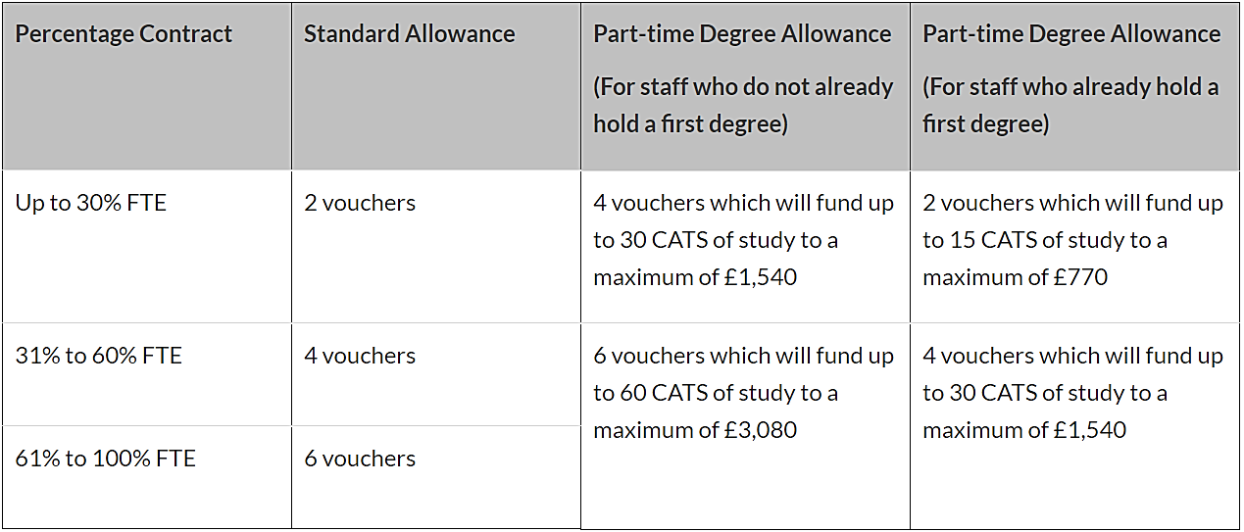
- Appraisal/development review
The PDR process for PSS is tailored more directly for PSS needs. In 2017, we provided tailored PSS training sessions on the PDR process in order to encourage greater engagement in the process. This was attended by 40% of PSS staff, which led to a substantial increase in participation (Table 5.6). PSS PDR has a focus on: 1) achievement and contributions to SLS and their team, as measured by the achievement of goals and 2) Personal development, including goal setting for the future. Line managers encourage engagement with training for personal development. Wherever possible we encourage staff to build relationships with those in equivalent positions in other departments to share good practice.
The SAT conducted a survey of PSS regarding their interest and participation in coaching and mentoring in August 2017 and found that 67% of those who responded would like to receive coaching or mentoring (Table 5.10). Comments indicated that coaching and mentoring provided, 1) access to knowledge and networks (14 responses), 2) career progression (14 responses), and 3) confidence building (9 responses). We will promote coaching and mentoring opportunities and trial a work shadowing programme in SLS to enable more staff to engage (SAP 5.4.1).

Have had  Coaching | Female | 9 (22)  (6 formal & 3 informal) | 39%
Have had  Coaching | Male | 4 (10)  (1 formal & 3 informal) | 40%
Have had Mentoring | Female | 2 (22)  (2 formal) | 9%
Have had Mentoring | Male | 0 (10) | 0%
Would like Coaching | Female | 7 (22) | 31%
Would like Coaching | Male | 5 (10) | 50%
Would like Mentoring | Female | 7 (22) | 31%
Would like Mentoring | Male | 3 (10) | 30%

Table 5.10 Results of coaching and mentoring experience and needs from August 2017 PSS survey

(iii) Support given to professional and support staff for career progression
Silver Action Plan
SAP 5.4.1: Promote the UoW work shadowing programme and conduct a follow up survey to assess impact.

The School is fully committed to enhancing career progression for our PSS. Since 2013, we have created more depth within technical support teams, which has enabled progression within those teams. Warwick has recently launched the Technician Commitment; a scheme designed to recognise the important contribution of technicians and support professional registration and career development. The Vice Chancellor, has created a Technicians Steering Committee to develop a framework which is transparent, fair and enables clear equality of opportunity for development and progression, through to Professorial-grade equivalent. Two of our SLS technicians (1 female, 1 male) have been featured on the ‘Meet our technicians’ pages showcasing their impressive work (Figure 5.6). The scheme website also highlights the recent awarding of RSB HE Bioscience Technician of the Year to our Teaching Laboratory Manager (Figure 5.7) who was nominated by SLS for her work on the International Biology Olympiad which we hosted in 2017.
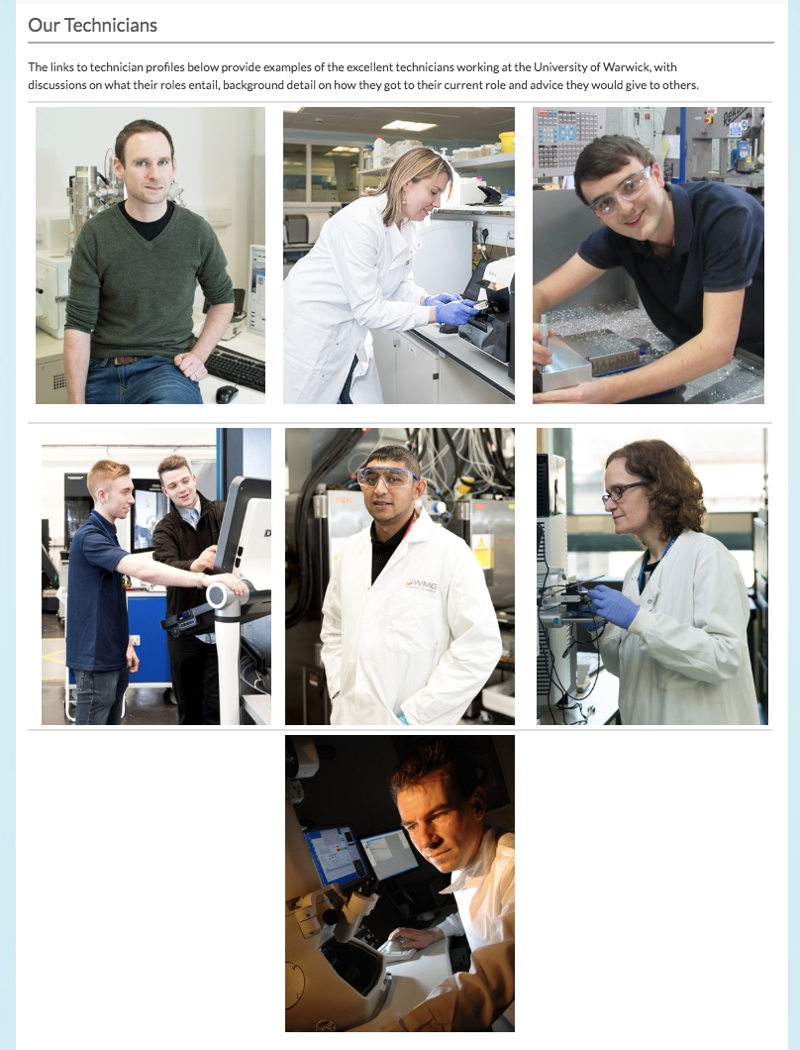
Figure 5.6 Meet the technicians UoW webpage from the Technician Commitment - SLS Technicians top centre and bottom centre

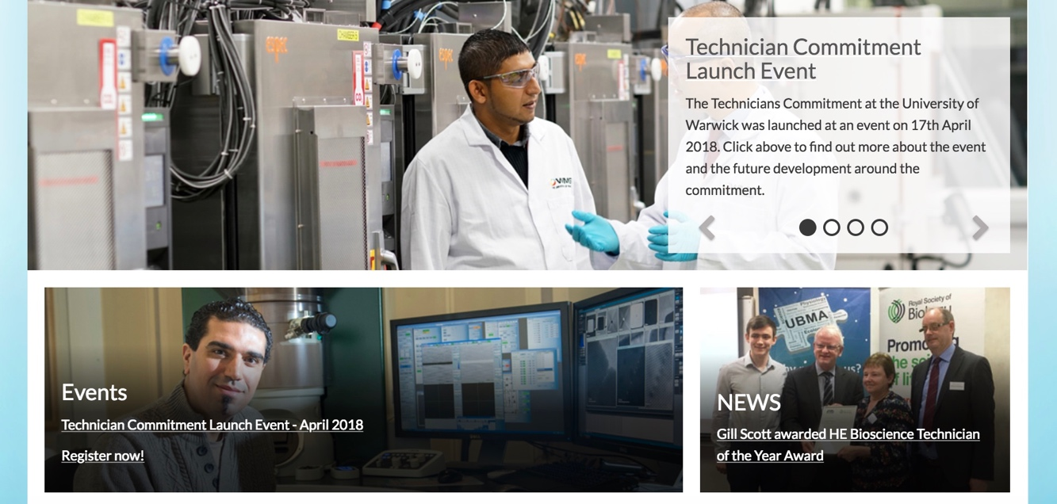
Figure 5.6 Gill Scott awarded HE Bioscience Technician of the Year Award featured on the UoW Technician Commitment webpage
Where there are limited opportunities for a staff member to progress within the School, PSS are encouraged to make use of shadowing and secondment opportunities within UoW to explore opportunities elsewhere. PSS staff are able to access the UoW Careers Network which matches individuals with senior staff members to work through CVs and applications.

- Flexible working and managing career breaks

(i) Cover and support for maternity and adoption leave: before leave
In our Bronze Action Plan, we sought to address circumstances where PDRF taking maternity leave between research projects funded by charity bodies could be disadvantaged in terms of salary increases and the duration of the second research project. We agreed that SLS would cover any shortfall in these circumstances and have provided financial support for 2 PDRF and a Project Coordinator.
Staff complete a ‘Maternity and Adoption Leave Plan’ with their line manager to plan for leave and University entitlements. A meeting takes place with the staff member, their manager and SLS HR to complete University ‘Checklists’ for employees and managers, which assess the need for risk assessment, maternity cover of duties, the UoW child care vouchers scheme, and Keeping in Touch (KIT) days. No staff have taken adoption leave in the last 4 years. UoW shared parental leave policy is also highlighted on our website.

(ii) Cover and support for maternity and adoption leave: during leave
Staff request a range of levels of communication whilst on leave ranging from involvement in any work which will impact their role to no contact while on leave.
Cover for maternity is dealt with on a case by case basis and is arranged well in advance of the period of leave wherever possible to ensure a smooth handover.
No work is required while on maternity or adoption leave but employees can take up to 10 paid KIT days. Since 2014 four staff have taken a total of 13 KIT days, which have been used for activities such as PhD student supervision and conference attendance.

(iii) Cover and support for maternity and adoption leave: returning to work
We recognise that returning to work can be a challenging time for new parents and we seek to make the transition as smooth as possible. HR contact returners to welcome them back and provide information on the University’s Working Parents’ Network and line managers ensure that desks, IT equipment etc are available to facilitate a smooth return. SLS provides a nursing mothers room, available to all SLS staff and students. Where possible requests for part time working and phased return to work are considered subject to business need. Accrued annual leave can be used to ease transition back to work.
SLS worked with UoW central HR to determine the financial impact of maternity, extended paternity and adoption leave for academic staff. This resulted in the ‘Warwick Academic Returners Fellowship’, launched in 2015 which provides funds to cover teaching commitments for a length of time which matches the length of leave taken so they can concentrate on research. This scheme is available to SLS academic returners but has not been used within SLS to date (SAP 5.4.2).

(iv) Maternity return rate
Silver Action Plan
SAP 5.4.2 Promote the range of support available in terms of maternity, paternity, adoption and shared parental leave, arrangements while on leave and support available through the Academic Returners Fellowship

Of the 15 women taking maternity leave over the last four years, 3 women did not return to work or left within 3 months of returning (Table 5.11). Reason for no return was that the end of fixed contracts had been reached. Where contracts are due to expire during parental leave this is discussed with line managers as part of the parental leave planning process in order to evaluate opportunities within SLS and elsewhere. All other women were still working in SLS 18 months after their return to work.

Table 5.11 Maternity return rate
Staff group | Year | No.  employees | Left before end of ML | Left within 3 mths of ML end | Left within 18 mths of ML end
Academic (including teaching and research only staff) | 2012/13 | 1 | 0 | 0 | 0
Academic (including teaching and research only staff) | 2014/15 | 2 | 0 | 0 | 0
Academic (including teaching and research only staff) | 2015/16 | 2 | 1 | 0 | 0
Academic (including teaching and research only staff) | 2016/17 | 2 | 0 | 0 | 0
Professional & Support Staff (grades 1-9) | 2013/14 | 1 | 0 | 0 | 0
Professional & Support Staff (grades 1-9) | 2014/15 | 3 | 0 | 0 | 0
Professional & Support Staff (grades 1-9) | 2015/16 | 3 | 1 | 1 | 0
Professional & Support Staff (grades 1-9) | 2016/17 | 2 | 0 | 0 | 0

(v) Paternity, shared parental, adoption, and parental leave uptake
Staff requesting formal paternity (Table 5.12) or adoption leave attend a meeting with SLS HR to discuss University policies and options, including parental leave and pay, shared parental leave, and time off to attend antenatal appointments. SLS policy is to encourage full uptake of paternity, parental and adoption support and benefits.

Table 5.12 Paternity leave rates
Staff Group/Year | 2012/13 | 2013/14 | 2014/15 | 2015/16 | 2016/17
Academic (including teaching& research only staff) | 3 | 1 | 5 | 0 | 0
Professional & Support staff (grades 1-9) | 0 | 1 | 0 | 0 | 0

In our Bronze Action Plan we planned to carry out a survey to better understand flexible working patterns in SLS and identify barriers in order to enable us to raise the profile of flexible working options. We carried out a survey in 2016 and 2017 and identified a range of factors that restrict uptake which we address in (SAP 5.5.1/SAP 5.5.2).

(vi) Flexible working
SLS provides a supportive environment and many staff have formal or informal flexible working arrangements. Flexible and part-time working has remained broadly stable within most groups over the last 5 years (Table 5.13). Applications for part-time and flexible working are supported subject to business need. Details and guidance on working flexibly are available to staff on the SLS HR intranet pages.
The 2016 PULSE survey found that 37 % of staff responded positively to the statement ‘I am satisfied with the support the University offers to help me balance my work and home life’, a reduction of 8% relative to 2014.
To address this issue, anonymous flexible working surveys were used to determine numbers of staff with informal flexible working arrangements. The surveys assessed reasons for, and barriers to, flexible working (Table 5.14). Most flexible working arrangements were found to be ad-hoc, and not formally reported. Results indicated that most flexible workers were female (61% average). Only 2% of survey responders had had a formal request to work flexibly turned down. The top three constraints to flexible working highlighted by the surveys were job requirements, car parking issues and scheduled seminar/lecture times. Results were publicised via the SLS website, email and at staff meetings and used to develop initiatives for the SAP (SAP 5.5.1/SAP 5.5.2). Unfortunately, the question on work and home life balance was removed from the 2018 survey but further discussions will be held with staff as part of the 2018 PULSE workshops.

Table 5.13 Part time working rates for SLS over the last 5 years
Year | Contract Type |  | Female |  |  | Male
Year |  |  | Academic staff  (including teaching and research only staff) | Levels 6 to 9 support staff | Levels 1a to 5 support staff | Academic staff  (including teaching and research only staff) | Levels 6 to 9 support staff | Levels 1a to 5 support staff
2013 | Full Time |  | 36 | 15 | 30 | 89 | 11 | 27
2013 | Part Time |  | 12 | 3 | 22 | 4 |  | 3
2013 | Part Time | % PT | 25% | 17% | 42% | 4% | 0% | 10%
2014 | Full Time |  | 45 | 12 | 26 | 87 | 11 | 28
2014 | Part Time |  | 7 | 4 | 23 | 6 |  | 3
2014 | Part Time | % PT | 14% | 25% | 47% | 7% | 0% | 10%
2015 | Full Time |  | 55 | 14 | 22 | 85 | 12 | 24
2015 | Part Time |  | 7 | 3 | 26 | 4 |  | 3
2015 | Part Time | % PT | 13% | 18% | 54% | 5% | 0% | 11%
2016 | Full Time |  | 59 | 13 | 25 | 88 | 12 | 30
2016 | Part Time |  | 7 | 2 | 22 | 6 | 1 | 2
2016 | Part Time | % PT | 11% | 13% | 47% | 6% | 8% | 6%
2017 | Full Time |  | 56 | 11 | 27 | 93 | 12 | 29
2017 | Part Time |  | 13 | 4 | 24 | 7 | 1 | 5
2017 | Part Time | % PT | 19% | 27% | 47% | 7% | 8% | 15%

Table 5.14 2017 Flexible Working Survey Results
Who responded | 96 people completed the survey: 34% of SLS staff.  57 academic/research staff; 31 school support staff; 9 research support staff; 2 others responded  57% of responders were female
How many have worked flexibly in the last 12 months? | 88%
How do they work flexibly? | 80% alter arrival and leaving times  55% work from home  48% work evenings and weekends  10% work flexi time  4%: work a condensed week/fortnight
Why do they work flexibly? | 48% work/life style balance  44% demands of job  42% childcare responsibilities  40% more productive  14% health reasons  8% other caring responsibilities
What constraints are there to flexible working? | 41% job requirements  37% car parking issues  27% scheduled meeting/seminar/lecture times  25% team requirements  24% no constraints  9% line manager
Are their flexible working arrangements formal or informal? | 83% have not formalised their flexible working arrangement  17% have formalised their flexible working arrangement
How many had a formal request to work flexibly turned down? | 2%
How many had an informal request to work flexibly turned down? | 5%
Silver Action Plan
SAP 5.5.1: Investigate practical solutions to a shortage of parking on the Gibbet Hill campus, particularly during term time
SAP 5.5.2 Encourage teaching staff with flexible working needs to communicate any problems with their lecture/seminar schedule that inhibit their need to work flexibly at the point of workload release to enable solutions to be identified
The School is as flexible and accommodating as possible for staff returning from career breaks who work part-time and wish to take up full-time work. Practice is tailored to both the individuals’ and business needs and phased returns encouraged wherever possible to enable staff to ease back into full time hours.

(vii) Transition from part-time back to full-time work after career breaks

- Organisation and Culture
- (i) Culture
Through our Bronze Action Plan we wanted to raise the level of transparency in SLS and develop a stronger sense of community. In order to achieve this, we reorganised our committee structure and feedback mechanisms to ensure clear reporting routes to and from committees, a greater emphasis on communication from all committees and regular all staff and all academic staff meetings. We were delighted that the 2016 PULSE survey saw a 42% increase for ‘openness and honesty in communications from Heads of Department/Senior Managers’ with a further 29% increase in the 2018 survey. There was also a 38% increase in those who responded positively to the ‘department/unit/service area doing a good job of keeping them informed about matters affecting them’ in 2016 which has increased by a further 10% in 2018.
Over the past 3 years following a review of the School we have had a strategic focus on culture and community in everything we do. We are proud of our diverse student and staff populations and seek to support and celebrate their success. This extends to our relationship with students and our commitment to community and collegiality was commended by the RSB following their accreditation visit in 2016.
We take staff feedback very seriously and given the clear links between staff experience and our commitment to the Athena Charter the SAT takes the lead on the analysis of the biannual PULSE Survey and has seen significant improvements to staff satisfaction as a result. Making this clear link enables the SAT to further explore the data through snap surveys and workshops and provide all members of the School with the opportunity to shape the resulting actions. These actions are then embedded in our AS Plan.
We have developed a popular annual Health and Wellbeing event for students and staff which brings people together with internal and external wellbeing services to encourage a healthy lifestyle for all, hold regular social events, ensure all staff are invited to our public science evenings and are committed to acknowledging our staff contributions through internal (WATE and Staff Award) and external (RSB Teacher of the Year and Technician of the Year) nominations.
The commitment of SLS to AS values is evident through all promotion and events and we strive to ensure that our diversity as a School is prominent. An AS banner was produced in January 2016 and is now a fixture at all internal and external SLS events (Figure 5.7).
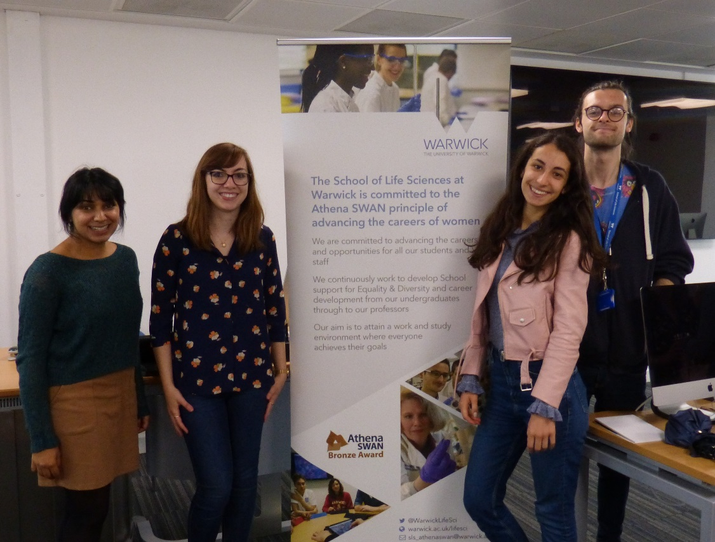
Figure 5.7 SLS Athena Banner

We have made great improvements. Our 2016 PULSE staff survey results indicated that only 17% of staff felt able to speak up and challenge the way things are done at UoW and only 39% believed that ideas that they communicated in the survey would be acted on. To address this, we developed a School Communication Strategy and held workshops with academic and PSS to shape our approach to communication. As a result of these workshops we introduced a range of measures:
- regular snap surveys (flexible working and mentoring are recent examples) to ensure staff consultation underpins the development of our policies,
- a monthly newsletter which updates on achievements and successes
- the monthly ‘meet the Head of School’ session to which all staff are invited to for informal discussion.
- a fixed iPad survey in the central Atrium in 2017, to capture staff comments and suggestions to be considered by the SAT. Feedback via this route has led to improvements to our induction book, intranet and newsletter.
Our results improved significantly in PULSE 2018 with 37% of staff feeling able to speak up and 49% believing that their ideas would be acted upon but there is room for further improvement and we aim to identify further approaches to ensuring staff engagement through the current PULSE consultation process. We recognise that people’s identities and social position are shaped by a range of factors and are currently reflecting on the ECU work on Intersectional Approaches to Research and Data as we develop staff workshops to explore their experiences in the School. The move towards subject level TEF in 2019 also provides an opportunity for us to consider our intersectional data relating to students more carefully to inform what we do.
SLS is in the process of planning a new building and renovations of the existing campus and we are working to ensure that AS values are in the foreground throughout the process.
Silver Action Plan
SAP 5.6.1: Analyse data on protected characteristics of SLS staff, students and job applicants, and identify specific actions related to recruitment, development and role models to ensure SLS is a supportive environment for everyone
SAP 5.6.2: Support raising of gender awareness using university resources and SLS media
SAP 5.6.3: Work with UoW Estates to ensure that all new building projects take account of UoW policies on accessibility and inclusivity including the provision of gender neutral toilet facilities

- HR policies
The HR Officer works with the HoS to ensure that HR policies for equality, dignity at work, bullying, harassment, grievance and disciplinary are followed consistently and equitably. Staff are updated on policies by email with links to webpages. For specific issues, e.g. disciplinary, performance issues, bullying and harassment UoW also has an online reporting form, highlighted to staff, which enables staff to speak to a Dignity Contact within SLS or externally at UoW. Staff are also able to report concerns anonymously online.
The 2016 and 2018 PULSE revealed that 8 % of SLS staff feel that they have been subject to bullying or harassment in the workplace. Of staff subjected to bullying in 2018, 10% (3) were on the grounds of disability, 13% (4) sex and 13% (4) ethnicity. Considerable work was undertaken following the 2016 survey to promote the UoW ‘Dignity at Warwick’ policy and the process for reporting bullying through SLS staff meetings, the AS webpage, the SLS induction booklet, posters and through distribution of the Diversity and Inclusion update emails to all staff. We are concerned by the continued poor performance in this area and will be building in further actions to our action plan following further staff consultation (SAP 3.1). In this context the requirement for all staff to complete the Diversity in the workplace training is particularly urgent and will be highlighted at the PULSE staff workshops (SAP 5.3.1).

SLS committees were comprehensively reorganised in 2014-2015, when new Research Management, Research Strategy and Teaching strategy committees were introduced. Female membership of committees in 2016 ranged from 28% to 36%, which reflects the relatively low number of female staff (20%) of academic staff in grades 7-9 (Table 5.15). Women chaired 3 of the 4 main decision making committees in 2015, 2 in 2016 and 1 in 2017 which reflects the standing down of the female HoS in 2017. SLS considers both gender representation, and workload model allocations when deciding committee membership, and the need to avoid overburdening women with committee membership is recognised.
- Representation of men and women on committees
Silver Action Plan
SAP 5.6.4: Introduce deputy committee Chair roles in 2018, in order to offer developmental opportunities to staff. We will encourage women to take Chair and deputy Chair roles through PDR discussions

Table 5.15 Membership of the key decision making committees in SLS
Research Management, Teaching Strategy and Research Strategy Committees did not exist prior to 2015
 | 2013 |  |  |  | 2014 |  |  |  | 2015 |  |  |  | 2016 |  |  |  | 2017
 | Chair | Male | Female | % Female | Chair | Male | Female | % Female | Chair | Male | Female | % Female | Chair | Male | Female | % Female | Chair | Male | Female | % Female
Research Management Committee |  |  |  |  |  |  |  |  | F | 8 | 4 | 33 | F | 9 | 4 | 31 | M | 10 | 4 | 29
Teaching Strategy Committee |  |  |  |  |  |  |  |  | F | 5 | 2 | 29 | M | 8 | 4 | 33 | F | 7 | 3 | 30
Research Strategy Committee |  |  |  |  |  |  |  |  | F | 4 | 2 | 33 | F | 6 | 3 | 33 | M | 6 | 3 | 33
Undergraduate Teaching Management Committee | M | 10 | 7 | 41 | M | 12 | 7 | 37 | M | 13 | 7 | 35 | M | 13 | 5 | 28 | M | 12 | 7 | 37
Postgraduate Affairs Committee | M | 11 | 8 | 42 | M | 12 | 9 | 43 | M | 9 | 7 | 44 | M | 9 | 5 | 36 | M | 5 | 4 | 44

We are proud that many of our staff sit on influential external committees. In 2017-2018 Warwick female academics have been members of UK Government Advisory committees, the Food Standards Agency Science Council, funding panels (BBSRC, Defra, Wellcome Trust, MRC, Royal Society), Advisory and Steering committees (European Bioinformatics Institute, BBSRC, MRC and NERC), and Council members of various Learned Societies. Membership of external committees is recorded informally through PDR and is considered when nominations for merit pay are made and we commit to collecting and reviewing the data centrally (SAP 5.6.6).
Silver Action Plan
SAP 5.6.5: The SLS workload model will be comprehensively reviewed in 2018 to ensure recognition of all roles and parity of contributions. In particular consideration will be given to membership of external committees, outreach and impact to encourage these activities to be recognised and due time allowance given. During the PDR process staff will be encouraged to discuss new significant roles that should be taken into account or that could be more equitably distributed (e.g. interview panel membership)
SAP 5.6.6: Collect data on external committee membership and analyse gender contributions to determine how staff can be supported and encouraged to participate in influential committees, feeding in to the workload model review

(iv) Participation on influential external committees

(v) Workload model
An academic workload model (Table 5.16) was introduced for 2012/13 academic year and continues to be an effective way of ensuring fairness and transparency in allocation of responsibilities and duties. The model balances teaching loads against research activity and administrative tasks. It recognises research activity (funded research projects and PhD student supervision), a general allowance for administrative activities, plus key administrative roles (e.g. Director of Undergraduate Studies). The model is subject to adjustment to take account of maternity/paternity leave, full-time versus part-time, probation and other factors related to special circumstances (e.g. caring responsibilities). It is designed so that teaching loads are less than 50% of contracted hours so academic staff are not excessively burdened with teaching.

Table 5.16 SLS workload model example– teaching allocations for new starters
Year | Assistant Professor  (hours per annum) | Associate/Full Professor  (hours per annum)
1 | 90 | 150
2 | 150 | 300
3 | 220 | Full load  (as dictated by the workload model)
4 | 300
5 | Full load  (as dictated by the workload model)
The model is managed by the Deputy Head of School and reviewed with individuals each year through the PDR. Administrative roles are rotated on a 3-yearly basis to ensure a fair workload allocation and balance of teaching and administrative duties. We are aware that the smaller number of women in the School can mean that they receive a disproportionate number of requests for interview panel membership and this is reviewed through PDR.
- Timing of departmental meetings and social gatherings
SLS considers 9.30-3pm core working hours. This information is highlighted to all staff, particularly those with committee scheduling responsibilities. Meetings, internal and external seminars, training and networking opportunities are scheduled to adhere to these hours. An annual committee meeting schedule is provided at the beginning of the academic year listing all major SLS-wide meetings, including any away-days to enable staff to plan their time. For all committees, minutes are recorded and made available to all staff via the SLS intranet and termly staff meetings. Summer and Christmas social gatherings are held to begin within core working hours to ensure all staff have the opportunity to attend.
- Visibility of role models
We have strong female role models within our senior management team, our Head of School 2015-2017, Deputy Head of School 2017-202, Head of Student Engagement and Recruitment and the Head of Technical Services. Two University interdisciplinary Research Centres, and 1 of the 4 research themes, are headed by women.
In our Bronze Action Plan we committed to Improving the proportion of females giving seminars. We actively suggested the nomination of female speakers and have increased invitations to female academics. In 2014 only 17 % of Departmental speakers were female and we have seen significant improvement in gender balance, which reached 28.5 % in 2017 (Table 5.15).

In July 2017, SLS organised a national AS event (Figure 5.9) opened by the University’s Provost on the topic of ‘Supporting Women’s Careers in Science’. The event was funded by SLS, Warwick’s E,D&I Team and Women in Science committees. The day was attended by 75 people, including participants from 2 other departments, 6 external universities, and a local sixth form college. Presentations were from a variety of speakers at a range of career stages who discussed inspirational stories, unusual career paths, how to overcome challenges and pitfalls, and the gender balance in STEM leadership.
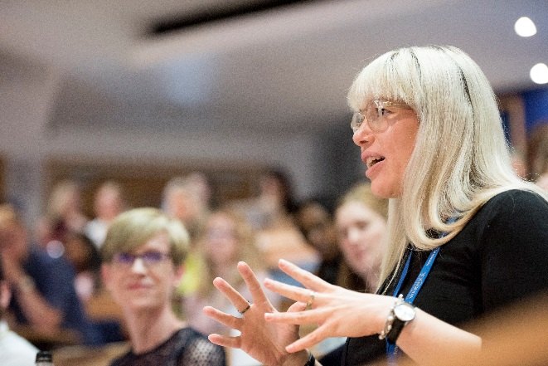 | 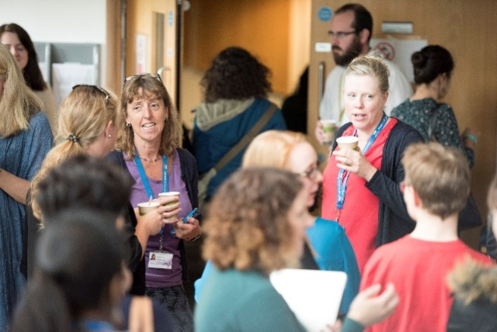
Figure 5.9 SLS Women in Science meeting, July 2017

In our Bronze Action Plan we recognised that SLS media lacked ‘personal’ reflections and examples of how staff achieve work life balance as a resource to staff and students at key career points. We worked with the International Gateway for Gifted Youth (IGGY) in 2016 to produce videos stories by two female and two male academics, which described career pathways, flexible working and work life balance. Videos appeared on the IGGY webpages until summer 2017 and remain on the SLS external website to provide inspiring role models for prospective students and staff.

We have continued to undertake annual audits of SLS media (website, newsletters, and notice boards, induction booklet) to ensure positive female models are visible.
Silver Action Plan
SAP 5.6.7: Maintain effort to achieve a gender balance of SLS invited speakers. We aim to reach at least 45 % female speakers by 2022
SAP 5.6.8: Make the ‘Supporting Women’s Careers in Science’ an annual Beacon event. In 2017, attendance was over 95 % female; feedback from participants suggested widening participation, including a dedicated session on male work life balance

The School of Life Sciences recognises that effective outreach engagement is crucial to our success. It underpins the recruitment of new students, enables us to share the outcomes of our research with the public and fulfil our social responsibility to the community and provides an opportunity to showcase the role of female students in STEM. SLS outreach activities are led by the Director of Outreach and are supported by at least 31 academic and PSS staff (17 female and 16 male).

(viii) Outreach activities
While the contributions of staff to outreach are currently well balanced we are working to ensure that outreach work is appropriately recognised within the workload model and will monitor the time spent to ensure that the contributions are not disproportionate between the genders (SAP 5.6.9).
Postgraduate and undergraduate students are also encouraged to take part in outreach activities as we recognise that these groups provide positive role models for younger outreach audiences. We introduced a new module, ‘Introduction to Secondary Teaching in Biology’ in collaboration with UoW Centre for Teaching Education in 2017. The module includes 10 days of work placement providing undergraduates with valuable experience and local schools with strong STEM role models.
Outreach activities in 2016-17 (Figure 5.10) included visiting 3 all girls’ schools, taking on 8 female and 6 male work experience students aged 16-18, and having over 250 students from local state schools visit SLS and experience working in undergraduate labs. In 2017 we hosted the International Biology Olympiad and presented at The Big Bang Fair in Birmingham and New Scientist Live in London. In 2016 we introduced Public Science Evenings run by SLS research themes every 2 months, typically engaging with local audiences of up to 100 people each time.

Kenilworth Show |  | BBC TV interview on Asian hornets
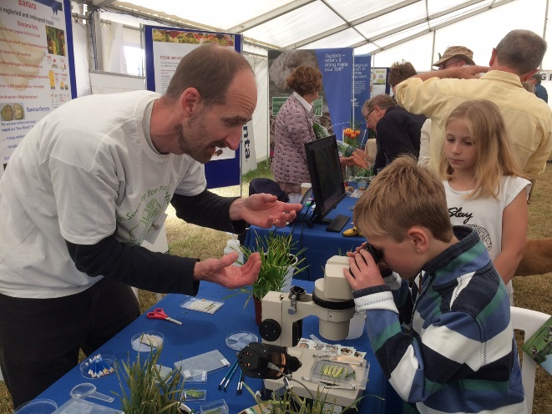 |  |  | 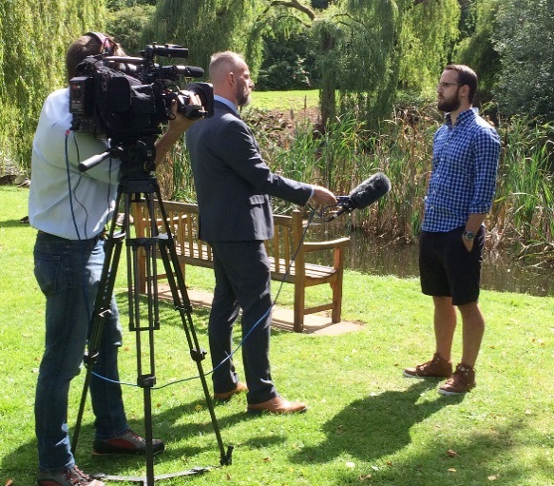
Public Science Evening |  |  | Celebration of Fascination of Plants Day - Wellesbourne
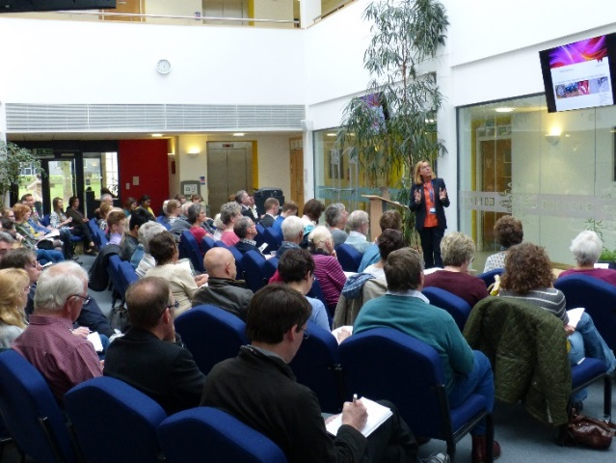 |  |  | 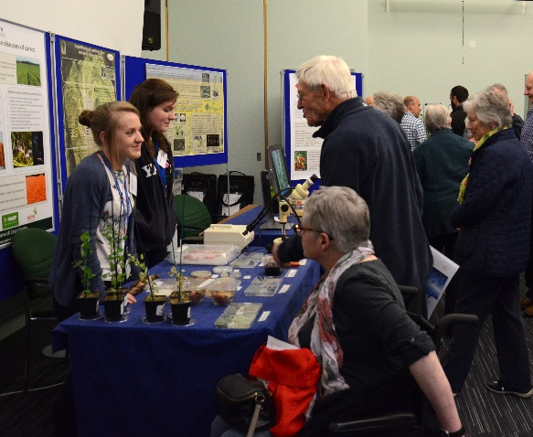

Figure 5.10 SLS staff interacting with the public
Silver Action Plan
SAP 5.6.9 Using data collected for the SLS workload model, analyse gender contributions to outreach in 2019. Data will be used to determine whether action is needed to balancer gender contributions to outreach to avoid disproportionate female contributions

(WORDS 6866)

CASE STUDIES: ImPACT ON INDIVIDUALS

1. Dr Miriam Gifford
My position as an academic at Warwick 8 years ago was my first after postdoctoral research, and 8 years later I am Deputy Head of School. I feel that I have progressed tremendously, not only professionally but also personally and scientifically. I have a good balance between all of these development areas, which is crucial not just for progression within Warwick, but also for my research profile internationally. At the same time, I am able to balance (sometimes juggle!) a busy family life with two primary school age children, the eldest of which was only 11 months when I started, and the youngest who was born just a couple of years into my time as an Assistant Professor.
Every step along the way has been important, building (mostly!) upwards. There are many specific activities that have helped me to progress, in combination with excellent mentoring, but above all it has come from the supportive culture and practice of SLS. Opportunities are not simply advertised, but championed, and leaders of our staff development groups personally approach those who might benefit. Everyone is valued and pushed to succeed by suggesting such opportunities. Importantly, the time it takes to attend workshops AND time to reflect and implement new ideas afterwards are both recognised.
Professionally, I have benefited from our support for career progression setting out clear guidelines for success and promotion, and I was put forward to be involved in strategy and decision-making in the department early in my career. Our committees roll their membership and are routinely monitored to ensure that they include a balance of career stages, gender and opinions – everyone is valued and included. Research themes were set up in Life Sciences two years ago, again supporting my career development since they have encouraged discussion of scientific ideas and peer review, underpinning excellent grant and paper writing. I also gained experience of leadership through co-leading our biotechnology theme.
In terms of personal development, I was inspired by the progression of a recent colleague who had attended the Aurora Leadership programme. I was encouraged to apply by our Athena SWAN chair and was supported with departmental funding to attend. Just as valuable as the scheme itself was the mentoring I was then able to access.
The School’s practices underpin my success in yet another way – they support the development of my research group. For example, my postdoctoral researcher was able to gain support in applying for, taking up and returning from maternity leave. The recent ‘Beacon’ event organized by Life Sciences acted to inspire and encourage my students and staff. They see that we take their development seriously, they are included as members of our committees and we have a new Postdoctoral affairs committee and a new Postdoctoral mentoring scheme that I act as a mentor for.
Overall then, I have benefited personally from our practices, and know that they will continue to support all in Life Sciences, as I will be championing our department going forward.

2. Dr Corinne Smith
I have been at Warwick since 2002 when I arrived on a Fellowship to start my own lab. I already had one small baby when I arrived and my second child arrived in 2003. At the start, back then, I found the department friendly and was comfortable with the people I worked with but I felt in the dark about how to develop. Over the years I did find helpful mentors but I felt guilty for bothering the people I wanted advice from and thought I was supposed to manage on my own. One of the great things about SLS today is that mentoring and support are openly discussed so I feel comfortable seeking this out. This has really paid off and I can attribute some of my recent career successes to this.
For example, during academic year 2014 to 2015 I attended the Aurora Leadership Programme which aims to develop leadership skills in a women-only context. I was supported in this by my department and was one of 2 members of staff selected by Warwick to attend. This course was particularly timely for me as our department had just gone through a lengthy process of restructuring and the stress of this had affected me significantly. My Head of School noticed this and supported me further by enabling me to have professional coaching. As a result of the leadership training and coaching my confidence improved but I still lacked belief in my ability to carry off ambitious research. When I wrote my next grant this lack of self-belief was picked up by the departmental internal review panel. Working with a mentor provided by the department I rewrote the grant according to the feedback and the grant was funded! Thus, departmental support has contributed hugely to my recent productivity and career success. The coaching I had gave me the confidence to apply for promotion and I was promoted to Reader in June 2016.
The increase in confidence I experienced led to my applying for a highly competitive Royal Society Leverhulme Trust Senior Research Fellowship in January 2016. In applying for this I benefited from the support of my Head of School and senior colleagues who spent time carefully reading the application and advising me on what to include. This invaluable support paid off and the application was successful.
While I have been in Warwick Life Sciences the School has had its challenges but I have always felt comfortable about balancing family and work life. Particularly in the last couple of years a more family-oriented atmosphere has developed. Social events help create this, such as the ‘SLS has got talent’ evening and the Christmas Lecture event. Now I am embarking on a new role as Biomedical Science Theme Lead and I hope to contribute further to this supportive and stimulating environment.

(WORDS 974)

Further information
The SLS Head of Student Engagement and Recruitment has recently been awarded UoW funding for a joint project with the LDC to explore student and staff understanding and experience of inclusivity in relation to learning and teaching. A joint student and staff team will conduct interviews and focus groups with staff and student representatives from a range of different UoW departments and will produce a toolkit for inclusive learning and teaching which can be used by departments to inform learning and teaching development. This work will be used to inform future teaching development in SLS.
(WORDS 95)

Action plan
Action Point Reference | Planned action/objective | Rationale (i.e. What evidence is there that prompted this action/objective?) | Key outputs and milestones | Timeframe |  | Person responsible (Include job title) | Success criteria and outcome
 |  |  |  | Start date | End date | Person responsible (Include job title) | Success criteria and outcome
SAP 3.1 | Analyse 2018 PULSE survey results and hold workshops with staff groups to develop specific actions and monitor progress | PULSE provides a 2 yearly snapshot to measure the impact of our initiatives and a guide to refocus our plans to achieve desired outcomes | Presentation to staff meeting to describe major PULSE results and trends; workshop with staff groups to discuss PULSE data and identify areas for action, and approaches for delivery | May-18 | May-19 | SAT Chair | Refocus efforts of the SAT team on key areas identified in the 2018 PULSE
SAP 3.2 | Review SAT membership annually to ensure a diverse SAT | Turnover of SAT members associated with end of their 3-year term and balancing of workload model | Annual check that SAT represents all staff and student groups | Annually July 2018 | Annually next revisit due July 2019 | SAT Chair | SAT balanced by gender and staff grouping
SAP 4.1 | As part of the West Midland RSB Committee organise an annual outreach event promoting AS and STEM in local schools and colleges | We want to build on our success in recruiting female students to share our experience with local A Level colleges and schools | The delivery of an RSB poster competition in 2018 with AS profiled and branded AS certificates | Oct 2018 | To be reviewed following the first event and repeated on an annual basis | Director of Undergraduate Studies | Evaluations from participants and teachers from the relevant schools
SAP 4.2 | Organise a national RSB / Heads of University Bioscience workshop to share good practice on promoting AS and STEM at UG level | We want to build on our success in recruiting female students to bring together all leading UG institutions to discuss good practice within bioscience degree programmes | We will submit workshop proposal for delivery in 2019 | January 2019 | Mid 2019 | Director of Undergraduate Studies | Attendance of a wide range of institutions at the event  Evaluation of the event including a questionnaire 3 months after the event to evaluate impact on AS work in each institution
SAP4.3 | Develop and implement an SLS eTrust Inspire annual residential summer school for 15-16 year old female students | We currently run a successful residential Headstart course each summer which supports students to gain experience of a University environment. The Inspire programme will enable us to target female students | Run the EDT Inspire program (Summer 2019) | Discussions have begun with a view to holding the first event in 2019 | Summer 2019 | Director of Undergraduate Studies | Recruit >20 female students (year 1) and will monitor HE level biology applications post course  Evaluation of confidence levels pre and post course
SAP 4.4 | Improve PGT student support through the provision of a structured pastoral tutorial programme and ensure all offer holders are aware of the support provided | Through feedback from students we recognise that PGT programmes could be improved to better pastoral support for students | Implementation of a structured tutorial programme for PGT | October 2018 | Review annually | Director of Postgraduate Taught Studies | Improved feedback through the PGT SSLC and PTES
SAP 4.5 | Increase promotion of part time PGT study | We offer part time variants of our PGT degrees which enable students to study flexibly but do not currently give these a high enough profile. | Increase profile of part time study in publicity material and on open days | October 2018 | Review annually | Director of Postgraduate Taught Studies | Increased number of enquiries about part time study  Increased part time recruitment
SAP 4.6 | Using the MASP model, we will introduce additional tailored support programs:  Scientific Training Program (STP) for NHS clinical  MSc/MA postgraduate degrees  PhD postgraduate research degrees | Introduction of MASP has resulted in increased applications, shortlisting and placement of UG into medical school so we want to expand the model to better support students looking to go on to other forms of further study | Introduction of the expanded MASP programme for all SLS students | July 2019 | Review success July 2020 | Director of Undergraduate Studies | Increased numbers of students accessing further study – to be measured through DLHE
SAP 4.7 | Improve our academic male/female staff ratio to at least the sector average by 2022 | Our female: male academic staff ratio remains 4% below the sector average in 2017. We have seen significant improvements over the last 3 years and aspire to reach and eventually better the sector average | Reach sector female academic staff: male academic staff ratio by 2022 | May 2018 for our current academic recruitment as approved through our 10-year plan | October 2022 | HoS | Sector female: male academic staff ratio at start of 2022 academic year
SAP 5.1.1 | Develop a range of case studies on our recruitment webpages showcasing recently recruited females to SLS, what attracted them to the department and their experience since taking up their appointment. | Low numbers of page visits on Athena Swan pages | Increased click through and page visits to the Athena SWAN page. | May 2018 | Ongoing in line with School web and communication strategy | Communications Officer | Doubling in the click through and page visits to the Athena SWAN page by Oct 2019
SAP 5.1.2 | Implement a Head of School and HR driven initiative to ensure that all staff with a role in Recruitment complete the mandatory Recruitment and Selection module by the end of 2018 | We are committed to all staff with role in recruitment completing this module | HR led checks for completed module prior to inviting staff to take part in recruitment | June 2018 | Review of progress end of 2018. Ongoing with reminders twice a year | HoS, HR Officer | Rolling system organised with reminders for staff when their qualifications expire
SAP 5.1.3 | Implement a Head of School and HR driven initiative to ensure all staff involved in recruitment and promotion selection complete the Unconscious Bias training module prior to the 2019 promotion process | We are committed to all staff with role in recruitment completing this new module | HR led checks for completed module prior to inviting staff to take part in recruitment | June 2019 | Review of progress end of 2019. Ongoing with reminders twice a year | HoS, HR Officer | Rolling system organised with reminders for staff when their qualifications expire
SAP 5.1.4 | Require male and female representation on all interview panels within SLS from July 2018 | We recognise that our figures for balanced gender representation on interview panels have gone down and this needs to be addressed | HR ensure panels do not go ahead without balanced gender representation | July 2018 | Ongoing with annual reporting of figures to the SAT | HR Officer | 100% of panels are gender balanced
SAP 5.1.5 | Include junior members of staff as observers to interview panels as part of their ongoing training and development and to allow for a wider pool of panellists in future rounds of interviews | Feedback from junior members of staff that they would welcome the opportunity to be trained in this area | Implementation of training for junior staff panel observers  Collation of a list of interested staff | November 2019 | Success to be reviewed in November 2020 | HoS, Theme Leads | Evaluation of the success of the programme with participants and identification of the skills that it provides the observers
SAP 5.1.6 | Revise current paper-based Induction Feedback process to a compulsory online form to ensure a full demographic of feedback and improved opportunity for response analytics for further enhancement of the induction programme | Current paper-based feedback form does not allow for easy collation and data analysis, which slows down process for improvement. By making it available online it will allow for strong response analytics to be undertaken | Online feedback form completed and available online.  Checks that starters have completed the form as part of probation meetings | December 2018 | December 2018 | HR Officer | Online feedback form completed and available online.  Increased response rates to 90%
SAP 5.1.7 | Develop the induction booklet into an online Virtual Learning Environment (VLE) module to enable completion ahead of arrival and easier links to other training and development modules available online at the institution | Whilst the current induction booklet is a professional and comprehensive resource, we are mindful that its current format encourages passive engagement from the user and that as a static document it can easily become out of date. By moving online we can encourage more active engagement and allow for easier links to external and Institutional policies and guidelines | Develop an induction module online | June 2020 | October 2021 | Academic Technologist, SAT Chair | Improved data on engagement with induction module
SAP 5.1.8 | Embed CPD within the PDR process to improve development and promotion prospects. Include discussion of the new University promotion criteria in the PDR process. | Low uptake of CPD courses in staff in SLS | Increased uptake of these opportunities by SLS | Baseline data collected in Spring 2018 for introduction Spring 2019 (next annual PDR round) | Promoted annually in line with PDR round | HoS, Theme Leads | Increased awareness in SLS staff of the availability and benefits of CPD opportunities (baseline data to be collected in 2018).  Increased uptake of these opportunities by SLS Staff; 10% year on year increases until 2021.
SAP 5.1.9 | Ensure Research Theme leads actively identify and seek out talent suitable for promotion or new opportunities from within their groups | Current opportunities for promotion have to be instigated by the applicant. This approach will ensure staff are encouraged to consider promotion and development | Increased numbers of staff reporting feeling supported to progress within the School. | Spring 2019 | Complete Jan 2020 with ongoing action as opportunities become available | Theme Leads and Line Managers | 20 % increase in numbers of staff reporting feeling supported to progress within SLS in PULSE 2018 and again in 2020.
SAP 5.2.1 | Implement compulsory PDR for all academic and PSS in SLS to ensure that all staff have the formal opportunity to consider their progress, performance, skills development and career progression on an annual basis. | Differing levels of uptake of the PDR process across PSS and Academic staff | All academic and PSS completing the PDR on an annual basis | Enhanced promotion in Spring 2018 for introduction in Spring 2019 | Promoted and reviewed annually | HoS, Line Managers | All academic and PSS completing the PDR on an annual basis  Increase in positive responses to PDR in PULSE from all staff groups in 2020
SAP 5.3.1 | Implement a Head of School driven initiative to make the E&D Diversity in the Workplace training module compulsory for all staff members | Reduced voluntary uptake of E&D Diversity in the workplace training by SLS Staff | Requirement for completion of training promoted to staff prior to PDR and then discussed at PDR | Spring 2018 alongside institutional timetable for PDR Process | Spring 2019 with annual reminder process in place | HoS and HR Officer | 90% completion by the 2019 PDR round
SAP 5.3.2 | Introduce a PDRF peer group seminar series, which will be organised by the Postdoctoral Society, where the contributors and audience will be exclusively PDRFs | Limited PDRF engagement with training and development opportunities | Publicise activities in the SLS departmental newsletter  Start weekly PDRF seminars | April 2019 | April 2020 | Director of Post-Doctoral Affairs | 50 % higher engagement score by PDRF in 2020 PULSE  50 % increase in positive engagement responses by PDRF in the 2020 PULSE
SAP 5.3.3 | Publicise and improve the mentoring of PDRF by promoting engagement with the scheme through PDR and ensuring all mentors complete the relevant training | While currently all PDRF are provided with a mentor there are inconsistencies in the experience of mentoring and the level at which the mentors experience is utilised | Increase in PDRF meetings with mentors  Publicise mentor training | Spring 2019 collection of data on success of current mentor scheme | April 2020 for implementation of improvements | Director of Post-Doctoral Affairs and Line Managers | Increase in PDRF perception of mentors (as tested through PDRF survey)
SAP 5.3.4 | Introduce a programme of hustings sessions and peer review for fellowship applications to better prepare PDRFs for these competitive opportunities | No successful applications for fellowships by PDRFs in the last 3 years | Hold first hustings session and instigate internal review for fellowship applications | October 2018 | October 2020 | Director of Post-Doctoral Affairs | Improved application success for PDRFs applying for independent fellowships by 2020
5.4.1 | Promote the UoW work shadowing programme and conduct a follow up survey to assess impact. | A recognition that work shadowing is an important approach for sharing good practice and raising aspirations | Invite representative from the work shadowing scheme to talk at a staff meeting  Embed discussion of work shadowing in the PSS PDR process | Spring 2019 | Spring 2021 | Learning and Development Centre, HR Officer | Increase participation in work shadowing (currently no participants from SLS)
5.4.2 | Promote the range of support available in terms of maternity, paternity, adoption and shared parental leave, arrangements while on leave and support available through the Academic Returners Fellowship | A recognition that while policies are available on the website these could be more clearly promoted to all staff | Annual outline of support available via email to all staff  The production of case studies from members of SLS who have utilised support available | August 2018 for initial email  Summer 2019 for collation of case studies | Summer 2019 with annual reminders | Head of Student Engagement and Recruitment | Increase in uptake of parental leave and Academic Returners Fellowship
5.5.1 | Investigate practical solutions to a shortage of parking on the Gibbet Hill campus, particularly during term time | Snap survey highlighted shortage of parking at GH reduces uptake of flexible working and CPD courses on central campus | Meeting with campus parking team to discuss options for improving access to parking at GH in term time and promote non-car ways to cross campus (shuttle bus, bike) | Discussions have been initiated | October 2022 (opening of new building and car parking facilities) | SAT Chair, Head of SLS Administration | Provision of extra staff parking spaces at GH by 2022 (after opening of new car park)
5.5.2 | Encourage teaching staff with flexible working needs to communicate any problems with their lecture/seminar schedule that inhibit their need to work flexibly at the point of workload release to enable solutions to be identified | Lecture and seminar times listed as a constraint to uptake of flexible working by academic staff | Reporting system introduced to allow staff to flag up issues with lecture / seminar time prior to finalisation of timetables | January 2019 | July 2019 | Director of Education | Scheme in place for 2019 academic year; publicised through SLS media
5.6.1 | Analyse data on protected characteristics of SLS staff, students and job applicants, and identify specific actions related to recruitment, development and role models to ensure SLS is a supportive environment for everyone | We do not currently undertake analysis of ethnicity within SLS processes and recognise that this may improve our understanding of the intersectional experience of our staff and students | Initiate collection of data on ethnicity across all SLS data; run workshops with staff to discuss the data and agree appropriate actions | October 2020 | October 2021 | Head of Student Engagement and Recruitment | Strategy in place for specific actions related to ethnicity in student, staff, recruitment, development and within SLS media (Oct 2020)
5.6.2 | Support raising of gender awareness using university resources and SLS media | We do not currently undertake analysis or consideration of gender identity within SLS processes | Work with UoW diversity and inclusion team to develop a strategy to support gender awareness-raising | January 2019 | October 2019 | SAT Chair | Strategy to promote gender awareness-raising in place across SLS media (April 2019)
5.6.3 | Work with UoW Estates to ensure that all new building projects take account of UoW policies on accessibility and inclusivity including the provision of gender neutral toilet facilities | No gender-neutral toilet facilities in SLS  Older buildings have been adapted to meet accessibility needs but not purpose built | Initiate meetings with UoW facilities team to discuss how gender-neutral facilities can be set up within SLS  Single occupancy toilets will be changed to all gendered toilets immediately | April 2018 | October 2022 | SAT Chair | Gender neutral facilities available in SLS by Oct 2020  Single occupancy toilets will be changed to all gendered toilets immediately
5.6.4 | Introduce deputy committee Chair roles in 2018, in order to offer developmental opportunities to staff. We will encourage women to take Chair and deputy Chair roles through PDR discussions | Reduction in females in committee Chair roles between 2013 and 2017 | Introduce deputy roles for 2018-2019 academic year | October 2018 | October 2019 | Deputy Head of School | Deputy Chairs in place for all SLS committees for October 2018. Equal numbers of male and female Chairs in SLS committees by Oct 2021
5.6.5 | The SLS workload model will be comprehensively reviewed in 2018 to ensure recognition of all roles and parity of contributions. In particular consideration will be given to membership of external committees, outreach and impact to encourage these activities to be recognised and due time allowance given. During the PDR process staff will be encouraged to discuss new significant roles that should be taken into account or that could be more equitably distributed (e.g. interview panel membership) | Workload model requires overview to include influential external committee responsibilities, outreach and impact activities. The revision will also better relate to the revised University promotion criteria | Workload model revised for 2018-2019 academic year  Identify significant contributions to external committees, impact or outreach activities that should be included in the workload model for the 2019-20 academic year | July 2018 | October 2019 | Deputy Head of School | Workload model includes influential external committees for 2019-2020 academic year
5.6.6 | Collect data on external committee membership and analyse gender contributions to determine how staff can be supported and encouraged to participate in influential committees, feeding in to the workload model review | We have no system in place to monitor involvement in external influential committees or to support female and male staff wishing to take on these roles | Initiate workshop to discuss pathways to participation in external influential committees and approaches to support applications e.g. mentoring | July 2019 | July 2021 | SAT Chair | Workshop complete and actions agreed by November 2020
5.6.7 | Maintain effort to achieve a gender balance of SLS invited speakers. We aim to reach at least 45 % female speakers by 2022 | Female SLS department speakers are less than 30 % in 2017-2018 | Specifically request nominations for female speakers and Increase proportion of invitations to female speakers | Work began on this in August 2016 with steady improvement seen | June 2022 | SAT Chair | 45% female speakers by 2022 reflecting the sector average
5.6.8 | Make the ‘Supporting Women’s Careers in Science’ an annual Beacon event. In 2017, attendance was over 95 % female; feedback from participants suggested widening participation, including a dedicated session on male work life balance | SLS staff highlighted the need for a beacon event to help staff manage work life options; PULSE 2016 reported that lower proportion of SLS staff consider UoW helps them manage their work- life balance, relative to UoW | 2018 event complete early summer, to include sessions on male work life balance | January 2018 | July 2020 | SAT members | Events run annually; increased proportion of male attendees (25 %); double the number of staff attending from external Universities by 2020
5.6.9 | Using data collected for the SLS workload model, analyse gender contributions to outreach in 2019. Data will be used to determine whether action is needed to balancer gender contributions to outreach to avoid disproportionate female contributions | Voluntary database of outreach suggests greater involvement of females than males in outreach | Outreach data included in workload model, allowing data base to be set up; data analysis to compare male and female contributions and whether action is needed | October 2018 | Reviewed annually | Deputy Director of School, Director of Outreach | Equal male and female contributions to outreach by 2020

