Construction of chimeric proteins with voltage-gated sodium channels Nav1.5 and Nav1.8

Mihaela Veronica Foisor
Department of Life Sciences
South Kensington Campus
Imperial College London
Supervisor: Dr.Kenji Okuse
Word count: 5150

Abstract

Current available drugs for treating neuropathic pain are not sustainable for a long term treatment due to being only partially effective and/or presenting severe side effects. The Na_{v}1.8 channel has been proven to be responsible for abnormal firing in the DRG that leads to the apparition of neuropathic pain. Due to its strict localization in the small unmyelinated C fibers, Na_{v}1.8 has become a strong drug target. Several blockers have been found, however A-803467 blocker, with 100-fold greater specificity to Na_{v}1.8 compared to other sodium channels, is the most promising. Here we attempt to locate the binding site of A-803467 by creating a chimeric protein with different ratios of hNa_{v}1.8 and rNa_{v}1.5. The aim of this project is to finish constructing the two genes so generation of chimeric proteins can proceed. RNA from HEK293 (hNa_{v}1.8) cells and from rat heart tissue (rNa_{v}1.5) was extracted and further used for cDNA synthesis. The cDNA was used as a template for sequential PCR on specific fragments of each gene. Successfully amplified fragments were than cloned or further joined with other fragments. As of now all hNa_{v}1.8 fragments are cloned, however they still need to be joined together to form the full construct. We have successfully joined and cloned the Q1 fragment of the rNa_{v}1.5 gene, yet 3/8 fragment remains to be joined. Significant progress has been made in the direction of completing the two constructs, and also with new suggestions and improvements to present techniques that will help future experiments. After the localization of A-803467 binding site to Na_{v}1.8 is completed, the affinity of the blocker can be improved and further drug trials can be performed.

Introduction
Learning and adapting to outside stimuli are crucial traits in a species’ evolution. One trait that is responsible for inducing learning abilities is pain. Pain gives a signal to the brain indicating danger and the necessity of a fast reaction to avoid further damage. Although pain sensation is an essential mechanism for survival, its misregulation can lead to severe consequences.
Pain is characterized as an unpleasant sensation at both the physical and psychical level, and is produced by noxious stimuli reaching the brain¹. Potential and actual tissue damage, such as cold and/or heat induced pain, lead to activation of nociceptor neurons from the visceral and somatic systems^{2,3}. Nociceptors transmit this information as action potentials to the brain by different types of nerve fibres; small unmyelinated C types fibres or large myelinated α fibres^{4,5}. When the impulses arrive at the central nervous system (CNS), the pain sensation is formed and recognized.
Pain can be classified by different characteristics, one being duration of manifestation. If pain is experienced for more than 12 weeks consecutively, it is classified as chronic pain⁶. Chronic pain affects 7.8 million people in the UK and accounts for 4.6 million GP appointments per year ⁷. As the elderly population is increasing and life expectancy is rising, the number of people affected by chronic pain is also significantly enlarging, with 56% of people over the age of 75 being affected ⁶. Short term treatments, such as physiotherapy, can improve the activity levels of patients; however rehabilitation does not have any effect on chronic pain at the psychical level. Depression, lower productivity rate⁷ and other mental diseases are consequences of chronic pain that lead to around 25% of patients losing employment and having a lower quality of life⁷.
When the damage that yields chronic pain is located in the somatosensory system, it is classified as neuropathic pain⁸. Neuropathic pain affects approximately 7-8% of the general population^{9,10} and has yet to have a successful treatment. Current pharmaceutical drugs available include antidepressants, anticonvulsants, opioid analgesics, or combinations of these. Due to inaccurate diagnosis and inappropriate use of drugs¹¹, in addition to the low efficacy (antidepressants, anticonvulsants) and high toxicity (opioids)¹², current therapies are unreliable.
In order to tackle neuropathic pain, it is essential to understand the pathways involved in generating it at a cellular level. Action potentials (AP) are produced by ions flowing in and out of neurons, hence creating electrical currents upon stimulation ¹³. Abnormal patterns of firing in nociceptors is known to lead to neuropathic pain. One of the major components in AP formation and propagation is voltage-gated sodium ion channels. In case of injury or damage, Na_{v} channels are increased and prolonged along both the dorsal root ganglia (DRG) and in affected sites^{14,15}. This agglomeration of Na_{v} together with other changes in neuronal structure leads to high spontaneous discharges and hyperexcitability¹⁶.
Currently, there are 9 mammalian sodium channel isoforms, Na_{v}1.1-1.9 that are expressed in different types of tissue¹⁷. In order to differentiate the sodium channels located in the DRG that are involved in nociception, tetrodotoxin (TTX) is used¹⁸. TTX was firstly discovered in puffer fish families as a method of escaping predation¹⁹ and is currently employed as a way of classifying Na_{v}s¹⁸ into TTX resistant (R) and TTX sensitive (S) channels. There are three TTX-R channels: Na_{v}1.8, Na_{v}1.9 and Na_{v}1.5; the latter is located in cardiac tissue and thus not related to pain pathways²⁰. Although both Na_{v}1.8 and Na_{v}1.9 channels have similar locations of expression (in peripheral small-diameter unmyelinated C fibres) Na_{v}1.9 has been shown to be involved in inflammation rather than neuropathic pain^{21,22}. However, due to its rapid recovery from the inactivation state, Na_{v}1.8 is responsible to maintaining around 80% of AP upstrokes during high firing rates in the DRG that lead to neuropathic pain^{23,24}. Although both Na_{v}1.7 and Na_{v}1.8 channels are involved in neuropathic pain, here we focus on the function of the Na_{v}1.8 channel and its potential to become a drug target.
Studies in rats have shown that Na_{v}1.8 channel changes expression in the presence of neuropathic damage. The Na_{v}1.8 channel tends to be downregulated in some areas^{25,26} and to be upregulated post-translationally in the sciatic nerve²⁷. This change in expression allows a lower threshold to be established, with faster activation of the channel hence leading to an aberrant firing pattern. Moreover, knocking down of the Na_{v}1.8 protein levels with antisense oligodeoxynucleotides(ODN), can alleviate hyperalgesic and allodynic syndromes by reducing the TTX-R current in nociceptors neurons²⁸. Similar results have been demonstrated in other experiments performed against Na_{v}1.8 mRNA levels in the DRG²⁹. However, knockout studies have shown no evidence of Na_{v}1.8 having any role in the development of pain pathways^{30,31}; if the gene is deleted mice still feel neuropathic pain later in development. This could be due to compensatory pathways establishing and taking over Na_{v}1.8 function.
Additionally, genome studies in humans that analysed different mutations leading to sodium channelopathies have also demonstrated Na_{v}1.8 involvement in neuropathic pathways. Mutations of the Na_{v}1.8 channel with gain-of-function like properties results in hyperactivation of DRG neurons, illustrating a strong connection to painful neuropathy³². Most mutations show linkage with the Na_{v}1.7 channel; Na_{v}1.7 is responsible for amplifying small stimuli leading to a shift in depolarization threshold of DRG neurons causing Na_{v}1.8 activation^{23,33}. Furthermore, two Na_{v}1.8 mutations predicted by algorithms, demonstrated the ability to enhance channel response to membrane depolarization without the interference on Na_{v}1.7 ³².
The distinct role of Na_{v}1.8 in neuropathic pain, in addition of its restricted localization on the small-diameter unmyelinated C fibres, marks Na_{v}1.8 as an ideal drug target. Several blockers have been found to inhibit Na_{v}1.8 function, each presenting special characteristics. Gabapentine and Mexiletine are two blockers that have been tested in animal models and indicated up to 50% reductions in neuropathic pain in a dose-dependent manner. However, both blockers displayed severe toxic side effects due to low selectivity and specificity^{34,35}. Ambroxol, specific to TTX-R channels, exhibits 3 fold more specificity to the Na_{v}1.8 channel³⁶. Although Ambroxol possesses significantly lower toxicity than Mexiletine³⁶, it is still not selective enough to be entering human clinical trials.
A-803467 is to date the most promising Na_{v}1.8 blocker. Firstly, A-803467 possesses a very high specificity to Nav1.8, 100 fold more to Na_{v}1.8 than to any other sodium channel³⁷. Although A-803467 is not completely selective, the pleiotropic effects are nonetheless minimal. Additionally, exciting indications that it does not attach to common anaesthetic binding sites³⁸ suggests it may avoid the usual side effects. There have been attempts to localize the binding site of A-803467 to Na_{v}1.8 by comparing different mutations in sites known to be important for Na_{v}1.8 function³⁹. Here, we endeavour to localize the bonding site of the A-803467 blocker by creating a chimeric protein and analysing its function in HEK293 cells⁴⁰.
In order to create the chimeric protein, we aim to use different ratios of human (h) Na_{v}1.8 and rat (r) Na_{v}1.5 channels (Figure 1). As both channels are TTX-R and HEK293 cells are engineered to express only TTX-S channels, this offers an easy method of separating the chimeric channel activity after expression in HEK293 cells⁴⁰. Moreover, Na_{v}1.5 has 65% homology and is phylogenetically the closest to the Na_{v}1.8 channel¹⁷. Additionally, a study has demonstrated that the binding site for A-803467 is different in Na_{v}1.8 than in Na_{v}1.5⁴¹, hence A-803467 will only bind to the chimera protein on fragments originating from the Na_{v}1.8 channel. After the binding site of A-803467 to Na_{v}1.8 is determined, it will allow us to design a more specific and selective blocker that will eliminate current side effects.

rNa_{v}1.5
hNa_{v}1.8
X
Figure 1| Localization of the Na_{v}1.8 binding site. The first two chimeric proteins will be made from half hNa_{v}1.8 and half rNa_{v}1.5. As we move forward with the isolation of the binding site, the hNa_{v}1.8 fragment will be slowly substituted with pieces from the rNa_{v}1.5 until the bonding site is limited to 50-100 base pairs. The red circle marks the fragments that the blocker binds to.
Analysis of binding site

This project involves finalizing the hNa_{v}1.8 and rNa_{v}1.5 constructs that will be further used for the creation of the chimeric protein. Most constructs are ready due to the work of previous students; there are two fragments for rNa_{v}1.5 and one fragment for hNa_{v}1.8 that are yet to be successfully cloned.
Materials and Methods
RNA extraction
For hNav1.8, HEK Recombinant Stable Cell Line (Millipore, Billerica, USA) that express the Nav1.8 gene were cultured for 10 days in 100mm plates with 10ml C.DMEM medium at 37˚C. For RNA extraction, Rneasy Mini Kit (Qiagen) was used according to the manufacturer’s protocol. The RNA was eluted in 50µl DEPC- treated water and stored at -20°C.
RNA extraction for the rNav1.5 was done directly from rat heart tissue. 30-65 mg of tissue was used for each RNA extraction using the TRIzol® Reagent (Thermo Fisher Scientific) according to manufacturer’s protocols. The RNA was eluted in 50µl DEPC- treated water and stored at -20°C.
cDNA synthesis
SuperScript III First-Strand cDNA Synthesis system for RT-PCR (Invitrogen) was used in order to synthesize the cDNA from hNav1.8 and rNav1.5 RNA. 2-4µl of RNA template was used for each random primed reaction depending on the concentration of the RNA available. The resulting 20µl of cDNA was immediately used for PCR or stored at -20°C.
Polymerase Chain Reaction (PCR)
In order to amplify the hNav1.8 and rNav1.5 fragments, Phire Hot Start II DNA Polymerase (Thermo Scientific) was used for 20 or 50 µl PCR reactions. The general conditions for the PCR reactions are shown in Table 1. For each specific set of primers (Table 2) an optimized PCR setting was used (Table 3). GeneAmp PCR System (Applied Biosystems) machine was used for all PCR reactions.
Table 1| General PCR conditions. Each parameter that differs for particular reactions is marked with an asterisk and detailed in Table 2 and Table 3.
Cycle Step | Temperature [°C] | Time | Cycles
Initial Denaturation | 98 | 1min | 1
Denaturation | 98 | 15 sec | 10-40*
Annealing | 57-66* | 20 sec | 10-40*
Extension | 72 | 30s-2min* | 10-40*
Final Extension | 72 | 4 min | 1
Holding | 4 | ∞ | 1

Table 2| Primers used for the generation of hNav1.8 and rNav1.5 fragments.
Fragment |  | Forward Primer | Reverse Primer | Length (bp)
hNa_{v}1.8 | 1/2 | ACCATGGAATTCCCCATTGGATC | TCAGAGGAGCTTGTGTCGTCCAC | 3255
New | 1/2A | AACTCTTCAAGGGCAACCTC | CCTCAAGGACGGAGGTTATG | 1101
New | 1/2B | AGGGCAATGAGTGTTGTCAG | GAGCTTGTGTCGTCCACTCC | 1242
rNa_{v}1.5 | 1/8 | ACCATGGCAAACCTCCTGTTACC | GCCAGTTTCTTCACAGACTG | 758
 | 2/8 | ATGTCTCAGCCTTACGCACCTTCC | CTGATTCAATGCTCTGGGACCATC | 884
 | 5/16 | CATCTTTCTGGGCTCCTTCTACC | GTCCACGGTGCTGTTCCTTTTG | 601
 | 6/16 | CAAAAGGAACAGCACCAGTGGAC | GCACCAGTGTCAGGTTCCCCAG | 749

Table 3| Optimized PCR conditions for each fragment.
Fragment |  | Tm [°C] | Extension Time [min] | Cycle Number
hNa_{v}1.8 | 1/2 | 60 | 2 | 35
 | 1/2 A | 58 | 2 | 36
 | 1/2 B | 59 | 2 | 36
rNa_{v}1.5 | 1/8 | 61 | 1 | 37
 | 2/8 | 60 | 1 | 37
 | 5/16 | 58 | 1 | 37
 | 6/16 | 62 | 1 | 37

Recombinant PCR
Recombinant PCR reactions for the Q1 and 3/8 fragments were done in two steps. In the first step, different ratios of templates were added (Table 4) without the primers and the PCR reaction was carried out as normal. In the second step the primers were added and the reaction was continued. For the 3/8 fragment different volumes of DMSO (0.5µl, 1µl and 1.5µl) were added in the reaction.

Table 4| Two steps PCR recombination conditions Q1 and 3/8 fragments the rNa_{v}1.5 channel.
Fragment 1 | Fragment 2 | Ratios | Tm [°C] | Extension Time [min] | Cycle Number | Step
1/8 | 2/8 | 1.5:1 | 68 | 2 | 15 | 1
1/8 | 2/8 | 1.5:1 | 61 | 2 | 20 | 2
5/16 | 6/16 | 1:1.2 | 64 | 2 | 15 | 1
5/16 | 6/16 | 1:1.2 | 60 | 2 | 20 | 2

Gel electrophoresis
All PCR fragments were analysed by running them on a 1% agarose gel at 150V for 30-45 minutes, depending on the fragment length. Approximately 9 µl of DNA product was mixed with 1µl of 6X DNA Loading Buffer and added into each gel lane. Depending on the length of the DNA fragments, 7 μl of Quick-Load® 100bp DNA Ladder (New England Biolabs) or 7 μl of Quick-Load® 1kb DNA Ladder (New England Biolabs) were used as controls.
DNA extraction from gel
The bands of interest were extracted under UV light with a clean scalpel blade and used immediately or stored at 4˚C. For DNA purification, Wizard® SV Gel and PCR Clean-Up System (Promega) was utilized by following the manufacturer’s protocol. The DNA was eluted with 40 µl of autoclaved water and used immediately or stored at -20˚C.
Bacterial transformations
For the cloning step, Zero Blunt TOPO® TA Cloning Kit (Invitrogen) was used as per protocol. For each plasmid transformation reaction, 4µl of fresh or stored at -20˚C purified PCR samples was used. The incubation time for the ligation reaction was prolonged up to 2 hours depending on the fragment length and then chemically transformed on the One Shot ® E. coli cells (Invitrogen). Each reaction was plated onto agar plates containing 50 µl/mg kanamycin in different volumes: 50µl, 100µl and 150µl. All plates were incubated at 37˚C for 24-36 hours.
After the transformation, 4-5 colonies were selected and grown overnight in 2ml of LB broth with 50 µl/mg kanamycin onto a shaking incubator at 37 ˚C and 220 rpm.
Plasmids purification
In order to purify 2 ml of bacterial cultures, PureLink® Quick Plasmid Miniprep Kit (Invitrogen) was used as per the manufacturer’s protocol. For elution, 50 µl of autoclaved water was used instead of TE. DNA concentration for each sample was verified using NanoDrop® Spectrophotometer (Thermo Scientific).
Plasmids digestion
Following plasmid purification, the verification of the insert inside the TOPO vector was performed with FastDigest enzymes (Thermo Scientific) together with 10X FastDigest Buffer and used as per protocol. For the enzymes selection, Webcutter 2.0 program was utilized. If 2 enzymes were needed for the digestion, 0.5 µl of each enzyme was added; if 3 enzymes were needed than 0.3 µl of each was added to the reaction (Table 5). The reactions were than run on an agarose gel.
Table 5| List of enzymes used for plasmid digestion. Asterisk marks enzymes that cut inside the DNA insert in order to better visualize fragments that have very similar sizes with the plasmid.
Insert |  | 1st Enzyme | 2nd Enzyme | 3rd Enzyme
Na_{v}1.8 | 1/2 A and B | KpnI | NotI
 | 1/2 | Kpnl | Notl | Bsml*
Na_{v}1.5 | Q1 | BamHI | SpeI

Sequencing
After plasmid digestion, the samples with expected sizes were diluted to a 50-100 ng/µl concentration. For the sequencing, 15µl of each sample was used together with 2µl M13 forward or reverse primers given by the TOPO kit. The resulting sequences were aligned against the human Nav1.8 gene (NM_006514).

Results
Cloning of 1/2 hNa_{v}1.8 was unsuccessful
The hNa_{v}1.8 gene is approximately 6.5kb long and impossible to amplify in one PCR reaction. Thus, hNa_{v}1.8 was cut in two pieces by previous students and the 2/2 fragment of the gene was already amplified and cloned into bacteria. The hNa_{v}1.8 1/2 fragment was attempted by previous students, but not successfully.
We have successfully managed to amplify the whole 1/2 fragment (Figure 2B). The PCR bands were extracted and purified before the cloning step. We run the purified bands on a gel to verify the degree of extraction from the gel (Figure 2C). In order to have a higher concentration of template, more PCR reactions were performed and purified, then combined and heat precipitated at 60˚C until the overall sample reached 20µl.
The resulting sample was ligated into the TOPO vectors. The first cloning of the hNa_{v}1.8 1/2 fragment resulted in only 1 colony after 48 hours. Hence, we doubled the ligation reaction time from 30 minutes to 1 hour; this resulted in 11 colonies after 36 hours, with most colonies on the 150µl plate. The DNA concentration of the overnight LB broth culture was verified, with most samples resulting in over 50µl/ng. After the plasmid purification and digestion only 1 band was present (Figure 2D). To verify presence of the insert, the undigested plasmid was run along with a combination of restriction enzymes that will generate cuts inside the insert (Figure 2E-F).
Due to the inconclusive results we have repeated the cloning experiment and prolonged the ligation reaction time. Unfortunately, similar results emerged: low colony number and failure to see the presence of the insert in the vector.
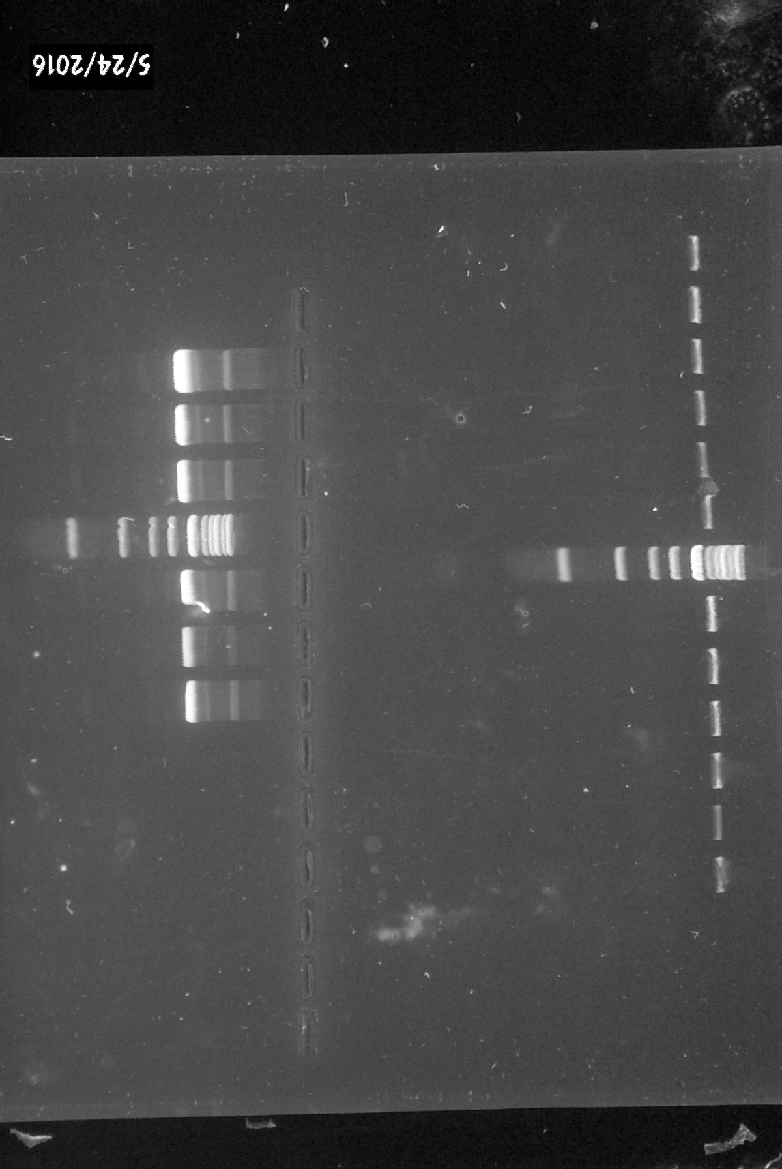
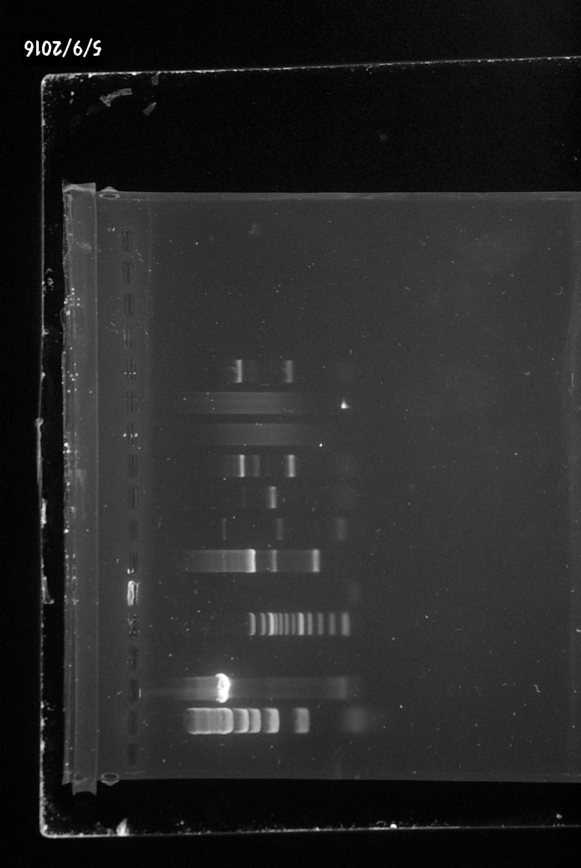
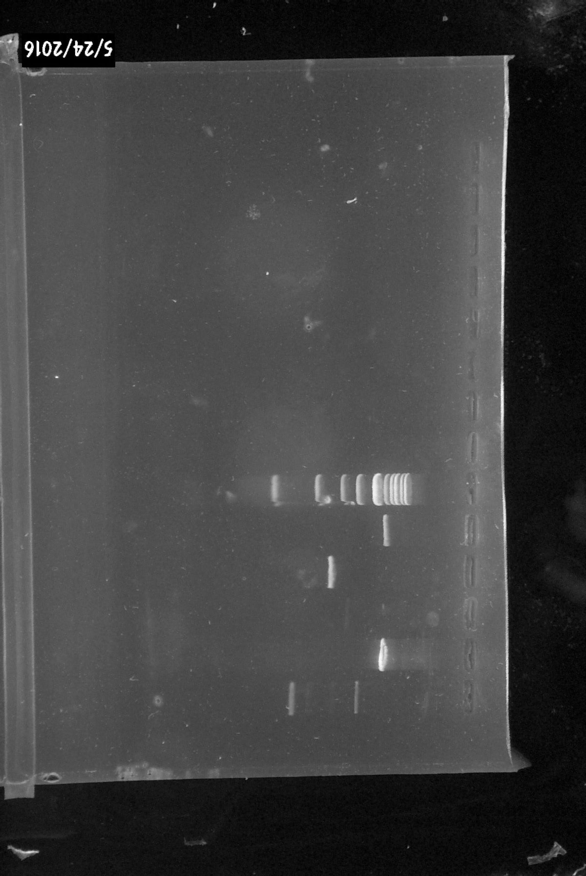
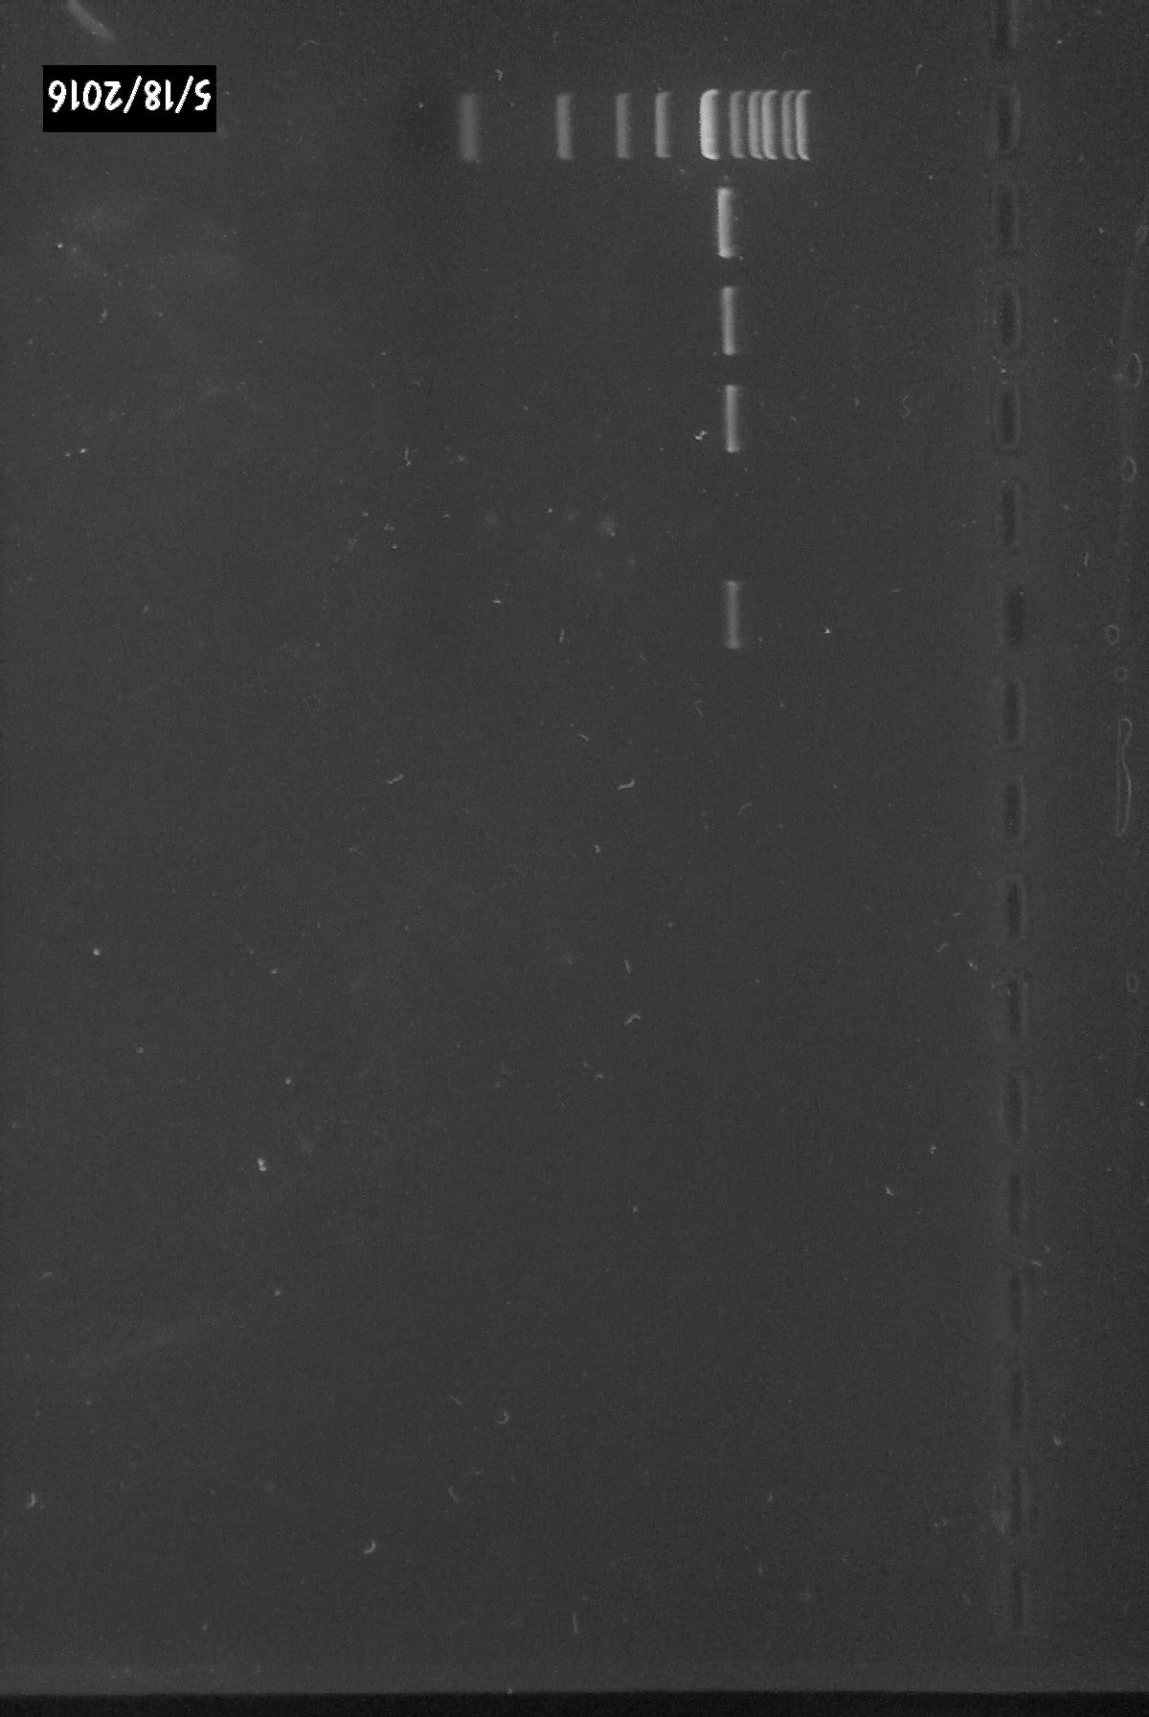
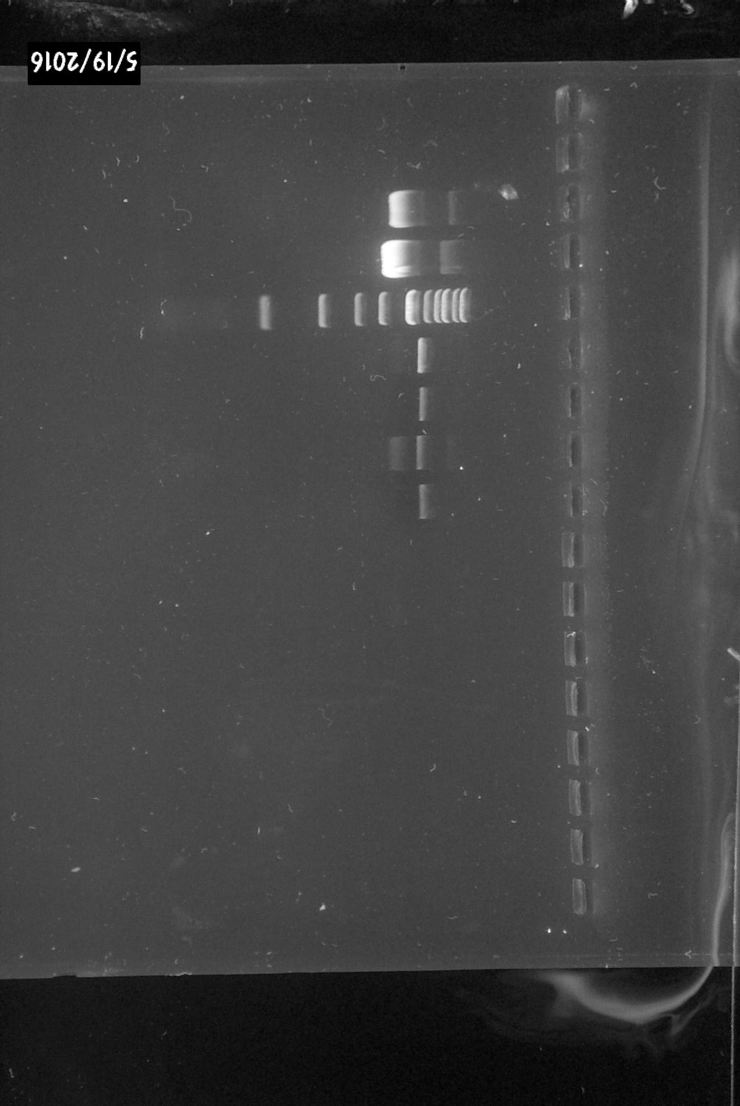
F)
L
L
P
P
P
Linearized P
4 kb
A)
1/2
2/2
B)
L
1/2
3.2kb
C)
L
1/2
3.2kb
D)
L
D
D
D
3.5kb
E)
L
D
D
D
7 kb
3.5kb
2.5kb

Figure 2| For the hNa_{v}1.8 gene, fragment 1/2 was amplified but the cloning step was unsuccessful. A) The hNav1.8 was cut into two pieces; 1/2 with the size of 3.2 kb and 2/2 which was already cloned before. B) PCR amplification reaction using cDNA template of the 1/2 fragment was successful, producing a very bright band with expected size

C) Gel extraction purification of the fragment was successful and estimated at 60%. D) After digestion of 3 independent colonies, we can only see one band that is in between the two expected sizes. Due to the insert size being very close to the plasmid size, we can’t assess if the bands are united as one or just the plasmid is present. E) The plasmid was digested with an additional enzyme that cuts only inside the insert. The 1st band has the size of undigested plasmid; however the 3rd band, that is around 2.5kb, would be expected if the 1/2 fragment is present in the plasmid. F) The undigested plasmid was run on a gel along with the linearized one. The size of the linearized plasmid is not the expected size (7.5kb) if the 1/2 fragment would be present. L- 1kb ladder; P- plasmid; D-digested plasmid; Plasmid size- 3.5kb

1/2A and 1/2 B fragments successfully amplified and cloned
Considering the unsuccessful cloning of the 1/2 fragment, we have redesigned the primers and cut the fragment in two more pieces. The amplification of the two new fragments was achieved (Figure 3A-B). The bands were extracted, purified and run on a gel to verify the quality of extraction (Figure 3C). Due to the very low purification percentage of the 1/2 B fragment, we have repeated the same experiment as with 1/2 fragment in order to have a higher copy number concentration for the cloning step.
The cloning step was done with 1 hour incubation time for the ligation reaction and resulted in few colonies after 24 hours. All the colonies were selected and grown overnight in 2ml LB broth media. After purification with miniprep we looked at the DNA concentration of each sample. For 1/2A fragment most colonies showed a concentration of over 100 ng/µl, however the 1/2 B fragment had all samples under 50 ng/µl. After plasmid digestion we could see the insert in all 4 independent colonies of 1/2 A (Figure 3D). For 1/2B fragment the bands were very faint; although they are approximately the expected size we cannot be sure if the cloning was successful without further investigation.
The colony that presented the highest concentration of 1/2A fragment was sent for sequencing. Due to the long fragment size, the sequencing was done from both directions with M13 primers. The forward sequencing showed an insertion of an extra T at 768 bp, however the second reading did not present this insertion. After looking at the data, we could see that the extra T loop for the forward sequencing is represented by a small spike. Considering that the forward reading at 768bp is very near the end where the sequencing becomes inaccurate, we concluded that the reverse reading was the correct one.

A)
L
1/2 A
1.1kb
B)
L
1/2 B
1.4kb
C)
L
1/2 A
1/2 B

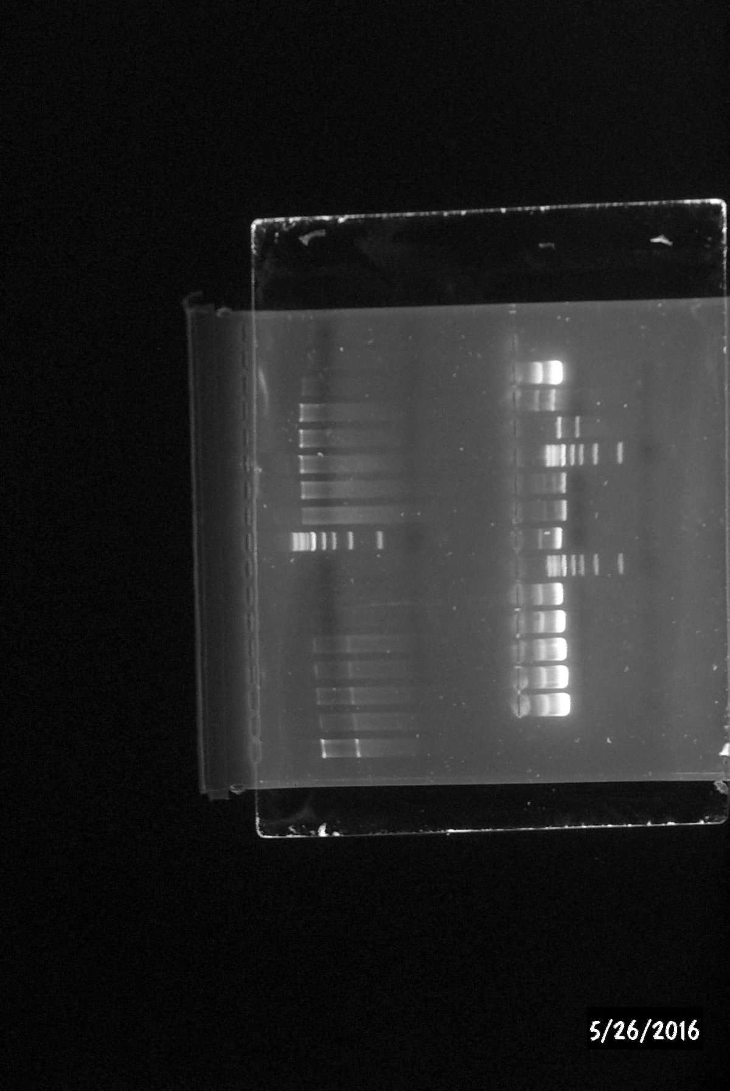
E)
L
P
~5kb
D)
L
D
D
D
D
1.1kb
3.5kb
1.4kb
1.1kb

Figure 3| Amplification and cloning of the hNa_{v}1.8 1/2 A and B fragments. A) After PCR amplification using cDNA template we have successfully amplified the 1/2 A fragment; the band has the expected size of 1.1kb. B) 1/2 B fragment was also successfully amplified, generating an expected band size of 1.4 kb. C) After gel purification, 1/2A fragment showed a high template concentration. However 1/2 B fragment had a very low purification efficiency, estimated at around 10%. D) Digestion of 4 independent colonies of 1/2A fragment generated expected insert band size. Colony number 1 was sent for sequencing. E) The 1/2B fragment had only one colony that presented a linearized plasmid band approximately around the expected size. The digested plasmid band was too faint to be able to be analyzed. L-1kb ladder; P-linearized plasmid; D- digested plasmid

Q1 (1/8 and 2/8) fragment was successfully joined and cloned
For the rNa_{v}1.5 gene, which was cut in 8 fragments, most of the fragments were already cloned. Q1 and 3/8 fragments were left to be joined and cloned (Figure 4A). The Q1 fragment, made of 1/8 and 2/8 fragments, was successfully amplified and joined.
After RNA was extracted with different yields, and after cDNA synthesis was done, we tested their quality by trying to amplify the GAPDH housekeeping gene (Figure 4B). The best quality RNA that also expressed the GAPDH gene (1283 µl/ng with a ratio of 260:280 of 2.03) was further used for amplification of fragments. The first attempts to amplify 1/8 and 2/8 resulted in faint smear band. Considering the RNA quality has been verified, we concluded the problem lies in the PCR conditions. In order to test the perfect number of cycle to get better amplification yield of the fragments, timepoints were taken at 30, 35 and 40 cycles (data not shown). Due to smearing still appearing for the 2/8 fragment, different Tm were tested for a more specific amplification (Figure 4C). After purifying the 1/8 and 2/8 bands, we tried to join them with PCR recombination in order to construct Q1 fragment.
The first few attempts of joining Q1 fragment resulted in no bands. Changing the PCR conditions (Tm and cycle number) for both steps of the PCR recombination did not show any positive results either. After trying different ratios of template for each reaction (Table 4) in combination with different PCR conditions, we manage to recombine the fragments and went forward into the cloning step (Figure 4D).
The purified Q1 fragment was used for the cloning step. Due to its similar size with the 1/2B fragment (1.5kb), we used the same incubation time for the ligation reaction. Only very few colonies resulted after 24 hours, however all LB broth colonies presented clouded solution. After miniprep purification, only one colony showed significant genomic DNA concentration (187 ng/µl). Digestion of the purified sample generated an expected band size (Figure 4E).

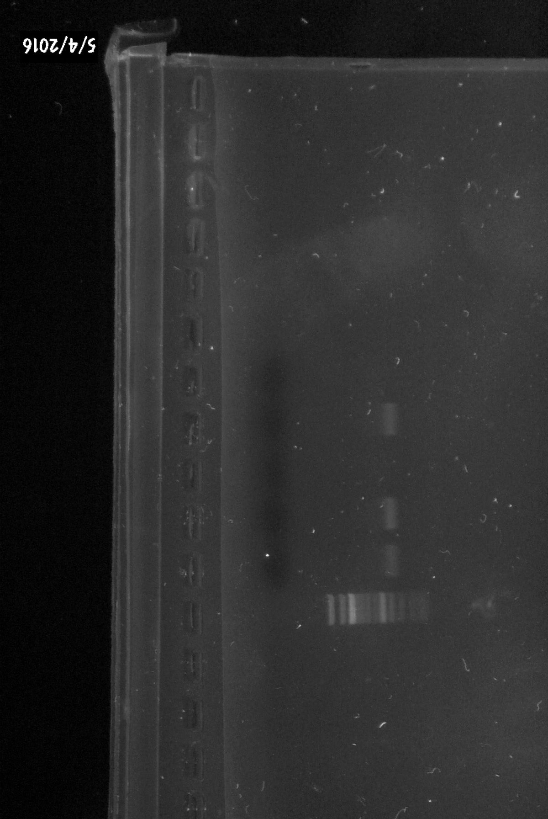
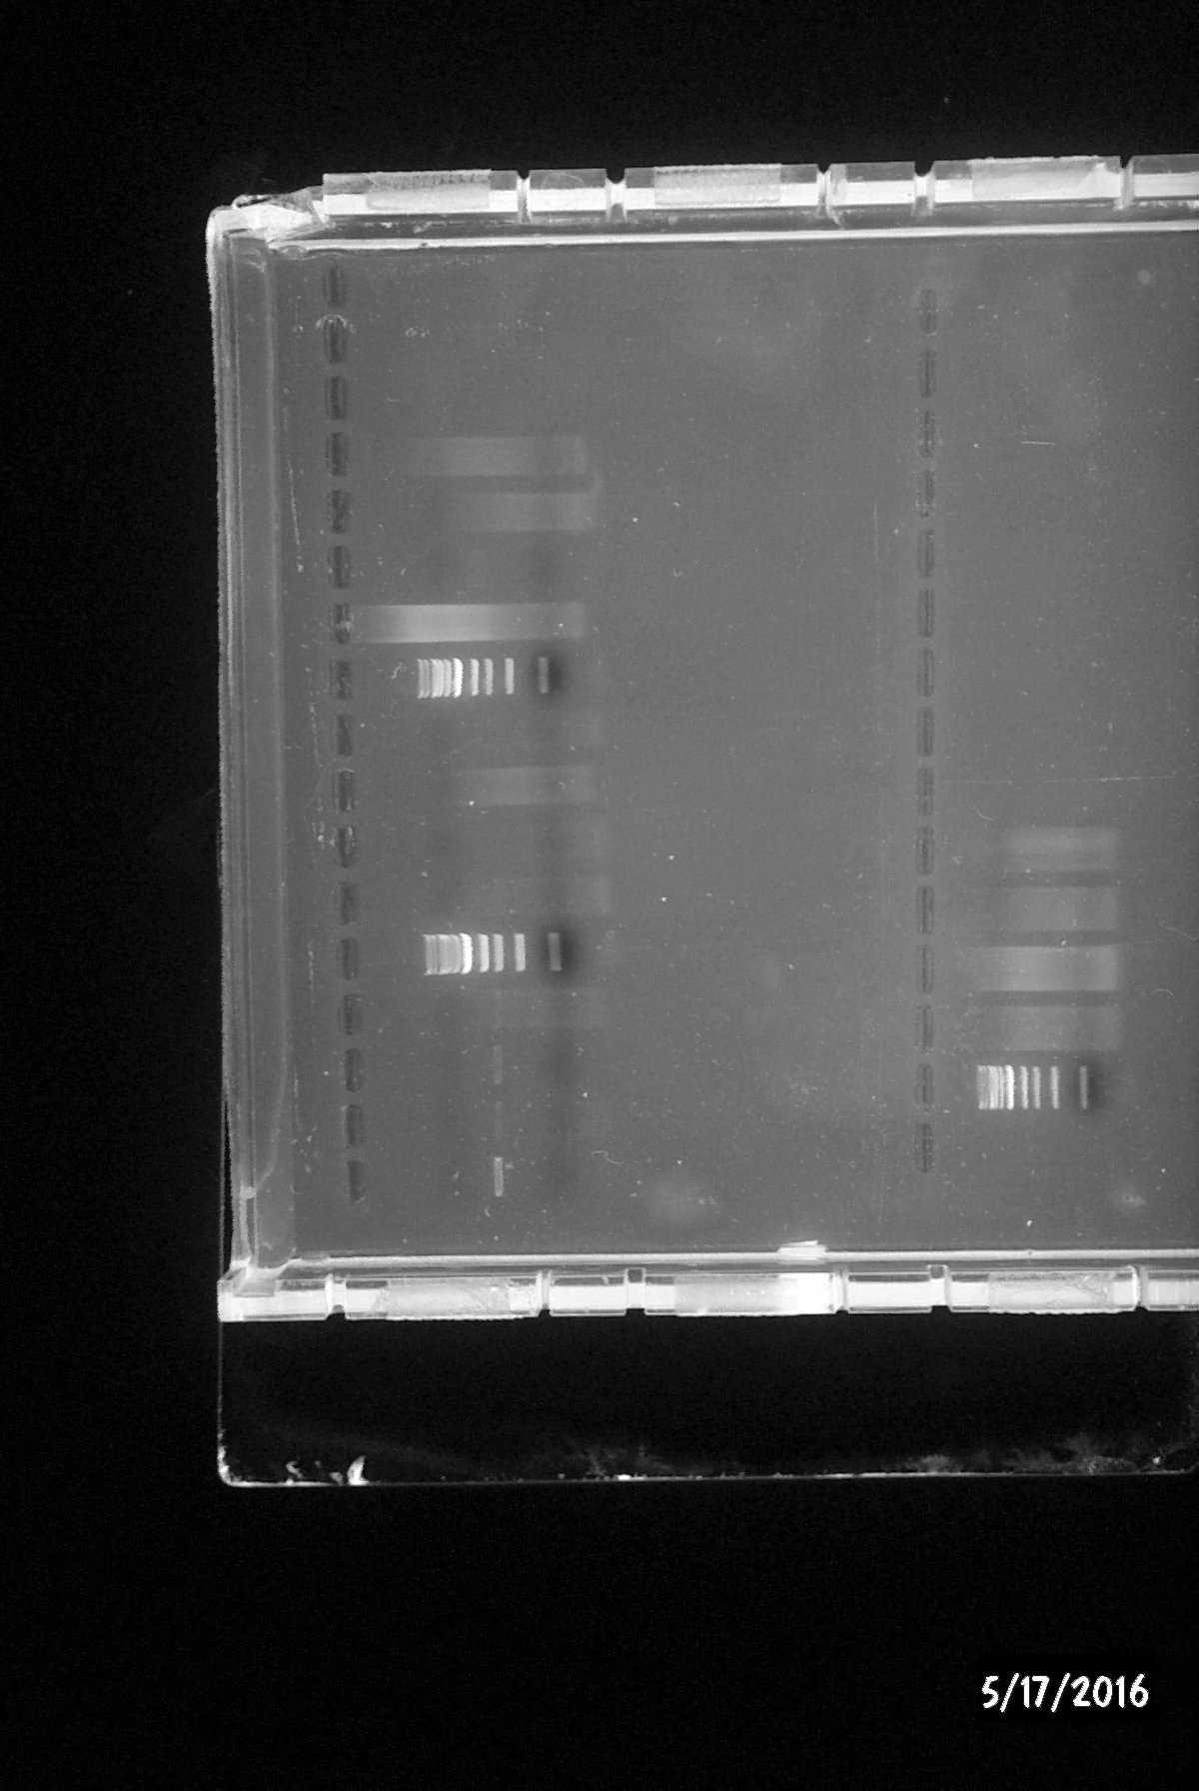
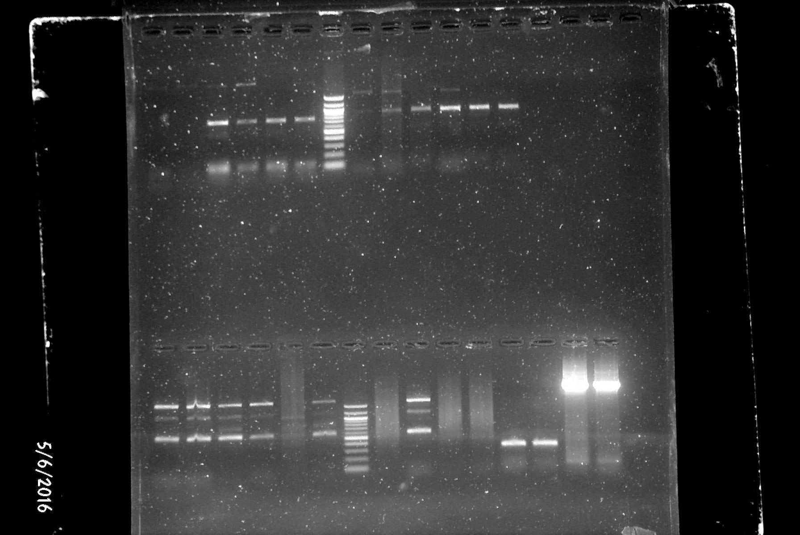

A)
1/8
2/8
4/8
5/8
6/8
7/8
8/8
5/16
6/16
3/8
Q1
B)

H
H
H
400 bp
C)
D)
L
Q1
1.5kb
E)
L
D
3.5kb
1.5kb
L
59˚
61˚
62˚
63˚
60˚
60˚
58˚
57˚

2/8
1/8
L₁₀₀
758bp
884bp

Figure 4| Successful amplification and cloning of the Q1 fragment of rNa_{v}1.5. A) rNa_{v}1.5 was cut into 8 pieces by previous students. Together 1/8 and 2/8 will form the Q1 fragment. B) Amplification of the housekeeping gene GAPDH from different cDNA templates resulted in expected bind sizes.

C) Verification of different annealing temperature for primer binding. After analyzing each band’s intensity, it was decided that 61˚C and 60˚C are best temperature for 1/8 and 2/8, respectively. D) PCR recombination of Q1 fragment generated a band of expected size. E) After plasmid digestion, bands with the sizes of the insert (1.5kb) and plasmid (3.5kb) were produced. L-1kb Ladder; L₁₀₀- 100bp Ladder; H -GAPDH housekeeping gene; D-digested plasmid

Recombination of 3/8 fragment was unsuccessful
The 3/8 fragment of the rNa_{v}1.5 gene is made of 5/16 and 6/16 smaller fragments. Similar experiments as with the 1/8 and 2/8 fragments were performed before successfully amplifying 5/16 and 6/16 (Figure 5B). The expected band sizes were extracted and purified before being used as template for the recombination PCR.
The first attempt of recombining the two fragments showed no bands. Firstly, we tried changing the ratio of templates from 1:1 to 1.2:1, 1.5:1, 2:1 and vice versa for the first step of the PCR recombination reaction. As no positive results were achieved we then moved into changing PCR recombination conditions for the different ratios (Tm and cycle number) which resulted in the appearance of faint smear band (Figure 5C). In order to minimalize the effect of secondary structures on the primers binding efficiency, we tried adding different DMSO concentrations in combination with the PCR conditions. Hence, we started from 2% DMSO addition until 8% of the final reaction volume was reached. Unfortunately, the PCR recombination was not successful and no clear bands were generated.
A)
1st Step
2nd Step
B)
L₁₀₀
6/16
5/16
C)
L
3/8

601bp
749bp

Figure 5| Joining of 3/8 fragment of the rNa_{v}1.5 was not achieved. A) The two steps mechanism of PCR recombination of two fragments. B) The amplification of 5/16 and 6/16 generated bands of expected sizes. Due to other unspecific primer amplifications, the expected bands were extracted and purified before attempting the PCR recombination step. C) Attempts of recombining the 3/8 fragment resulted in a smear band. L- 1kb ladder; L₁₀₀- 100bp ladder

Discussion

This project is a continuation of the work done by previous students, trying to finalize the hNa_{v}1.8 and rNa_{v}1.5 constructs. For the hNa_{v}1.8 gene, we have successfully cloned the entire length of construct; however it is cloned in 3 different fragments. Before the chimeric construction is started, the full length will need to be joined together. The rNa_{v}1.5 gene situation is more complex; most of the fragments were cloned before by previous students, only Q1 and 3/8 were left. We have successfully joined and cloned the Q1 fragment, but not the 3/8 fragment. In order for the chimeric constructs to start, 3/8 will need to be cloned and joined and then further reunite with Q1.
hNa_{v}1.8
Despite its length of 3257 bp, hNa_{v}1.8 1/2 fragment has been amplified before without presenting any problems. Yet, the cloning step was attempted several times before, without successfully transforming into bacteria. We have also managed to amplify the fragment and although we improved the cloning conditions, we encountered the same problem as before. After the digestion step, only one band was generated around 3.5kb. Seeing as the length of 1/2 fragment and vector are very similar, we’ve digested the plasmid with 3 enzymes; the extra enzyme cutting inside the insert. Although it seems as the band around 2.5kb is as expected (Figure 2E), it can also be the result of coiled undigested vectors. In order to verify which theory is correct we have run the linearized plasmid and compared with the expected size in the insert was to be present. As the resulting band size is corresponding to the vector size alone, we have concluded that the cloning was unsuccessful.
The most plausible reason for this repeated failure is laying in the cloning reaction; the vector does not taking up the insert or partially taking it up without completing ligation. Considering that 1/2 fragment is significantly bigger than the other fragments that were cloned, it is possible that the vector has troubles taking up the insert due to its size. Although we have increased the ligation reaction time, it can always be increased more in the future as it does not affect the quality of the vectors. TOPO kit is considered to be most effective for fragments up to 4kb. As the 1/2 fragments is close to its limit, it may be worth trying other cloning kits, such as TOPO XL or GATEWAY technology kit.
It is also important to mention that although the gel purification appeared successful, it rarely completely purifies the gel bands. Hence, if some of the primers or other small DNA fragments are left, they will be taken up by the vectors instantly due to their negligible size. Since the 1/2 fragment is very long, heat precipitation at 70˚C would probably not denature the DNA but it will affect the PCR primers or other small remaining DNA.
Furthermore, higher cloning results have been proven by electroporation method rather than chemically transforming the vectors⁴². However, our E.coli competent cells were not designed for electroporation, thus acquiring of new competent cells would have been necessary.
Considering all the factors presented above, we’ve decided that the easier method of improving cloning of 1/2 fragment is cutting it in two separate fragments. The two new fragments 1/2 A and 1/2 B, have been generated and successfully transformed into bacteria. 1/2B fragment presented a very faint band for the linearized plasmid digestion. Although it size appears as expected, it would require further verification before sequencing. One way of verifying that the insert is indeed present is by performing PCR with the specific primers for the insert. After running on a gel, a band of the size of the insert should be present.
rNa_{v}1.5
Despite the different conditions that were tried, 3/8 fragment was yet to be successfully joined. Conditions tested shown a faint smear band that spread on the entire lane. This could be due to unspecific binding of primers, yet we have tried different conditions for Tm and cycle number without receiving any significant changes. Another reason for the unspecific binding could be the exhaustion of polymerase after a certain number of cycles. This could be easily prevented by adding extra polymerase after 30 cycles.
Additionally, changing the primers sequence could also improve the PCR recombination step. There are 60 base pairs overlap between the fragments, which should normally be enough for the recombination PCR reaction. However, if the overlap includes certain 2nd structures that will not allow primers to bind, it could explain the appearance of a smear band from the top on the lane. Therefore, partially changing the primer sequence, couple of base pairs up or down; or if necessary completely redesigning the primers to achieve a bigger overlap between the fragments could result in successful amplification.
Recombination PCR depends a lot on the purity and quality of the template. There are different ways on generating the templates, each with different purity levels. In this case we’ve used PCR products or purified PCR products that have lower concentration but better quality. Due to time constraints, we’ve tried to increase the template concentration by heat precipitation rather than cloning both fragments into bacteria. However, for higher purity cloning 5/1 and 6/16 fragments into bacteria would be recommended.

Future work
The full length of the hNa_{v}1.8 construct is now successfully transformed into bacteria. In order for the full length of the hNav1.8 gene to be finalized, the 3 fragments need to be joined and cloned. Due to the length of the channel being over 6kb, we would suggest Gateway cloning technology (Invitrogen) for the cloning of the final construct. The Gateway method would allow all fragments to be integrated and cloned together, bypassing the recombination PCR step and requiring only one overall reaction. Moreover, this method is based on sticky-end ligation hence allowing directional cloning of the fragments. Before the chimeric proteins production, the full length would have to be sequenced and made sure no mutations are present.
For the rNa_{v}1.5 gene, 3/8 and Q1 joined fragment it’s still not achieved. Following one or all the recommendations presented above, the 3/8 fragment should be able to be joined. Cloning of the 3/8 fragment should be successful in the same conditions as the Q1 fragment. Joining the Q1 and 3/8 fragments will results in a relative big segment (around 2.5kb), hence it may present similar problems as the 1/2 fragment at the cloning step. However, as the two fragments were cloned before the PCR recombination attempt, they will present a significant higher purity and concentration than the PCR template used for the 1/2 fragment.
Finalization of the rNa_{v}1.5 and hNa_{v}1.8 constructs marks the end of the 1st phase of the binding site localization. The 2nd phase, the creation of the different chimeric proteins, will be done by a 3 step PCR recombination method (Figure 6).

Figure 6| 3 step PCR method of creating a chimeric channel. In the 1st step one of the fragments will be amplified and extended to overlap with the other fragment. In the 2nd step and 3rd step, that are basically a PCR recombination reaction, the two fragments will be used together as template and then amplified with primers so the full length is generated⁴⁵.

1st Step
2nd Step
3rd Step

After the chimeric protein constructs are ready, they will need to be inserted into expressing cells for further experiments. The most probable to be used as expressing cells are HEK293 cells. One of the reasons is that they are already engineered to express only TTX-S channels⁴⁰. This will allow us to use tetrodotoxin and eliminate any other noises from undesired sodium channels.
Inserting the constructs into the HEK cells can be done by different methods. One method is by virus-mediated transfection, specifically retrovirus murine leukemia virus (MLV). This would allow long term transgene expression in HEK cells, however there are major drawbacks such as insertional mutagenesis, toxicity and cell death ⁴³.
The most common way is transfecting the cells with the purified plasmids from bacterial transfections. Nucleic acid can be inserted into the nucleus by different methods. In this case, we would suggest micro-injection of the constructs into the cells ⁴⁴.
After the chimeric protein is expressed and the binding site of the A-803467 blocker is narrowed down as much as possible, the resulting sequence will be send for further structure analysis. Discovering the exact binding sequence of A-803467 is crucial and will be used for improving the specificity of the blocker to the Nav1.8 channel.

Acknowledgments

This project was a unique experience that changed my perspective on what working in science involves. I would like to thank Dr. Kenji Okuse for his help and continued support throughout this project.
I would also like to thank Nikita Demchenko for his assistance and support around the lab.
Finally, I would like to thank the Life Sciences Department for giving me this opportunity and supporting me throughout my studies at Imperial College.

References
1. Merskey, H. & Bogduk, N. Classification of chronic pain. Seattle IASP Press (1994).
2. Iggo, A. Cutaneous heat and cold receptors with slowly conducting (C) afferent fibres. Q. J. Exp. Physiol. Cogn. Med. Sci. 44, 362 (1959).
3. LaMotte, R. H., Thalhammer, J. G., Torebjörk, H. E. & Robinson, C. J. Peripheral neural mechanisms of cutaneous hyperalgesia following mild injury by heat. J. Neurosci. 2, 765–781 (1982).
4. Sengupta, J. N. & Gebhart, G. F. Characterization of mechanosensitive pelvic nerve afferent fibers innervating the colon of the rat Characterization of Mechanosensitive Pelvic Nerve Merent Fibers Innervating the Colon of the Rat. J. Neurophysiol. 71, 2046–2060 (1994).
5. Bessou, P. & Perl, E. R. Response of cutaneous sensory units with unmyelinated fibers to noxious stimuli. J. Neurophysiol. 32, 1025–1043 (1969).
6. Bridges, S. Chronic pain. In: Health & Social Care Information Centre. Health Survey for England (2013). Available at: http://www.hscic.gov.uk/catalogue/PUB13218.
7. Donaldson L. Pain: Breaking through the barrier. In: Department of Health. 150 years of the Annual Report of the Chief Medical Ofﬁcer: On the state of public health 2008. (2009).
8. Treede, R. D. et al. Neuropathic pain: Redefinition and a grading system for clinical and research purposes. Neurology 70, 1630–1635 (2008).
9. Bouhassira, D., Lant??ri-Minet, M., Attal, N., Laurent, B. & Touboul, C. Prevalence of chronic pain with neuropathic characteristics in the general population. Pain 136, 380–387 (2008).
10. Torrance, N., Smith, B. H., Bennett, M. I. & Lee, A. J. The epidemiology of chronic pain of predominantly neuropathic origin. Results from a general population survey. J. Pain 7, 281–9 (2006).
11. Finnerup, N. B. et al. Pharmacotherapy for neuropathic pain in adults: A systematic review and meta-analysis. Lancet Neurol. 14, 162–173 (2015).
12. Finnerup, N. B., Sindrup, S. H. & Jensen, T. S. The evidence for pharmacological treatment of neuropathic pain. Pain 150, 573–581 (2010).
13. Hodgkin, A. L. & Huxley, A. F. A Quantitative Description of Membrane Current and its Application to Conduction and Excitation in Nerves. J. Physiol. 117, 500–544 (1952).
14. Novakovic, S. D. et al. Distribution of the tetrodotoxin-resistant sodium channel PN3 in rat sensory neurons in normal and neuropathic conditions. J. Neurosci. 18, 2174–2187 (1998).
15. Xie, Y., Zhang, J., Petersen, M. & LaMotte, R. H. Functional changes in dorsal root ganglion cells after chronic nerve constriction in the rat. J. Neurophysiol. 73, 1811–20 (1995).
16. Study, R. E. & Kral, M. G. Spontaneous action potential activity in isolated dorsal root ganglion neurons from rats with a painful neuropathy. Pain 65, 235–42 (1996).
17. Catterall, W. a, Goldin, A. L. & Waxman, S. G. International Union of Pharmacology. XLVII. Nomenclature and structure-function relationships of voltage-gated sodium channels. Pharmacol. Rev. 57, 397–409 (2005).
18. Chong, H. L. & Ruben, P. C. Interaction between voltage-gated sodium channels and the neurotoxin, tetrodotoxin. Channels 2, 407–412 (2008).
19. Venkatesh, B. et al. Genetic basis of tetrodotoxin resistance in pufferfishes. Curr. Biol. 15, 2069–2072 (2005).
20. Gellens, M. E. et al. Primary structure and functional expression of the human cardiac tetrodotoxin-insensitive voltage-dependent sodium channel. Proc. Natl. Acad. Sci. U. S. A. 89, 554–8 (1992).
21. Amaya, F. et al. The Voltage-Gated Sodium Channel Na v 1 . 9 Is an Effector of Peripheral Inflammatory Pain Hypersensitivity. Mouse Genome 26, 12852–12860 (2006).
22. Strassman, a M. & Raymond, S. a. Electrophysiological evidence for tetrodotoxin-resistant sodium channels in slowly conducting dural sensory fibers. J. Neurophysiol. 81, 413–424 (1999).
23. Renganathan, M., Cummins, T. R. & Waxman, S. G. Contribution of Na(v)1.8 sodium channels to action potential electrogenesis in DRG neurons. J. Neurophysiol. 86, 629–640 (2001).
24. Waxman, S. G. Channel, neuronal and clinical function in sodium channelopathies: from genotype to phenotype. Nat. Neurosci. 10, 405–409 (2007).
25. Benn, S. C., Costigan, M., Tate, S., Fitzgerald, M. & Woolf, C. J. Developmental Expression of the TTX-Resistant Voltage-Gated Sodium Channels Na v 1 . 8 ( SNS ) and Na v 1 . 9 ( SNS2 ) in Primary Sensory Neurons. 21, 6077–6085 (2001).
26. Berta, T. et al. Transcriptional and functional profiles of voltage-gated Na+ channels in injured and non-injured DRG neurons in the SNI model of neuropathic pain. Mol. Cell. Neurosci. 37, 196–208 (2008).
27. Thakor, D. K. et al. Increased peripheral nerve excitability and local NaV1.8 mRNA up-regulation in painful neuropathy. Mol. Pain 5, 14 (2009).
28. Lai, J. et al. Inhibition of neuropathic pain by decreased expression of the tetrodotoxin-resistant sodium channel, NaV1.8. Pain 95, 143–152 (2002).
29. Ruangsri, S. et al. Relationship of axonal voltage-gated sodium channel 1.8 (NaV1.8) mRNA accumulation to sciatic nerve injury-induced painful neuropathy in rats. J. Biol. Chem. 286, 39836–39847 (2011).
30. Nassar, M. A., Levato, A., Stirling, L. C. & Wood, J. N. Neuropathic pain develops normally in mice lacking both Na(v)1.7 and Na(v)1.8. Mol. Pain 1, 24 (2005).
31. Abrahamsen, B. et al. The cell and molecular basis of mechanical, cold, and inflammatory pain. Science 321, 702–705 (2008).
32. Faber, C. G. et al. Gain-of-function Nav1.8 mutations in painful neuropathy. Proc. Natl. Acad. Sci. U. S. A. 109, 19444–19449 (2012).
33. Rush, A. M. et al. A single sodium channel mutation produces hyper- or hypoexcitability in different types of neurons. Proc. Natl. Acad. Sci. U. S. A. 103, 8245–50 (2006).
34. Rose, M. A. & Kam, P. C. A. Gabapentin: Pharmacology and its use in pain management. Anaesthesia 57, 451–462 (2002).
35. Erichsen, H. K., Hao, J. X., Xu, X. J. & Blackburn-Munro, G. A comparison of the antinociceptive effects of voltage-activated Na+ channel blockers in two rat models of neuropathic pain. Eur. J. Pharmacol. 458, 275–282 (2003).
36. Gaida, W., Klinder, K., Arndt, K. & Weiser, T. Ambroxol, a Nav1.8-preferring Na+ channel blocker, effectively suppresses pain symptoms in animal models of chronic, neuropathic and inflammatory pain. Neuropharmacology 49, 1220–1227 (2005).
37. Jarvis, M. F. et al. A-803467, a potent and selective Nav1.8 sodium channel blocker, attenuates neuropathic and inflammatory pain in the rat. Proc. Natl. Acad. Sci. U. S. A. 104, 8520–5 (2007).
38. Cummins, T. R. & Rush, A. M. Voltage-gated sodium channel blockers for the treatment of neuropathic pain. Expert Rev. Neurother. 7, 1597–612 (2007).
39. Browne, L. E., Blaney, F. E., Yusaf, S. P., Clare, J. J. & Wray, D. Structural determinants of drugs acting on the Nav1.8 channel. J. Biol. Chem. 284, 10523–36 (2009).
40. He, B. & Soderlund, D. M. Human embryonic kidney (HEK293) cells express endogenous voltage-gated sodium currents and Na v 1.7 sodium channels. Neurosci. Lett. 469, 268–72 (2010).
41. Han, Z., Jiang, Y., Xiao, F., Cao, K. & Wang, D. W. The effects of A-803467 on cardiac Nav1.5 channels. Eur. J. Pharmacol. 754, 52–60 (2015).
42. Morrison, S. L. Transformation of E. coli by electroporation. Curr. Protoc. Immunol. Appendix 3, Appendix 3N (2001).
43. Kim, T. K. & Eberwine, J. H. Mammalian cell transfection: The present and the future. Anal. Bioanal. Chem. 397, 3173–3178 (2010).
44. Ikeda, S. R., Lovinger, D. M., McCool, B. A. & Lewis, D. L. Heterologous expression of metabotropic glutamate receptors in adult rat sympathetic neurons: subtype-specific coupling to ion channels. Neuron 14, 1029–38 (1995).
45. Wurch, T., Lestienne, F. & Pauwels, P. J. A modified overlap extension PCR method to create chimeric genes in the absence of restriction enzymes. Biotechnol. Tech. 12, 653–657 (1998).

