
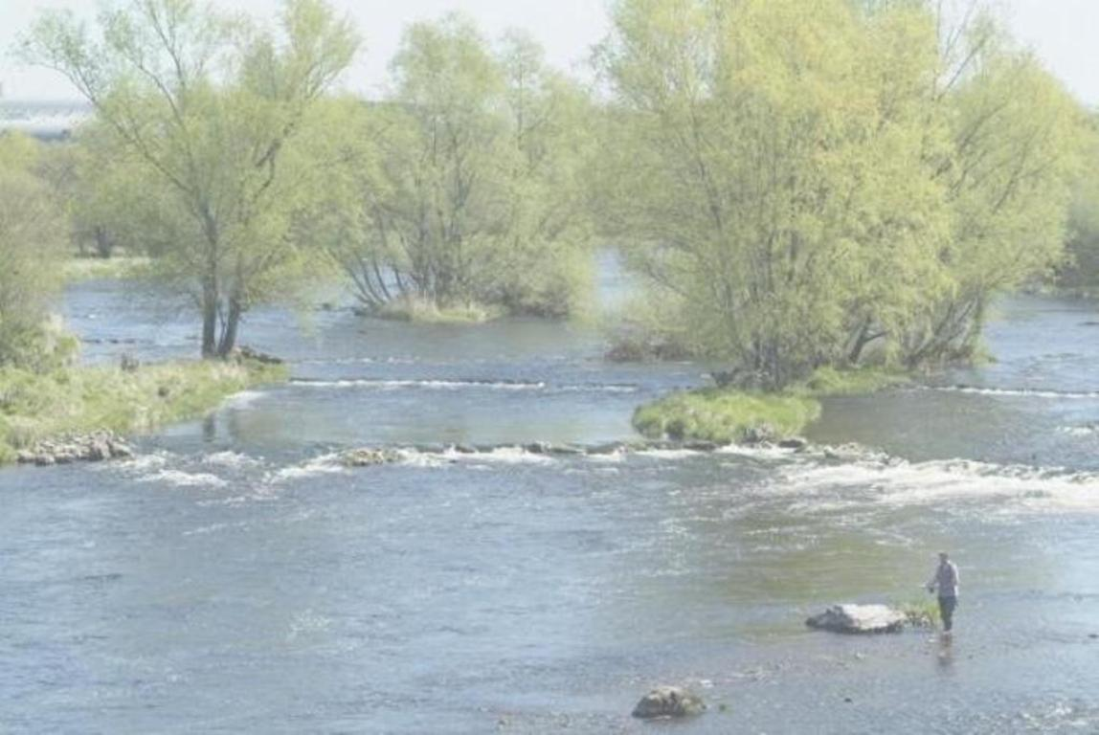

Student Mathematical Modelling
Workshop

University of Limerick
19th – 21st June 2013

This 3 day residential workshop will provide participants with hands-on experience in the mathematical modelling of real-world problems. It will also act as an introduction to study groups (solving problems) with industry. It is designed for final-year undergraduates, Masters’ students and early-stage PhD researchers in mathematics, science and engineering. There is no charge to attend and it is hoped that most participants will be able to stay on in Limerick for ESGI93 the following week (23rdJune – 28thJune).

For further information please contact Peg Hanrahan
Email: peg.hanrahan@ul.ie
Tel: +353 61 213013
Or see www.macsi.ul.ie/esgi93 for registration.

