MathSys Centre for Doctoral Training MA932 Research Study Group Problem Summary

Efficient Multi-Objective Simulation-Based Optimisation

External partner: ESTECO
Academic convenor: Prof Juergen Branke (Warwick Business School)
External partner contact: Dr. Mariapia Marchi (ESTECO)

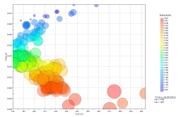

Background: ESTECO’s main software product is modeFRONTIER, one of the leading platforms for multiobjective engineering design optimisation. It uses metaheuristics for optimisation, and is able to link with a wide range of simulation tools to evaluate candidate solutions. The main challenges in this domain are
- There are often multiple optimisation criteria. In such cases, it is usually not possible to find one solution best according to all criteria, but the algorithm is supposed to search for a set of so-called “Pareto-optimal” solutions, with different trade-offs. The goal is to generate a representative subset of such solutions for a decision maker to choose from. Evolutionary algorithms are particularly suitable for this task, as they work with a population of solutions and can generate a set of Pareto optimal solutions in one run.
- Simulations are computationally expensive, so only few solutions can be evaluated. To reduce the number of simulations, surrogate models can be constructed and used to approximate the solution quality. modeFRONTIER uses Polynomial Chaos for this purpose.
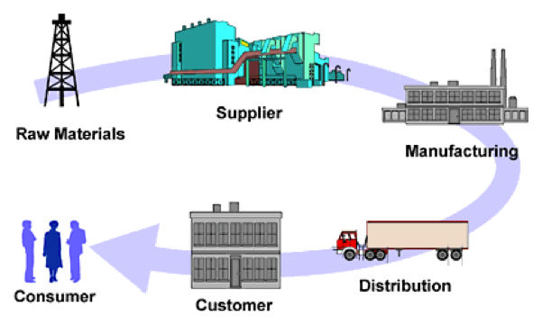

Project: ESTECO would like to be able to extend their software to also work well with stochastic simulators (such as discrete event simulations used in social science or epidemiology). This poses an additional challenge to optimisation, as a solution’s objective function values are now stochastic, making it difficult to decide whether an observed quality difference is genuine or simply due to random noise. The goal is thus to develop novel strategies to handle noisy multi-objective simulation optimisation problems.

Application: The problem has applications in many areas, including traffic light control, epidemiology, scheduling or call centres, to name just a few. In this study group, we suggest to work on a Supply Chain Management problem in the Chemical Process Industry. There are several plant sites, each with several processing lines. Each of these lines has unique processing capabilities and is responsible for a different category of products, depending on demand amounts and changeover costs. Demand forecasts for the products are determined based on the sales regions. The demand is assumed normally distributed. All of the plant sites can serve all of the sales regions, and transportation is assumed to always be available (but servicing demand from a more distant plant is more expensive). The objectives are to minimise inventory holding and transportation cost, and maximise customer service level (the percentage of demand that can be serviced from stock). Decision variables are the target inventory levels for each product at each processing centre. Simple rules are then used for intentory control and distribution.

Further remarks: There are different ways to tackle this problem. The first issue is to support the decision maker to pick the best solution, if the solution quality is actually noisy. One can think about what information should be provided, how one should interact with the decision maker, and perhaps collect additional information by running more simulations of the most interesting solutions.
Then, of course, the optimisation algorithm itself needs to be modified so that it can deal with the noise efficiently. Surrogate models can be used not only to save simulation runs, but also to improve an estimate of the quality of a solution by taking into account the quality of similar solutions. Common random numbers or other variance reduction techniques can be used to improve the estimates of quality differences. Sequential re-sampling of promising solutions may improve quality estimates where needed.

Pre-requisits: Students will have to implement and test their proposed algorithm, so programming skills are needed. Evolutionary algorithms or simulated annealing are to be used for optimisation, so knowledge of these tools is helpful, but could be learned quickly. Depending on the approach pursued, knowledge in response surface modelling, statistics, uncertainty quantification or machine learning would be helpful.

PhD topic: This Research Study Group project will lead into a follow on individual MSc research project. If the project goes well, it is expected that it will lead to a PhD project co-sponsored and co-supervised by ESTECO.

Relevant publications:
Ball. R.; Branke, J.; Meisel, S.: „Optimal sampling for simulated annealing under noise”. Journal on Computing, 2017, http://wrap.warwick.ac.uk/89590/
J. Branke, C. Schmidt, and H. Schmeck. “Efﬁcient Fitness Estimation in Noisy Environments”. In: Genetic and Evolutionary Computation Conference. 2001, pp. 243–250
J. E. Fieldsend and R. M. Everson. “The Rolling Tide Evolutionary Algorithm: A MultiObjective Optimiser for Noisy Optmisation Problems”. In: IEEE Transactions on Evolutionary Computation, 19(1), 2015, pp. 103–117
Shim, V. A., Tan, K. C., Chia, J. Y., and Al Mamun, A. Multi-objective Optimization with Estimation of Distribution Algorithm in a Noisy Environment. Evolutionary Computation, 21(1), 2013, pp. 149–177
Syberfeldt, A., Ng, A., John, R. I., and Moore, P. Evolutionary Optimisation of Noisy Multi-Objective Problems Using Conﬁdence-Based Dynamic Resampling. European Journal of Operational Research, 204(3), 2010, pp. 533–544

