Personalized Medicine in Mental Disorders
To identify the etiology of several mental disorders at Five-O scales (envirO(nment), symptO(m), endophenO(m), neurO(n) and genO(me)., see Fig. 1, adapted from [15]), we will develop and apply advanced mathematical and computer science tools to tackle some of the very large datasets that we have assembled. 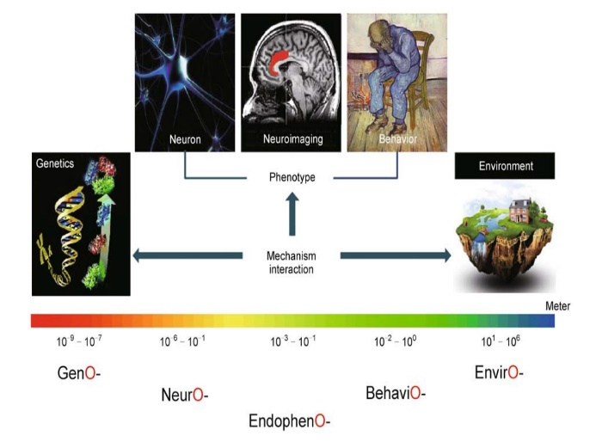
Fig. 1 The Five-O (GenO-, NeurO-, EndophenO-, BehaviO- and EnvirO-) approach for the investigation of mental disorders. Multi-level multi-modal data are collected and integrated by comprehensive modelling and cutting-edge computational tools, to identify biomarkers for various neuropsychiatric disorders, reveal their genetic basis, account for their underlying biological processes and mechanisms, as well as their interaction with environmental factors.
Back ground
Mental disorders account for 22.9% of years lived with disability (YLD) overall [13] and 28% of the disease burden among non-communicable diseases [32]. As they have their greatest impact among adults at working age the costs of mental disorders are high and amounted in Europe in 2010 to €523.3 billion [33]. The burden to society of YLD due to mental disorders has increased by 37.6% since 1990 [13] rendering the public health challenge extraordinary. Affective/anxiety disorders and schizophrenia alone account for almost 2/3 of the YLD caused by mental disorders. These figures testify to a “therapeutic stagnation” which has failed to alleviate patient suffering, results in a tremendous public health burden, and more recently has led to a disinvestment of the pharmaceutical industry from brain-related disorders (www.ddw-online.com). Drug discovery in neuropsychiatry has been hindered by the traditional way of diagnosing mental and neurological disorders, which is predominantly based on clinical observation and subjective-verbal measures, and is categorical. More promising is a dimensional approach (e.g. Research Domain Criteria, RDoC; [34]) utilizing validated neurobehavioural constructs that may (i) improve stratification of patient samples in clinical trials (ii) provide new transdiagnostic concepts that cut across traditional classifications with greater biological validity, for example for genetic studies and (iii) harmonise much more effectively with translational animal models. Among the major unmet clinical needs in the treatment of neuropsychiatric disorders are treatment-resistant major depressive disorder and the negative symptoms in schizophrenia. Since these disorders share as core psychopathological features impairments in motivation/affect and executive functioning we hypothesize that a detailed characterisation of symptoms related to these behavioural domains may yield neurobehavioural constructs useful for patient stratification and drug discovery thus generating innovative treatment options. It is, however, important to relate putative neurobehavioural constructs to traditional psychopathological categories and the way they are typically measured by regulatory authorities.
In the past five years or so, my group, working together with various clinical groups around the world, has accumulated some of the largest data sets for a few disorders such as schizophrenia, depression, autism and bipolar. For example, we have 3000+ schizophrenia with PANSS scores. They are first treated with 7 drugs randomly assigned for two weeks and then their PANSS scores are reassessed. We have around 1000+ schizophrenia with brain imaging, the largest in the world. Among these 1000+ schizophrenia patients, we have around 500 of them with the whole genome sequence. These largest datasets, together with our mathematical and biological background and our team, put us at the forefront of potential breakthroughs.
Going beyond single disorder and personalized medicine
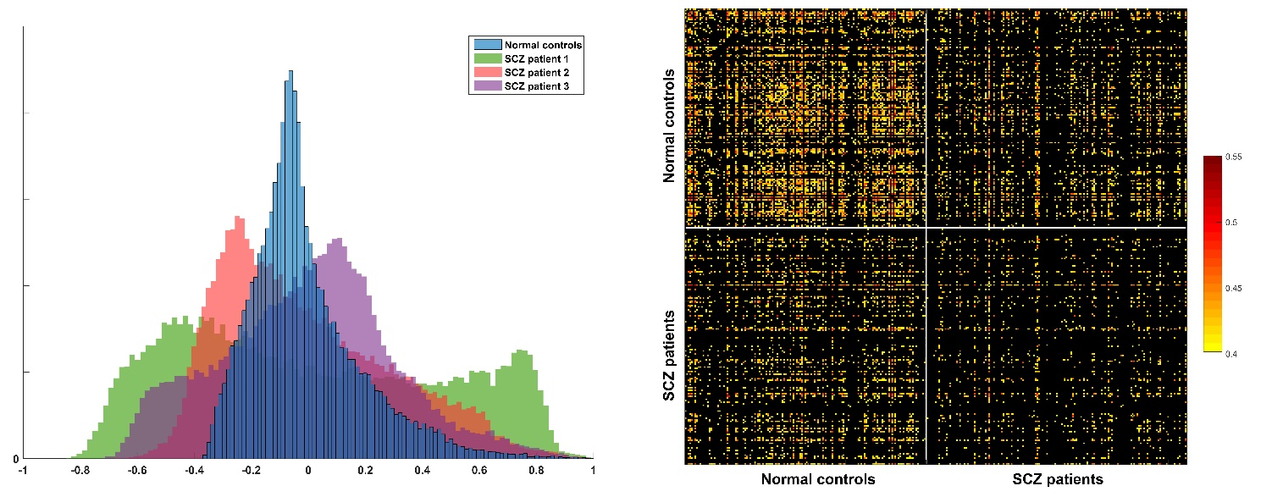
Fig. 2. Left. Histogram of a healthy bank from 150 healthy controls and three randomly selected patients with schizophrenia for one selected voxel. It is clearly seen that each patient exhibits different pattern of histogram. Right. The correlation between the top 2,000 most different voxels. The left top corner is for healthy controls, and the right bottom corner is for patient. It is readily seen that all healthy controls are alike, but each patient is different.
As pointed out by Dr. T. Insel (director of NIMH and now in Google), currently all mental disorders are classified according to symptoms and the classification lacks an objective approach. An approach to improve on this traditional method is to use a trans-diagnostic approach. This puts all the data from different mental disorders together and works out the ‘trunk’ which all mental diseases share and ‘branches’ which are different in different mental disorders. In this new proposed research, we do not have a prior assumption on the type of the mental disorder, and this is a strength of the new approach. In Fig. 2, we plot the histogram of the functional connectivity from one voxel to the other 47636 voxels in the brain for 160 healthy controls, and compare this with the histogram from three randomly selected schizophrenia patients. One of the striking features is the distinct pattern of each patient. The implication is profound: each patient exhibits a different pattern of functional networks, and this could serve as the basis of personalized medicine.
For the three month project, the student will first get familiar with various software dealing with brain images such as SPM etc. It is a fund part to learn. After it, we can work on either the trans-diagnostic approach or the personalized medicine approach. Our project will enable the student get familiar with working on big data and in particular, high dimensional, noisy and temporal data, develop novel statistics and machine learning approach to tackle the real problem.

References (Full papers of mine can be downloaded from my homepage http://www.dcs.warwick.ac.uk/~feng. Papers from my group are indicated by *)
[1]* W Pu, et al. (2016). Psychological Medicine (accepted)
[2]* H Cui, et al. (2016). Human Brain Mapping (accepted)
[3]* CY Tao, J Feng (2016). J. Neurosci Methods (accepted)
[4]* KC Kadosh et al. (2015). NeuroImage , doi:10.1016/j.neuroimage.2015.09.070
[5]* S A. Ojelade, et al. (2015). PNAS , doi:10.1073/pnas.1417222112
[6]* Yao Y, et al. J Feng (2015). Human Brain Mapping DOI: 10.1002/hbm.22932
[7]* Jia TY, et al. (2016). The neural basis of reward anticipation and its genetic determinants PNAS (in press)
[8] http://www.imagemend.eu/
[9]* Cheng W, et al. J. Feng (2015). Nature Partner Journal Schizophrenia , doi:10.1038/npjschz.2015.16, Featured Article
[10]* Cheng W, Rolls ET, Gu HG, Zhang J, J Feng (2015). Brain vol. 138; 1382--1393, doi: 10.1093/brain/awv051, Editor's Choice.,
[11]* S Guo, S et al. L Palaniyappan (2015). B J Psychiatry doi:10.1192/bjp.bp.114.15579.
[12]* Zhang J, et al J Feng (2014). Cerebral Cortex doi:10.1093/cercor/bhu173.
[13] Whiteford HA, et al.(2013) Lancet.;382(9904):1575-86.
[14]* S Desrivieres, et al. J Feng, G Schumann (2014). Molecular Psychiatry doi:10.1038/mp.2013.197
[15]* T Ge, G Schumann, J Feng (2013). Quantitative Biology DOI: 10.1007/s40484-013-0023-1
[16]* X. Gan, et al J Feng (2015). J. Neurosci Methods doi:10.1016/j.jneumeth.2015.02.010
[17]* S Guo, S et al. J Feng (2013). Schizophrenia Bulletins doi:10.1093/schbul/sbt163.
[18]* Loth E. et al. Feng J , Schumann G. (2013). Biol. Psychiatry doi:10.1016/j.biopsych.2013.07.043.
[19]* Luo Q et al. (2013). PLoS Comp Biol DOI: 10.1371/journal.pcbi.1003265,
[20]* Guo SX, et al. Feng J (2013). NeuroImage DOI: 10.1016/j.nicl.2013.06. 008.
[21]* Chen D., Feng J.F.,and Qian M.(1997) Science in China series A vol. 40: 1129-1135.
[22]* Q Luo,et al. Feng J (2013). NeuroImage 79: 241—26.
[23]* Feng J.F.,Shcherbina M. and Tirozzi B.(2001) Communications in Mathematical Physics vol. 216, 139-177.
[24]* T Ge; J Feng; D Hibar; P Thompson; T Nichols (2012). NeuroImage vol. 63: 858-873
[25]* Cheng W. Rolls E., Feng JF (2016) Depression, in preparation
[26]* HJ Tao, et al. JF Feng (2011). Molecular Psychiatry doi:10.1038/mp.2011.127
[27]* Rossoni E., Feng J.F., et al. (2008) PLoS Comp. Biol. 4(7): e1000123. doi:10.1371/journal.pcbi.1000123
[28]* Feng J.F.(1997) Phys. Rev. Lett vol. 79(21), 4505-4508.
[29]* Brown D.,Feng J.F., and Feerick S.(1999) Phys. Rev. Lett vol 82, 4731-4734.
[30]* Feng J.F.,and Tuckwell H.C.(2003) Phys. Rev. Letts. vol. 91, 018101
[31]* Zhang J., et al. Feng JF (2016) The original of schizophrenia: a big bang theory, in preparation.
[32] Prince M, et al.. Lancet. 2007;370(9590):859-77.
[33] Gustavsson A, et al. European neuropsychopharmacology. 2011;21(10):718-79.
[34]. Abbot, A. Schizophrenia: Nature. 2010;468(7321):158-9

