Supervisors: Juergen Branke & Sebastian Vollmer
Title: Hyperparameter tuning of iterative algorithms
Desired skills: Julia, Gaussian Process
The best performing machine learning pipelines compare and combine multiple atomic models and tune their hyperparameters. One hyperparameter in particular is the number of steps to train a model, as this directly scales the learning cost. For instance, a hyperparameter-tuning-algorithm might decide whether to pause training and start a new model or resume the training of a previously-considered model.
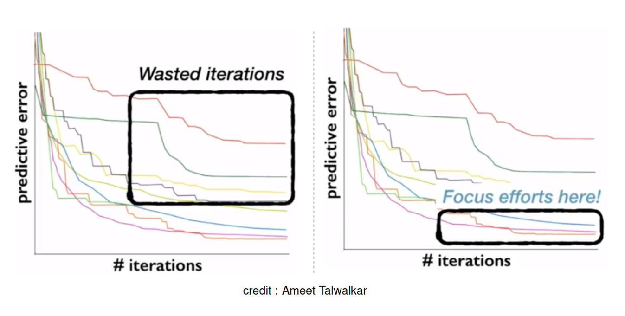]
This can be missleading In the early stages of training, Model B looks more promising than
Model A even though the latter ultimately performs better. Therefore,
we must be careful not to prematurely terminate training for Model A.

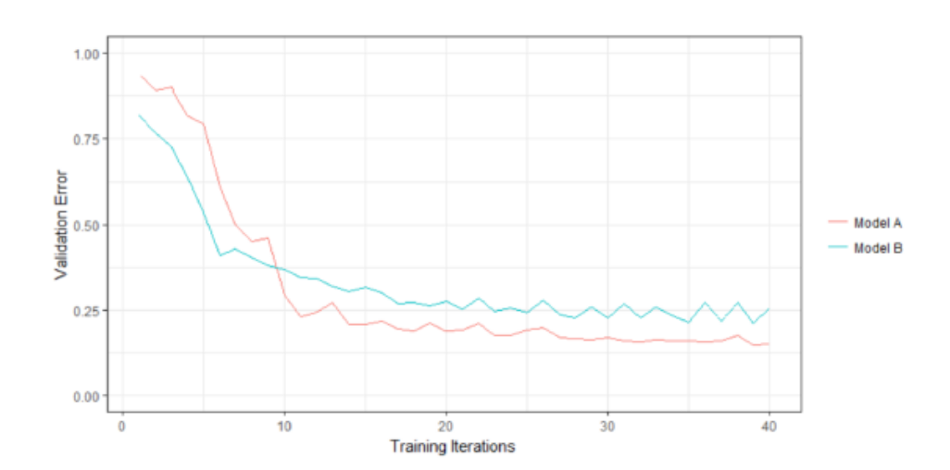

This project aims at comparing existing methodologies with a few new ideas.

References:
https://arxiv.org/pdf/1603.06560
https://arxiv.org/abs/1406.3896
https://openreview.net/forum?id=SknC0bW0-

