Multiresolution Graph Modeling of Whole Slide Images for Predictive Tasks in Computational Pathology
Fayyaz Minhas
Nasir Rajpoot
MathSys Project Proposal

Motivation and scientific requirement
Fuelled by government level support in many countries, computational pathology is poised to revolutionize the practice of pathology in clinical settings through the development of Artificial Intelligence and Deep Learning solutions. With the aim of assisting pathologists in the diagnosis of cancer, the digitization of tissue scanning and automated analysis of the resulting multi-gigapixel whole slide images through AI techniques has the potential of opening new avenues of research and improvement in health care delivery to cancer patients. The Tissue Image Analytics (TIA) Lab in the Department of Computer Science at Warwick is leading the computational arm of the £15 Million PathLAKE centre of excellence on AI in digital pathology and hosts one of the largest repositories of digitized whole slide images and associated computational hardware. It provides a unique opportunity to students to participate in this scientific and technological endeavour.
The field of computational pathology aims at developing intelligent solutions for predictive modelling on the basis of whole slide images (WSIs) of cancer tissues such as predicting the type, grade and stage of cancer or its response to therapy or survival. One of the challenges in the development of machine learning solutions for computational pathology stems from the fact that the WSI is very large (100K x 100K in pixel dimensions) and consists of a very large number (>500K) of cells. Consequently, the whole of the WSI cannot fit in memory at once. Conventional methods in this domain typically work by dividing the image in tiles or patches and then developing machine learning solutions for the patches. However, this inherently limits the ability of the machine learning model to model context and inter-dependence between different patches. Furthermore, such approaches do not explicitly model the communication patterns between different cells in the tissue. Another limitation of this approach is that there is no clear method of aggregating individual patch level predictions for a slide level prediction. Existing methods also do not consider the multiresolution nature of whole slide images.
Proposal Details
One possible way of modelling the multiresolution nature of the whole slide image while keeping the above limitations of existing methods in consideration is to use graph based modelling of a whole slide image. This project focuses on the development of a multiresolution approach to graph construction and prediction through graph neural networks. This approach is, in principle, similar to how pathologists work – by considering the interactions between different cells at different levels of magnification as is illustrated in the figure below.
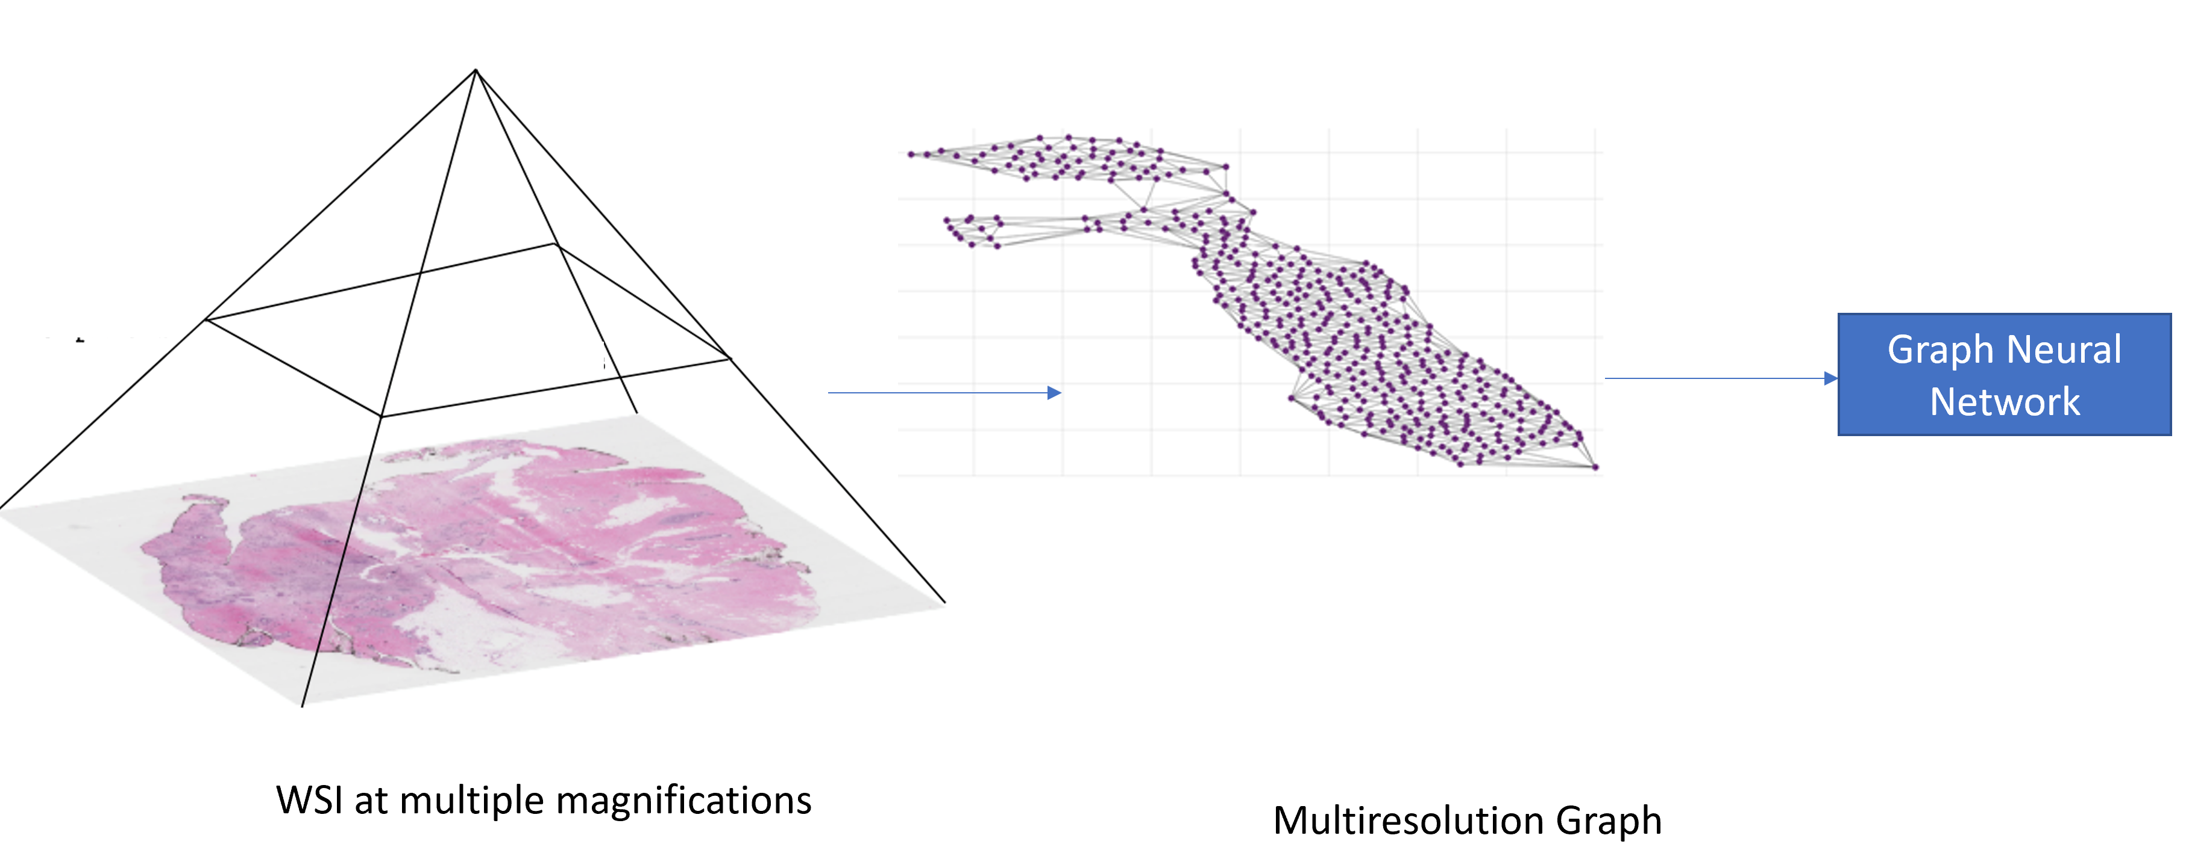
Specifically, the project shall focus on:
- Development of methods for constructing multiresolution graphs for whole slide images
- Development of bespoke machine learning models based on graphs
- Demonstration of the predictive power of the proposed method for predicting mutations from whole slide images

