STUDY CONTACTS: |  | EMAIL: | PHONE:
Lead Study Facilitator: Sue Wright |  | S.wright.3@warwick.ac.uk | 02476 575919
Lead Research Nurse: Pauline Darbyshire |  | p.darbyshire@warwick.ac.uk | 07876468557
Study Title: ARCHIE – The early use of Antibiotics in ‘at Risk’ CHildren with InfluEnza

Summary & Trial type: | Children with underlying conditions who develop flu are at greater risk of becoming unwell from further infections than otherwise healthy children. The ARCHIE study will help researchers find out whether giving “at risk” children antibiotics within the first five days of developing flu-like illness will reduce the chances of them becoming more unwell or developing further infections.  Type of study: double-blind randomised placebo-controlled trial (CTIMP)
Objectives: | Primary objective: To determine whether early treatment with a 5-day course of co-amoxiclav reduces the need for re-consultation due to clinical deterioration in ‘at risk’ children who present in primary care with influenza/influenza-like illness (ILI).  Secondary objectives: To examine the cost-effectiveness of early co-amoxiclav use in ‘at risk’ children with influenza/ILI and its impact on antibiotic resistance and respiratory bacterial carriage
Chief Investigator: | Dr Kay Wang
Sponsor: | University of Oxford
Funder: | NIHR – Programme grants for Applied Research (PGfAR)
Recruitment Period: | 2nd October 2017 > 25th April 2018
Total Recruitment Target: | 650
Practice Target: | 1-2 Patients per GP Practice
Eligible Practices: | Those who meet the criteria set out in the CRN practice feasibility form distributed at the “Expression of interest” stage.
Study Process: (see flowchart on pages 4-5)

CRN Involvement: | - CRN support is available to assist with running the database search.  - CRN Research Nurses to conduct all home visits and Medical Record Reviews.
Practice Involvement: | GP  - Before each influenza season, to screen the list of patients generated by a database search to ensure all children are eligible.  - During each influenza season, identify potential participants opportunistically using a brief set of eligibility criteria.  - Contact a trial researcher who will guide them through the full eligibility assessment.  - The GP will retain the role of safety assessment and may need to assess causality of any serious adverse events that may occur.  Admin  - Before each influenza season, practices to flag notes for ‘at risk’ children following screened database search.  - Notify the parents/guardians in advance of the influenza season via text message or mailing (Optional for the practice)  General  - Display of posters and leaflets promoting ARCHIE.
Patient Involvement: | - Participants will have a baseline assessment at home which will include a nasal and a throat swab baseline questionnaire and be randomised to co-amoxiclav or placebo.  - Parents/guardians to complete weekly study diary and questionnaires.  - Further option of consenting to extended section of ARCHIE (Involves further Home Visits for swab collection at 3,6 and 12 months).
Study Team Involvement: | - Study team will update practices with any study amendments.
Documentation/Equipment Provided to the Practice:

Study Protocol | - 19 April 2017 ARCHIE version 3
Patient Information Sheet | - 1Apr14 V2.2 (Parent PIL)
Ethics Approval | - 10th October 2013
HRA Approval | - 1st August 2016
Patient Invite Letter | - Preseason general cover letter8Aug16 v1
Mailing Materials / Site File | Study team will provide all resources for the mail out, study marketing materials plus a Study Site File
Benefits to the practice:

Reimbursement: | One-off costs:  - Study set-up - £74.72  Per Patient Cost:  - GP Screening - £1.80  - Flagging patients on practice system - £0.26 Sub-total based on 100 eligible patients - £206.00  Optional Patient Contact: Option for the practice to conduct one (or none) of the following…  - Mail-out - £0.33 (Plus postage costs claimed from the study team)  OR  - Text Message - £0.33 Sub-total based on 100 eligible patients - £33.00  Per Patient Cost:  - Study introduction during appointment  - GP to assess eligibility during routine appointment  - Discuss study with child and parent  - Telephone central study team with patient details - £14.40  Please Note: This cost is paid only when GP calls central study team to confirm patient eligibility.  Sub-total base on 10 eligible patients - £144.00  Total costs – £457.72 (No Mail-out/Text - £424.72)
Reimbursement: | The study team will supply the study leaflets and will reimburse postage costs.  Please contact Sharon Tonner to be reimbursed for postage: Sharon Tonner, ARCHIE Study, Primary Care Clinical Trials Unit, Nuffield Department of Primary Care Health Sciences, University of Oxford, Radcliffe Observatory Quarter, Woodstock Road, Oxford, OX2 6GG
Reimbursement: | The study contributes to the 2017/18 RSI scheme.
Search & Reporting Process:

Inclusions:  (Refer to Protocol for complete list of criteria) | Inclusion Criteria (summary):  - Aged 6 months to 12 years inclusive.  - In ‘at risk’ category (e.g. underlying respiratory, cardiac, neurological, renal or liver condition).  - Presenting within first 5 days of influenza-like illness during influenza season.
Exclusions:  (Refer to Protocol for complete list of criteria) | Exclusion Criteria (summary):  - Known contraindication to co‐amoxiclav  - Child given antibiotics for treatment of an acute infection within the last 72 hours.  - Child requires immediate antibiotics (clinician’s judgement).  - Child requires immediate hospital admission for treatment of an influenza‐related complication  - (Clinician’s judgement).  - Child has been observed on hospital ward or ambulatory care unit for longer than 24 hours.  - Presence of any reason to prevent healthcare professional from obtaining nasal swab.  - Child with known cystic fibrosis.  - Child previously entered into the ARCHIE study.  - Child has been involved in another medicinal trial within the last 90 days.
DATA EXTRACTION:  Report fields: | This report will provide all patient information needed for the GP to complete screening and for the practice administration team to complete the patient flagging process (Required) plus the study invitation mail/text send out (Optional).  - EMIS Number  - NHS Number  - Title  - Given Name  - Family Name  - Date of Birth  - Gender  - House Name/Flat Number  - Number and Street  - Locality  - Town  - County  - Postcode  - Usual GP’s Full Name
GP Screening | - CRN will provide the practice with the patient report for screening.  - The screening must be completed within 10 working days.
Death and Departure Check | - Once patients have been screened, the practice will check to ensure patient details are correct at the time of mailing/text send out (Optional for practice).
Mailing of Study Information | - Patients will be sent postal information about the study or a text message. This process is optional, to be completed by the practice.
Patient Tagging | - After GP screening is complete, practice staff to add a READ code to the practice database (Instructions provided by CRN), to flag potential ARCHIE participants should they consult with the appropriate symptoms within the recruitment period.

CRN West Midlands – Study Process for GP Practices - Pre-Recruitment Activity

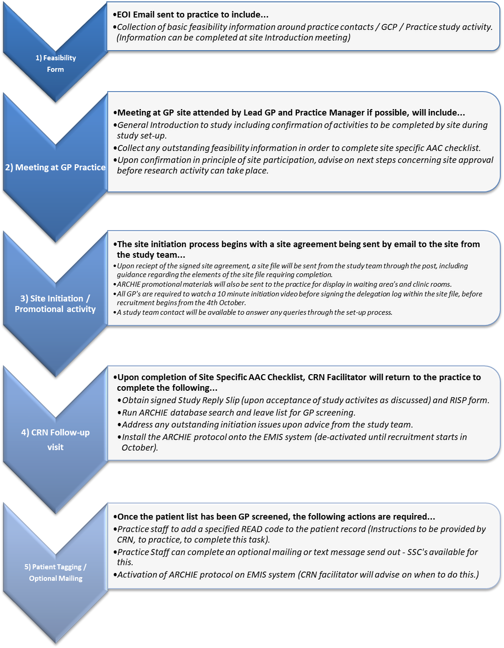
CRN West Midlands – Study Process for GP Practices - Recruitment & Follow-up Activity

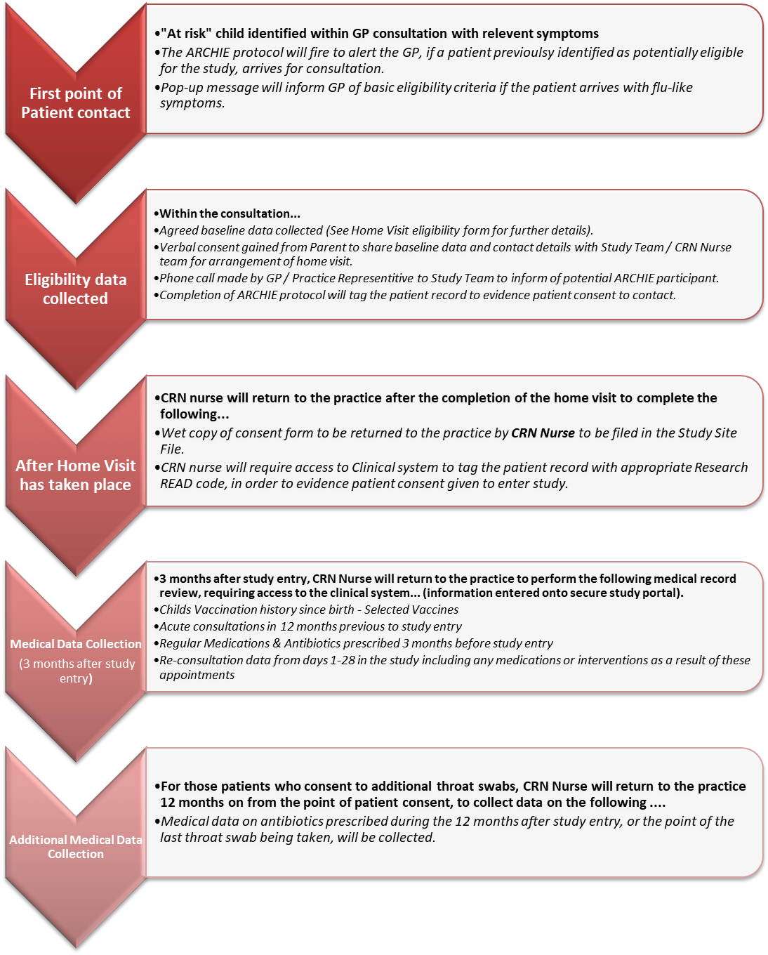

EXAMPLE PATIENT LETTER (OPTIONAL MAILING TO BE COMPLETED BY THE PRACTICE)
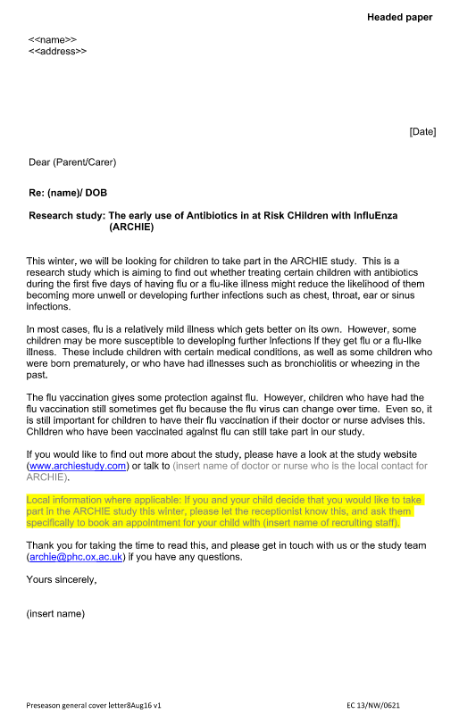
Please select which exclusion categories to apply to this search.

Please find a full list of associated READ codes on the rear of this form.

Exclusion category |  | Description | Tick to exclude…
1 | Dementia & Alzheimer’s related codes | - Codes related to Dementia and other cerebral degeneration, including Alzheimer’s.  Amendments……………………………………………………………………………. | [ ]
2 | Other significant/severe mental illness | - Codes related to organic and non-organic psychoses.  - Other mental and behavioural disorders.  Amendments……………………………………………………………………………… | [ ]
3 | Learning difficulties | - Learning disabilities register if applicable.  - Codes related to Mental retardation and learning disabilities of varying levels of severity.  Amendments……………………………………………………………………………… | N/A  Included for ARCHIE
4 | Palliative care / Terminal illness | - Codes related to Palliative care and differing specialist treatment.  - Terminal illness and associated care.  Amendments……………………………………………………………………………… | [ ]
5 | Blind | - Codes related to blindness and low vision.  - Registered blind.  Amendments……………………………………………………………………………… | [ ]
6 | Nursing homes | - Codes related to Nursing, care or residential institutions.  - Housebound.  - Manual check if residential home addresses are provided by the practice.  Amendments……………………………………………………………………………… | [ ]
7 | Substance misuse | - Codes related to Drug misuse behaviour or dependence.  - Alcohol dependence syndrome.  Amendments……………………………………………………………………………… | [ ]
8 | Bereavement/Grieving  (Exclude if coded in last 6 months) | - Codes related to bereavement and associated counselling.  Amendments……………………………………………………………………………… | [ ]
9 | Data access dissent | - Code related to dissent from secondary use of GP patient identifiable data.  - Also declined consent for researcher to access clinical record.  Amendments……………………………………………………………………………… | [√ ]
Any Other Codes  (please specify) |  | ………………………………………………………………………………………………………….
I confirm that I have read the enclosed information. The practice accepts the responsibility of screening the patient list returned by this search and therefore is responsible for the selection of recipients of literature related to this study.

Practice Name __________________________________________________Practice Code ________________
Signed _____________________________________________________________________________________
Print _______________________________________________________ Date ___________________________
Full list of associated READ codes
* = plus all associated READ child codes (unless otherwise stated)
1 – Dementia & Alzheimer’s related codes
- F11* Other cerebral degeneration, inc Alzheimer’s Fyu30 [X]Other Alzheimer's disease
- F110* Alzheimer's disease E012* Other alcoholic dementia
- E00* Senile/presenile organic psych E041 Dementia in conditions EC
- E02y1 Drug-induced dementia Eu01* [X]Vascular dementia
- Eu00* [X]Dementia in Alzheimer's Eu02* [X]Dementia in disease EC
- F0300 Encephalitis-kuru F21y2 Binswanger's disease
- A410 Kuru A411 Jakob-Creutzfeldt disease
- Eu041 Delirium Superimposed on Dementia
2 - Other significant/severe mental illness
- E0* Organic psychotic conditions
- Eu1* Mental and behavioural disorders due to psychoactive substances
- Eu2* Schizophrenia, schizotypal and delusional disorders
- E1* Non-organic psychoses Eu31* Bipolar affective disorder
- Eu03 [x] Organic amnesic synd not induced… Eu04 [x] Delirium, not induced by alcohol + other psycho…
- Eu05 [x] Oth mental disorder brain damage/dysfu… Eu06 [x] Personality and behave disorder brain dis dam…
- Eu0z [x] Unspecified organic or symptomatic mental di…
3 – Learning Difficulties -
- E3*/Eu7* Mental retardation Eu815 Severe learning disability
- 918e On learning disabilities register Eu817 Profound learning disability
- Eu814 Moderate learning disability Eu81z Development disorder of scholastic skills, unspecified
4 - Palliative care / Terminal illness
- ZV57C Palliative care 8BAR Specialist palliative treatment – inpatient
- 8BJ1 Palliative treatment 8BAS Specialist palliative treatment – daycare
- 1Z0* Terminal illness 8BAT Specialist palliative care treatment – outpatient
- 8BA2* Terminal care 8CM1* On gold standards palliative care framework
- 8BAN Comm specialist palliativ care 8BAP Specialist palliative care
- 8BAQ Final days pathway 8CM3 Palliative care plan review
- 8CM4 Liverpool care pathway dying 8CMW3 End of life care pathway
- 8CMb ICP for end of life 8H7g* Ref to palliative care service
- 8HH7 Ref com spec palliativ care tm 9K9 Palliative cre hndvr frm cmplt
- 9Ng7 On end of life care register 9NgD Under palliative care serv
- 9Nh0 Under care com pall care team 9NlJ Seen by palliative care service
- 9b9B Palliative medicine 9e02 Noti pr ca OOHS palli ca pl pl
- 5149 Radiotherapy-tumour palliation 8CM0 Cancer Care Plan
5 – Blind
- 6689 Registered blind F49 Blindness and low vision
6 - Nursing homes
- 13F6* Nursing/other home 13FX Lives in Care Home
- 13F7* Residential Institution 13CA Housebound
7 - Substance misuse
- E24* Drug dependence
- E23* Alcohol dependence syndrome
- 13c* Drug User - (Not Including 13cl “Has never Injected Drugs” & 13cp – “Does not misuse drugs”)
- EMISQDR1* Drug Misuse Behaviour - (Not Including EMISNQMI184 “Misuse Free” & EMISQDO7 “Does not misuse drugs”)
- 1V* Drug Misuse Behaviour
8 - Bereavement / Grieving
- 13Hc Bereavement 13M* Family bereavement
- 8O81* Bereavement Support PC0084 Bereavement counselling
- 675* Grieving counselling – [includes miscarriage & bereavement] 8HHK Referral to bereavement counsellor
9 - Data access dissent
- 9Ndd Declined consent for researcher to access clinical record 9Nu0 Dissent from secondary use of GP patient identifiable data

