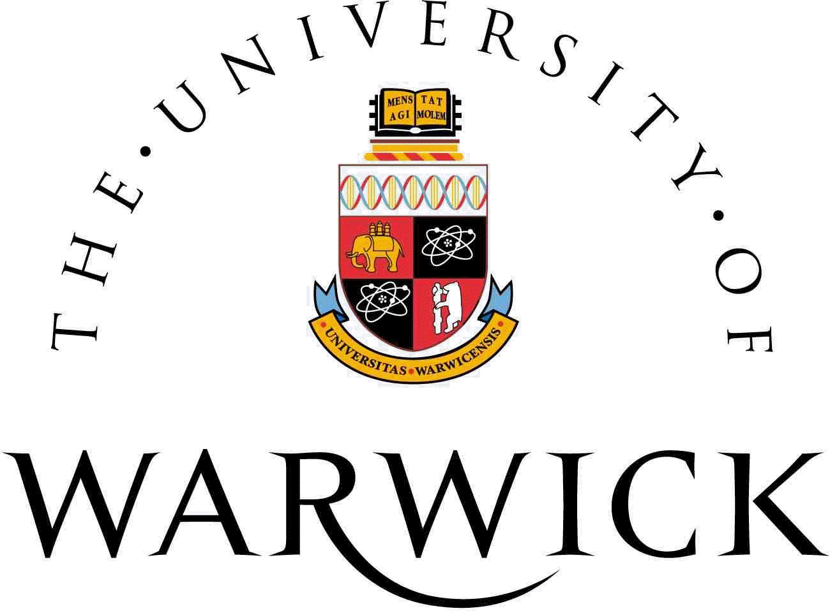
SUB-SAHARAN AFRICA RESEARCH NETWORK SYMPOSIUM


Tuesday, 6th May 2014
Institute of Advanced Study, Millburn Hill Road, CV4 7 HS, University of Warwick
Millburn House is two buildings along from University House - it is marked as building 40 on this online main campus map
09.30 | Registration
10.00-10.15 | Welcome and Introduction | Prof Richard Aldrich- IAS Director
Session 1
10.15-10.45 | Introduction to SSARN and a book launch titled ‘Advanced Techniques for Modelling Maternal and Child Health in Africa’. The Springer Series on Demographic Methods and Population Analysis, Vol. 34. Springer Science, 2013 | Dr Ngianga-Bakwin Kandala
10.55 | Break
Session 2
11.10-11.40 | Nation-building revisited: The case of the contemporary African literatures written in Portuguese | Emanuelle Santos
11.45-12.15 | Can up-skilling non-physician clinicians (NPCs) make a difference to practice and help towards reductions in maternal and neonatal mortality, in Malawi and Tanzania? | Dr David Ellard
12.20 | Lunch
Session 3
13.20-13.50 | The Defence of National Borders | Dr Paul Komba (University of Cambridge)
13.55-14.25 | Prevalence of food insecurity in patients with diabetes in western Kenya | Stephanie Cheng
14.30 | Break
14.40-15.10 | Using existing data to inform public health policy for non-communicable disease in low-resource settings | Dr Saverio Stranges
15.15-15.45 | Space-time mapping of stunting among children below five years in Somalia using Bayesian geo statistical approach | Damaris K Kinyoki
15.50-16.10 | Discussions & Networking
16.30 | Close

