ETATMBA report January 2013

D1.1 50 NPCs as advanced leaders will be recruited and trained
MS14 Final 30 NPCs trained as advanced leaders

This deliverable has been achieved, and indeed considerably exceeded.

The content of this deliverable has already been extensively described in the periodic review. Structured education programmes have been tailored to meet the individual needs of NPCs and the healthcare systems in Malawi and Tanzania and students have successfully been completing the courses in numbers greater than anticipated.

A total of 112 NPCs have been trained in both Malawi and Tanzania:
60 Tanzanian Assistant Medical Officers (AMOs)
52 Malawi Clinical Officers
58 nurse-midwives were also trained alongside the Tanzanian AMOs, as these professional groups work in such close partnership that it would be ineffective to train one group without the other.

The overall objective of creating local leaders in obstetric care is being met by developing programmes tailored to the stage of development and roles that NPCs undertake in each country. Curricula have been designed and developed, faculty recruited and trained and local clinicians engaged in the designs teaching and evaluation of the programmes.

Local variations on leadership training have been necessary to meet the differing needs of the two sets of clinical officers. In Tanzania, after selection from secondary school, Medical Assistants undergo a three-year training course and after graduation work in rural dispensaries or health centres where their main roles are diagnosis, treatment of common diseases and referral, while the area of surgery is limited to minor procedures only. Thus their course is a longer and more concentrated period of several weeks, and combined with a separate course on leadership training aimed at meeting the challenges of setting up and sustaining a service in the health centres they return to. The remoteness of these health centres meant that it was critical that nurse-midwives were trained alongside them in anaesthesia, in order for a practical, working team to be established.

Meanwhile, in Malawi the NPCs on the training courses have a different level of experience. They have all worked in District or Missionary Hospitals and have been taught and practice emergency obstetric care including surgery. The reasons for the continuing high maternal mortality in Malawi is not simply lack of access to service but the need to ensure that these services are effective and that the workforce is supported and developed to provide sustainable delivery. This has been the focus for their leadership training, with the students identifying areas where improvements could be made, completing a formal audit to demonstrate a particular deficiency, and then implementing a change which led to a marked improvement upon re-audit. A key point in their training was the importance of cascading their new knowledge to all members of the team to improve the performance of the clinical service. To achieve this without interruption of the current clinical service, a modular design with in-service training and support has been developed. Fifty-two NPCs have been enrolled in an accredited diploma programme that aims to build up to a degree. A Pilot module and two modules in emergency obstetric care and leadership have been completed and examined and assessed work within their districts on service improvement through audit continues.

The students in Tanzania have good career progression resulting from their training courses, but in Malawi there is much more emphasis on the importance of a degree. The development of a degree course has long been discussed but prior to the ETATMBA project, no tangible progress had been made. The NPCs in Malawi were very motivated to gain a qualification from their studies, and this has given the impetus to the development of a degree programme for Malawi clinical officers. While this is not itself one of the project’s deliverables, it is a significant achievement which builds professional recognition and leadership status for the clinical officers and provides them with a defined career path where they can use their training to teach others. The creation of the Malawian BSc will benefit clinical officers in the future, but it was felt that the current students – the very ones whose enthusiasm has brought about such dramatic progress in the development of a course – should not lose out. The training has thus been formally approved by the University of Warwick, first as an Advanced Diploma and now, in combination with their original clinical officer training, the students will leave the course with a BSc in Obstetrics.

From September 2013 a second cohort of 12 students annually will be trained by the College of Medicine to achieve a degree over two years. In addition to obstetrics degrees, BScs in surgery, medicine, paediatrics and anaesthetics have been approved and will be commencing in 2013 (obstetrics, surgery) and 2014 (medicine, paediatrics, anaesthetics).

Malawi: Advanced Leadership module: lecture
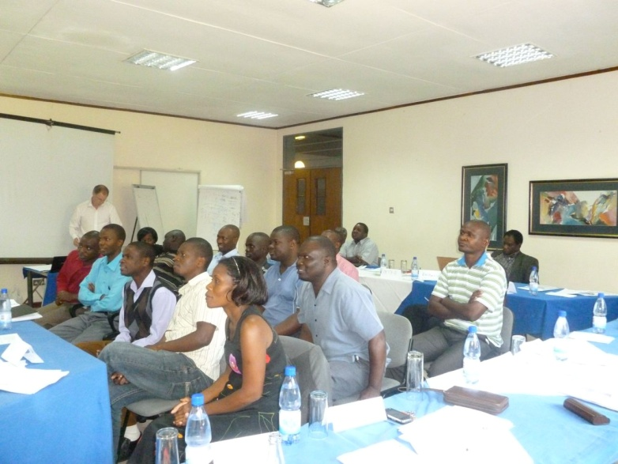

Malawi: Advanced Leadership module: presentation by students
