

16 – 17 May 2013
Scarman House, University of Warwick

Delegate Information

Warwick Medical School
2nd International Symposium on
Advances in Human Metabolism Research

16 – 17 May 2013

Thursday 16 May 2013

Society for Endocrinology Seminar
‘Metabolism, Mitochondria and Fatty Acids’
Scarman House, University of Warwick, CV4 7AL, UK

Official Dinner
Scarman House, University of Warwick, CV4 7AL, UK

Friday 17 May 2013

Training workshop - Lectures
Scarman House, University of Warwick, CV4 7AL, UK

Training workshop – Practical Sessions and Tour of the Human Metabolism Research Unit
University Hospitals Coventry and Warwickshire
Coventry, CV2 2DX, UK

16 – 17 May 2013
Scarman House, University of Warwick

Warwick Medical School
1st International Symposium on
Advances in Human Metabolism Research

Day 1: Thursday 16 May

Conference Registration

Registration opens at Scarman House from 8.30hrs.

Upon arrival please register and collect your delegate pack plus badge from the registration desk. The registration desk is located in the main reception of Scarman House.
You will need your delegate badge to gain entry into the conference and exhibition areas. If you have registered for the workshop please make sure that you retain your badge for day 2. Please display your badge predominantly at all times.

The programme begins at 09.15hrs. Please make sure you arrive promptly for the beginning of this programme. If you intend to be late please inform the organisation team.

Official Dinner

The dinner is booked for 19.30hrs and will take place Scarman House, University of Warwick.

Dress code: Business attire.

All dietary requirements have been catered for according to your preferences noted on your registration form.

Accommodation

Accommodation is not included in any of our packages. For booking enquiries please contact Warwick Conferences and quote ‘Metabolism Symposium – Scarman House’.

Day 2: Friday 17 May

Registration opens at Scarman House at 08.00hrs.

Upon arrival please register and collect your delegate pack plus badge from the registration desk. The registration desk is located in the main reception of Scarman House.

16 – 17 May 2013
Scarman House, University of Warwick

You will need your delegate badge to gain entry into the conference and exhibition areas for the day. Please display your badge predominantly at all times.

The programme begins at 08.15hrs. Please make sure you arrive promptly for the beginning of this programme. If you intend to be late please inform the organisation team.

Practical Sessions and Tours of Human Metabolism Research Unit

The practical sessions will start at 11.15hrs promptly.

A shuttle bus will be in place to take you from Scarman House, University of Warwick to UHCW and back. The shuttle bus will leave at 10.50hrs from the main reception of Scarman House.

Free car parking is available at Scarman House via a barrier operated system. Disabled parking spaces are available at the front of the car park. Please collect a free parking token from the registration desk on departure.

If you are making your own way to UHCW please go to the main entrance of the Clinical Sciences Building at UHCW (directions and maps below and in attachment). Please note that car parking at the hospital is pay on foot.

Pick up from UHCW will be at 17.15hrs from the Clinical Sciences Building for a return journey to Scarman House, University of Warwick.

Exhibitors

Location: The ‘Exhibition’ will take place in the Courtyard, Scarman House.
Exhibition Area: Company names will be labelled on the tables in each stand. Exhibition space is limited to 3 x 3m. A table and one chair will be provided. Power sockets are available. Please bring your own extension lead, which we will happily position and make safe for you.
Exhibitor Parking and Drop Off: Unlimited free parking is available at Scarman House. Please be sure to collect a token from reception on departure. There is an unloading bay directly outside Scarman House to drop any goods off.
Setting Up: All stands need to be set up between 7 a.m. and 8.30 a.m. on Thursday 16 May 2013. If you require overnight storage of your material on Wednesday 15 May 2013 please liaise with reception at Scarman House and request that all your material is stored in the cloakroom. Please note that all stands need to be set up for the duration of the symposium on 16 May 2013.

Break Down: All stands can be taken down after 18.00. Please note all items must be cleared from the exhibition suite by Thursday 16 May at 18.30. Any items left after this time will be disposed of. Any costs incurred will be charged directly back to the exhibitor.
Shipping: If stands are being couriered separately ahead of the meeting please address all your material to: F.A.O. Dr Filipa Vance, Warwick Medical School 2nd International Symposium on Advances in Human Metabolism Research, Scarman House, University of Warwick, Gibbet Hill Road Coventry, CV4 7AL
Poster Session

Location: The Poster Session will take place in the Courtyard, Scarman House. The location of your assigned poster board will be given to you at registration.
Poster set-up: All posters must be on display for the duration of the symposium. All posters must be on display for the duration of the symposium and can be set up between 07:00hrs to 08.30hrs on 16 May. Posters will be mounted on felt boards and all materials will be made available at poster set-up.
Judging: The theme for this poster session is ‘Metabolism, Mitochondria and Fatty Acids’ and includes clinical and basic approaches to scientific research. Dr John Clapham (Chair), Dr Charles Affourtit and Professor James Hamilton will be judging this competition.
The selection criteria are based on the scientific content and on the quality of the poster presentation. The judging session will take place at 12.45-14.15 on 16 May 2013. Presenters must be available to answer questions on their work between 13.00 and 13.45.
The poster prizes, £100 each, will be awarded to the two best posters, one clinical and one basic research, on display.
The winners will be announced, and will receive their prize, at ‘Cheese and Wine Reception’ between 16:00hr and 18:00hrs.
Removing your poster: All posters can be taken down after 18.00hrs. Please note all items must be cleared from the exhibition suite by Thursday 16 May at 18.30hrs. Any items left after this time will be disposed of. Any costs incurred will be charged directly back to the exhibitor.
Venue Location

Scarman House
Gibbet Hill Road, University of Warwick, Coventry, CV4 7AL, UK

Scarman is located at the University of Warwick on the outskirts of Coventry and is easily accessible by road and rail.

By Road: CV4 7AL directs you to Gibbet Hill Road, the main road which runs through the University. Scarman House is signposted from this road.
Parking: Free car parking is accessible via a barrier operated system. Disabled parking spaces are available at the front of the car park. Please collect a free parking token from the registration desk.

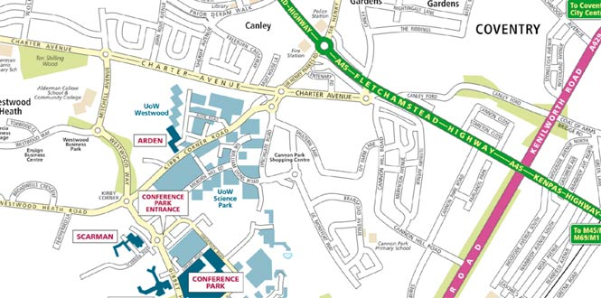

Rail: The nearest rail station for the University is Coventry - approximately four miles from the campus. Coventry Station is easily reached from London (Euston), Birmingham and Leicester, all of which run regular and frequent services direct to Coventry. From Coventry Station, there are frequent local bus services to the University. A taxi rank is located at the station.

University Hospitals Coventry and Warwickshire
Clifford Bridge Road, Coventry, CV2 2DX, UK
By Road: CV2 2DX directs you to the main hospital car park. The Clinical Sciences Building is situated two buildings away from the main entrance (as indicated by red arrow below). Detailed driving instructions can be found at
http://www.uhcw.nhs.uk/find-us/university-hospital
Parking: All parking at the hospital is pay on foot.
By Bus: There are many regular bus routes servicing the hospital. For further information please consult www.networkwestmidlands.com
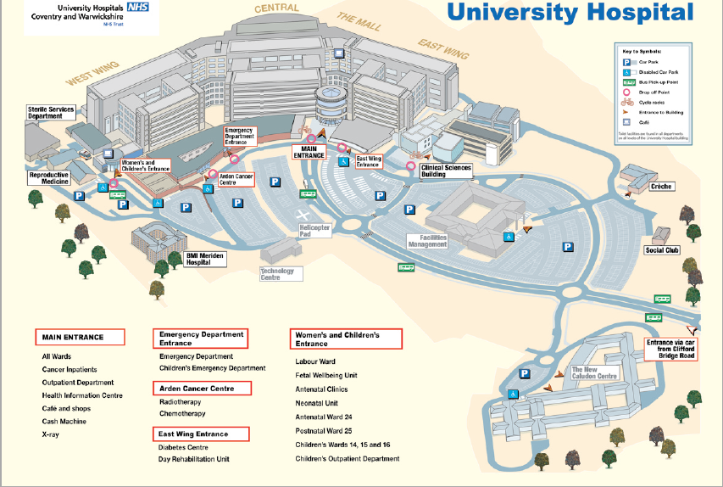

Other practical information

Coats and Luggage Facilities: If you require assistance with your luggage, please ask at Reception. For your convenience we provide a secure area at Scarman house to store luggage or exhibition equipment near Reception.

Smoking: Smoking is not permitted in the venue. There are smoking areas situated outside the venue where Reception staff can guide you.

Tourist information: For further information on local attractions please visit http://www2.warwick.ac.uk/about/visiting/region/

Accessibility: We have toilet, lifts and access ramps which can accommodate wheelchair users. If you have any specific access issues please contact the organisers.

For the most up to date information regarding the conference please visit www.warwick.ac.uk/hmrsymposium

