Edna Adan Ismail is one of the most influential women in Africa today. A talismanic figure whose life and work have inspired people all around the world. Her long career in public life, which has seen her making lasting contributions in the fields of health, peace building and foreign affairs, has been marked by an exceptional devotion to advancing the cause of women and children.
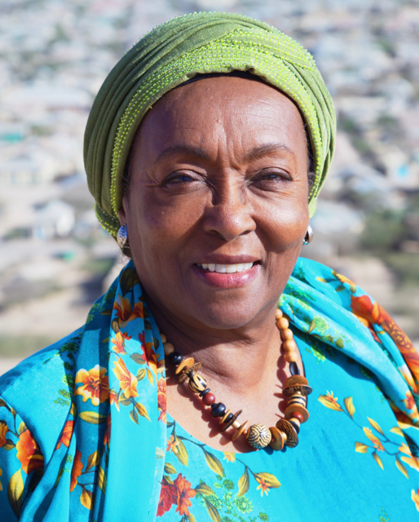
From her time as a trainee nurse and midwife in London in the 1950s to her becoming the First Lady, and presently running the pioneering Edna Adan University Hospital, Edna has never ceased to be a tireless campaigner and champion of women’s rights and health. Born in Hargeisa in British Somaliland Protectorate, Edna trained as a nurse/midwife in London and returned home 1961. In 1963, she married Mohamed Ibrahim Egal who had been the President of an Independent Somaliland before moving to Libya in 1965 to share her skills as a midwife trainer for the World Health Organization (WHO). She returned to the Horn of Africa in 1967 when her husband became Prime Minister of Somalia.
Despite the tragic setback of the civilian government being overthrown by a military coup led by General Mohamed Siyad Barre in October 1969, Edna Adan persevered with her work and in 1976, became the first woman director in the Somali Ministry of Health. In 1986, as Somalia descended into civil war, she re-joined WHO as Regional Nursing/midwifery Advisor, served as a Technical Officer for Reproductive Health from 1987-91, and then became WHO Representative in the Republic of Djibouti from 1991-97. As the first person to publicly speak out against FGM in a region where the practice remains widespread, Edna has been a fearless and tireless campaigner for more than 40 years, leading the campaign in the Horn of Africa and internationally, and training legions of midwives to follow in her footsteps.
Faced with a healthcare system that had been demolished by the long civil war, upon retirement in 1997, Edna founded the Not-For-Profit Edna Adan University Hospital with the aim of improving women's health in a region with one of the highest maternal and infant mortality rates in the world. Established as a maternity teaching hospital with a goal of training 1,000 midwives, over the past 18 years it has grown into a major referral institution for obstetrical, surgical, medical and paediatric cases from a wide geographical area in the Horn of Africa. With the opening of the Edna Adan University in 2010, the level of training has been raised and the programmes have greatly multiplied. Today, over 1,500 students ( 70% women) are enrolled on courses in nursing, midwifery, medicine, pharmacology, laboratory technology, anaesthesia, dental technology and public health. As community midwife training has taken root, the programme has expanded to regional hospitals in Somaliland.
In parallel to the founding of the hospital, in 2002 Edna embarked upon a career in politics and served as minister of Social Affairs and Family Welfare in Somaliland and as a stellar Foreign Minister from 2003-06. Her time in government is remembered fondly and she became a much-loved figure in the land of her birth. As the only female minister in the government at the time, she used her position to raise the concerns and amplify the voice of women.
Edna’s story chimes with the aspirations of women everywhere. It is no surprise that it has struck a chord with so many, her story being included in the PBS documentary Half the Sky: Turning Oppression into Opportunity for Women Worldwide in 2012, and her work being regularly featured and celebrated by prominent journalists such as Nicholas Kristof. Among her numerous awards, Edna Adan received the French Légion d’honneur (2011), and Djibouti made her ‘Commandeur Dans l’Ordre National du 27 Juin’, (1997). Most recently she was the inaugural recipient of the Renfield Foundation Award for Global Women’s Health by the University of Pennsylvania, rates from Clark University and also Pennsylvania University in the US. Was made an Honorary Fellow of the Royal College of Obstetricians in the UK, as well as from Cardiff and London South Bank universities in the UK. In Africa, she was awarded the Chancellor’s Gold, Medal, Pretoria University, for her work on Human Rights, and an Honorary Doctoral Degree from Ahfad University for Women in the Sudan.

In July 2017, she was appointed Somaliland’s Special Envoy for the Peace Talks between Somaliland and Somalia, a monumental task which, if successful, would bring peace back to the Somali-inhabited Horn of Africa.
In 2019, Harper Collins published Edna’s memoirs “ A Woman of Firsts” which has become a best seller and which has been translated into several languages.

In September 2023, Edna was the 2023 Templeton Prize Awardee,

