

Easy Read Leaflet
Why am I reading this?
You are reading this leaflet because your heart stopped while you were in hospital.

This is called a cardiac arrest.
When your heart stops, you become unconscious.

During this time, you were added to a research study called AIRWAYS-3.

What is AIRWAYS-3 about and why is it important?
   | AIRWAYS-3 is a big study to find out the best way to help people breathe when their heart stops.  The study is taking place in England, Wales and some hospitals in Europe.

What do we want to know?
   | When your heart stops, doctors need to help you breathe.  Right now, doctors usually put a tube into your windpipe.  But this can be hard to do and may take a few minutes. Sometimes it may not work at all.  Another way to help you breathe is to put a tube just above your voice box.  This can be quicker and easier to put in.  At the moment, we don’t know which way is better at helping you breathe when your heart stops.

Taking part in the study: why am I already in the study?
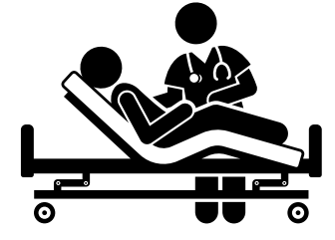 | When your heart stopped, doctors had to act fast.  They used one of the breathing tubes to help you.  This happened quickly because it was an emergency.

What will happen if I stay in the study?
 | You don't need any extra treatments.  A doctor or nurse will talk to you about how you're feeling and ask if you want to stay in the study.  If you say yes:  - You will sign a form.  - You will be asked some questions later about how you are feeling.  - You will get a short booklet to fill out 3 months after your cardiac arrest, and another one at 6 months.  We will also look at your health records.  This includes:  - Your name, address and date of birth.  - Your race or ethnic background.  - What happened when your heart stopped.  - How you are getting better.

What will happen if I do not have consciousness or mental capacity to decide if I want to stay in the study?
     | - If you are too unwell to decide for yourself, the research team will not decide alone. They will first speak to a close family member or friend and explain the study.  - They will then ask them what you would likely want to do.  - If there is no suitable family member or friend, they will ask an independent doctor for their view.  - If they think you would not want to be in the study, you will not stay in the study, and this decision will be respected and recorded.  - If you later become well, the research team will come and ask you again. Your decision will then override any other decision.

Do I have to stay in the study?
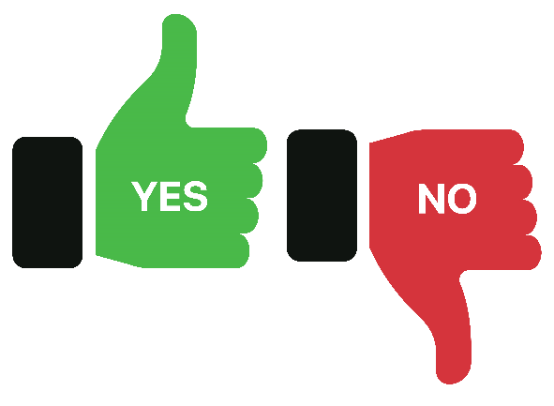 | No, you can stop at any time you want.  It won't change your care and you don't have to give a reason.
Risks and benefits
 |  | There are no risks or benefits just for you.  By helping to take part, it means doctors may be able to treat people better in the future.

What are my choices?
 | You can choose:  - To answer the follow-up question booklets and let us use your health data.  - Let us use your health data but not answer any question booklets.  - Stop being in the study.  Whatever you choose your care will stay the same.

How will my information be used?
   | The University of Warwick is collecting the information from the study.  Your information will be kept safe and private.  Only staff working on the study and who need to see your personal information will be able to see it.  After the study ends, the university and the hospital that treated you will keep the information for 5 years then remove anything that links the information to you.

What will happen with the study results?
 | Results will be shared with doctors and other healthcare staff.  Your name will not be used.  The study is led by Professor Jonathan Benger and funded by the National Institute of Health and Care Research.
Has this study been checked?
 | Yes, the study has been checked and approved by an NHS Research Ethics Committee.  This makes sure that your safety and rights are protected.
What if I’m not happy?
 |  | If you have problem or complaint, you can:  - Talk to the researchers  - Use the NHS Complaints Procedure
What happens next?
   |  | A member of the research team will speak with you about what you’d like to do.  You can ask questions and take your time to decide.
More information
For information about how we use or process information, please see:
- www.hra.nhs.uk/information-about-patients/
- https://warwick.ac.uk/services/legalandcomplianceservices/dataprotection/otherprivacynotices/research/
- Email DPO@warwick.ac.uk

For more information about the study, please visit or contact:
https://www.warwick.ac.uk/airways3
airways3@warwick.ac.uk

