
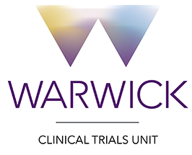

Note to File
Study title: AIRWAYS-3

Subject: Investigator Site File - Non-compliance Forms

Please note, that all completed non-compliance forms are stored electronically on the AIRWAYS-3 database: AIRWAYS-3 (warwick.ac.uk)

Name | Chloe Norman
Role | Trial Manager
Signature | CN
Date | 26.10.2022

